**CYBERSECURTIY LAB – 10**

**HYDRA TOOL**

**NAME : SREENIDHI GANACHARI**

**REGISTRATION NUMBER : 19BCE7230**

Hydra is a parallelized login cracker which supports numerous protocols to attack. It is very fast and flexible, and new modules are easy to add.This tool makes it possible for researchers and security consultants to show how easy it would be to gain unauthorized access to a system remotely.

Hydra is a pre-installed tool in Kali Linux used to brute-force username and password to different services such as ftp, ssh, telnet, MS-SQL, etc. Brute-force can be used to try different usernames and passwords against a target to identify correct credentials. Below is the list of all protocols supported by hydra.

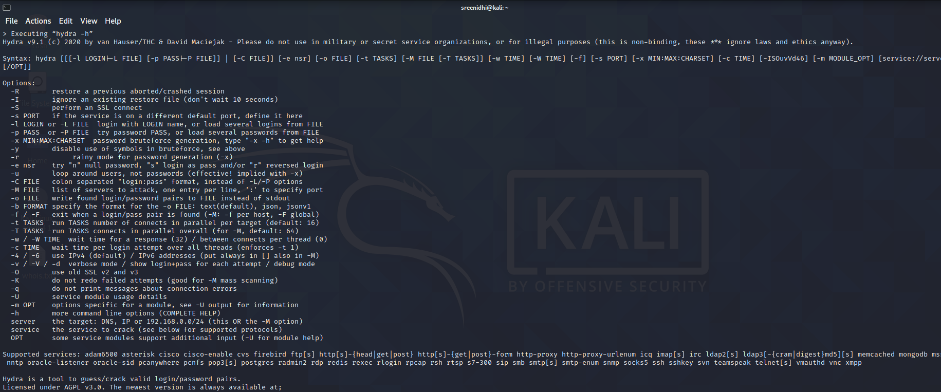

1) Trying to get the password through ftp server

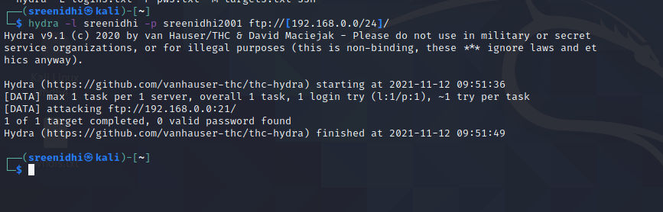

2) Using wordlist to get the password from a target system

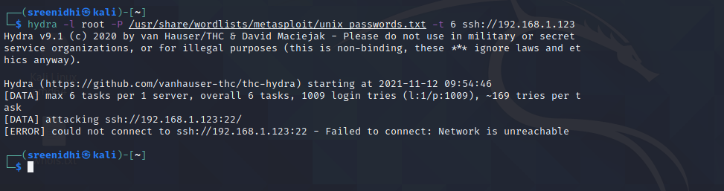

3) Working on the wordlist

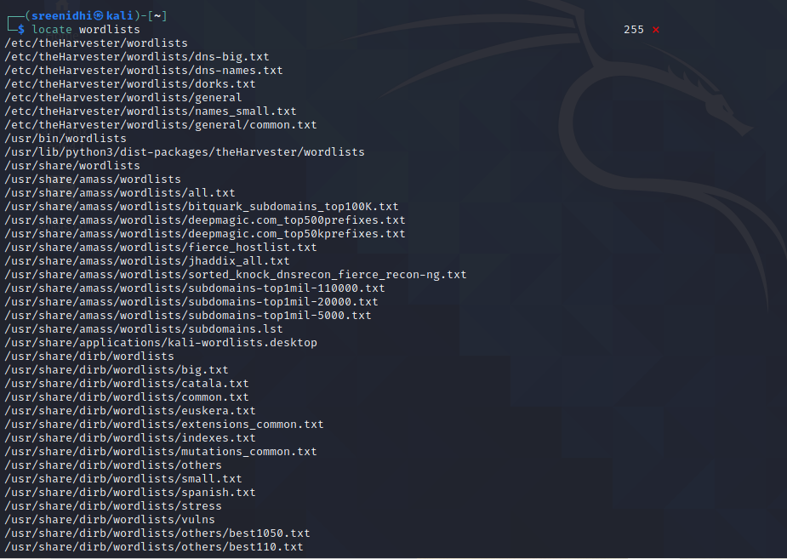

4) Using IP address of the target system along with john the ripper tool to exploit and crack the password

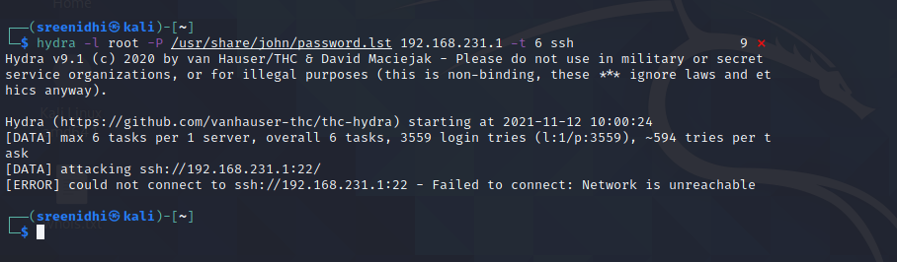

5) Using domain name to crack the password along with the IP address

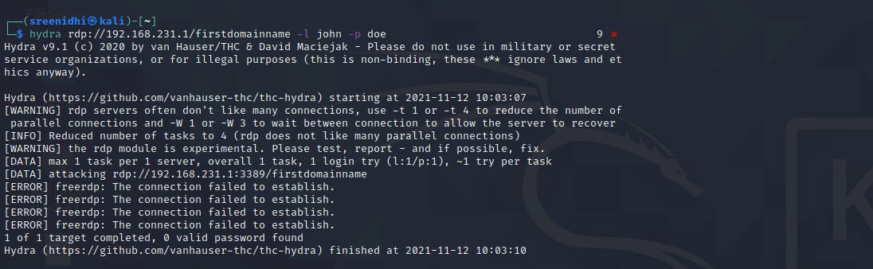

6) Using domain name to crack the password along with the IP address

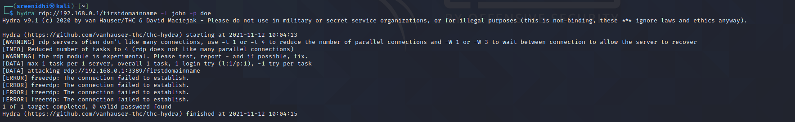

7) Using mysql command and a list of passwords to crack the password

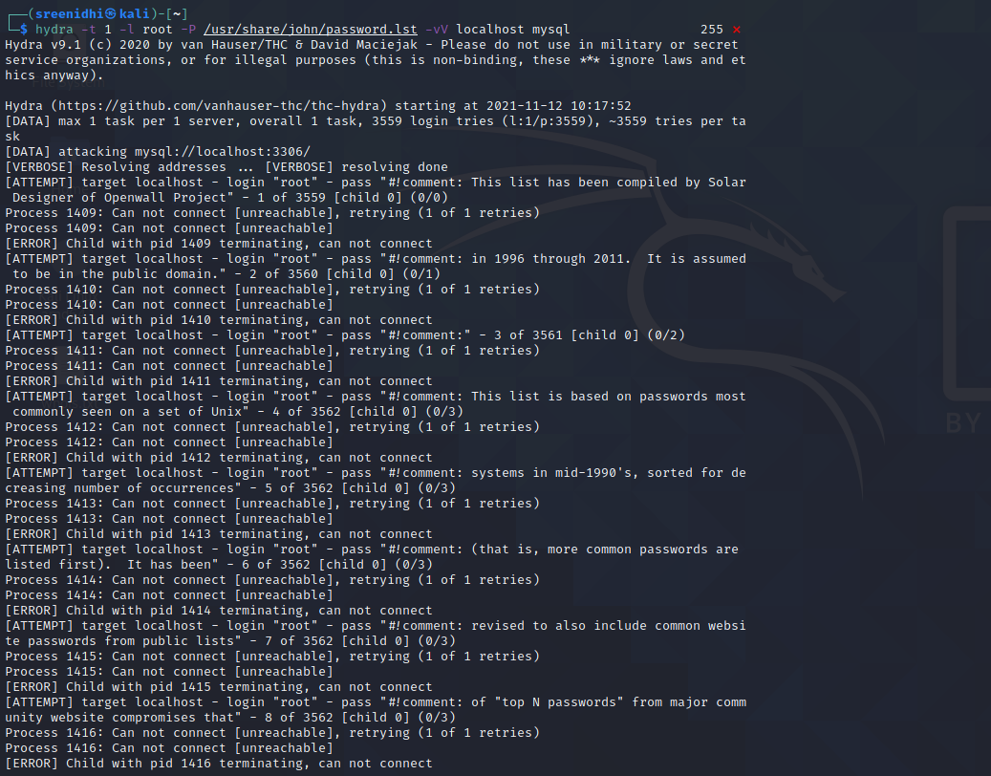

8) Using the ssh command along with the hostname and IP address

