**CYBER SECURITY LAB**

**LAB 2 – NMAP BASIC COMMANDS**

**NAME : SREENIDHI GANACHARI**

**REGISTRATION NUMBER : 19BCE7230**

Nmap (Network Mapper) is a free and open-source network scanner created by Gordon Lyon (also known by his pseudonym Fyodor Vaskovich).Nmap is used to discover hosts and services on a computer network by sending packets and analyzing the responses.Nmap provides a number of features for probing computer networks, including host discovery and service and operating system detection. These features are extensible by scripts that provide more advanced service detection, vulnerability detection, and other features. Nmap can adapt to network conditions including latency and congestion during a scan.

1) sL

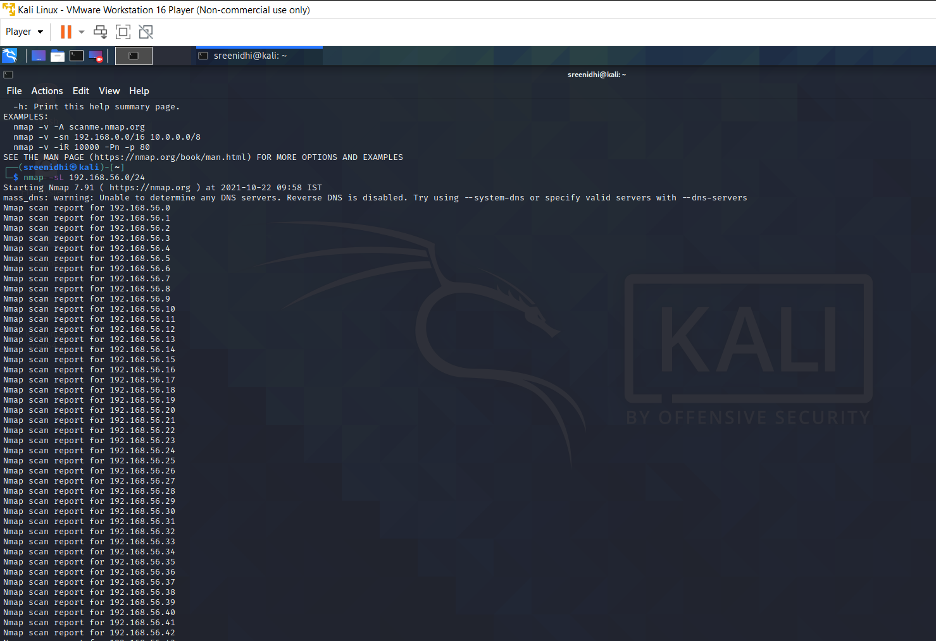

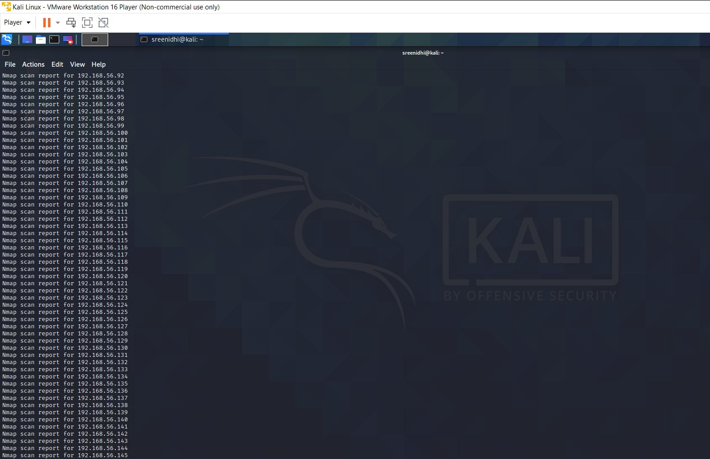

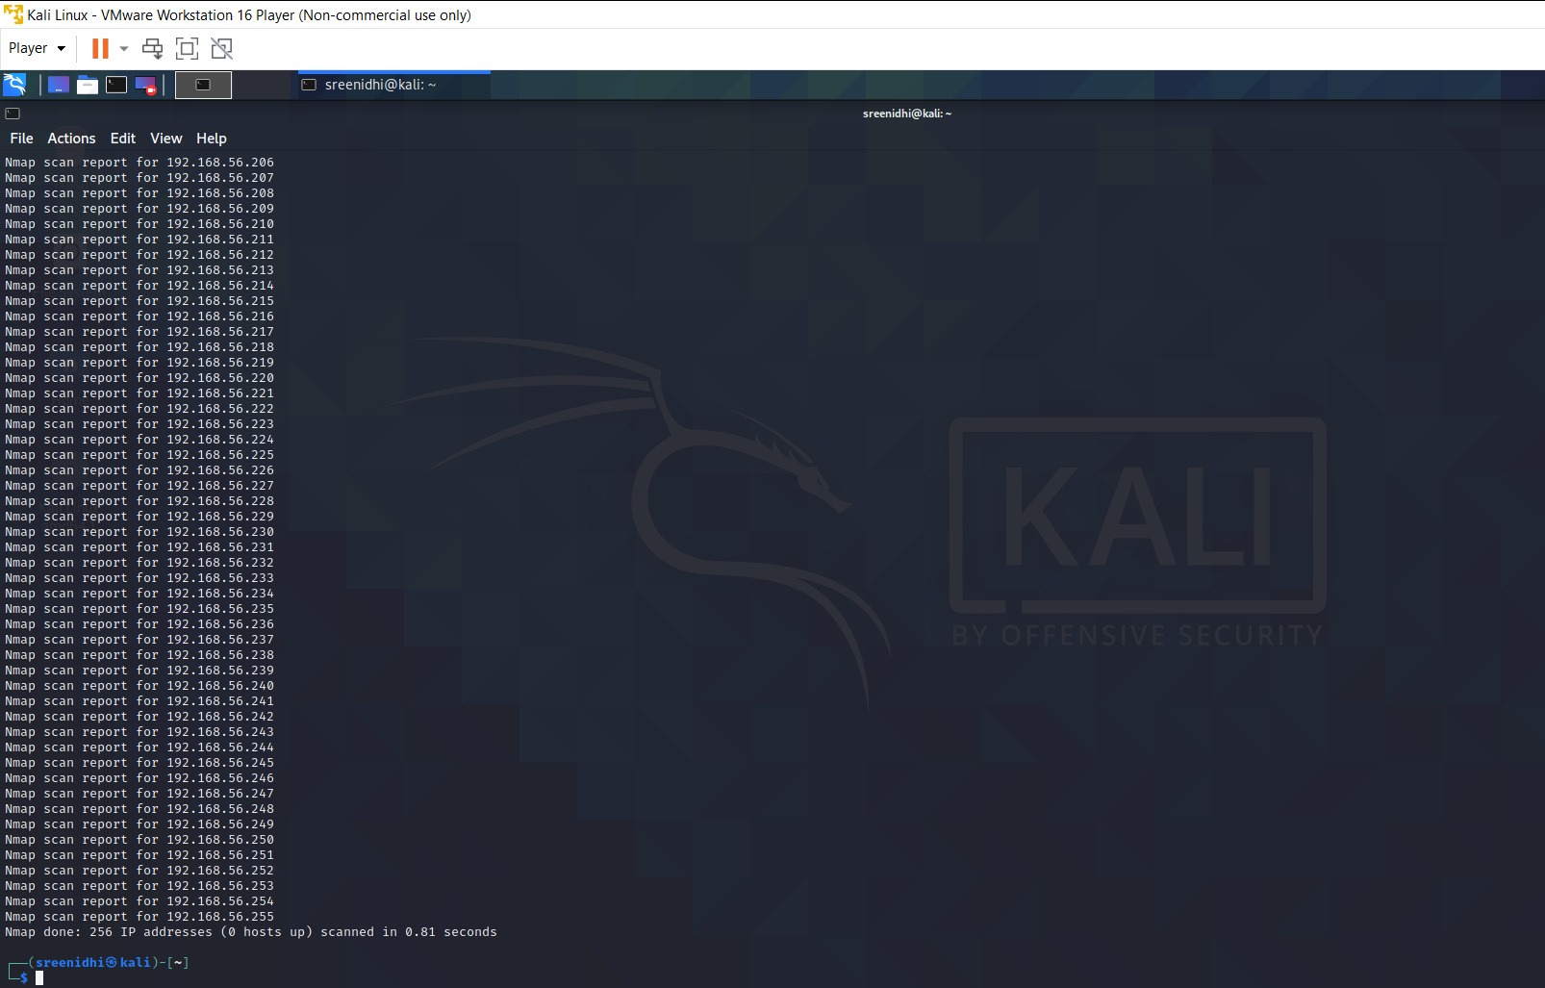

2) sn

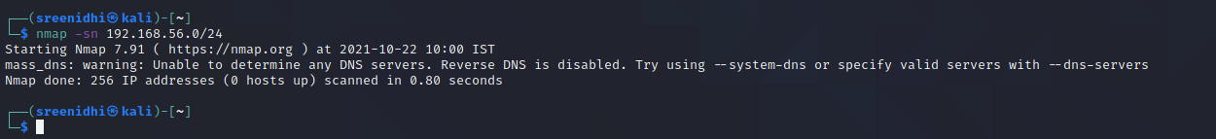

3) nmap 192.168.56.1,100-102



4)nmap -sV

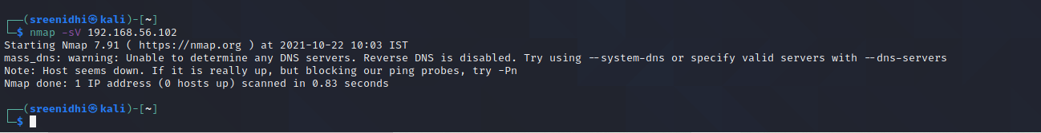

5)nmap -sC



6)locate .nse|grep ftp

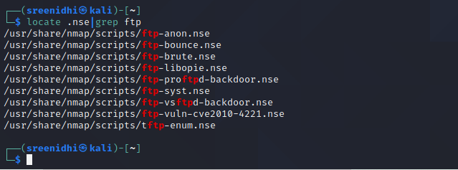

7)nmap –script-help=ftp-vsftd-backdoor.nse

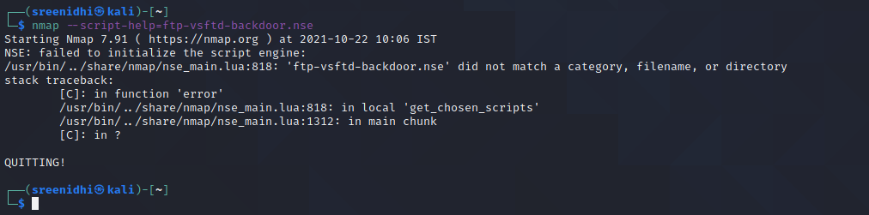

8) nmap –script-help=ftp-vsftd-backdoor.nse 192.168.56.102 -p 21

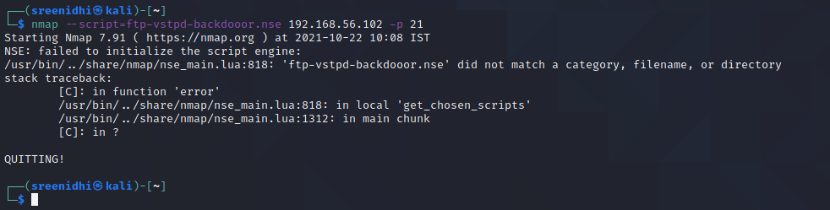

9)nmap -A

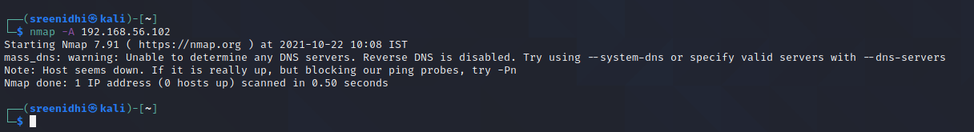

10) nmap -v -A -sV

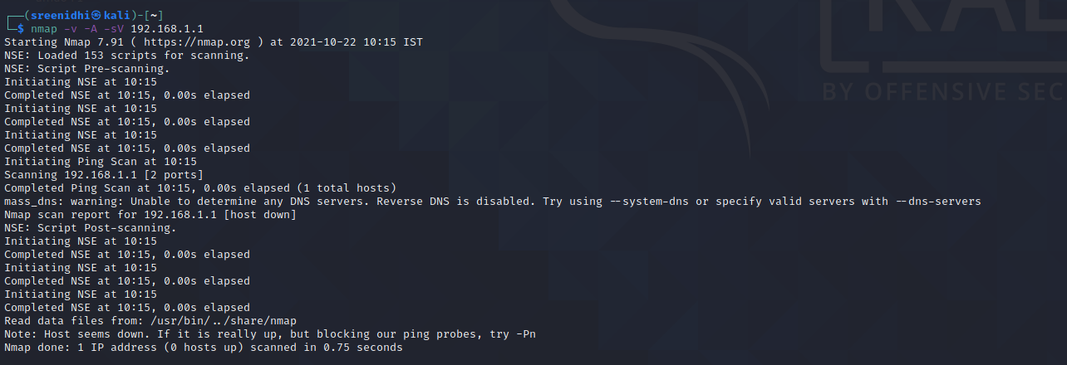

11) nmap -T4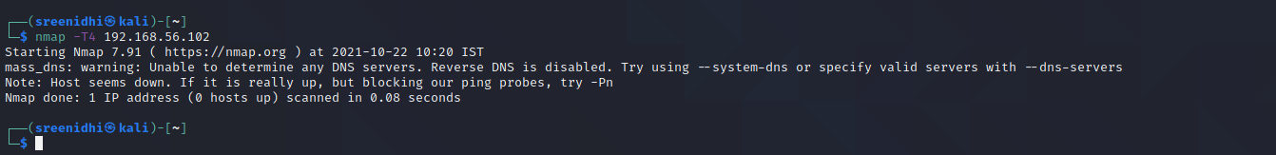

12)nmap -sS

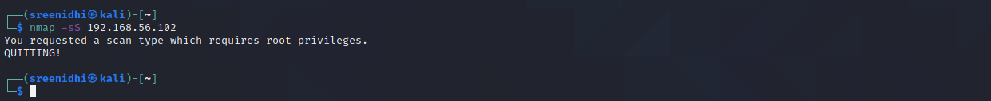

13)nmap -PE

