**CYBER SECURITY LAB – 4**

**MACCHANGER COMMANDS**

**NAME : SREENIDHI GANACHARI**

**REGISTRATION NUMBER : 19BCE7230**

GNU MAC Changer is an utility that makes the manipulation of MAC addresses of network interfaces easier. MAC addresses are unique identifiers on networks, they only need to be unique, they can be changed on most network hardware. MAC addresses have started to be abused by unscrupulous marketing firms, government agencies, and others to provide an easy way to track a computer across multiple networks. By changing the MAC address regularly, this kind of tracking can be thwarted, or at least made a lot more difficult.

1)

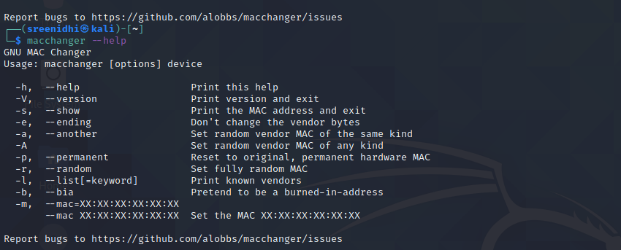

2)

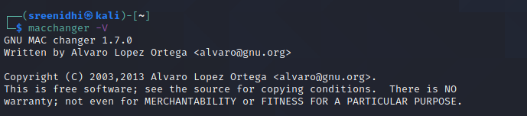

3)

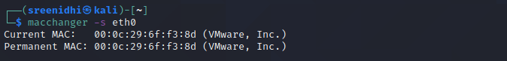

4)

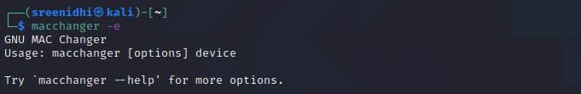

5)



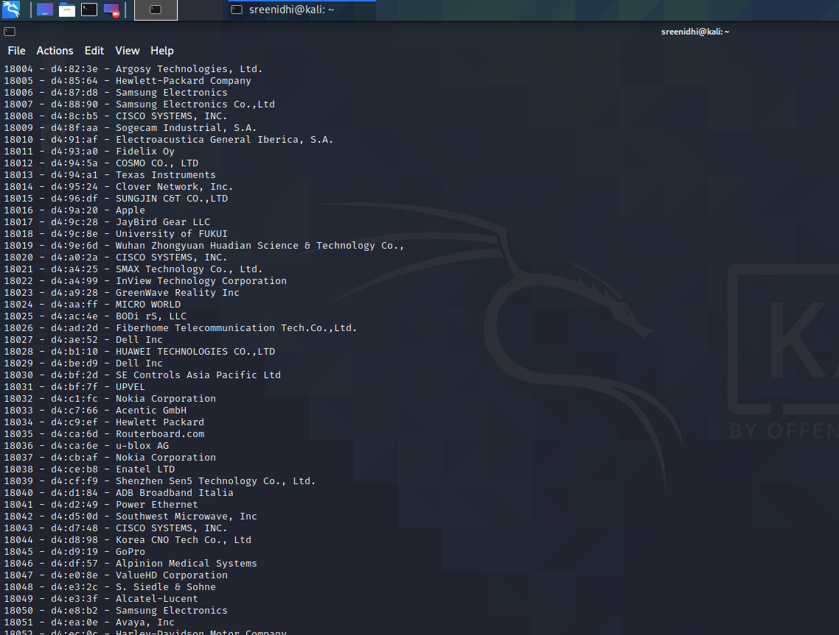

6)

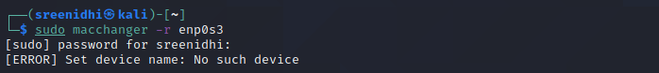

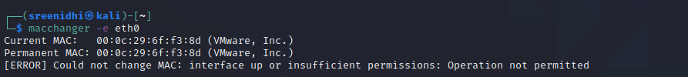

7)

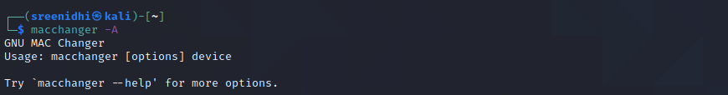

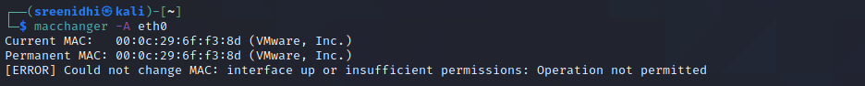

8)



9)

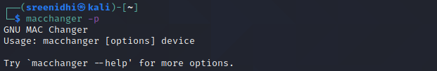

10)

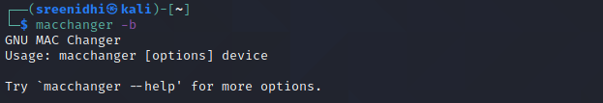

11)

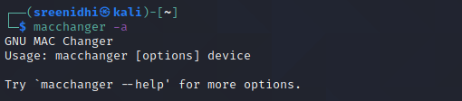

12)

