**CYBER SECURITY LAB -7**

**NIKTO TOOL COMMANDS**

**NAME: SREENIDHI GANACHARI**

**REGISTRATION NUMBER : 19BCE7230**

Nikto is a pluggable web server and CGI scanner written in Perl, using rfp’s LibWhisker to perform fast security or informational checks. It is an open-source, free, and easy-to-use tool that helps you to find potential problems and vulnerabilities very quickly. Nikto checks for the presence of multiple index files, HTTP server options, and identifies installed web servers and software. Using Nikto allows you to test a web server very quickly.

Features:

* Easily updatable CSV-format checks database
* Output reports in plain text or HTML
* Available HTTP versions automatic switching
* Generic as well as specific server software checks
* SSL support (through libnet-ssleay-perl)
* Proxy support (with authentication)
* Cookies support

1)

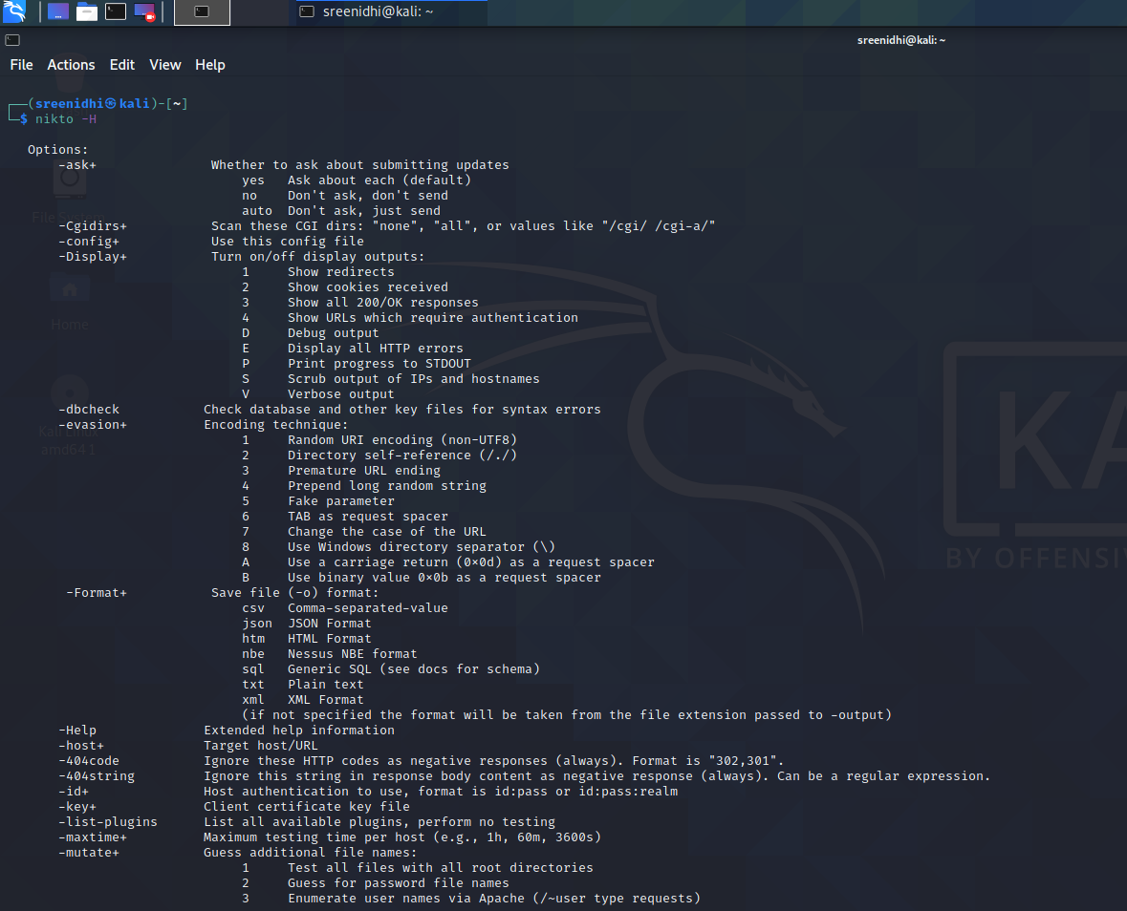

2)

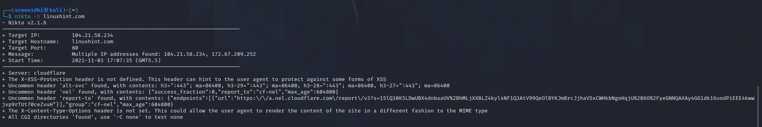

3)

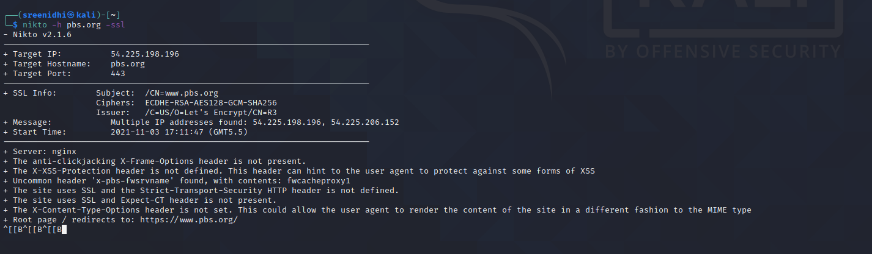

4)

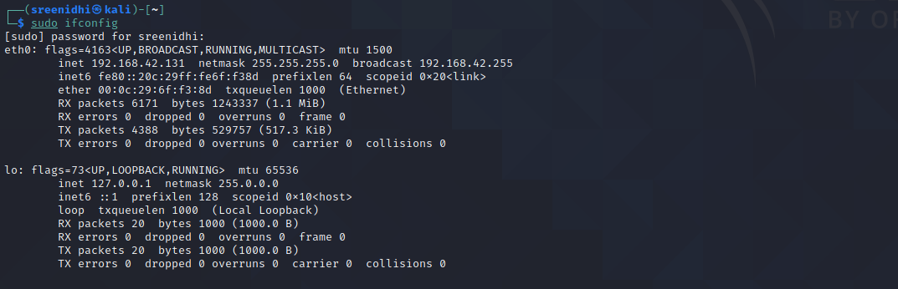

5)



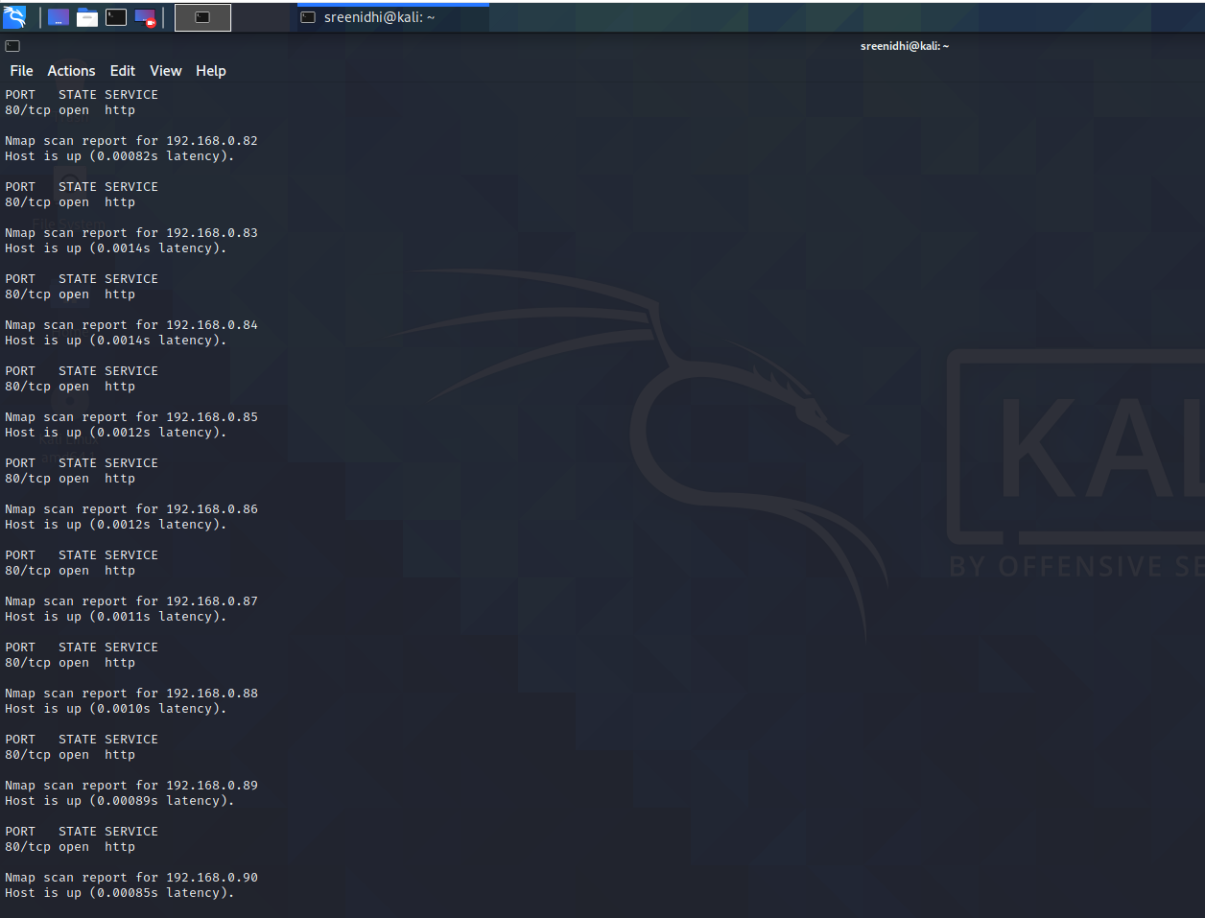

6)



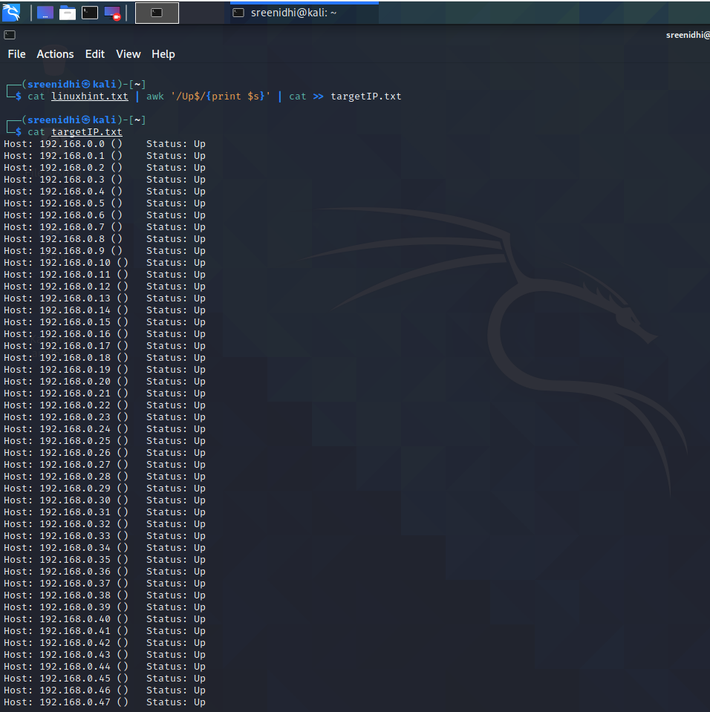

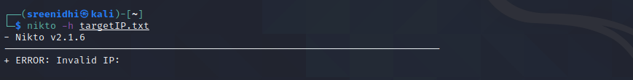

7)

