**CYBERSECURTIY LAB – 8**

**JOHN THE RIPPER TOOL**

**NAME : SREENIDHI GANACHARI**

**REGISTRATION NUMBER : 19BCE7230**

John the Ripper is a fast password cracker, currently available for many flavors of Unix, macOS, Windows, DOS, BeOS, and OpenVMS (the latter requires a contributed patch). Its primary purpose is to detect weak Unix passwords. Besides several crypt(3) password hash types most commonly found on various Unix flavors, supported out of the box are Kerberos/AFS and Windows LM hashes, as well as DES-based tripcodes, plus hundreds of additional hashes and ciphers in "-jumbo" versions.

1) Getting the hash codes of passwords of each file in the Operating System

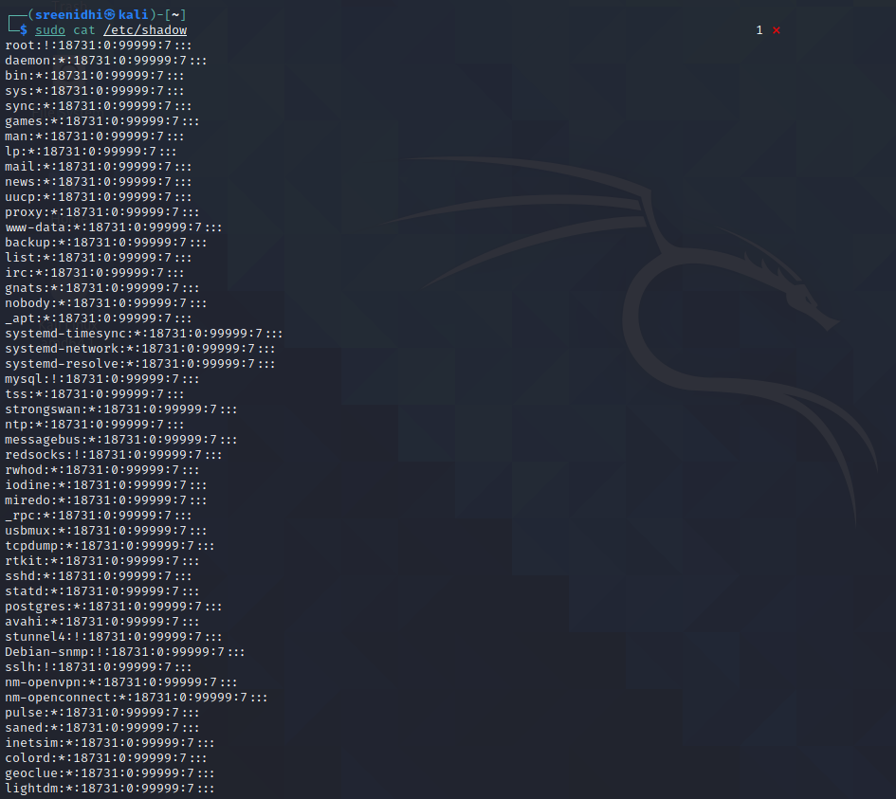

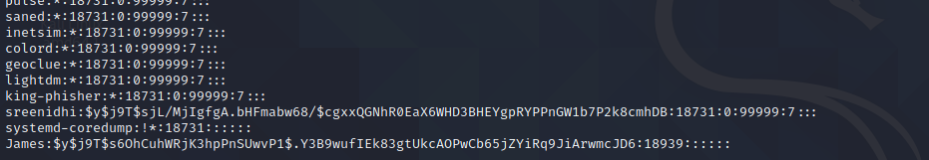

2) Creation of a user , setting a password for cracking it .

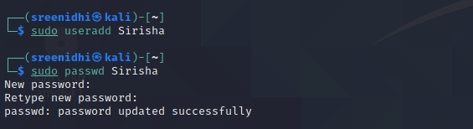

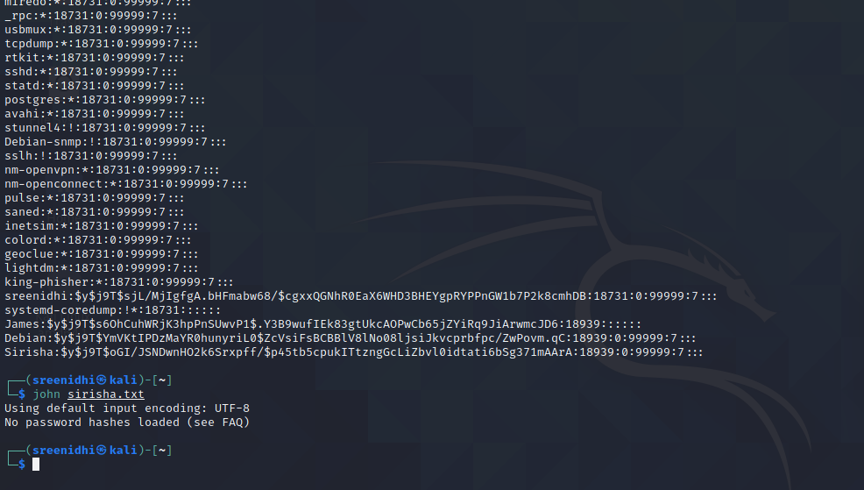

3) Creation of ZIP File

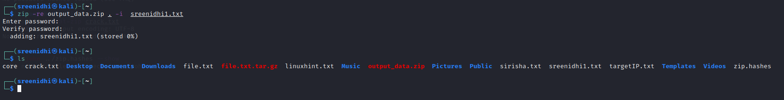

4) Checking the hash code of the password





5) Cracking the password of the zip file created using single method .

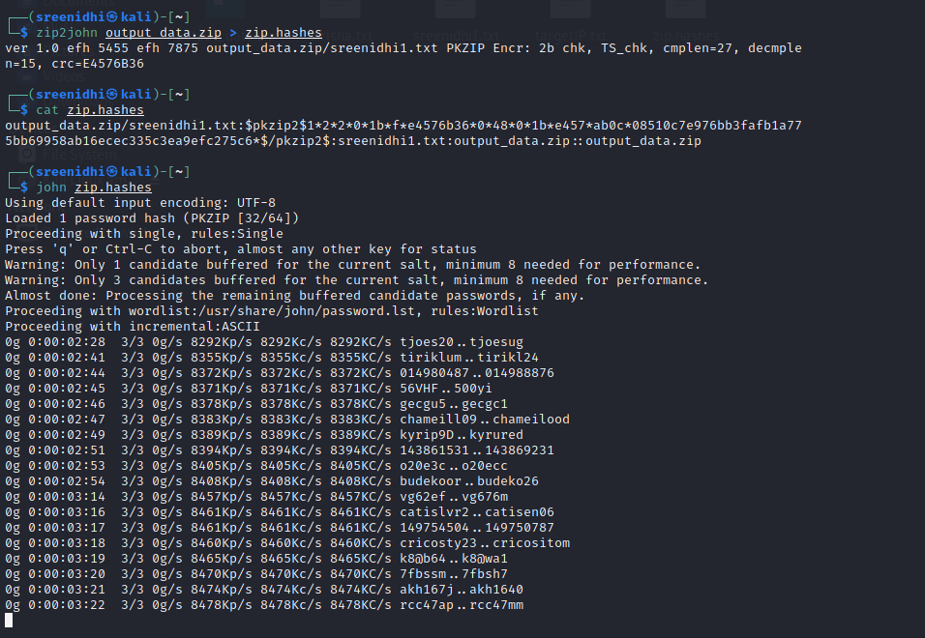

6) Cracking of password using the wordlist method .

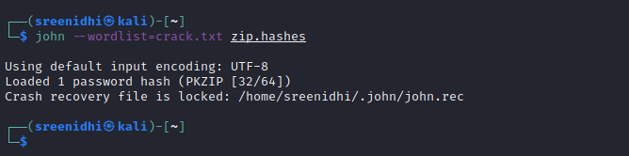

7) Unzipping the zip file with a password .

