**CYBERSECURITY LAB – 9**

**WHOIS TOOL**

**NAME : SREENIDHI GANACHARI**

**REGISTRATION NUMBER : 19BCE7230**

A whois Kali linux command is a utility as a part of the information gathering used in all of the Linux-based operating systems. this tool is part of information security assessment, and one of information gathering techniques. there are a lot of information gathering strategies. It is used to identify domain information and more.

* Unknown and distant hosts
* Networks
* Even Netadmins if you use the command the right way and you are lucky enough

“WHOIS is a database managed by local internet registrar, availing to us the personal information about the owner for example`: his contact details, his organization, and his IP as well as his geographical location ” we can use whois command to retrieve that information.

1)

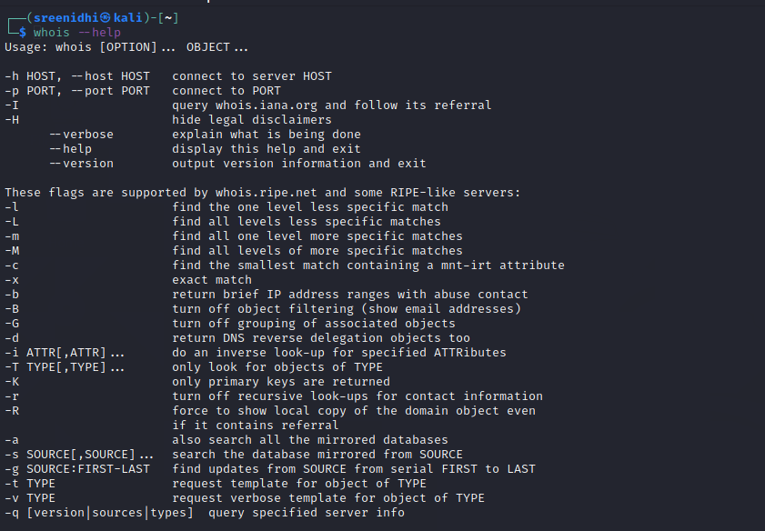

2)

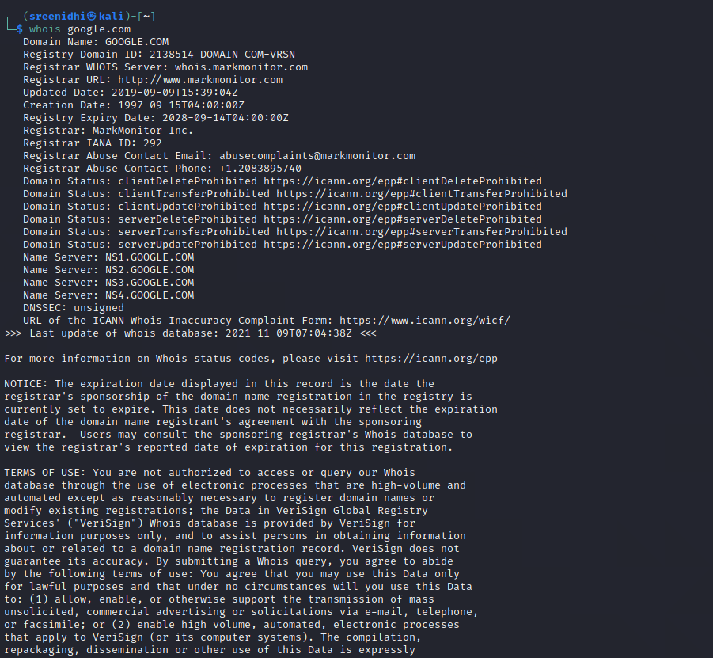

3)

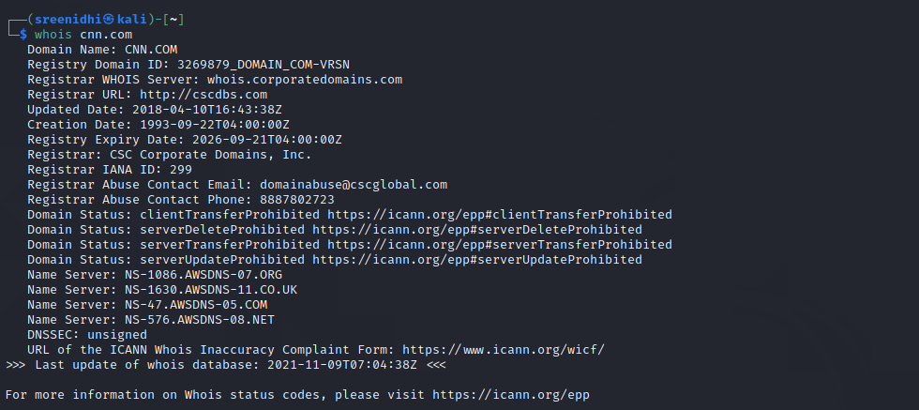

4)

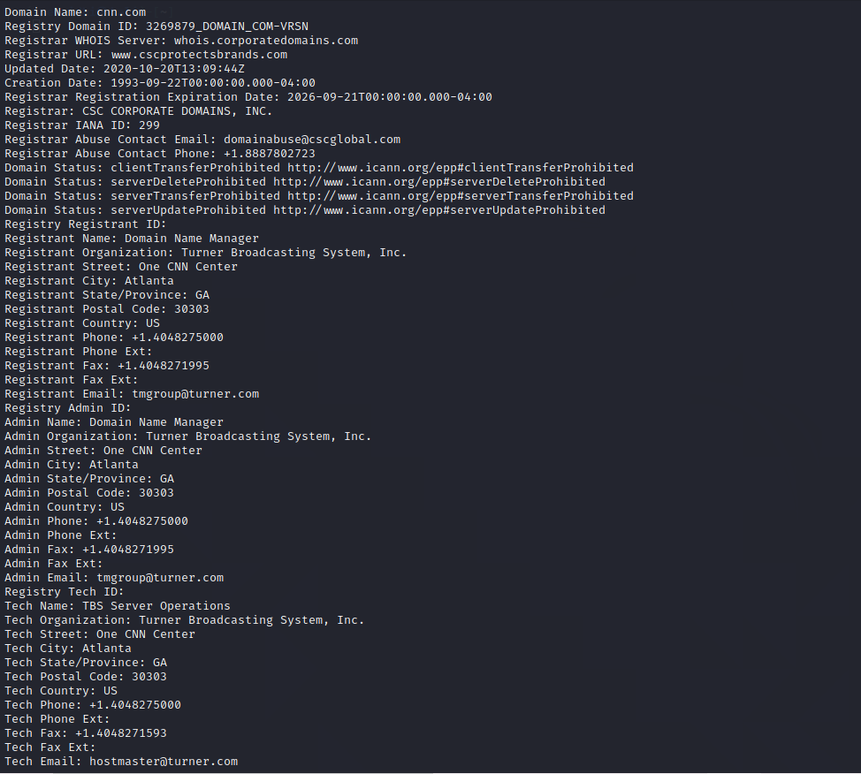

5) For the IP addresses, the information is much more substantial. Here you got addresses, phone numbers, organization handles and everything

For the site name, you got the server name registrar and the referral URL which is of course for the whois command. as you can notice that the information is certainly less substantial but fun and relevant if you are just starting.

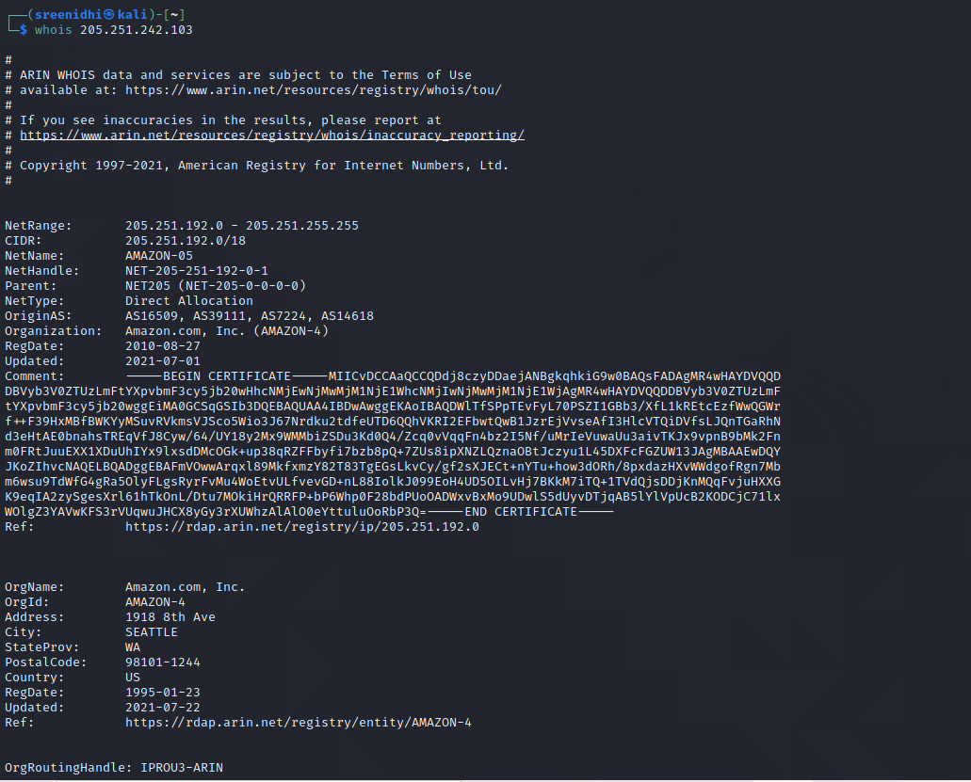

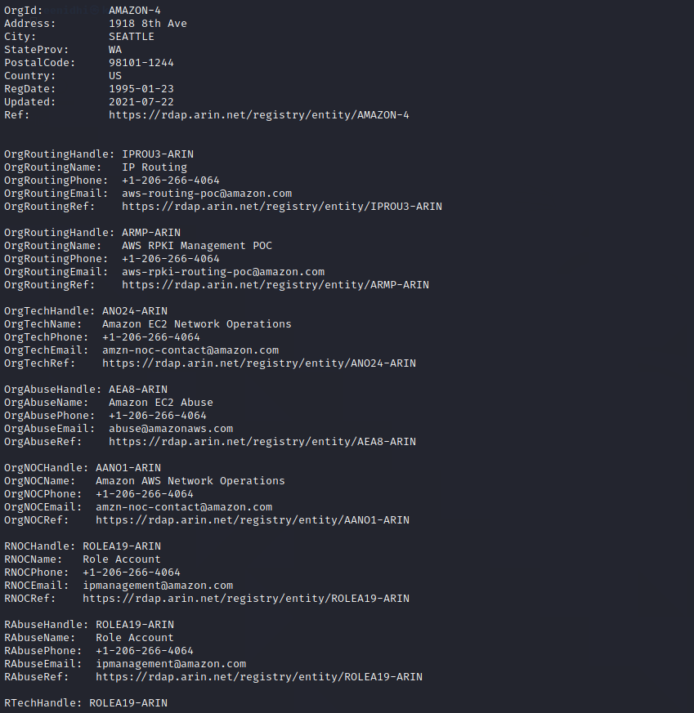

6)

