**SECURE CODING LAB 5**

**NAME : SREENIDHI GANACHARI**

**REGISTRATION NUMBER : 19BCE7230**

**SLOT: L 39+40**

Create a task name “Reg.no_Task1” to run on a specific time

Schedule an another task to run only on Weekends



Change the time of the scheduled task

Delete the scheduled task

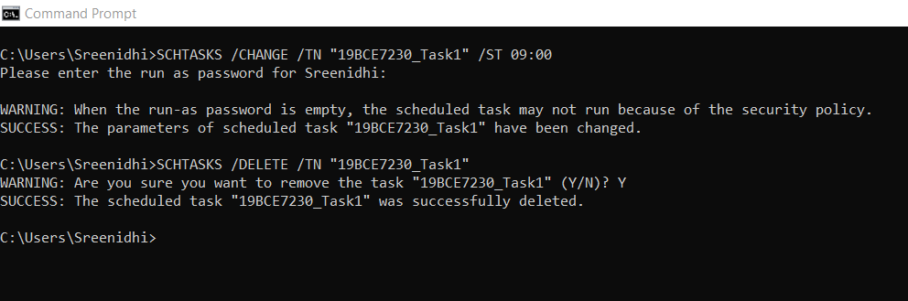

Schedule an another task to run only on Weekdays

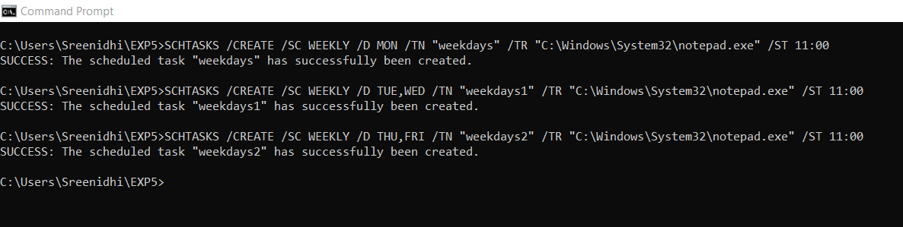

Schedule an another task to run only on Weekends

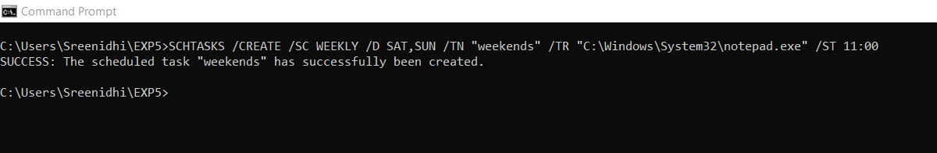

Creating and replicating files

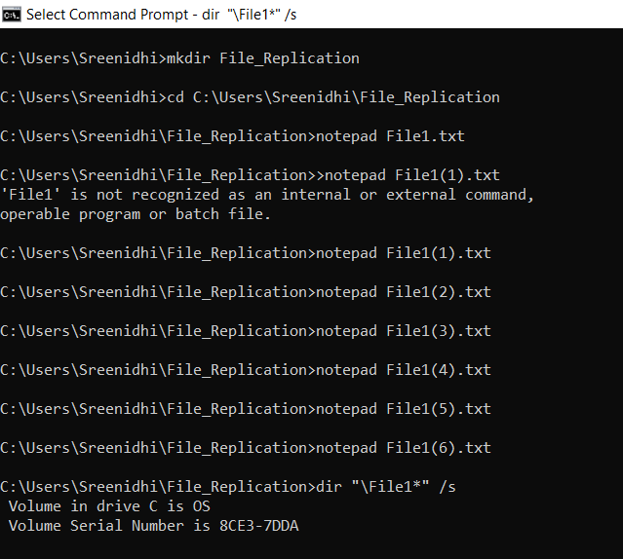

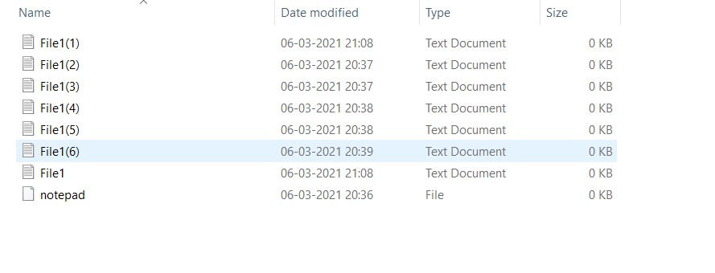

Finding the files location

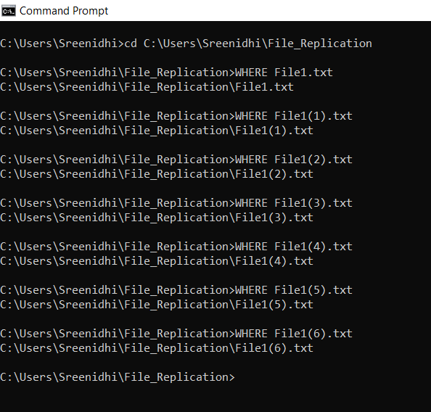

Deleting all the files

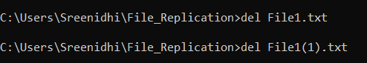

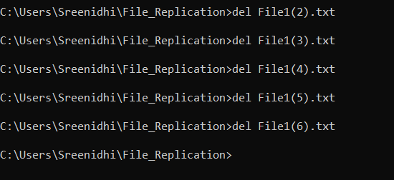

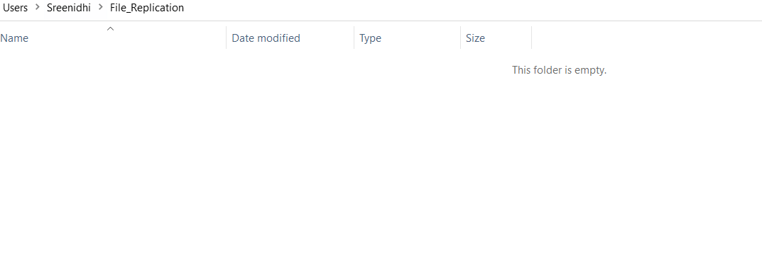

Write a file replication code to copy the same file for 50 times on the same directory.

