**SECURE CODING**

**LAB -1 (3-2-2021)**

The Operating System used in my laptop is Windows 10 . The first step of security is the password and the wi-fi access is also password secured .

**Control Panel –**

Under Security and Maintenance in virus and threat protection – the Antivirus Software used is Quick Heal Antivirus Pro . It is turned on and the protection updates , threats are all given here . The PC is secure according to the given updates .

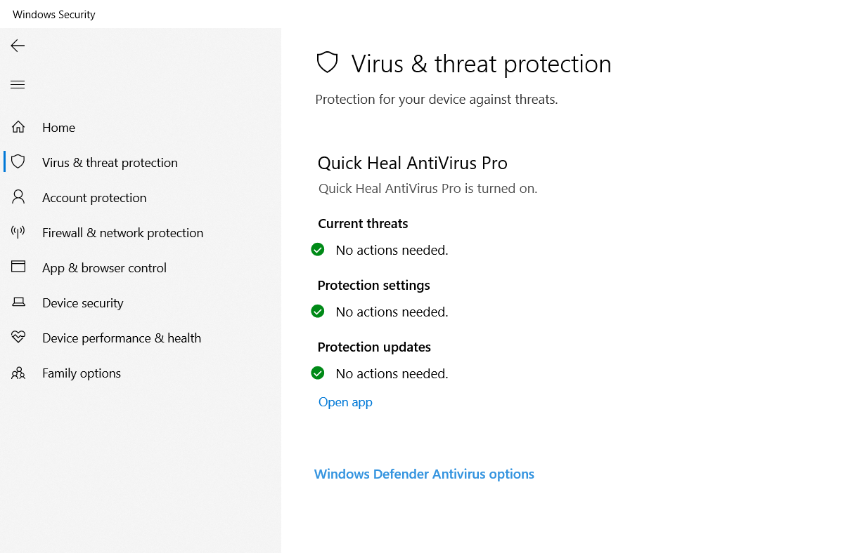

The Dynamic Lock ( it is a new feature that uses proximity of a bluetooth paired phone to handle Windows 10 device access is not set up and this may be a point of vulnerability .

Under App and browser control Windows defender smartscreen protects the computer and warns for unrecognized apps and websites or files from the web .

The smartscreen protect of Microsoft edge also protects the device from malicious sites and downloads .

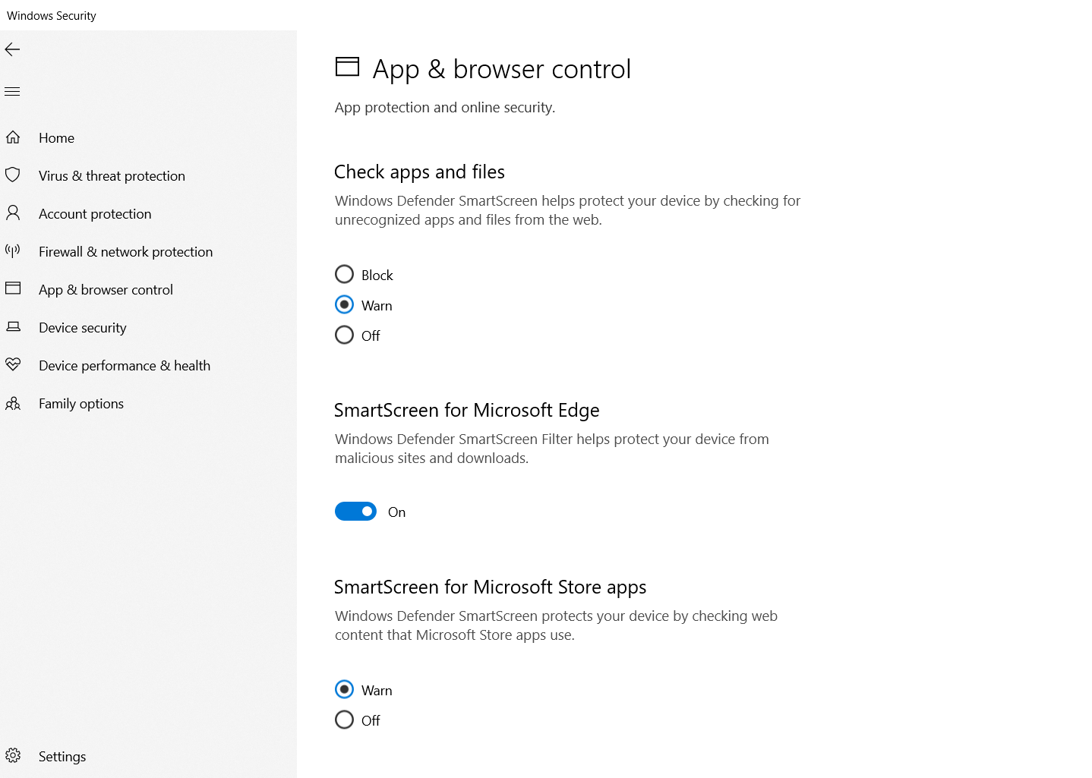

**Under Device Security -**

Core isolation – This is a virtualization – based security that protects the core parts of the device.

Secure boot -This provides additional encryption

Security Processor – This prevents malicious software from loading when the device starts .

All the above provide additional encryption and also prevent the malicious software from downloading .

The Widows Defender Firewall in the device also helps in protecting the computer from malicious software and hackers .

The protection in the system is available only to the C drive and is off for the D and E drive .

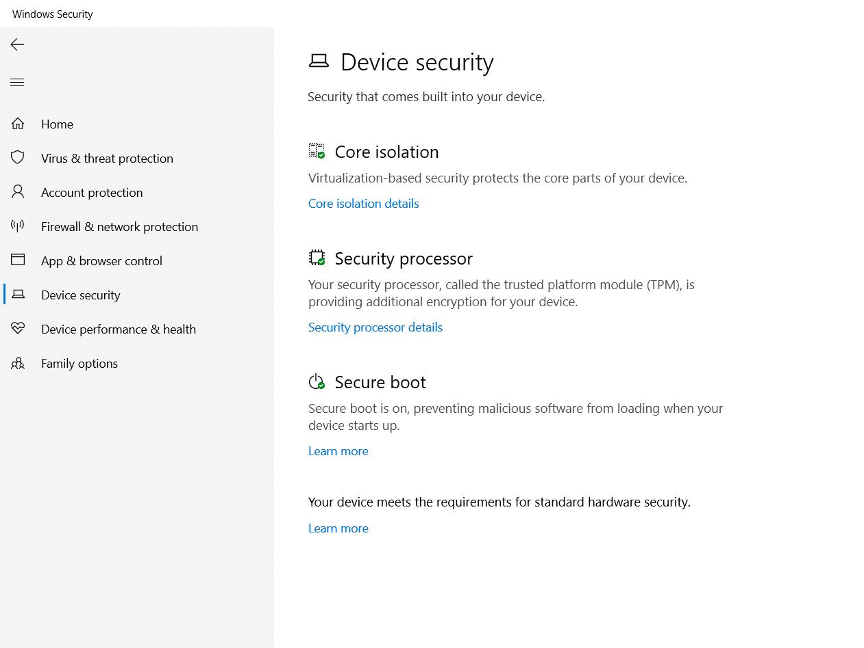

**Internet Properties –**

There are various zones in the security section – Internet , Intranet ,Trusted Sites and Restricted Sites

The security level of each zone is medium-high , custom , medium and high respectively ,thus these help us to protect the device from malicious sites .