SOFTWARE DESIGN DOCUMENT(SDD)

Smart Ticket & Issue Management System
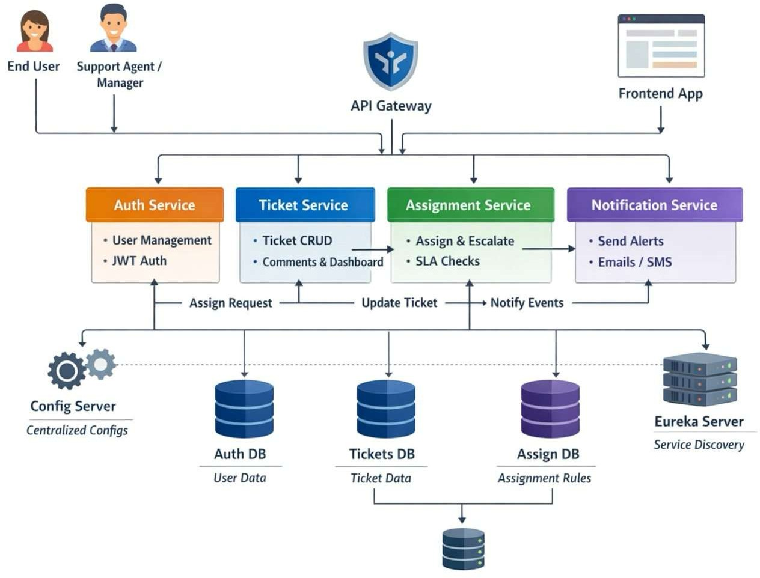

DOCUMENT CONTROL

Item Details
Project Name Smart Ticket & Issue Management System Version 1.0
Author A.Sreenidhi
Date 27-12-25
Status Final

PURPOSE OF THE DOCUMENT
This document describes the system architecture, design decisions, component structure, APIs, data models, and non-functional aspects of the Smart Ticket & Issue Management System.

It is intended for:

- Developers
- Reviewers
- Interview discussions
- Maintenance & enhancement planning

SYSTEM OVERVIEW

Business Objective
Provide a scalable, secure, and maintainable system to:

- Manage Users & Identities
- Handle Ticket Lifecycle
- Ticket Allocation
- Support growth through microservices

High-Level Features
- User Registration & Secure Login
- Real-time Ticket Tracking
- Role-based access (USER / ADMIN / Manager / Agent)

ARCHITECTURE OVERVIEW (HLD)
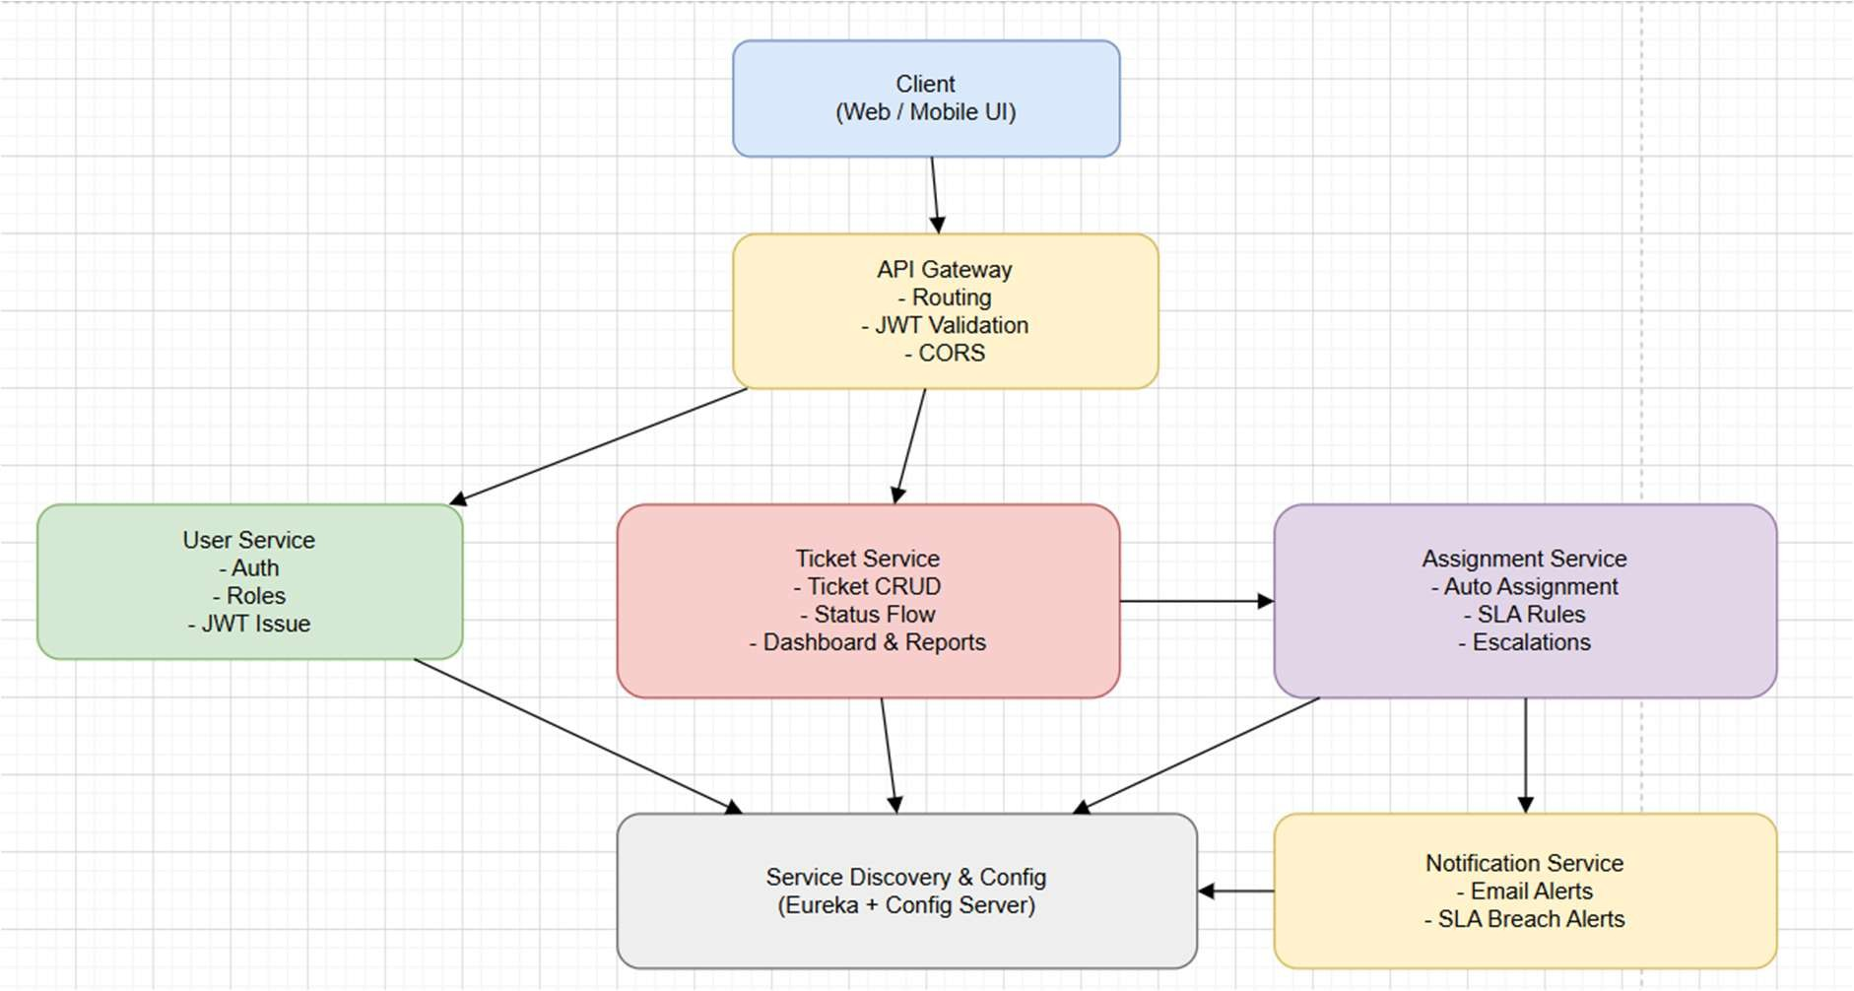

Architecture Style
- Microservices Architecture
- REST-based communication
- Containerized deployment

Core Components
- Angular Frontend
- API Gateway (optional)
- User Service
- Product Service
- Order Service
- MongoDB (per service)
- CI/CD Pipeline

TECHNOLOGY STACK

Backend
- Java 17
- Spring Boot
- Spring ReactiveWeb
- Spring Data MongoDB
- Spring Validation

Frontend
- Angular
- Angular Material
- RxJS

Database
- MongoDB (one DB per microservice)

DevOps
- Docker
- Docker Compose
- Jenkins
- SonarQube

Testing
- JUnit 5
- Mockito
- Spring Boot Test

MICROSERVICES DESIGN

User Service

Responsibilities

    - User registration
    - Authentication
    - Role management

APIs

POST /auth/register POST /auth/login GET /users/{id}

GET /auth
GET /users
PUT /users/{id}/role PUT /users/{id}/status

Database

    - users collection

Ticket Service

Responsibilities

    - Ticket CRUD
    - Lifecycle Management
    - Reopen/Cancel
    - History/Activity Logs
    - Comments
    - Dashboard

APIs

POST /tickets
GET /tickets/{id}
GET /tickets/user/{userId} GET /tickets/status/{status} GET /tickets/agent/{agentId}
PUT /tickets/{id}/assign PUT /tickets/{id}/status PUT /tickets/{id}/close

PUT /tickets/{id}/reopen PUT /tickets/{id}/cancel

GET /reports/tickets-by-status GET /reports/tickets-by-priority GET /reports/avg-resolution-time GET /reports/sla-breaches
GET /dashboard/summary

POST /tickets/{id}/comments GET /tickets/{id}/comments
GET /tickets/{id}/history
GET /tickets?status=&priority=&page=&size=

Database

    - Ticket collection

Assignment Service

Responsibilities

- Assign tickets to agents
- Decide priority based on rules
- Enforce SLA rules
- Handle escalations
- Track agent workload

APIs

POST /api/assign/{ticketId}
GET /api/escalations/manager/{mgrId} GET /api/agents/workload
GET /api/escalations/logs GET /api/agent/{agentId} POST /api/sla/check

Database

- assignment collection

Notification Service

Responsibilities

    - Sends notifications

APIs

POST /notify/ticket-created POST /notify/ticket-assigned

POST /notify/sla-breach

Database

    - notification collection

Api Gateway

Responsibilities

    - forwarding api points

DATA DESIGN (LLD)

User Document
{ "_id": "user_101",
"name": "sreenidhi",
"email": "sreenidhi@gmail.com", "password": "encrypted", "role": "USER",
"active": true
}

Ticket Document
{

"_id": "ticket_201",
"title": "Phone not working", "description": "Screen is not responding", "category": "HARDWARE",
"priority": "HIGH",
"status": "OPEN", "createdBy": "user_101", "assignedAgentId": "agent_1", "createdAt": "timestamp", "updatedAt": "timestamp", “dueDate": "timestamp", "slaBreached": false

}

Assignment Document
{

"_id": "assgn_8821", "ticketId": "ticket_201", "agentId": "agent_1", "assignedBy": "manager_1", "assignedAt": "timestamp",

"priority": "HIGH", "sla": {

"responseBy": "timestamp", "resolutionBy": "timestamp", "escalated": false

},
"status": "ACTIVE", "lastUpdatedAt": "timestamp"

}

Notification Document

{
"_id": "notif_1001", "userId": "user_101", "email": "abc@gmail.com", "type": "TICKET_ASSIGNED",
"message": "Your ticket has been assigned", "read": false,
"createdAt": "timestamp"
}

API DESIGN & VALIDATION
- RESTful principles
- JSON request/response
- Bean Validation at DTO layer
- Service-level business rule enforcement
- Standard HTTP status codes

ERROR HANDLING STRATEGY

Global Exception Handling
- Centralized using @ControllerAdvice
- Standard error response format

{
"timestamp": "TimeStamp", "status": 400,
"error": "Validation Error", "message": "Invalid Ticket Data"
}

SECURITY DESIGN
- Password encryption (BCrypt)
- Role-based access control
- JWT authentication

- Secure API access

NON-FUNCTIONAL REQUIREMENTS
Area Design Decision Scalability Stateless services, Docker Performance Pagination, async calls Availability Independent services Maintainability POM-like layered backend Security Validation, encryption Observability Logging & monitoring

TESTING STRATEGY

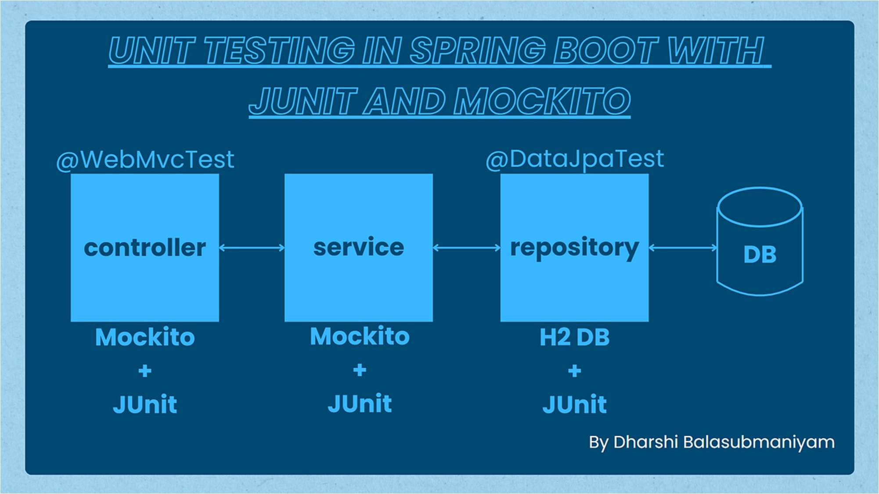

Backend
- Unit tests (Service layer)
- Controller tests (MockMvc)
- Minimum 90% coverage

Frontend
- Component tests
- Service tests

Quality Gates
- SonarQube enforced
- Build fails on violations

CI/CD DESIGN
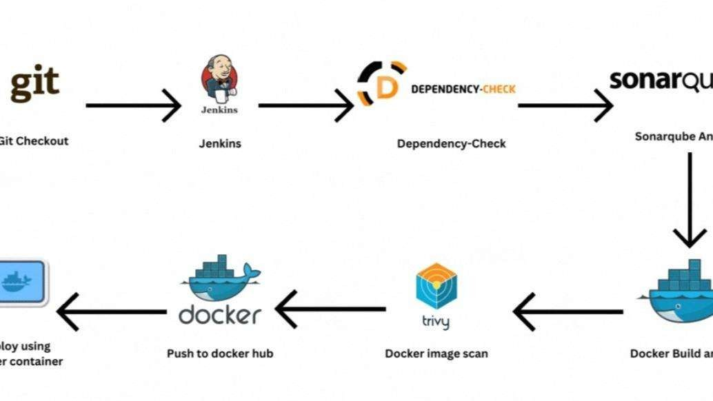
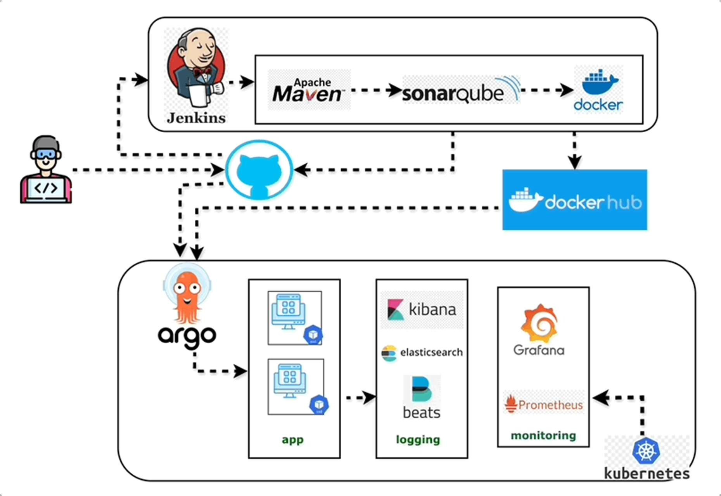

Pipeline Flow

- Git Commit
- Jenkins Build
- Unit Tests
- SonarQube Scan
- Quality Gate Check
- Docker Build
- Docker Compose Deploy

DEPLOYMENT DESIGN
- Docker image per microservice
- docker-compose for orchestration
- Environment-specific configs

ASSUMPTIONS & CONSTRAINTS

Assumptions
- Services communicate over REST
- MongoDB available
- Docker environment present

Constraints
- No distributed transactions
- Event-driven architecture out of scope

FUTURE ENHANCEMENTS
- Spring Cloud Gateway
- Kafka-based async communication
- Kubernetes deployment
- Centralized logging (ELK)

CONCLUSION
This design ensures:
✔ Clean separation of concerns
✔ Scalability & maintainability
✔ Testability & CI/CD readiness
✔ Interview-ready explanation

SEQUENCE DIAGRAMS
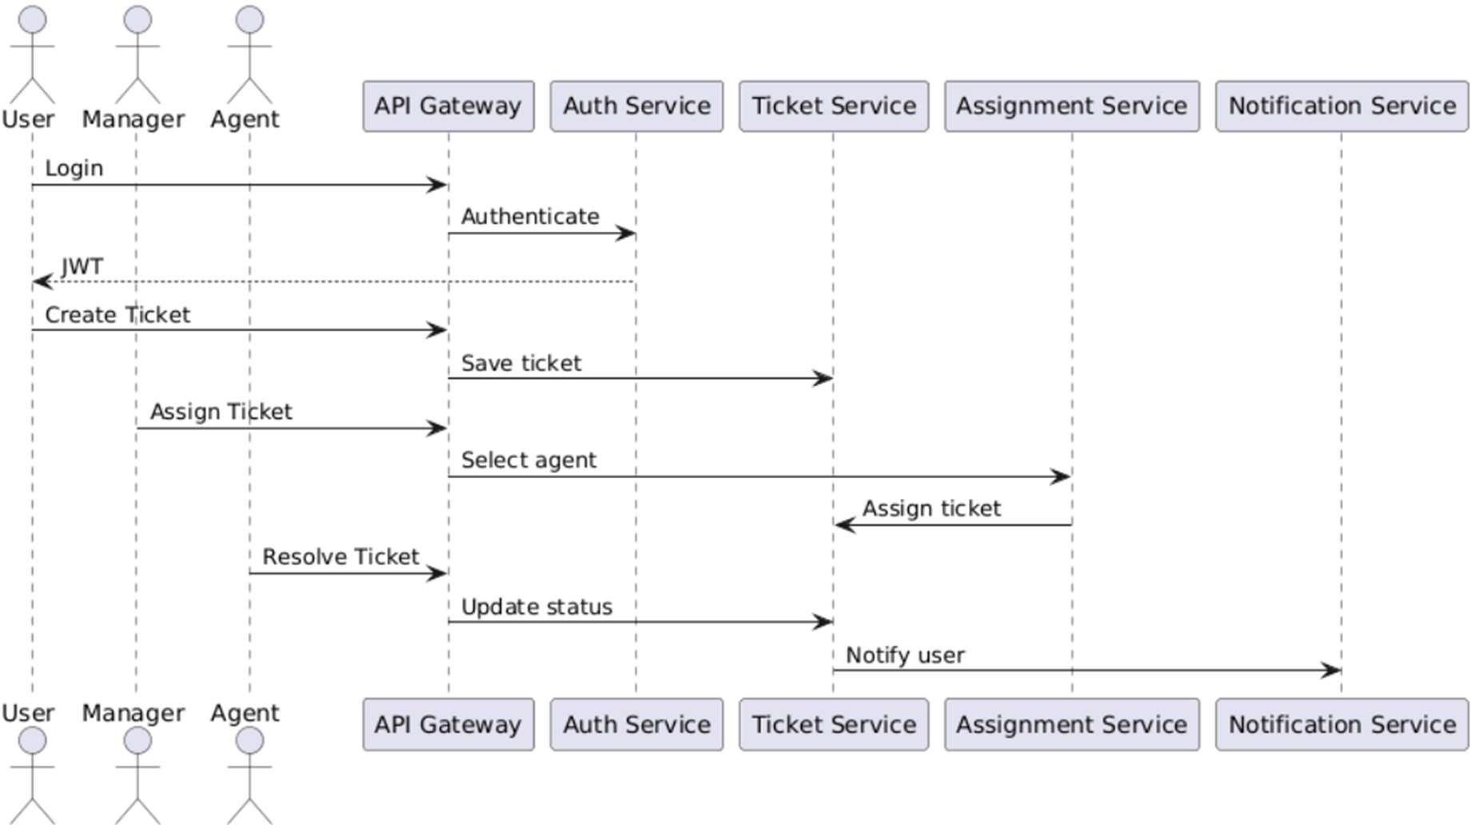

User Login Flow -
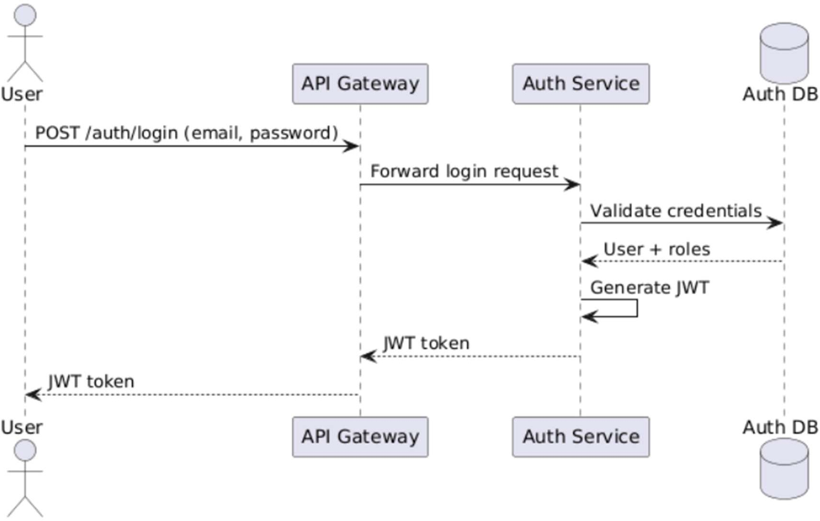

Ticket Creation -

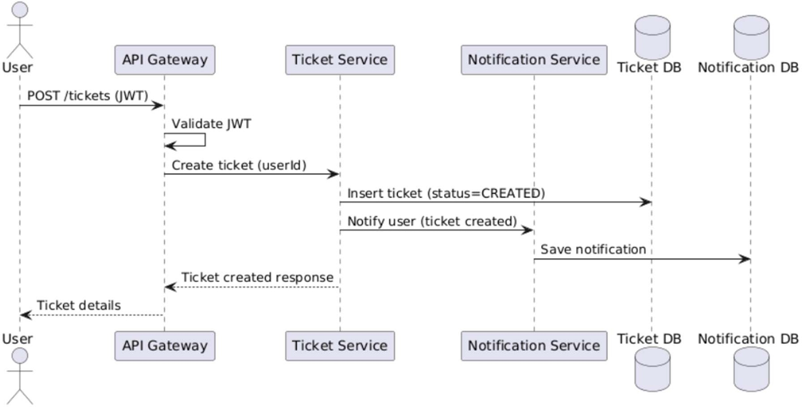

Manager Assigns Ticket to Agent -
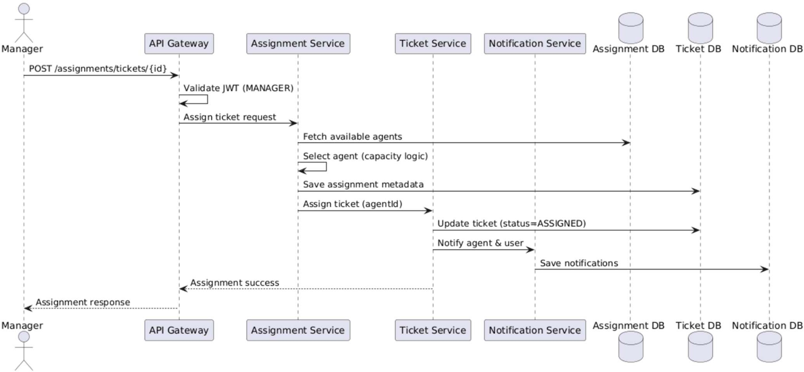

Agent Resolves Ticket -

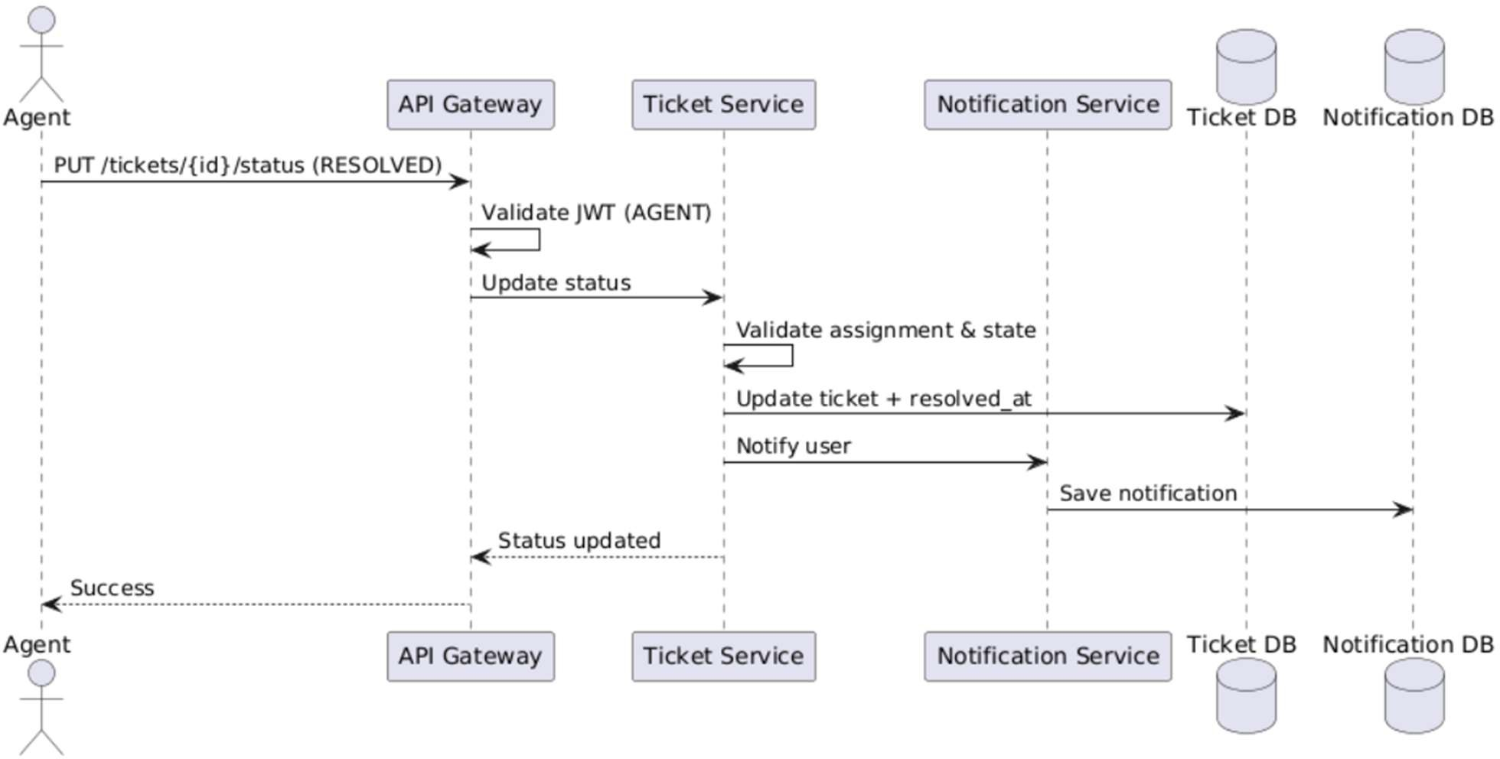

User Registration — Sequence Diagram

Scenario
A new user registers using the Angular UI.

Flow
  - User enters details in Angular UI
  - Angular sends POST /auth/register to User Service
  - User Service validates request (email, password)
  - User Service checks email uniqueness in MongoDB
  - Password is encrypted
  - User is saved in MongoDB
  - Success response sent back to UI

Participants
    - User
    - Angular UI
    - User Service
    - MongoDB

Key Design Points
    - Validation at API boundary

    - Encryption at service layer
    - No direct DB access from UI

User Login — Sequence Diagram
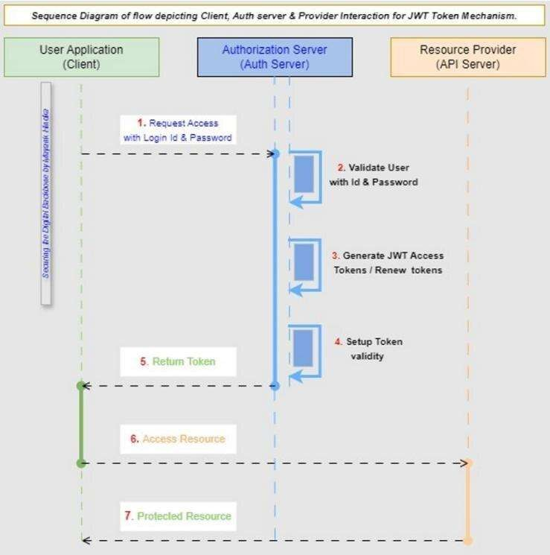

Scenario
Registered user logs into the system.

Flow
  - User submits login form
  - Angular calls POST /auth/login
  - User Service fetches user from MongoDB
  - Password is verified
  - (Optional) JWT token generated
  - Response sent to Angular
  - Angular stores token and navigates user

Participants
    - User
    - Angular UI
    - User Service
    - MongoDB

Failure Cases
    - Invalid credentials → 401
    - Inactive user → 403

Ticket Creation

Scenario
User creates a ticket.

Flow
  - User submits ticket form
  - Angular → API Gateway → Ticket Service
  - Ticket Service validates request
  - Ticket stored in MongoDB
  - Ticket Service calls Assignment Service
  - Assignment Service assigns agent & SLA
  - Notification Service sends email
  - Success response returned

Participants
- User
- Angular UI
- API Gateway
- Ticket Service
- Assignment Service
- Notification Service
- MongoDB

Manager Assigns Ticket

Scenario
Manager manually assigns or reassigns a ticket.

Flow
  - Manager triggers assign action
  - Angular → API Gateway → Assignment Service
  - Role validation (MANAGER)
  - Assignment rules applied
  - Assignment saved
  - Ticket status updated
  - Notification sent to agent

Participants
    - User
    - Angular UI

    - MongoDB

Agent Resolves Ticket

Scenario
Agent Resolves Ticket.

Flow
  - Agent updates ticket status
  - Ticket Service validates transition
  - Status updated to RESOLVED/CLOSED
  - Resolution time logged
  - Notification sent to user

Valid Transitions
- OPEN → IN_PROGRESS
- IN_PROGRESS → RESOLVED
- RESOLVED → CLOSED
- CLOSED → REOPENED

CI/CD Pipeline — Sequence Diagram
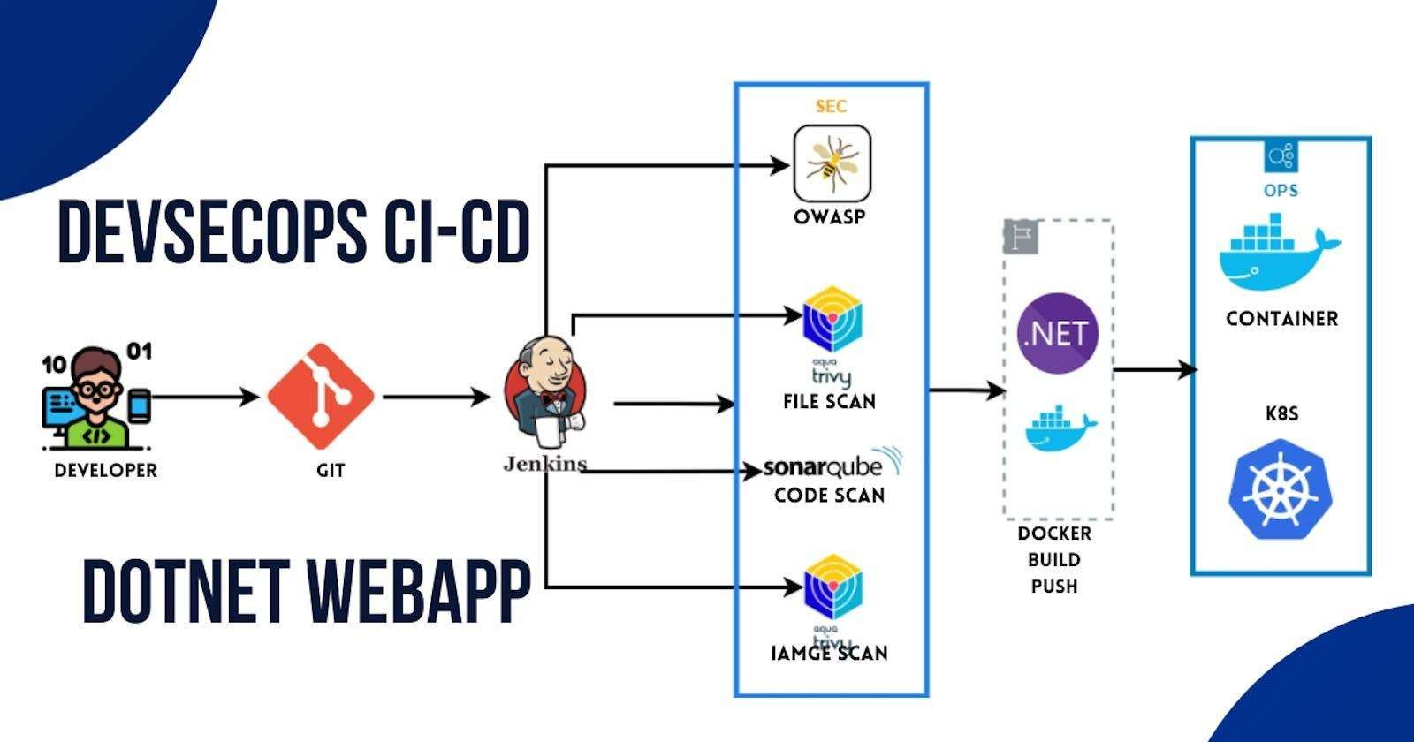

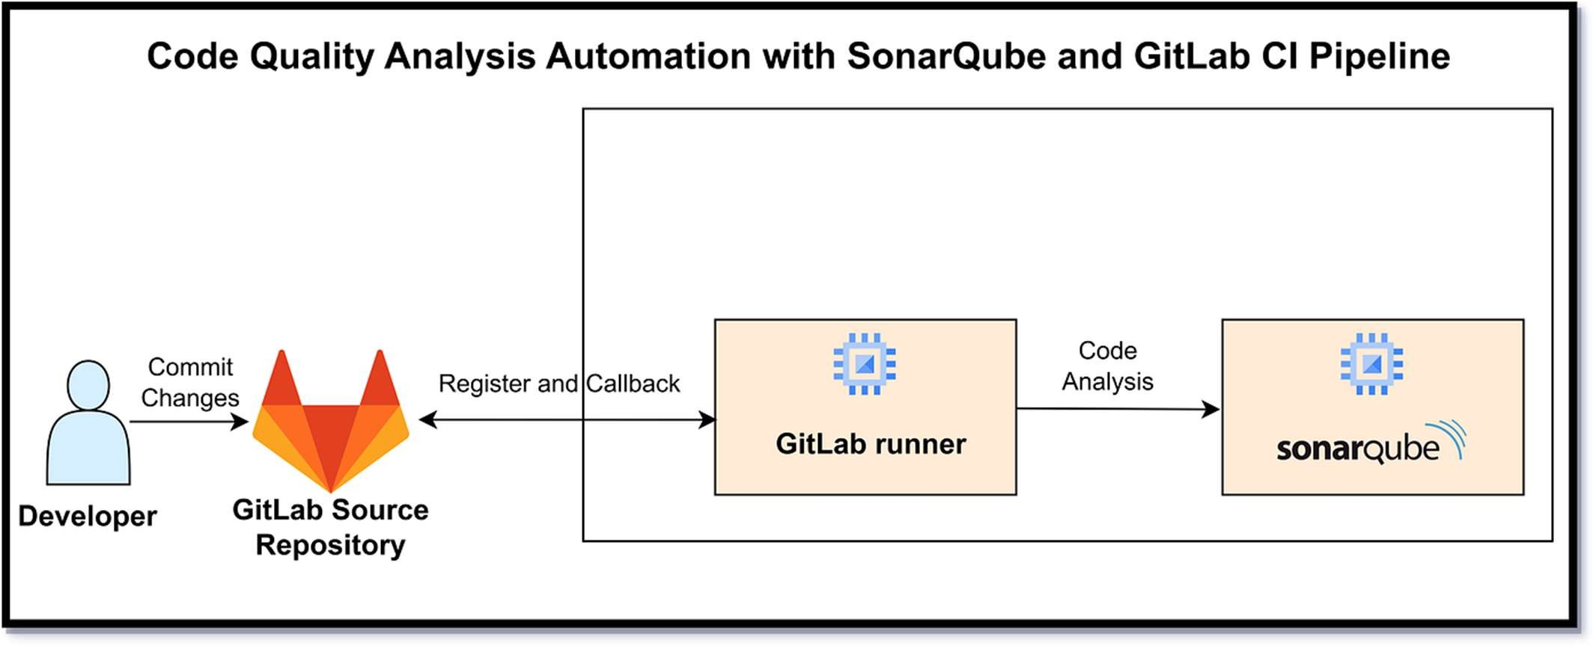

Scenario
Developer pushes code to Git repository.

Flow
  - Developer pushes code
  - Jenkins pipeline triggered
  - Jenkins runs unit tests
  - Jenkins runs SonarQube scan
  - Quality gate checked
  - Docker images built
  - Docker Compose deploys services

Participants
    - Developer
    - Git
    - Jenkins
    - SonarQube
    - Docker

Error Handling — Sequence Diagram

Scenario
Invalid request sent to backend.

Flow
  - Angular sends invalid request
  - Controller validation fails
  - Global exception handler triggered
  - Standard error response returned

Key Point
    - Consistent error structure across services

Business Rules

User Service

  - Email must be unique

  - Password must be encrypted using BCrypt

  - Users must have one role: USER / AGENT / MANAGER / ADMIN

  - Only ADMIN can change user roles

  - Inactive users cannot log in

  - JWT must contain userId and role

  - Expired or invalid token → 401 Unauthorized

Authentication & Authorization

  - API Gateway handles authentication

  - Public endpoints:

    - /auth/register
    - /auth/login
  - All other APIs require JWT

  - Role-based access control enforced at service level

Ticket Creation

  - Only authenticated USER can create tickets

  - Mandatory fields: title, description, category

  - Ticket status on creation: OPEN

  - Ticket must be linked to userId

  - Ticket creation triggers assignment & notification

Assignment Service

  - One active assignment per ticket

  - Assignment based on workload & availability

  - MANAGER can manually assign tickets

  - Reassignment deactivates previous assignment

  - Assignment history must be preserved

Notification Service

  - Notifications sent for:

    - Ticket creation
    - Ticket assignment
    - Ticket resolution
    - SLA breach
  - Notification failures must not block main flow

  - All notifications must be logged

Reports & Dashboard

  - Reports available only in Ticket Service

  - Dashboard access: MANAGER, ADMIN

  - Reports are read-only

  - Data must be aggregated and paginated

Error Handling

  - Centralized exception handling

  - Standard error response format

  - Proper HTTP status codes used

