**COEN275: Project: Sequence Diagrams & State Diagrams**

**Sreenidhi and Roopashree**

1. **Sequence Diagram1: Customer drops an item into RCM and receives credit for the item.**

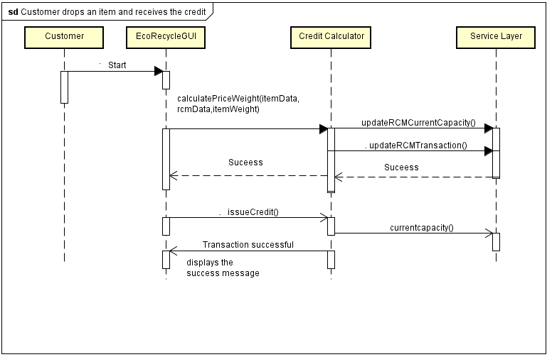

1. **Sequence Diagram2: To activate a machine**

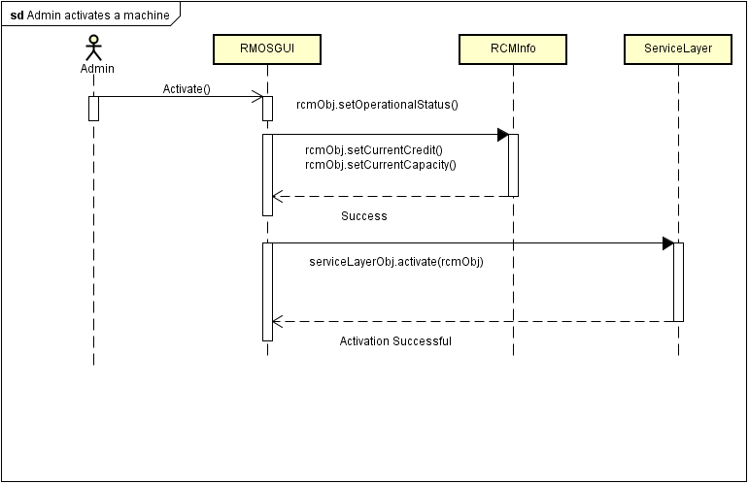

1. **State Diagram: Admin Adds a Machine**

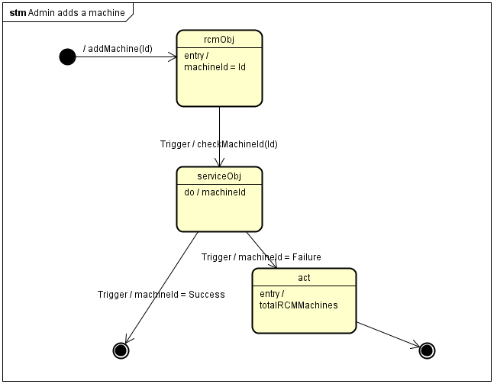

1. **Package Diagram**

