**COEN275 : Project : Statistics Screenshot**

**Sreenidhi and Roopashree**

1. **When Machine1 is selected for a Day and for Credit.**

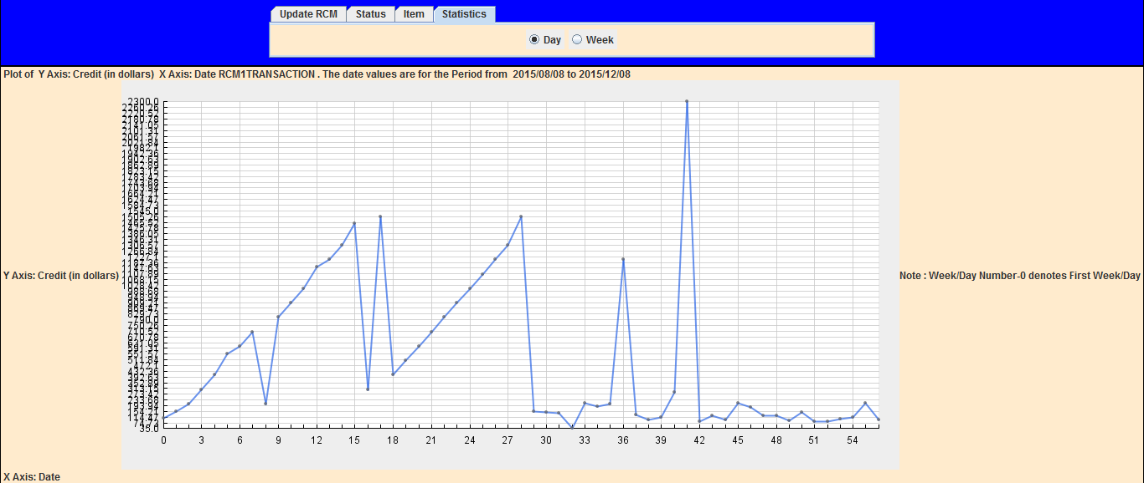

1. **When Machine1 is selected for a Week and for Credit.**

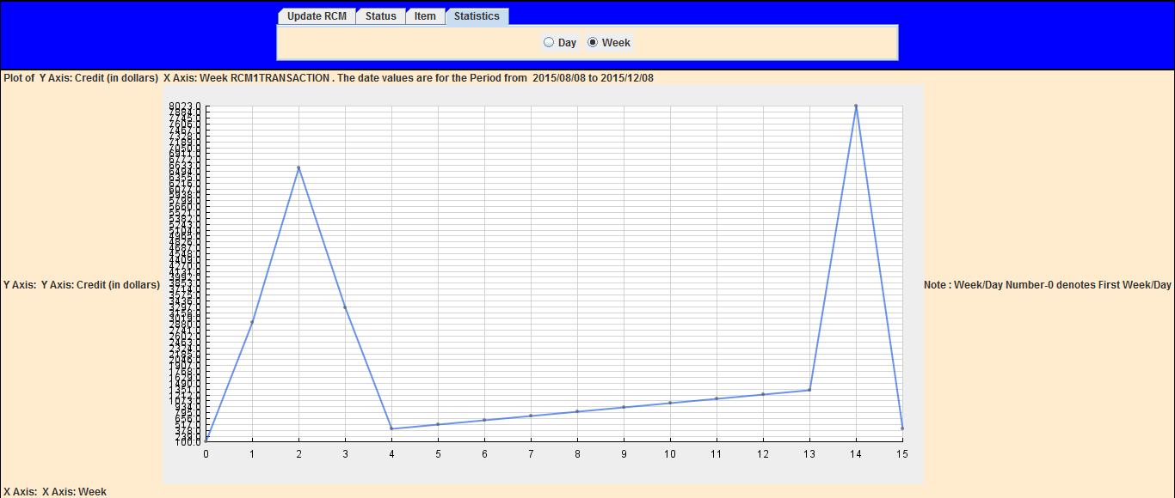

1. **When Machine1 is selected for a Day and for Weight.**

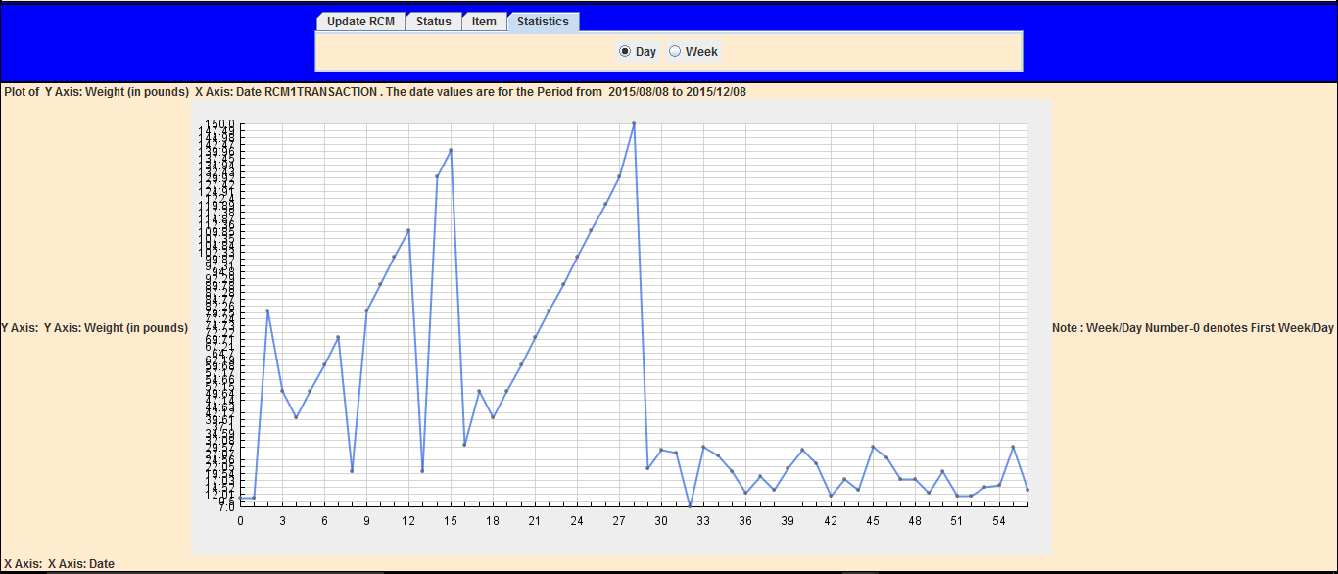

1. **When Machine1 is selected for a Week and for Weight.**

