How We’ll Work Together
- Daily Tasks: I’ll give you a small task to complete each day (or whenever you have time).
- Step-by-Step Instructions: I’ll explain exactly what to do and why it’s important.
- Debugging Help: If you get stuck, share the error or issue, and I’ll help you fix it.
- No Courses Needed: You’ll learn by building the project itself.

Step 1: Set Up Your Development Environment
What to Do
- Install Node.js:
  - Go to Node.js and download the LTS version.
  - Install it on your computer.
  - Verify the installation by opening a terminal and running:
bash
Copy
node -v
npm -v
You should see version numbers for Node.js and npm (Node Package Manager).
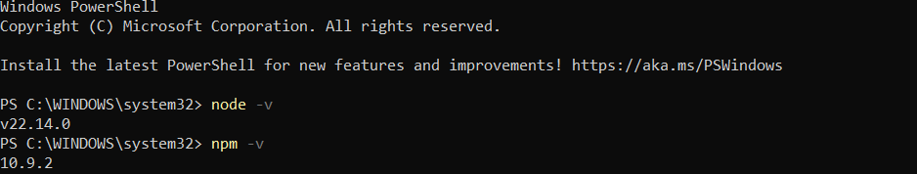
- Install VS Code:
  - Download and install VS Code, a code editor.
- Install Git:
  - Download and install Git.
  - Verify the installation by running:
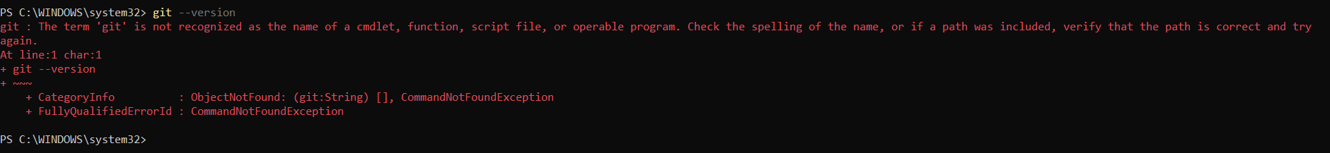
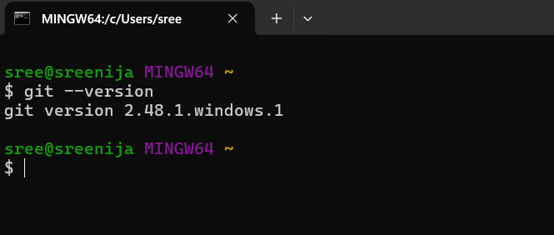
bash
Copy
git --version
- Create a GitHub Account:
  - Go to GitHub and create an account if you don’t have one.
  - Create a new repository called air-assist.
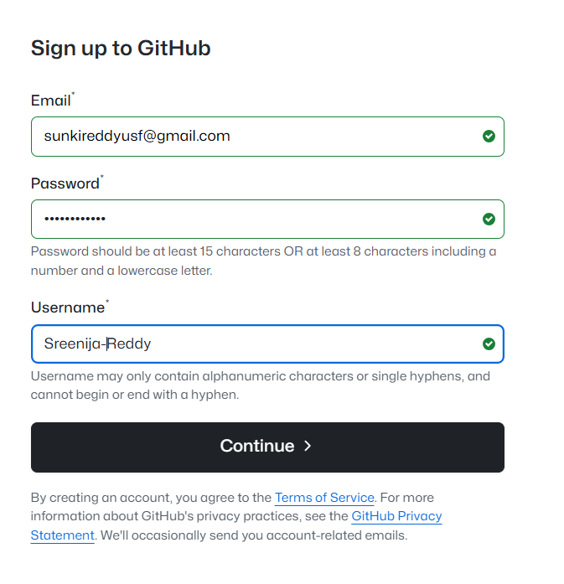
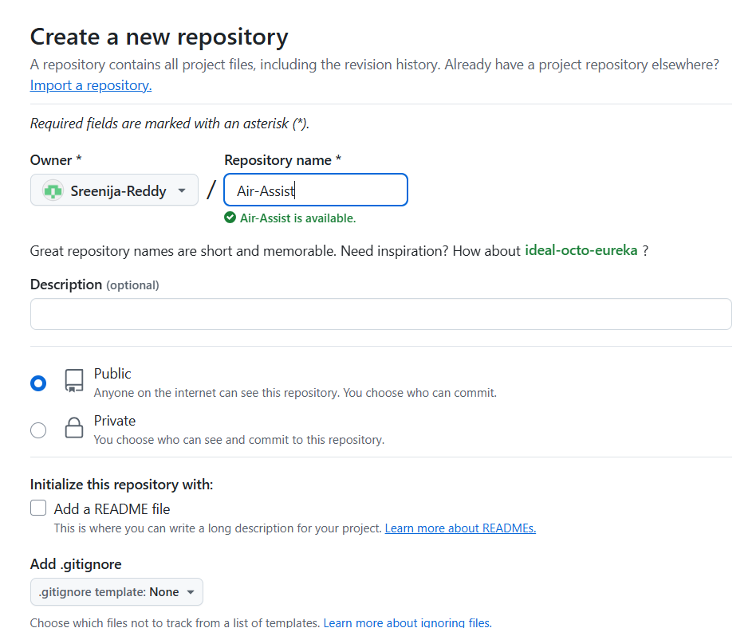
- Clone the Repository:
  - Open a terminal and run:
bash
Copy
git clone https://github.com/your-username/air-assist.git
cd air-assist
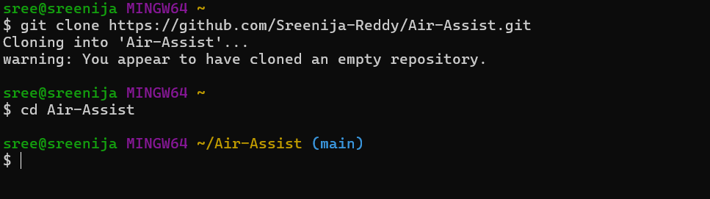
Why We’re Doing This
- Node.js: It’s the runtime we’ll use to build the backend.
- VS Code: It’s a lightweight and powerful code editor.
- Git and GitHub: These will help you track changes in your code and collaborate with others.

Step 2: Initialize Your Backend
What to Do
- Initialize a Node.js Project:
  - In your project folder (air-assist), run:
bash
Copy
npm init -y
This creates a package.json file, which will track your project’s dependencies.
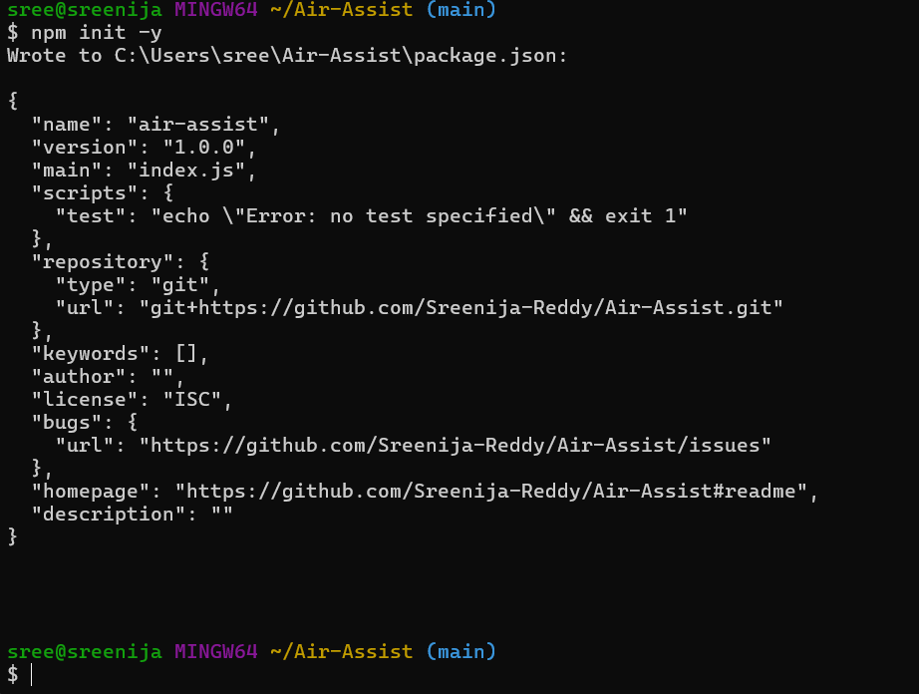
- Install Express.js:
  - Run:
bash
Copy
npm install express
Express is a framework that makes it easy to build a backend server.
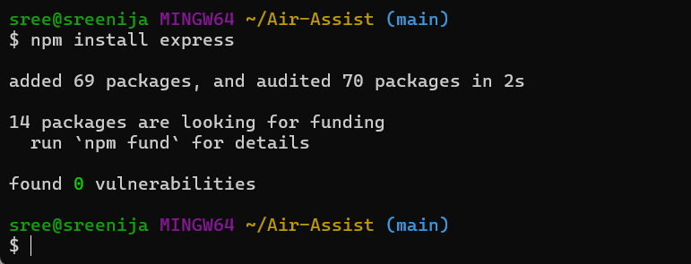
- Create a Basic Server:
  - Create a file called server.js in your project folder.
  - Add the following code:
javascript
Copy
const express = require('express');
const app = express();
const PORT = 5000;

app.get('/', (req, res) => {
res.send('Hello, Air Assist!');
});

app.listen(PORT, () => {
console.log(`Server running on http://localhost:${PORT}`);
});
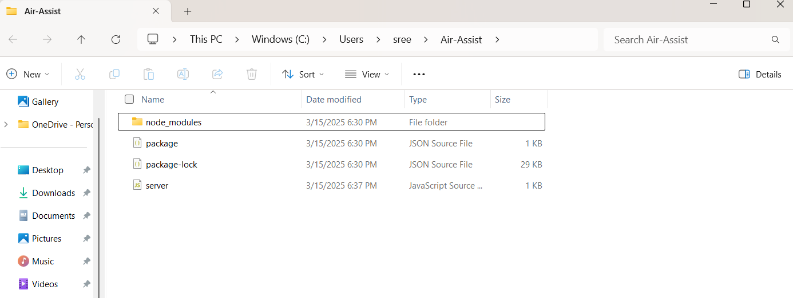
- Run the Server:
  - In the terminal, run:
bash
Copy
node server.js
  - Open your browser and go to http://localhost:5000. You should see "Hello, Air Assist!"
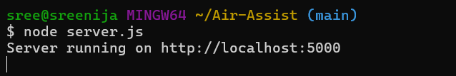
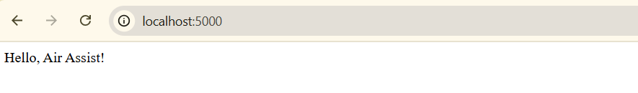
Why We’re Doing This
- Express.js: It simplifies backend development by providing tools to handle routes, requests, and responses.
- Basic Server: This is the foundation of your backend. It will handle all the logic for your app.

Step 3: Set Up Your Frontend
What to Do
- Install React:
  - In your project folder, run:
bash
Copy
npx create-react-app client
This creates a new React app in a folder called client.
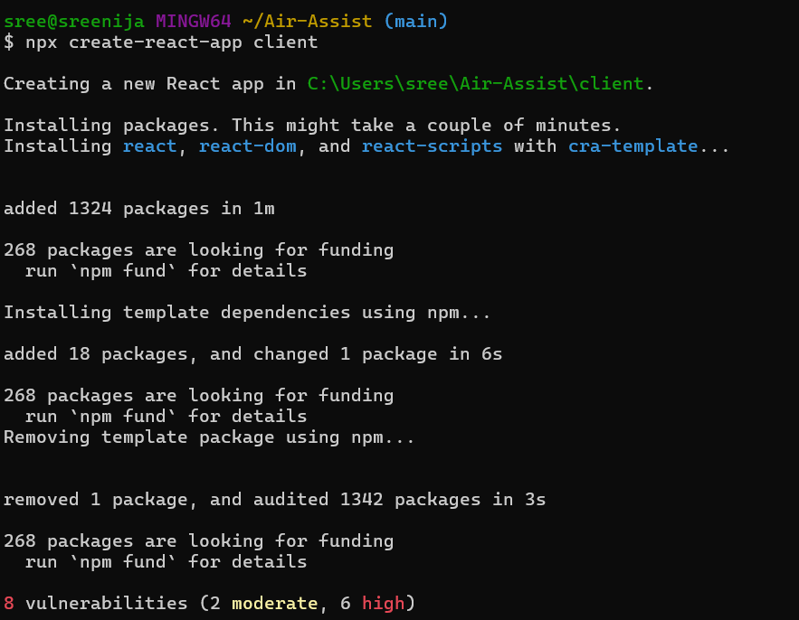
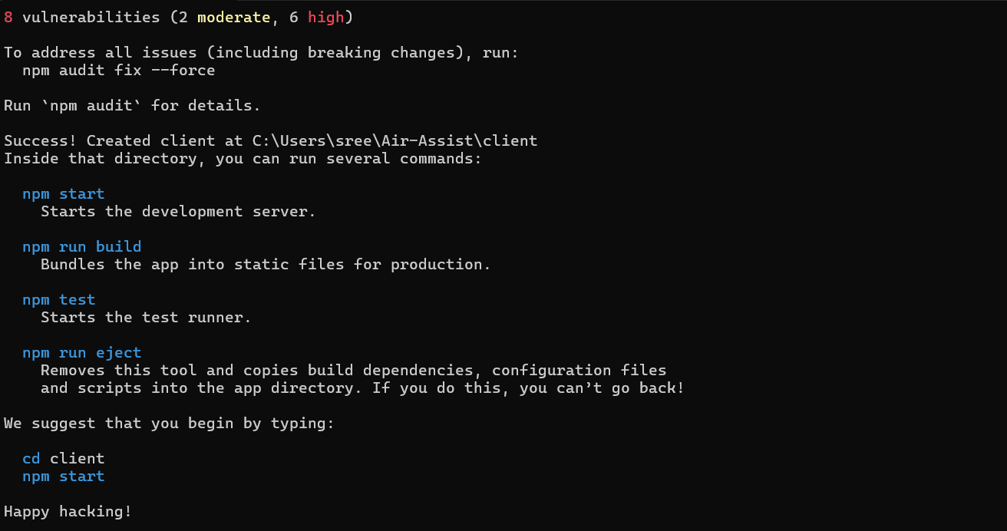
- Start the React App:
  - Navigate to the client folder and start the app:
bash
Copy
cd client
npm start
  - Your React app will open in the browser at http://localhost:3000.
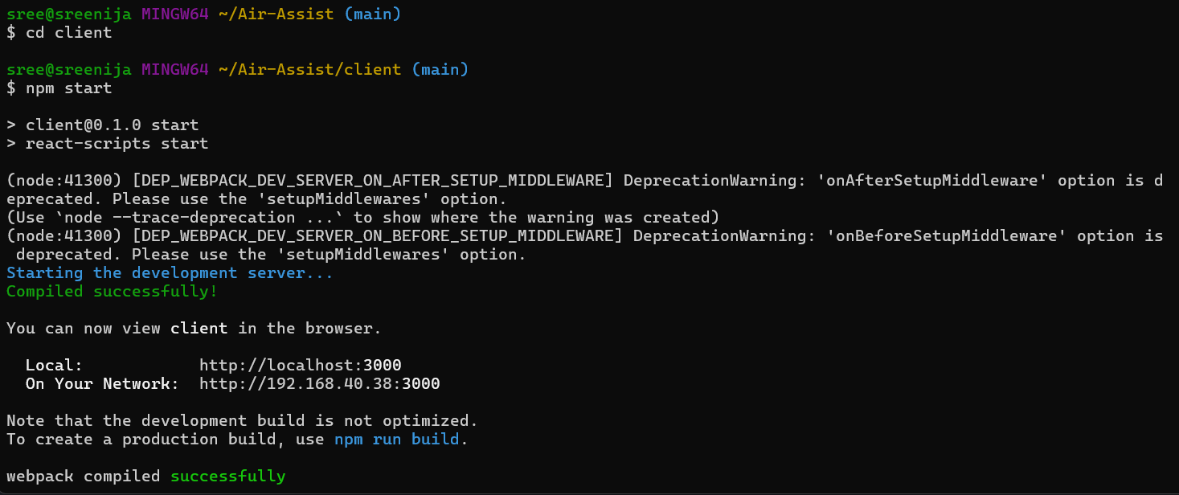
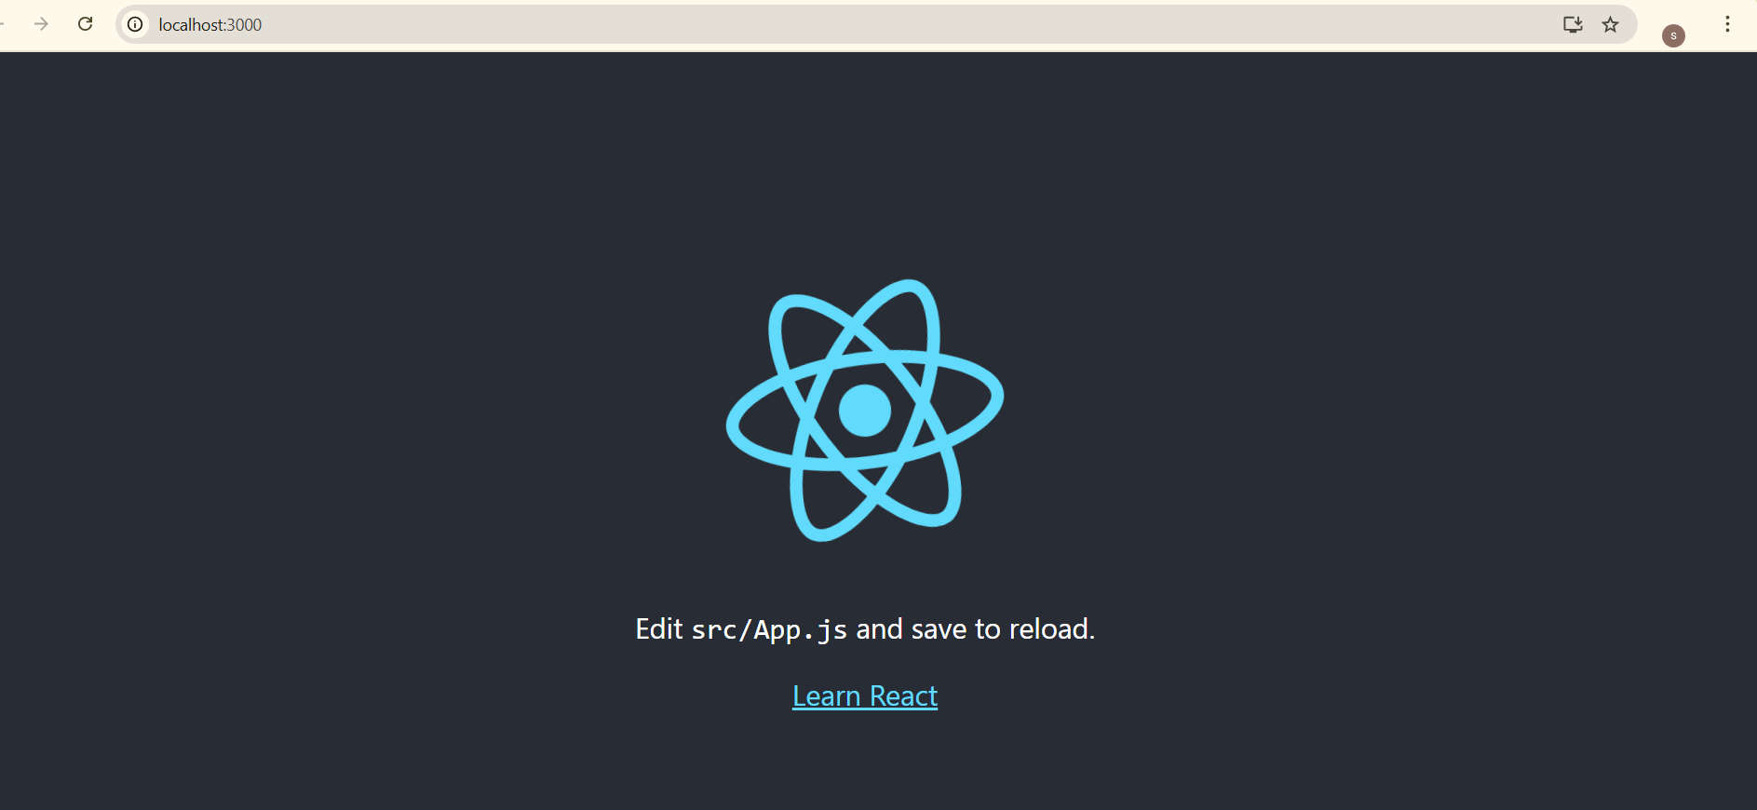
- Clean Up the React App:
  - Delete unnecessary files in the src folder (e.g., App.test.js, logo.svg).
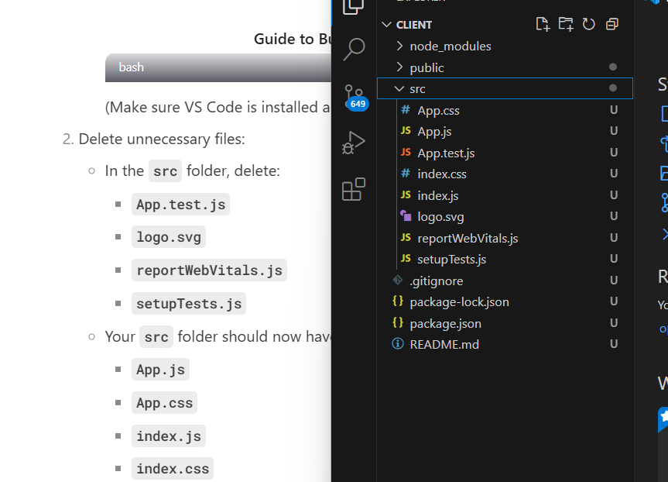
  - Update App.js to display a simple message:
javascript
Copy
function App() {
return (
<div>
<h1>Welcome to Air Assist!</h1>
</div>
);
}
export default App;
before: 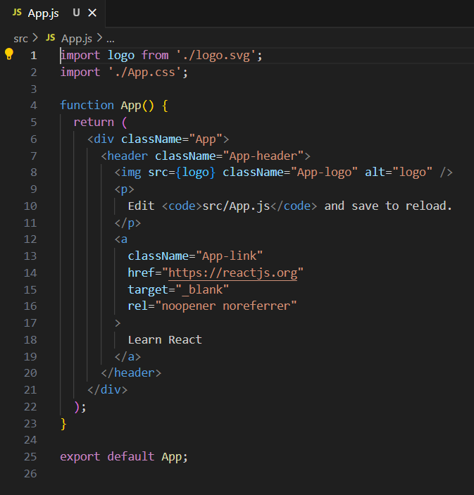
After: 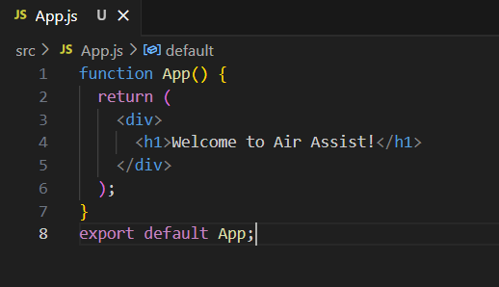
Index.js file before
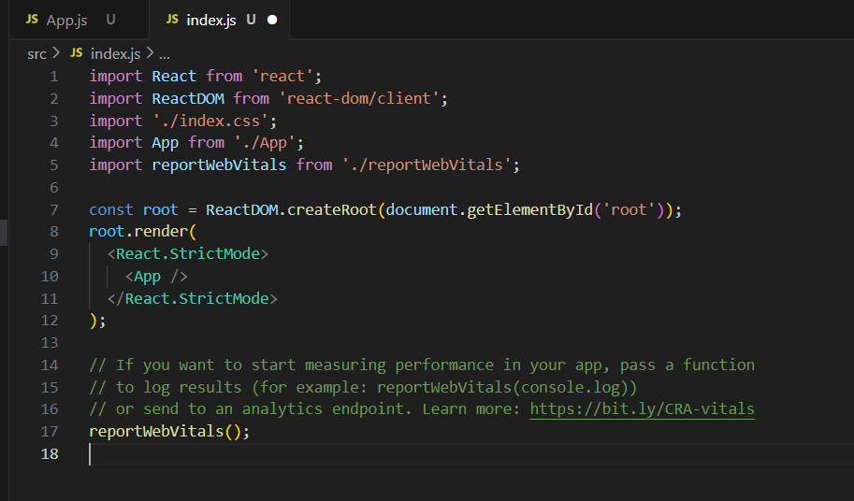
Update index.js like
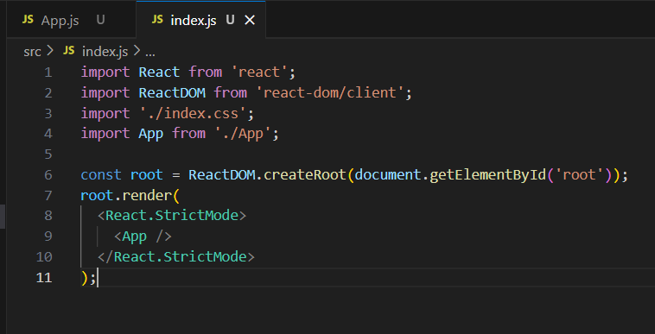
Why We’re Doing This
- React: It’s a powerful library for building user interfaces.
- Frontend-Backend Separation: Keeping the frontend and backend in separate folders makes your project more organized.

Step 4: Connect Frontend and Backend
What to Do
- Install Axios:
  - Axios is a library for making HTTP requests from the frontend to the backend.
  - In the client folder, run:
bash
Copy
npm install axios
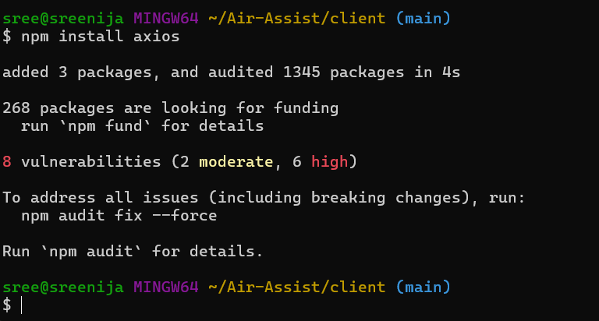
Great! You’ve successfully installed Axios in your React app. The message about vulnerabilities is common in many npm packages, and it doesn’t necessarily mean your app is at risk. However, it’s good practice to address these issues if possible.

What to Do Next
1. Fix Vulnerabilities (Optional)
If you want to address the vulnerabilities, you can run:
bash
Copy
npm audit fix
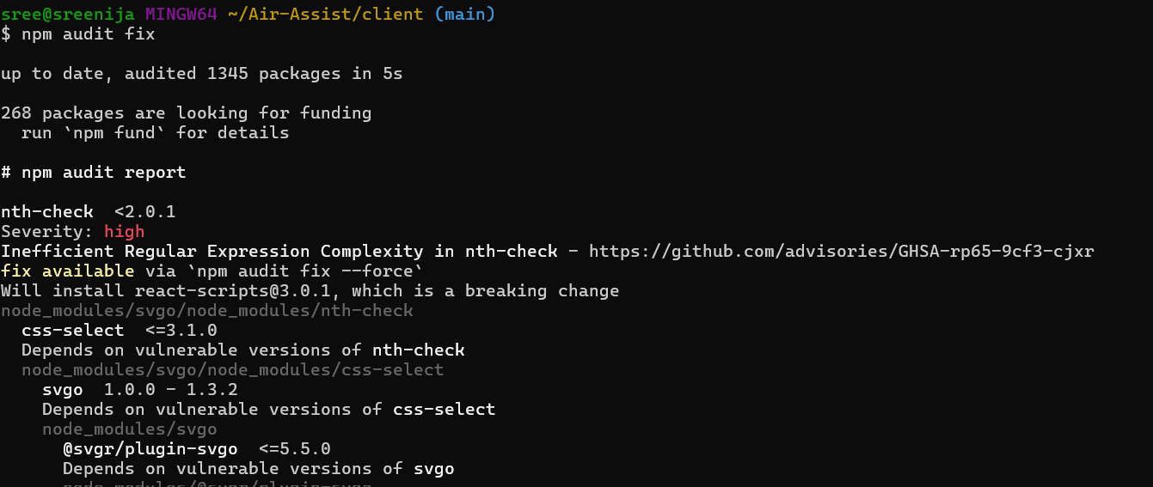
This will attempt to automatically fix any issues. If some issues remain, you can force the fixes with:
bash
Copy
npm audit fix –force
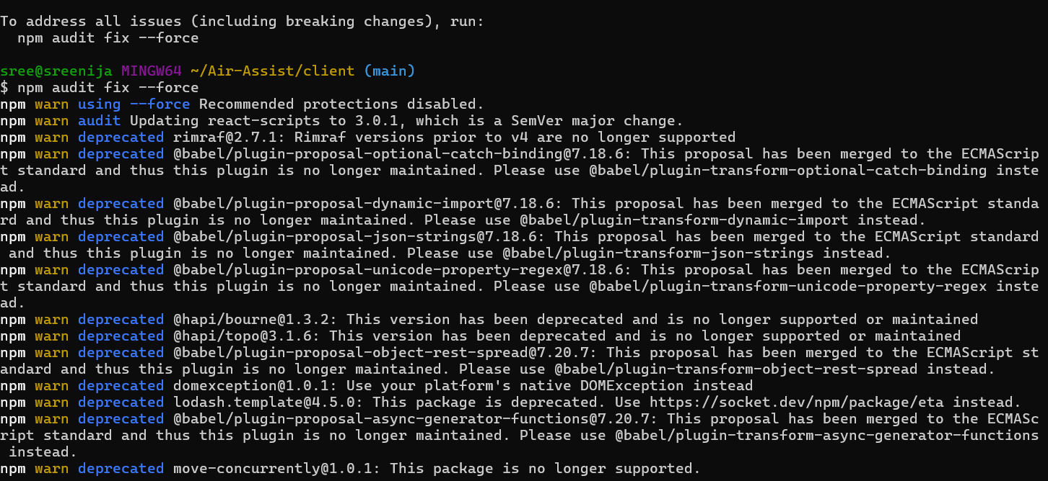
However, be cautious with --force as it might introduce breaking changes. For now, you can proceed without fixing these vulnerabilities, as they are unlikely to affect your development environment.

2. Update App.js to Fetch Data from the Backend
Now that Axios is installed, let’s update your App.js file to fetch data from your backend.
- Open the App.js file in your client/src folder.
- Replace the existing code with the following:
javascript
Copy
import React, { useEffect, useState } from 'react';
import axios from 'axios';

function App() {
const [message, setMessage] = useState('');

useEffect(() => {
axios.get('http://localhost:5000')
.then(response => {
setMessage(response.data);
})
.catch(error => {
console.error('Error fetching data:', error);
});
}, []);

return (
<div>
<h1>Welcome to Air Assist!</h1>
<p>{message}</p>
</div>
);
}

export default App;
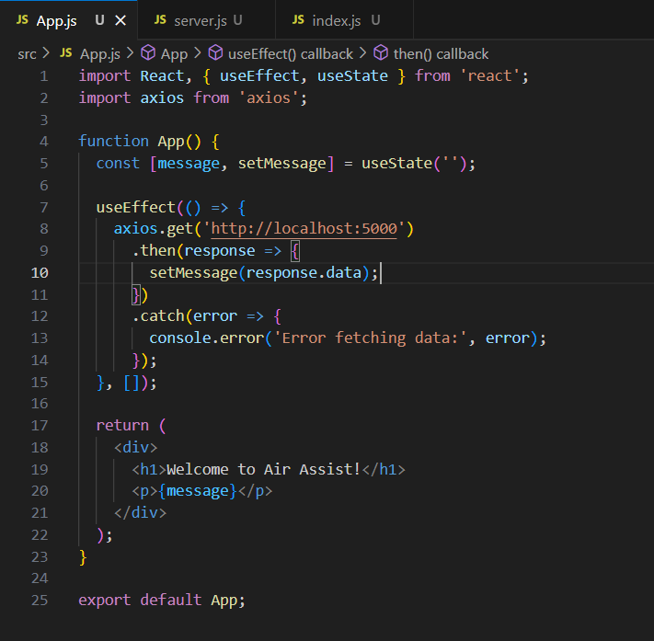

3. Enable CORS in the Backend
To allow your frontend (running on http://localhost:3000) to communicate with your backend (running on http://localhost:5000), you need to enable CORS in your backend.
- Open your server.js file in the root of your project (Air-Assist).
- Add the following lines at the top of the file (after const express = require('express');):
javascript
Copy
const cors = require('cors');
app.use(cors());
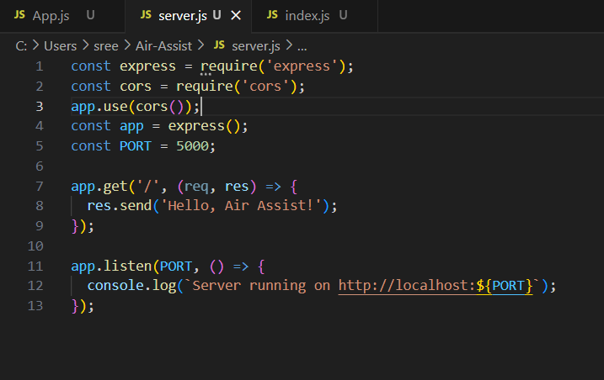
- Install the cors package:
  - In your terminal, navigate to the root of your project (Air-Assist):
bash
Copy
cd ..
  - Install cors:
bash
Copy
npm install cors
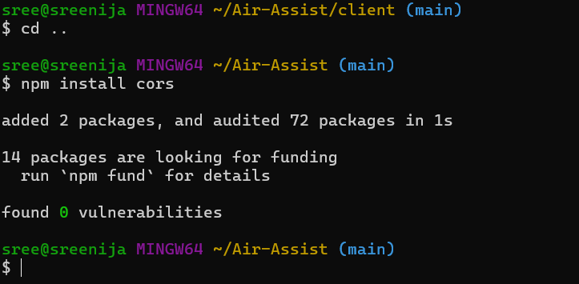
- Restart your backend server:
bash
Copy
node server.js
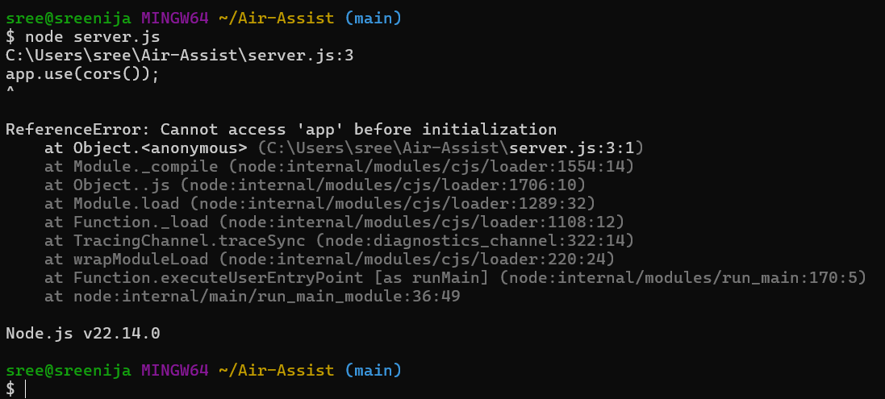

4. Test the Connection
- Make sure your backend server is running:
  - In the root of your project (Air-Assist), run:
bash
Copy
node server.js
- Make sure your React app is running:
  - In the client folder, run:
bash
Copy
npm start
- Open your browser and go to http://localhost:3000.
  - You should see:
Copy
Welcome to Air Assist!
Hello, Air Assist!
< I did not see thisthis result in port 5000 >
------------------------------------------------------------------------------------------------------------------------------------
I got error in frontend part
so I asked deep seek for quick fix
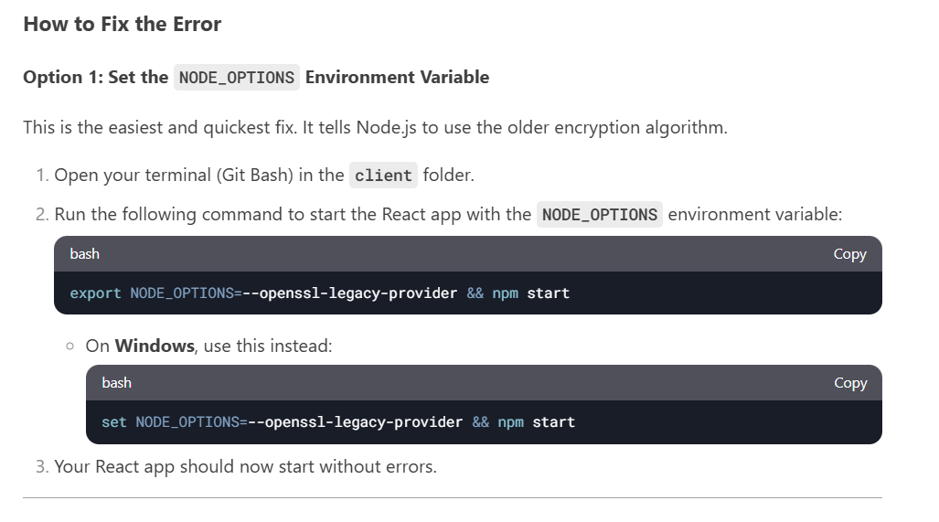
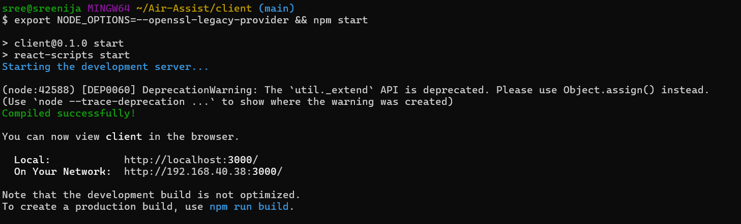

What We’ve Done
- Installed Axios to handle HTTP requests in the frontend.
- Fetched data from the backend and displayed it in the frontend.
- Enabled CORS to allow communication between the frontend and backend.

Both front end worked and Backend worked well independently – but when it came is fetching data from backend to front end- I got issue
So I uninstalled node.js and reinstalled less newer versions version 20. Smtng
Now both front end and backend are working good.
Cleared all errors

The thing is you must be in client – to execute front end
you have to be in air-assist to be in backend
I executed backend first (in one git terminal) and then executed front end later (in another git terminal)

