**MOCKITO:**

Testing Framework: JUnit 5

Mocking Framework: Mockito

IDE Used: IntelliJ IDEA

Build Tool: Maven

# EXERCISE-1.Mocking and Stubbing:

To test a service class that depends on an external API by mocking the API and stubbing its method to return a predefined response.

## Implementation Details:

- A mock of the ExternalApi interface was created using Mockito.

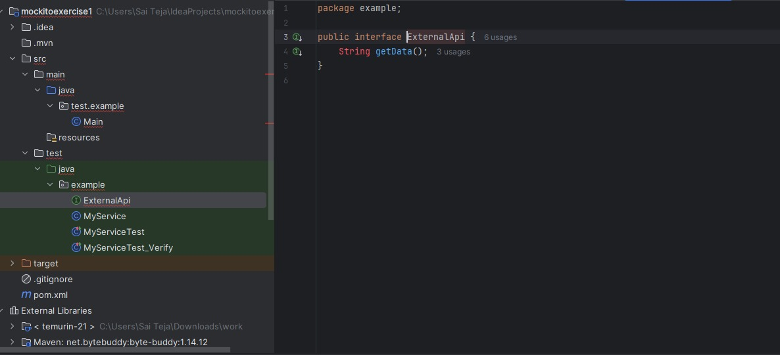

- The method getData() was stubbed to return a specific value, "Mock Data".

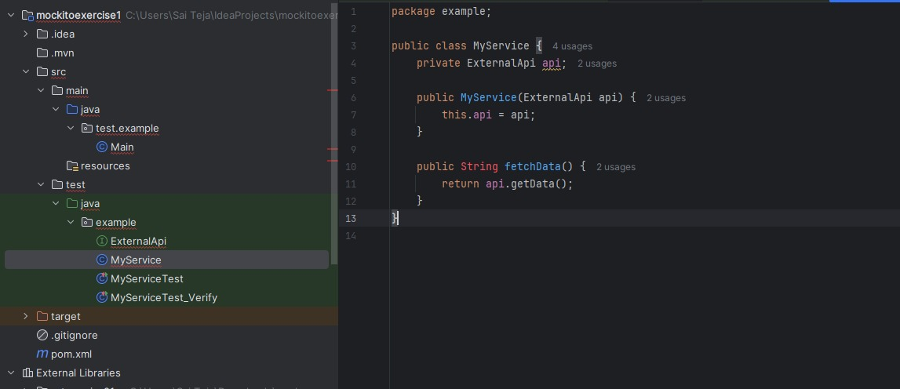

- The mock object was injected into the MyService class.

- The test validated that fetchData() returned the expected stubbed value.

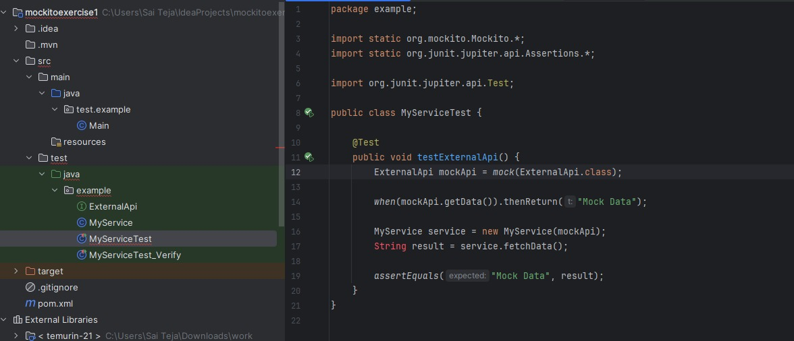

## 

ExternalApi mockApi = mock(ExternalApi.class);  
when(mockApi.getData()).thenReturn("Mock Data");  
MyService service = new MyService(mockApi);  
String result = service.fetchData();  
assertEquals("Mock Data", result);

# Exercise 2: Verifying Interactions

To verify that a specific method (getData()) on a mock object was invoked during the execution of a service method.

- A mock object of ExternalApi was created.



- The fetchData() method of MyService was called, which internally invokes getData().



- The verify() function from Mockito was used to confirm the method call.

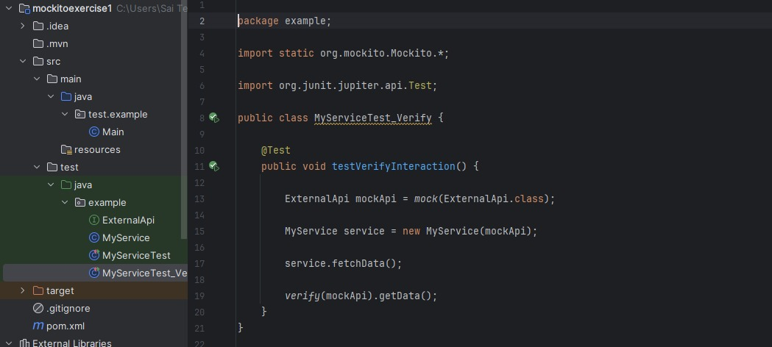

ExternalApi mockApi = mock(ExternalApi.class);  
MyService service = new MyService(mockApi);  
service.fetchData();  
verify(mockApi).getData();