**WEEK-2: PL/SQL**

**EXERCISE 1: CONTROL STRUCTURES**

1. CREATE CUSTOMER TABLE

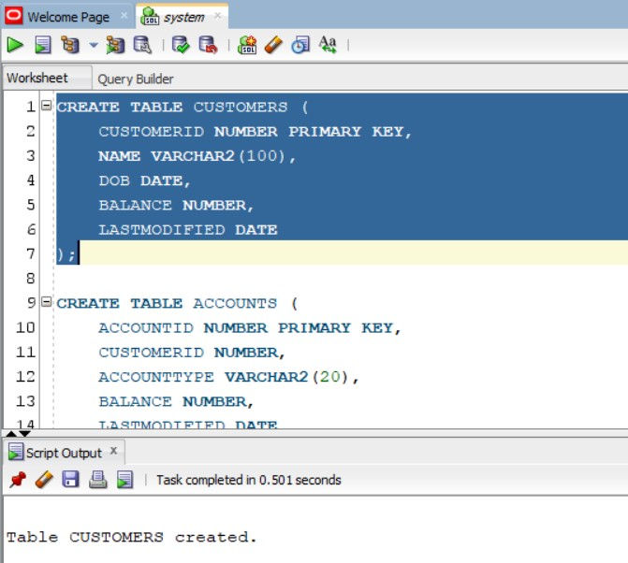

1. CREATE LOANS TABLE

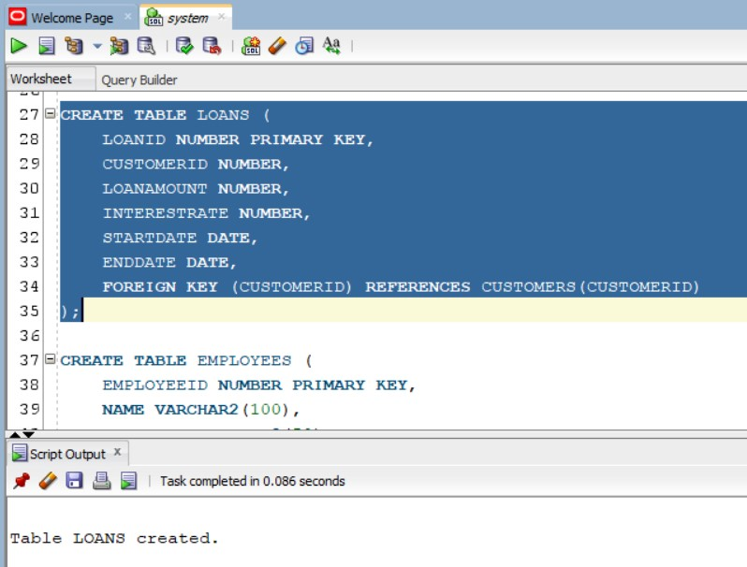

1. CREATE TRANSACTION TABLE

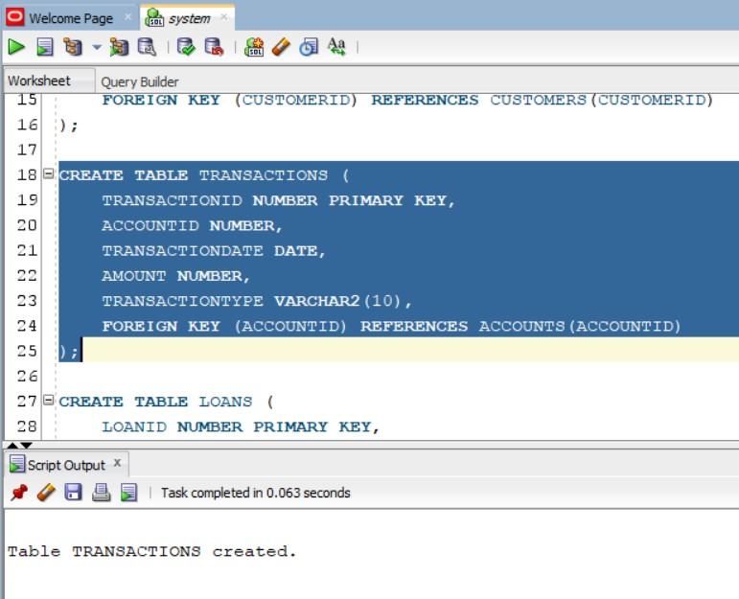

1. CREATE ACCOUNTS TABLE

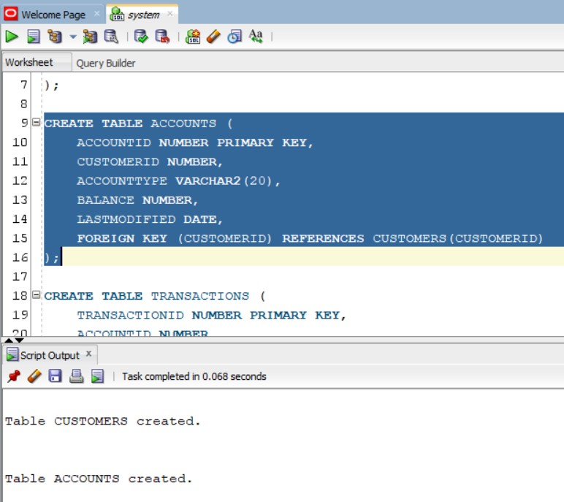

1. CREATE EMPLOYEES TABLE

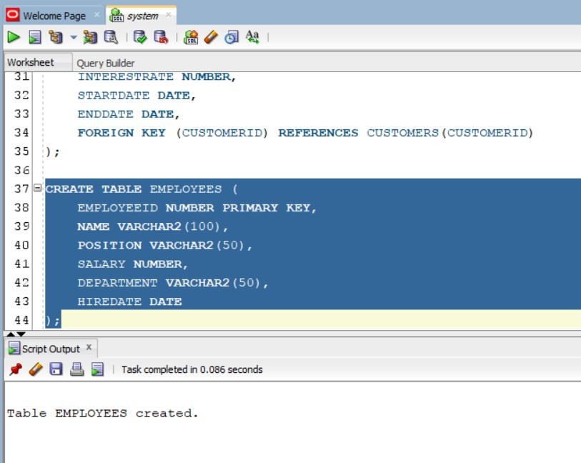

1. INSERT INTO CUSTOMER TABLE

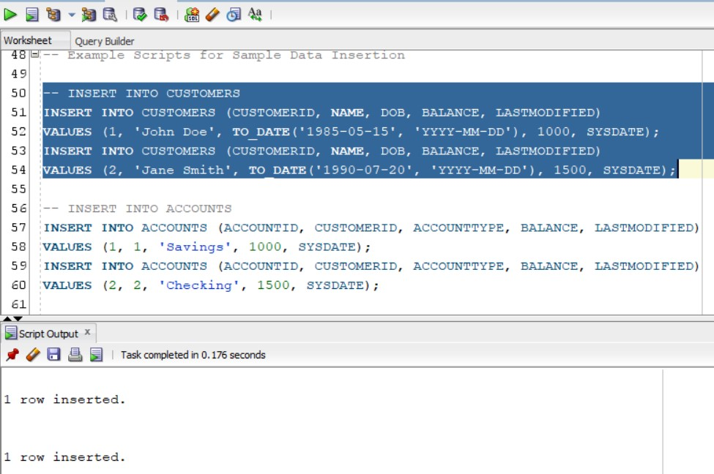

1. INSERT INTO LOANS TABLE

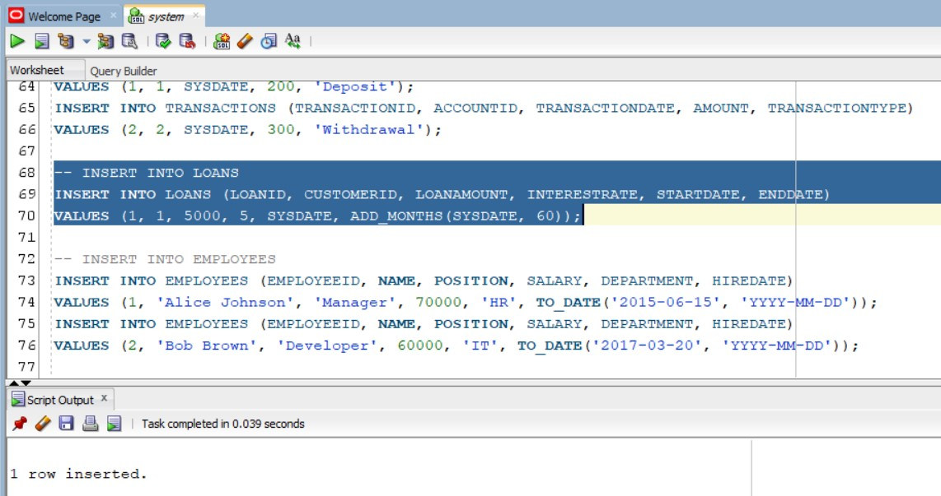

1. INSERT INTO TRANSACTION TABLE

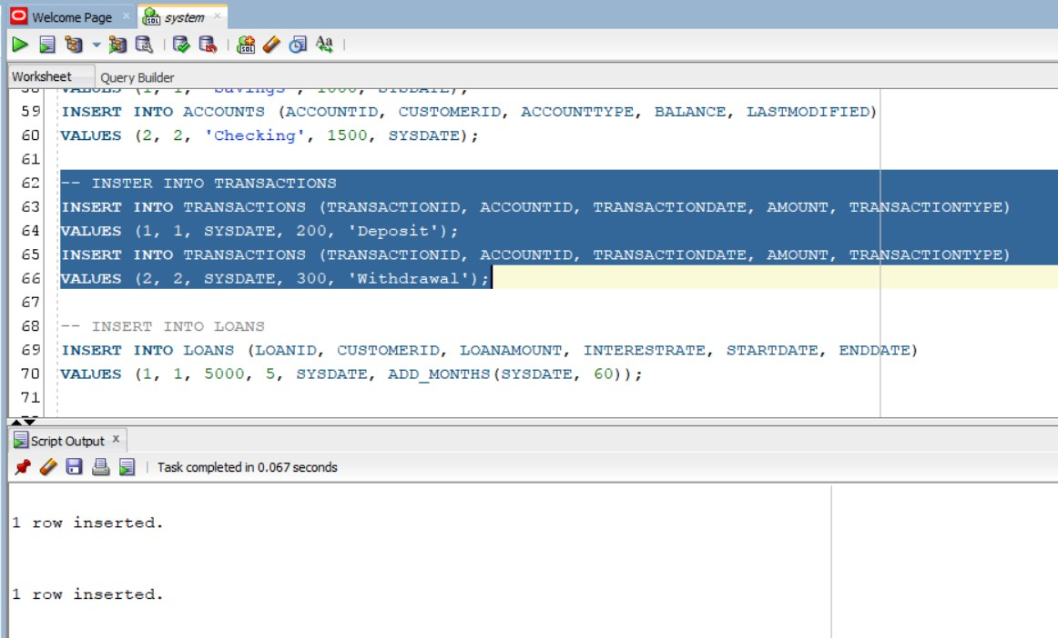

1. INSERT INTO ACCOUNTS TABLE

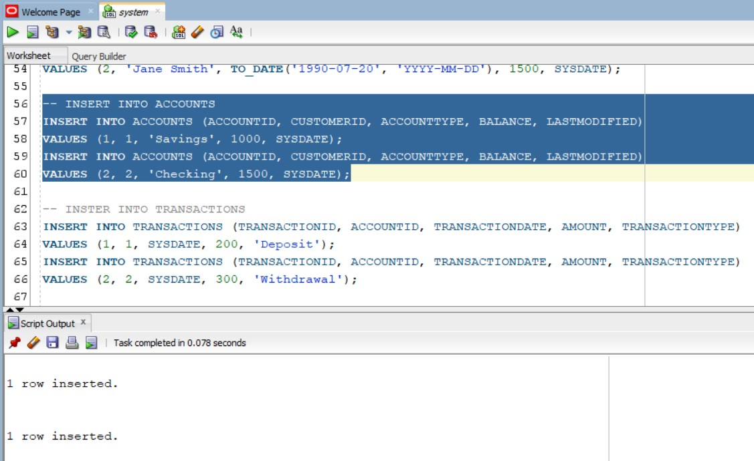

1. INSERT INTO EMPLOYEES TABLE

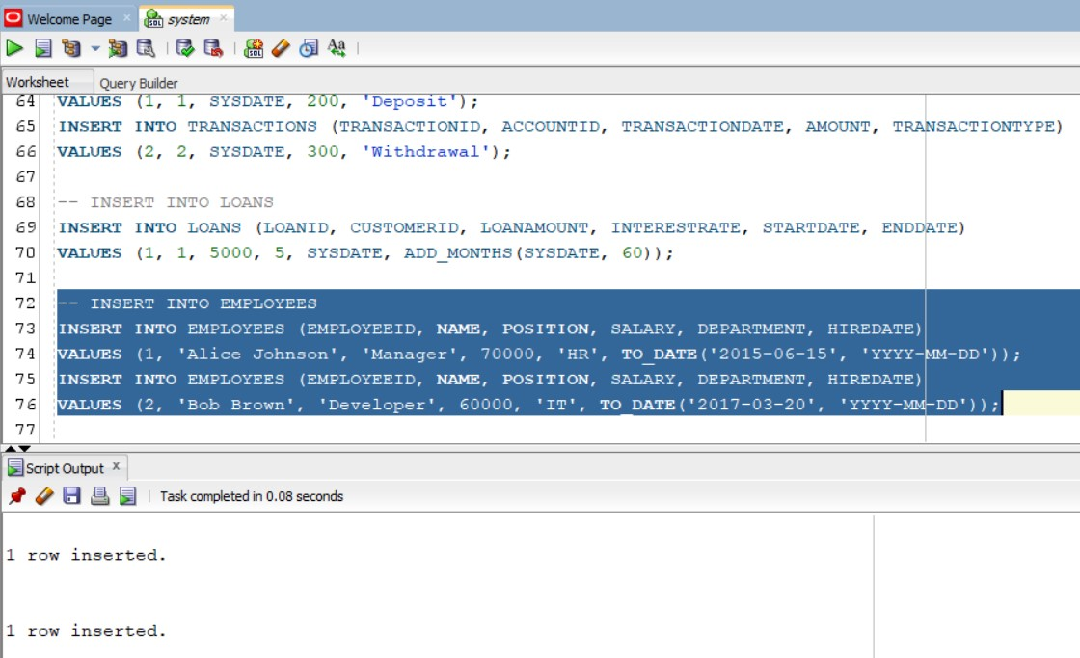

SCENARIO 1:

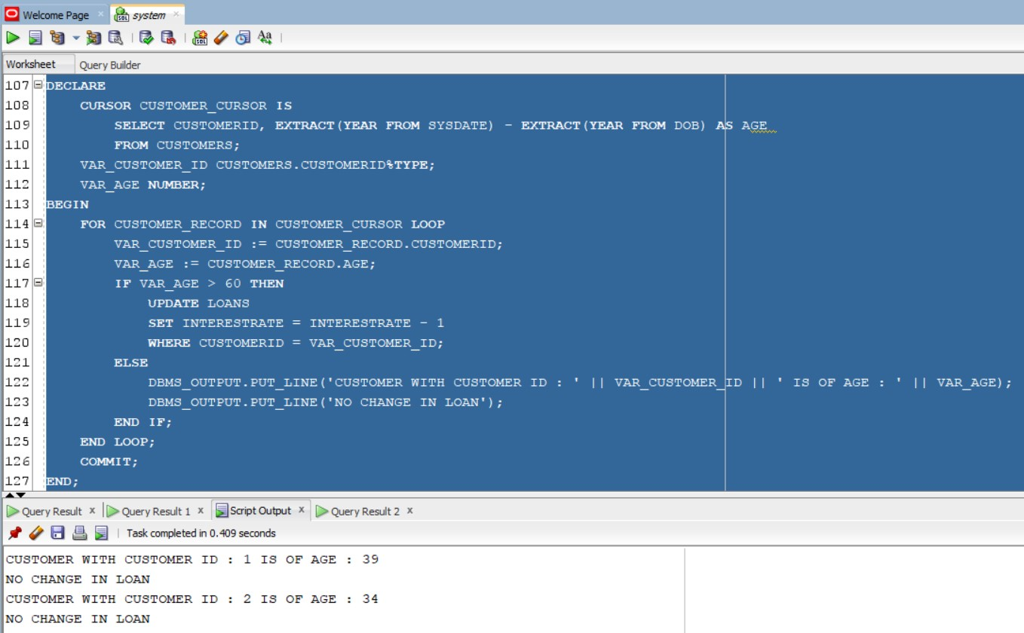

SCENARIO 2:

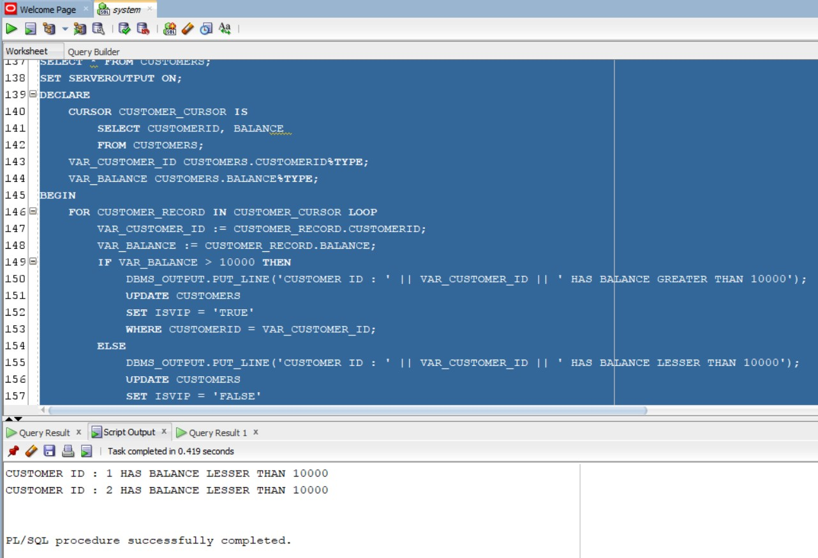

SCENARIO 3:

