GitHub Webhook
What is a GitHub Webhook Trigger?
A webhook makes GitHub notify Jenkins immediately when someone:
- pushes code
- creates pull request
- merges a branch
So Jenkins does not poll or wait. It runs instantly.
Prerequisites
- Jenkins should be reachable from GitHub
(Cloud / Public IP / ngrok / GitHub Enterprise case)
- Jenkins needs these plugins:
- GitHub Integration plugin
First prerequisite
- Jenkins should be reachable from GitHub
(Cloud / Public IP / ngrok / GitHub Enterprise case)
- First go to app repo setting after look for option called “webhooks”
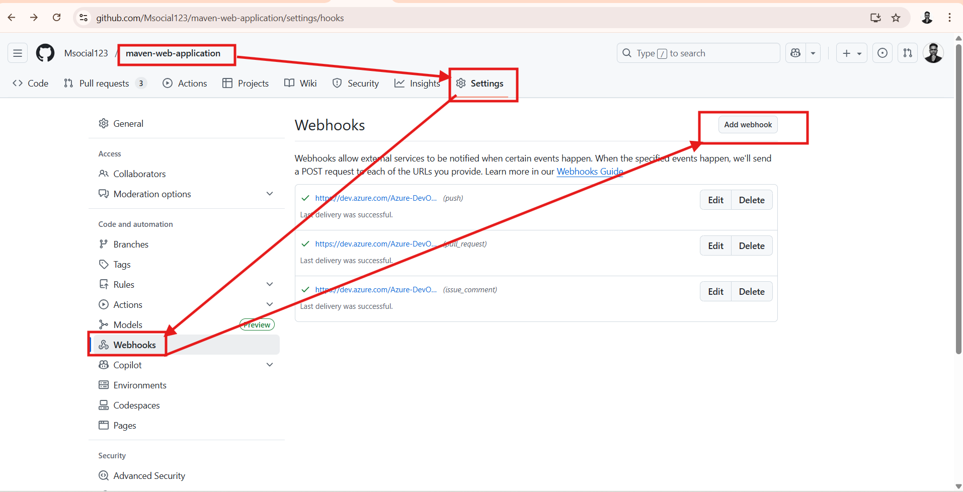

- Next click on add webhook
- Provider jenkins url and required details as shown below image
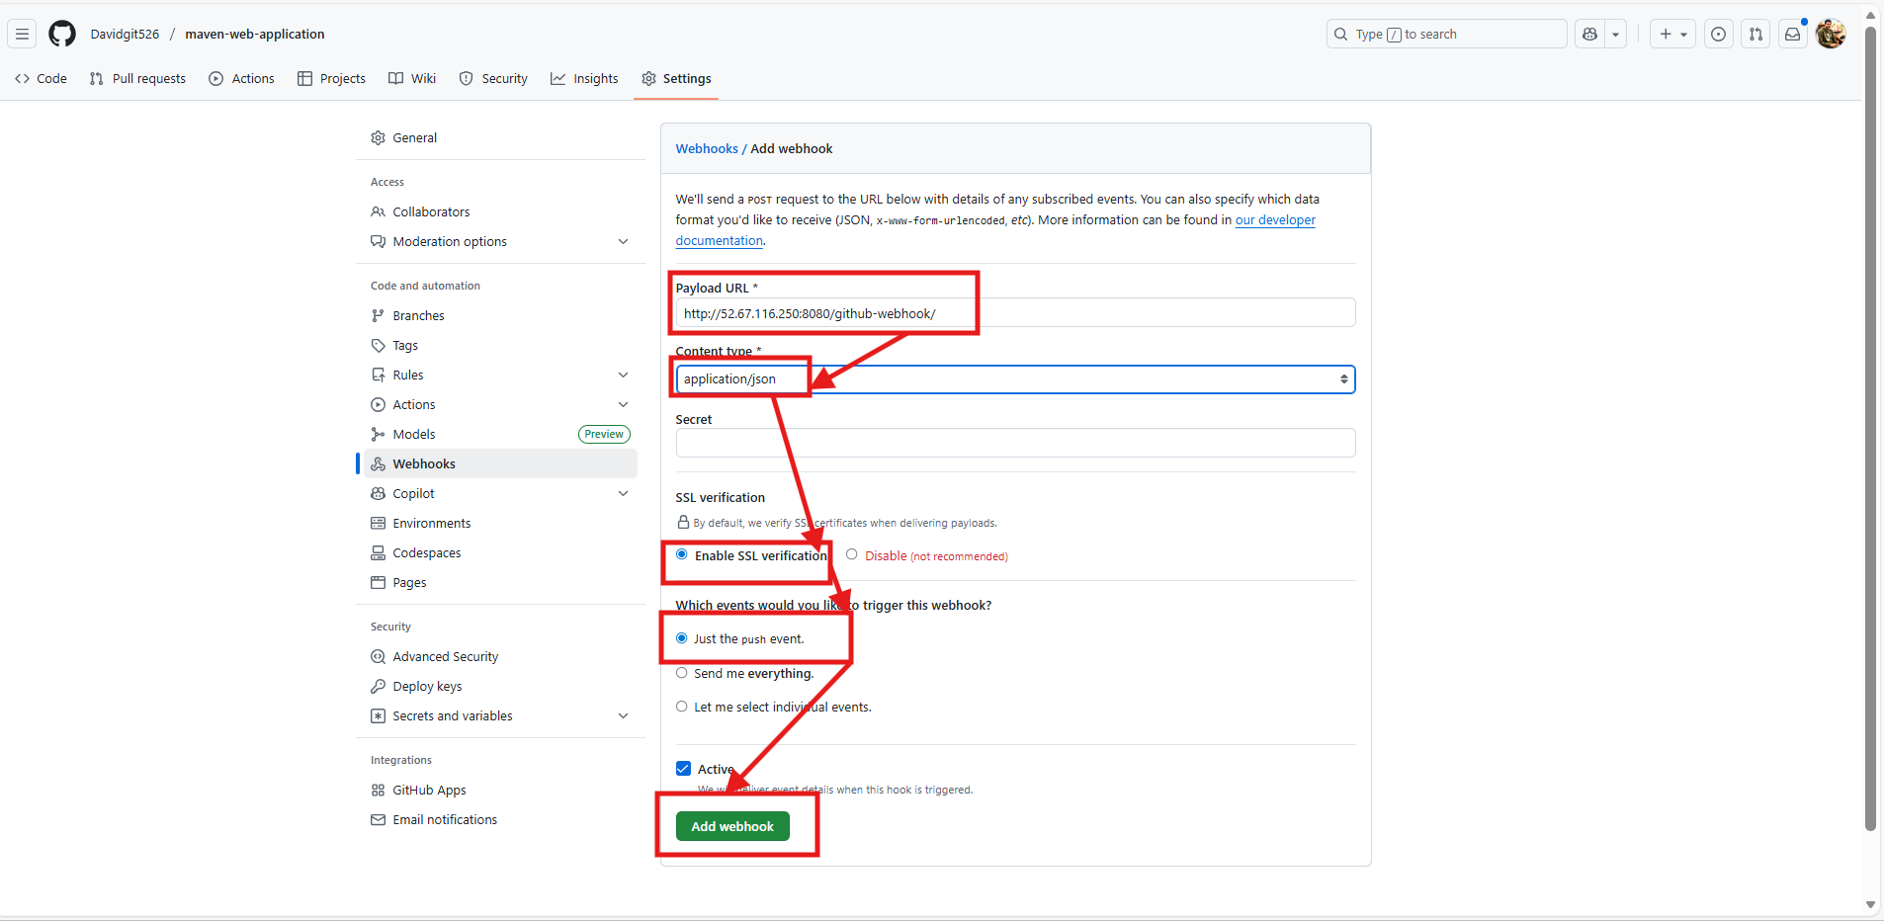

Why /github-webhook/ matters?
Jenkins listens for webhook events ONLY on: /github-webhook/
If you don’t add it → pipeline will never trigger.

- Then click on Add webhook
- Webhook created
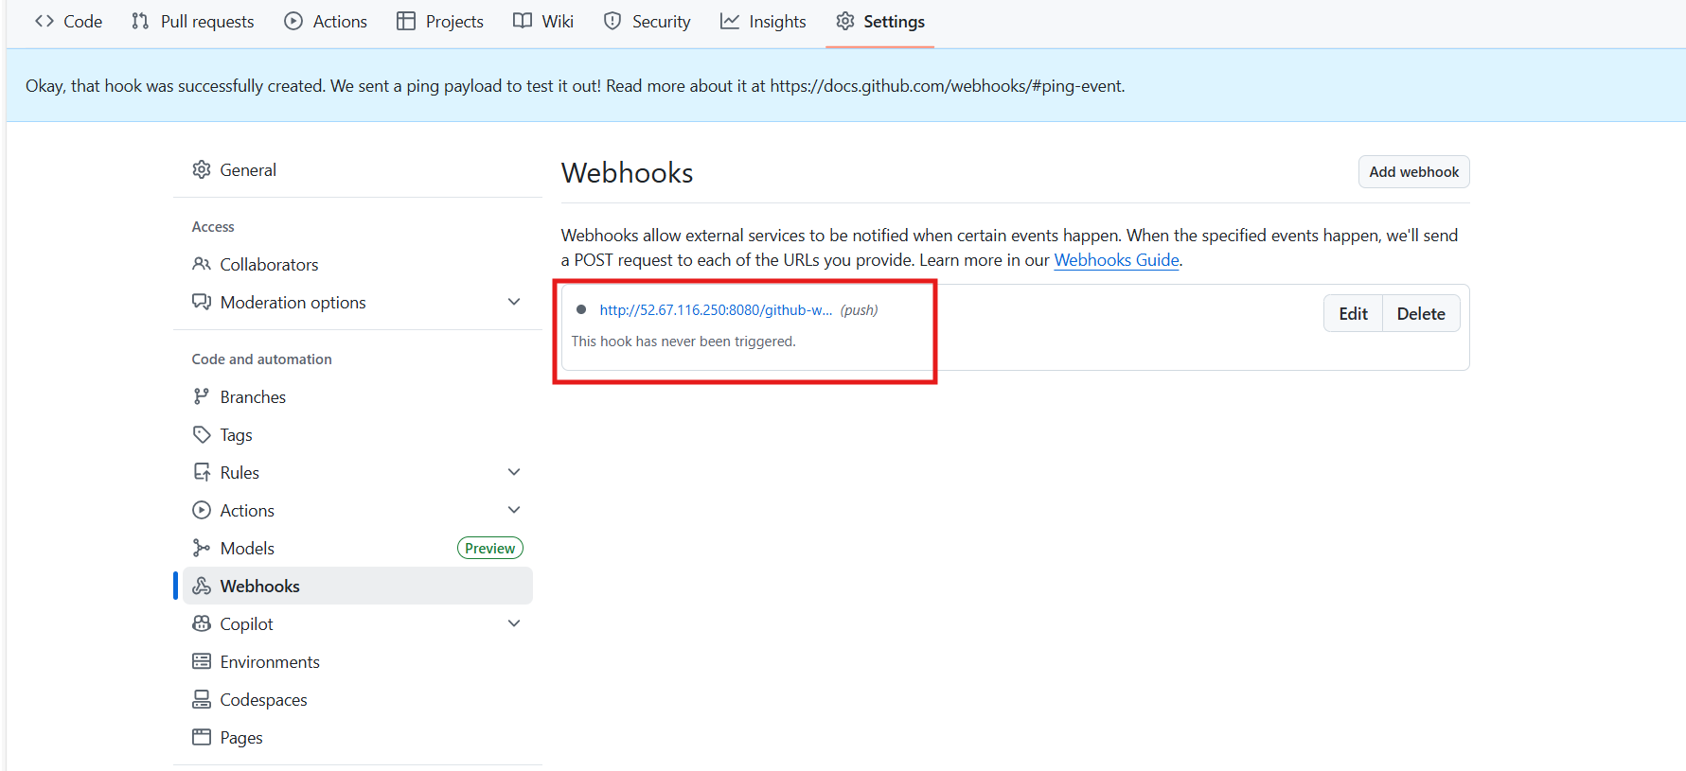

Second perquisite
- Jenkins needs these plugins: GitHub Integration plugin
- Let’s install above plugin on jenkins server
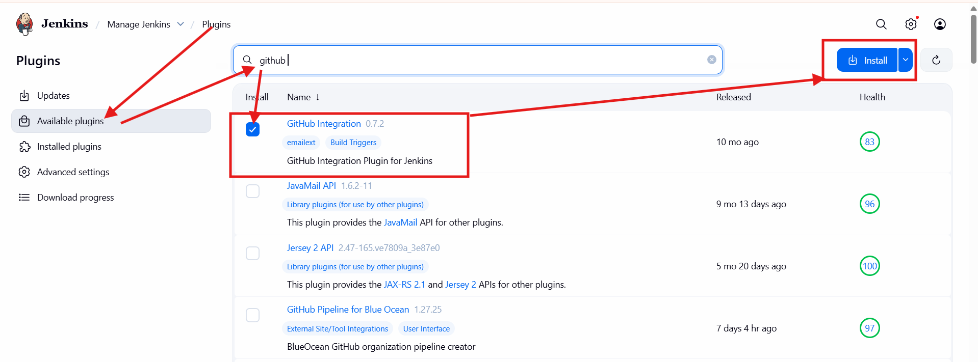

- Plugin installed
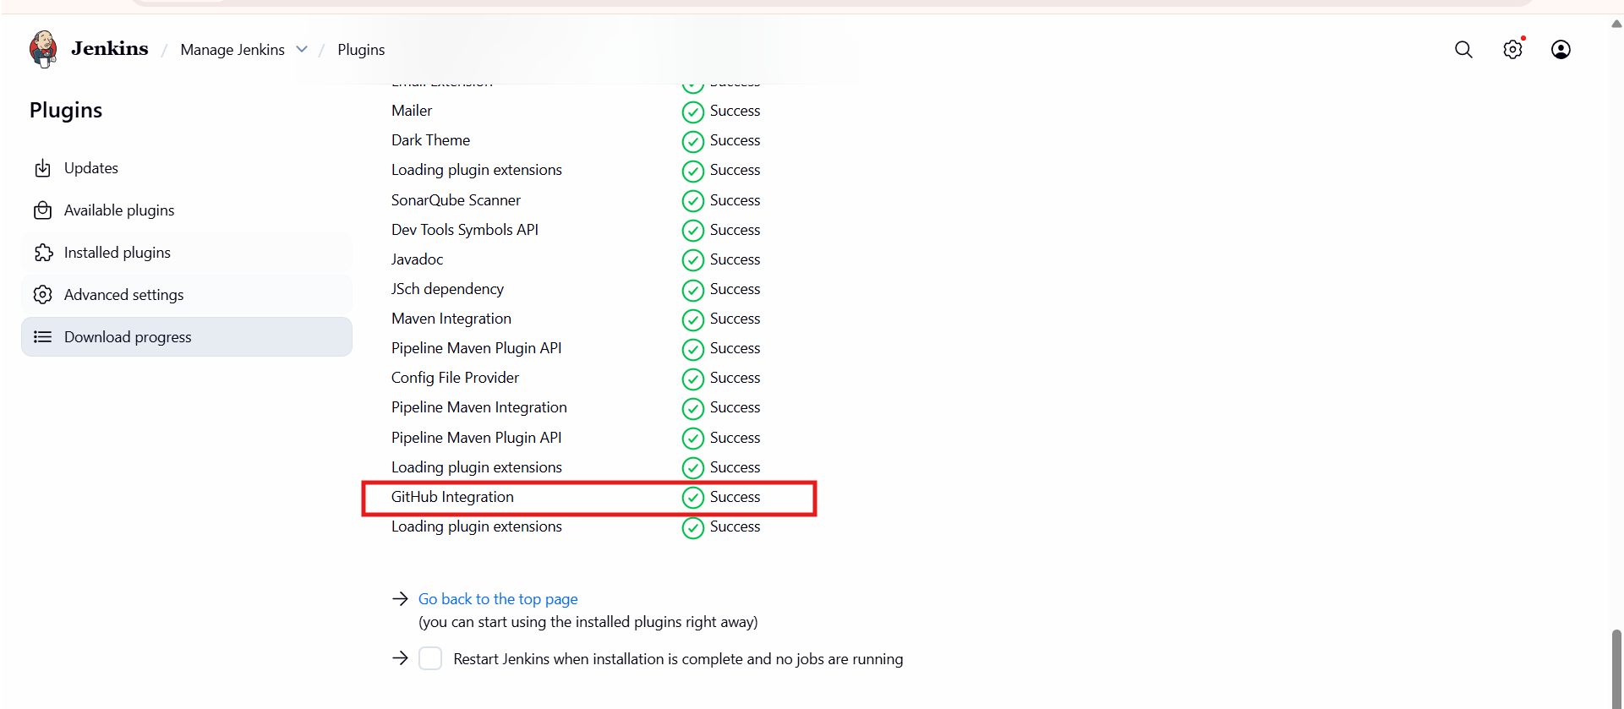

- Now let’s configure this webhook in jenkins pipeline triggers section
- Go to the pipeline click on configure click on triggers look for option called “GitHub hook trigger for GITScm polling” select this option
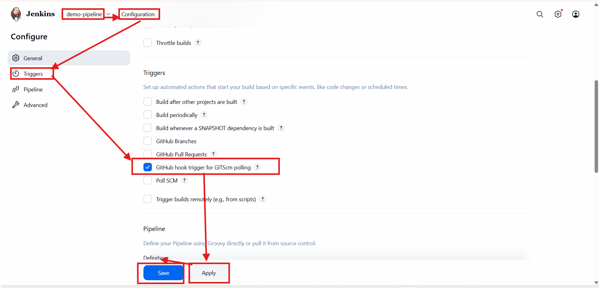

- Now whenever dev team commits any occurs automatically pipeline will trigger

- After this in your pipeline script you must include this following stage

triggers {
githubPush()
}

Why it’s ️ matter?
- You DEFINITELY need to mention it in a Jenkins Pipeline when you want the pipeline to be triggered by GitHub webhook automatically.
- Becz webhook will run only your pipeline when commit occurs but not clone the app repo.

