AMULYA MAHIMALURU
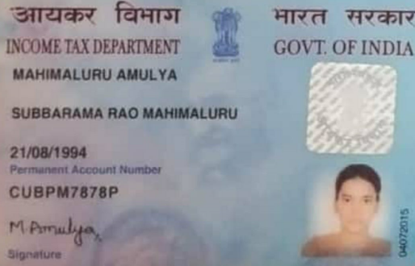

+91-8333045870

E-Mail: amulyaammu0403@gmail.com

Experience Summary
- 3.1 years of exclusive experience in Hadoop and its components like HDFS, Hive, SQOOP, SPARK & Python.

As a Big data developer,

- Worked on Ingestion components like SQOOP and HIVE.
- Worked in the processing layer of the different projects by using SPARK components like RDDs, Data frames and SQL.
- Created Python/Spark application for data transformation and aggregation.
- Produced unit tests for Spark transformations.
- Wrote shell scripts to automate the process of scheduling by invoking various components of big data pipelines.
- Knowledge on No SQL databases like HBase.
- Worked on the critical issues raised while deploying the code using CI/CD pipelines.

Technical Skills
Tools | MS- PowerBI
Data Base | Oracle SQL
Project Management | Waterfall, Agile
Languages known | C, Python
Hadoop Ecosystems | Hue, Hive, SQOOP, HDFS.
Distribution System | Cloudera, Hortonworks

Qualifications:

- BTECH from JNTU Ananthapur with Electronics and Communication Engineering as a specialization with an aggregate of 67% in the year 2015.

Professional Experience:

- Working as an Associate Developer in Cognizant Technologies Solutions PVT. Ltd, Hyderabad, India from Apr’ 2018 to Aug 2021.
Project Experience

Project Title | Gold Membership
Duration | Oct 2019 to Till date
Client | HCSC
Environment | Big Data- Hadoop, HDFS, Hive, SQOOP, Spark, Python, GIT, Jenkins, Urban code, SQL.
Project - 1:

Description:

This project has different sources and different layers to process the data. Different data sources such as Blue chip, VMS, RMS, HPS and others. Few of them are flat files and others are database sources. After getting the data to HDFS, we have processed the data in several layers to load the data in the final gold layer,
(RAW-CDC-GCF-GOLD-PIT) These are the layers which we have used to process the data.

Roles and Responsibilities:

- Created Hive create table hql statements and select hql to load the required data into cdc tables from raw tables.
- Loading the data into GCF tables using hql.
- Wrote spark scala code to apply transformations on the fields of hive table and load the final gold hive table.
- Reviewed the code developed and verified it to follow the standards.
- Finally loaded the data into pit table which maintains historical information.

Project -2:
Project Title | ACE EO Consumption.
Duration | May 2018 to Oct 2019
Client | HCSC
Environment | Big Data- Hadoop, HDFS, Hive, SQOOP, Spark and Scala, Phoenix, NoSQL(HBase)

Description:

EO’s are the value driven interactions that engage critical moments across various channels to improve the service efficiency, care efficiency and health outcome.
There are three phases in the project.
- In the first phase of this initiative business wants to build consumption view loaded with the relevant interaction data from salesforce and engagement interaction opportunity in Engagement opportunity Aggregator and member related data in Member Gold.
- Salesforce related data is used as a driver table to join Member gold and Engagement opportunity and to load EOE final table and generates extract file
- Extract file will be Ftp’d to the downstream systems.
The purpose of this project is to provide a tactical solution to the business need to generate various metrics on the Engagement opportunities.

Roles and Responsibilities:

- Updated few transformation rules with data frames to derive few output fields.
- Developed Scala code to generate the final csv extract file.
- Developed the code to get the data from hive through spark and also from Phoenix through spark.
- Used Analytical and Windowing functions to generate sequence number for hive final table.
- Developed shell script to automate the spark-submit.
- Developed Few HQL’s to load the data to hive gold membership intermediate table.
- Worked on the code which joins the three data frames and applied transformations on the resultant data frame.
- Wrote Spark SQL code to read the most recent data from Phoenix tables.

Place : Hyderabad
Date : 12/12/2021

