Quiz Agent: AI-Powered Adaptive Assessment

Implementation Strategy and

Technical Architecture (Team 58)

1. Problem Understanding
Modern educational and corporate training environments face a significant bottleneck: the manual creation of high-quality, relevant assessment materials. Traditional standardized quizzes often follow a "one-size-fits-all" model, which fails to account for:

- Diverse Knowledge Baselines: Learners arrive with varying levels of prior knowledge.
- Cognitive Overload/Boredom: Quizzes that are too hard cause frustration, while those too easy lead to disengagement.
- Content Fragmentation: Useful information is locked in static PDFs, lengthy YouTube videos, or complex web articles, making it slow to extract actionable self-tests.
- Memorization over Mastery: Without dynamic question variation, learners often memorize answers rather than understanding concepts during retakes.

The Solution: The Quiz Agent solves these issues by automating the generation of contextually accurate quizzes from any source and dynamically adjusting difficulty based on real-time and historical performance.

2. Solution Workflow
Our system implements a sophisticated, multi-stage pipeline designed for both solo mastery and team competition:

Phase I: Discovery and Input Validation
User provides content via typed topics, PDF uploads, or URLs (YouTube/Web).
- AI Sentinel: Before processing, a Google Gemini-powered validation layer checks if the input is "educational" and "meaningful." This avoids "hallucination bursts" from nonsensical prompts.

Phase II: Contextual Extraction and Adaptive Synthesis
1. Semantic Analysis: The engine parses the source (PDF text, YouTube transcript, or HTML) using Google Gemini 1.5 Pro to extract key learning objectives.
2. Baseline Profiling: The system queries the user’s performance history for the specific topic to determine an initial difficulty level (Beginner, Intermediate, or Advanced).
3. Cross-Mode Question Generation: It synthesizes a mix of Multiple Choice (MCQ), True/False, and Fill-in-the-blank questions tailored to the baseline.

Phase III: Evaluation and Feedback
- Semantic Answer Evaluation: For non-MCQ types, the system uses AI to evaluate answers based on meaning rather than exact string matching, allowing for flexible and fair grading.
- Smart Remediation: Each result includes AI-generated feedback identifying "Focus Areas" and "Growth Tips."

3. High-Level Architecture
We transitioned from a split client-server model to a unified Next.js Monolith to maximize performance and simplify deployment:
- Frontend: Next.js (App Router) with React Server Components (RSC) for fast initial loads and Client Components for the interactive "Neural HUD" quiz interface.
- Backend Logic: Next.js Server Actions - All database interactions and AI orchestrations are handled via secure, type-safe actions, eliminating the latency of external REST/WebSocket overhead.
- Data Layer: MongoDB Atlas using Mongoose for flexible storage of multi-modal quiz data and room states.
- Authentication: Clerk (Middleware-based) for seamless session management and user identification.
- Synchronization: Polling-based State Machine - To replace legacy WebSockets, we implemented "Lazy Advance" logic. A 3-second heartbeat polls the server, which calculates the current room state based on high-precision timestamps, ensuring sub-second synchronization across unlimited clients.
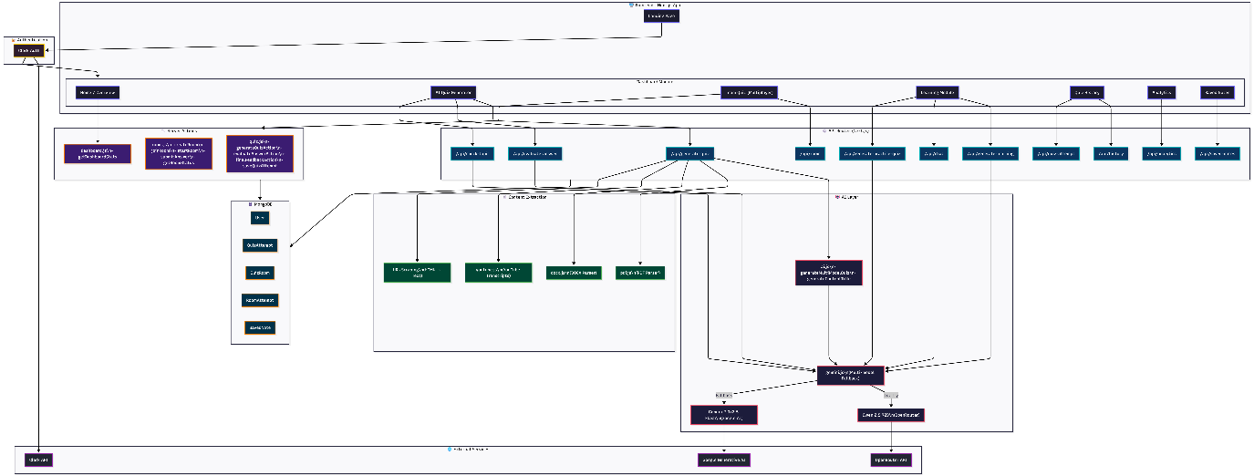
(Zoom it for better quality)

4. Key Features
- Multi-Source Extraction: Advanced scrapers for YouTube transcripts and generic web content, alongside raw PDF binary parsing.
- Universal Retake System: A robust feature allowing users to retake any quiz from history in two modes:
  - Same Questions: Shuffle options and questions to fight "positional memory."
  - New Questions: Trigger a fresh AI generation based on the same source material to ensure concept mastery.
- Team Quiz Logic: Competitive multiplayer rooms with live leaderboards, automated 5s countdowns, and synchronized transition states.
- Dynamic Difficulty Scaling: System adjusts the complexity of the next generation based on the average accuracy of the previous attempt.
- Today's Activity Tracking: A dashboard streak and completion system to encourage daily learning habits.

5. Challenges and Resolutions
- Culling WebSocket Complexity: Real-time team quizzes are notoriously difficult to scale with WebSockets in serverless environments.
  - Resolution: Developed the Server-Side Timestamp Oracle. The server acts as a "source of truth" for time; clients simply poll for the "Current Room Phase," and the server decides which question should be shown based on the elapsed time.
- Mongoose Serialization Issues: Next.js Server Actions often fail when returning complex Mongoose documents due to circular references.
  - Resolution: Implemented a POJO Transformation Layer that de-hydrates DB objects into plain JavaScript objects before they cross the network boundary.
- Handling Non-Standard URLs: Some websites block simple scrapers.

6. Future Enhancements

6.1 Advanced AI Transformations
- Voice-to-Knowledge Integration: Enable users to generate quizzes through direct voice input or lecture recordings using high-accuracy processing (e.g., OpenAI Whisper).
- Multilingual Support: Broaden AI orchestration to support 50+ global languages, breaking language barriers for a worldwide educational reach.

6.2 Collaborative and Adaptive Learning 2.0
- AI-Generated Study Paths: Dynamically suggest learning modules based on historical performance to address identified knowledge gaps.
- Real-Time Collaboration: Gamify social learning with live leaderboards and shared knowledge bases for group projects.

6.3 Platform Ecosystem and Accessibility
- Browser Extension: One-click quiz generation from any educational webpage.
- Mobile Native Experience: Dedicated iOS/Android apps with offline study mode support.

