Create a crud api using python flask and ran it locally. Attached a screenshot of the result(**figure 1**)

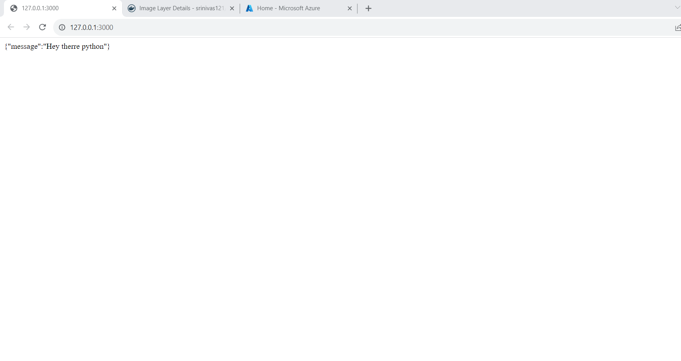

(Figure 1)

* Created a Docker file to build a Docker image, next pushed the docker image into the docker hub. Attached screenshot for reference(Figure 2)

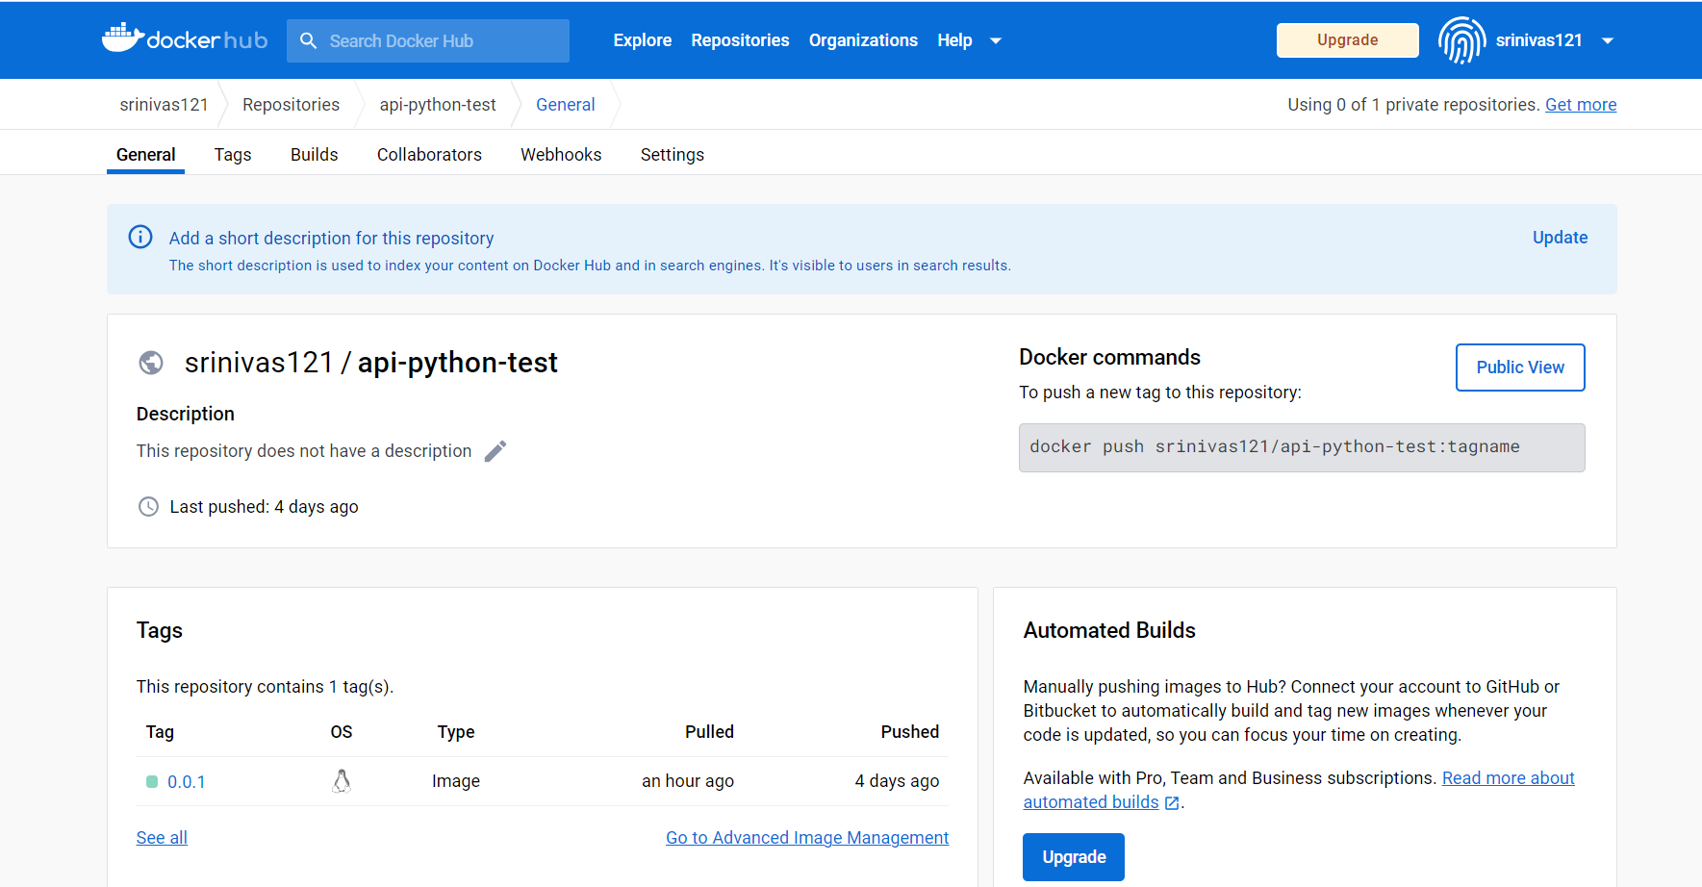

(Figure 2)

* Now added the required code to the infra folder to create Kubernetes cluster and Azure Container Registry.
* I used the Azure DevOps pipeline for CI and CD
* In Azure DevOps I used classic pipelines for CI and CD, attaching screenshots of the classic pipeline for CI (Figure 3)and CD (Figure 4)

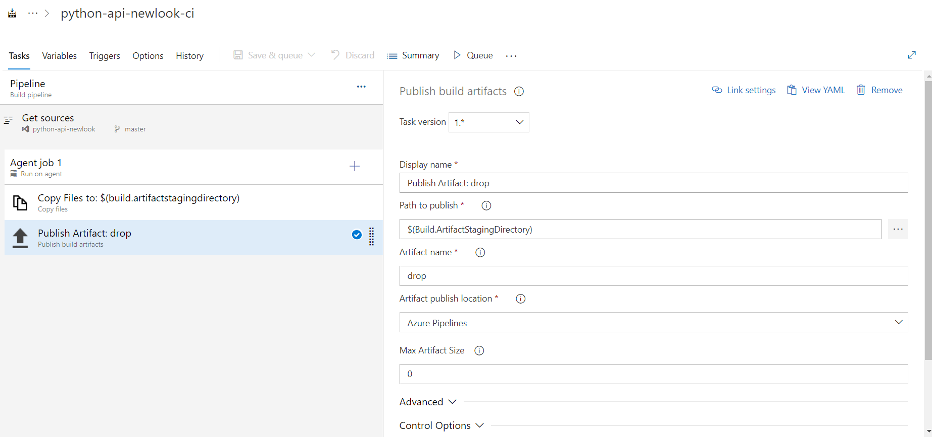

(Figure 3)

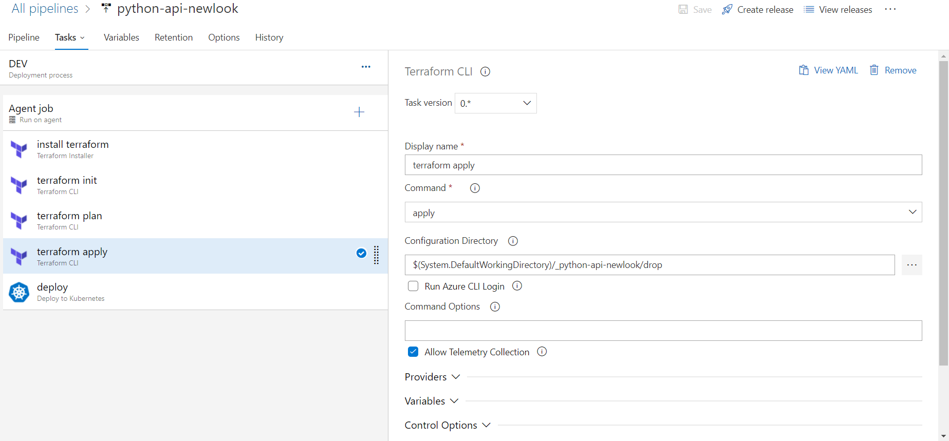

(Figure 4)

* After deployment it generated external ip, attaching screenshot for the reference(Figure 5)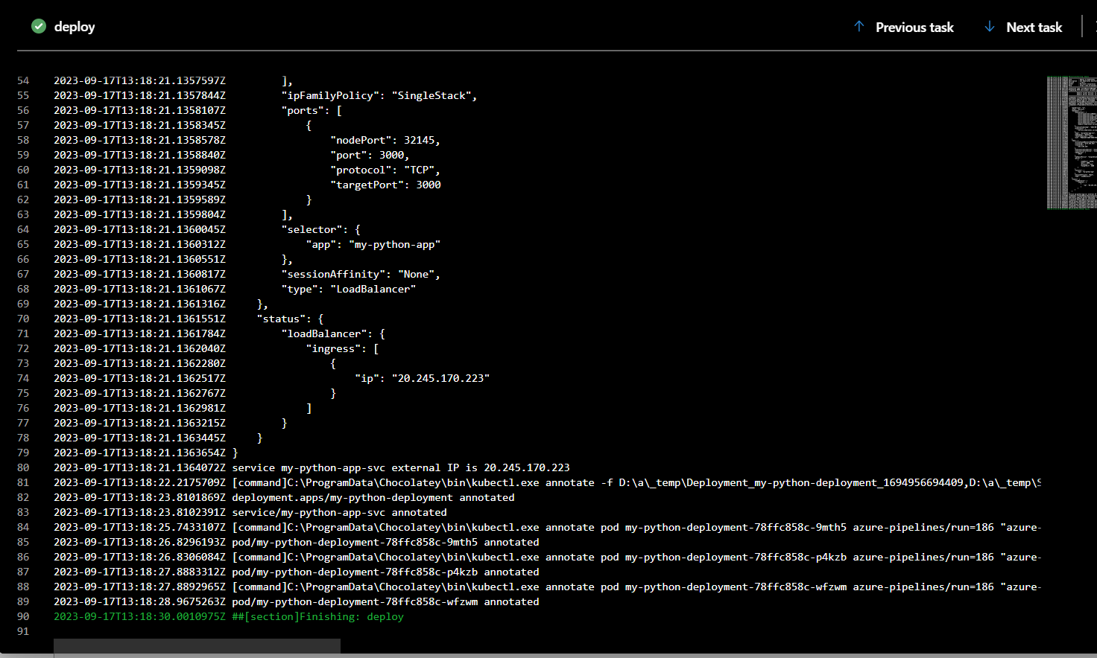

(Figure 5)

* Using the external ip and port number, tried accesses through internet and the result is show in the screenshot (Figure 6)

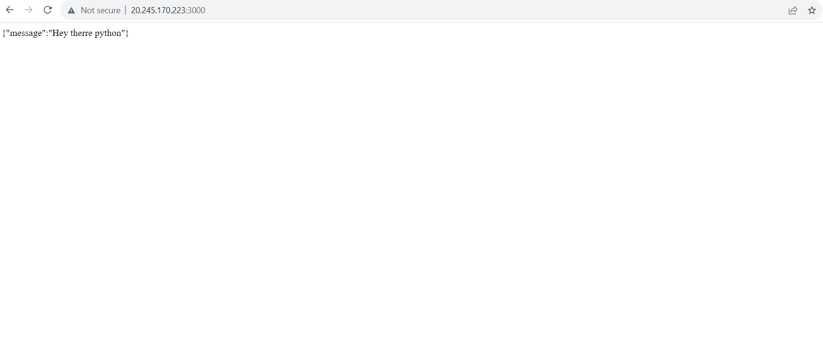

(Figure 6)

This is my git hub link for source code https://github.com/Sreenuj121/python-api