**Computer Vision, IIIT Sri City (Spring 2019)**

**Dr. Shiv Ram Dubey**

**Programming Assignment – 2**

**Release Date: 06-March-2019, Deadline: 15-March-2019 (5.00 pm)**

**1. Stitching Pairs of Images**

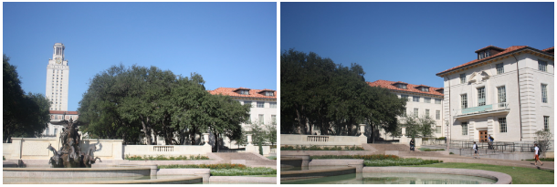

The first step is to write code to stitch together a single pair of images. For this part, you will be working with the following ‘uttower_left.JPG’ and ‘uttower_right.JPG’ pair (shown above and also uploaded).

Steps:

1. Compute Sift key-points and descriptors for both images.
2. Compute distances between every descriptor in one image and every descriptor in the other image.
3. Select putative matches based on the matrix of pairwise descriptor distances obtained above. You can select all pairs whose descriptor distances are below a specified threshold, or select the top few hundred descriptor pairs with the smallest pairwise distances.
4. Run RANSAC to estimate a homography mapping one image onto the other. Report the number of inliers and the average residual for the inliers (squared distance between the point coordinates in one image and the transformed coordinates of the matching point in the other image). Also, display the locations of inlier matches in both images.

For RANSAC, a very simple implementation is sufficient. Use four matches to initialize the homography in each iteration. You should output a single transformation that gets the most inliers in the course of all the iterations. For the various RANSAC parameters (number of iterations, inlier threshold), play around with a few "reasonable" values and pick the ones that work best.

1. Warp one image onto the other using the estimated transformation.
2. Create a new image big enough to hold the panorama and composite the two images into it. You can composite by simply averaging the pixel values where the two images overlap.

**2. Single-View Metrology**

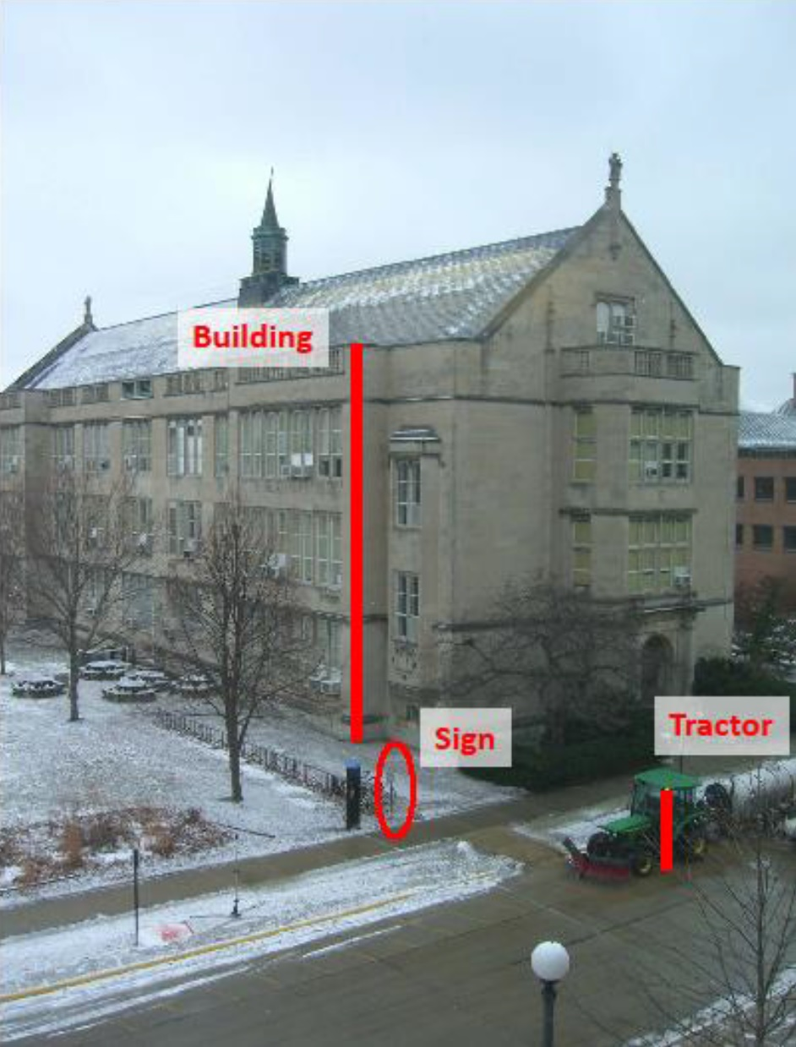

For the “img.jpg”, shown above and also uploaded, estimate the horizon (i.e. vanishing line) and draw/plot it on the image. Assume that the sign is 1.65 meter. Estimate the heights of the tractor, the building, and the camera (in meters).

* Turn in an illustration that shows the horizon line, and the lines and measurements used to estimate the heights of the building, tractor, and camera.
* Report the estimated heights of the building, tractor, and camera in meters.

**3. Stereo Matching**

The goal of the assignment is to implement a simple window-based stereo matching algorithm for rectified stereo pairs. You will be using the following stereo pair (shown below and also uploaded): “tsukuba1.ppm” and “tsukuba2.ppm”

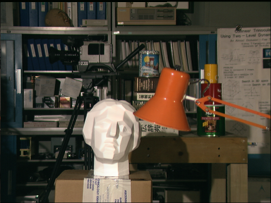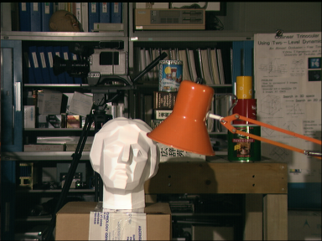

Basic Outline: pick a window around each pixel in the first (reference) image, and then search the corresponding scanline in the second image for a matching window. The output should be a disparity map with respect to the first view (use the ground truth map given in “tsukuba_gt.pgm” for qualitative reference). You should experiment with the following settings and parameters:

* **Search window size:** show disparity maps for several window sizes and discuss which window size works the best (or what are the tradeoffs between using different window sizes). How does the running time depend on window size?
* **Disparity range:** what is the range of the scanline in the second image that should be traversed in order to find a match for a given location in the first image? Examine the stereo pair to determine what is the maximum disparity value that makes sense, where to start the search on the scanline, and which direction to search in. Report which settings you ended up using.
* **Matching function:** try sum of squared differences (SSD) and normalized correlation. Discuss in your report whether there is any difference between using these two functions, both in terms of quality of the results and in terms of running time.

**Acknowledgments:** This assignment is inspired from the Computer Vision courses by Derek Hoem and Svetlana Lazebnik, University of Illinois Urbana-Champaign.