# **Deep Learning Assignment 1**

**V Sree Pragna , S20160010106**

### **Question-1** : Multi layer Perceptron

1. When multi layer perceptron is run for 750 epochs

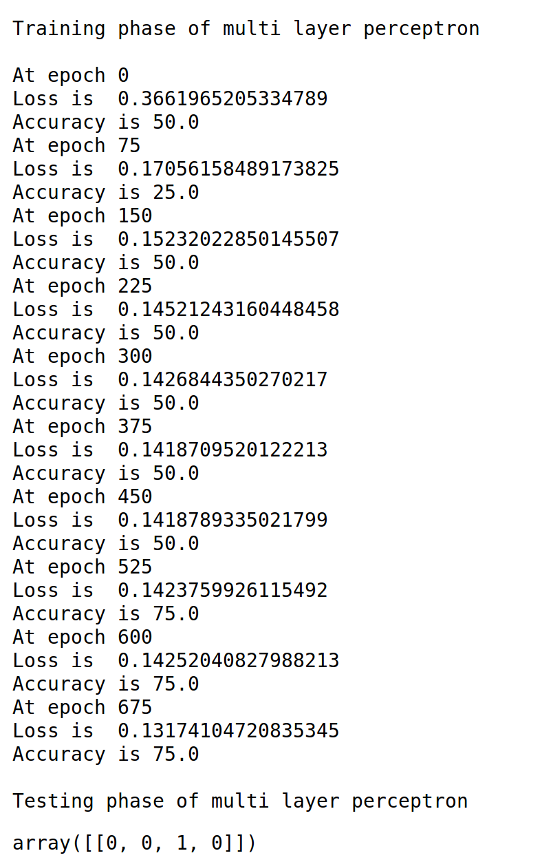

(b) When multi layer perceptron is run for 1500 epochs

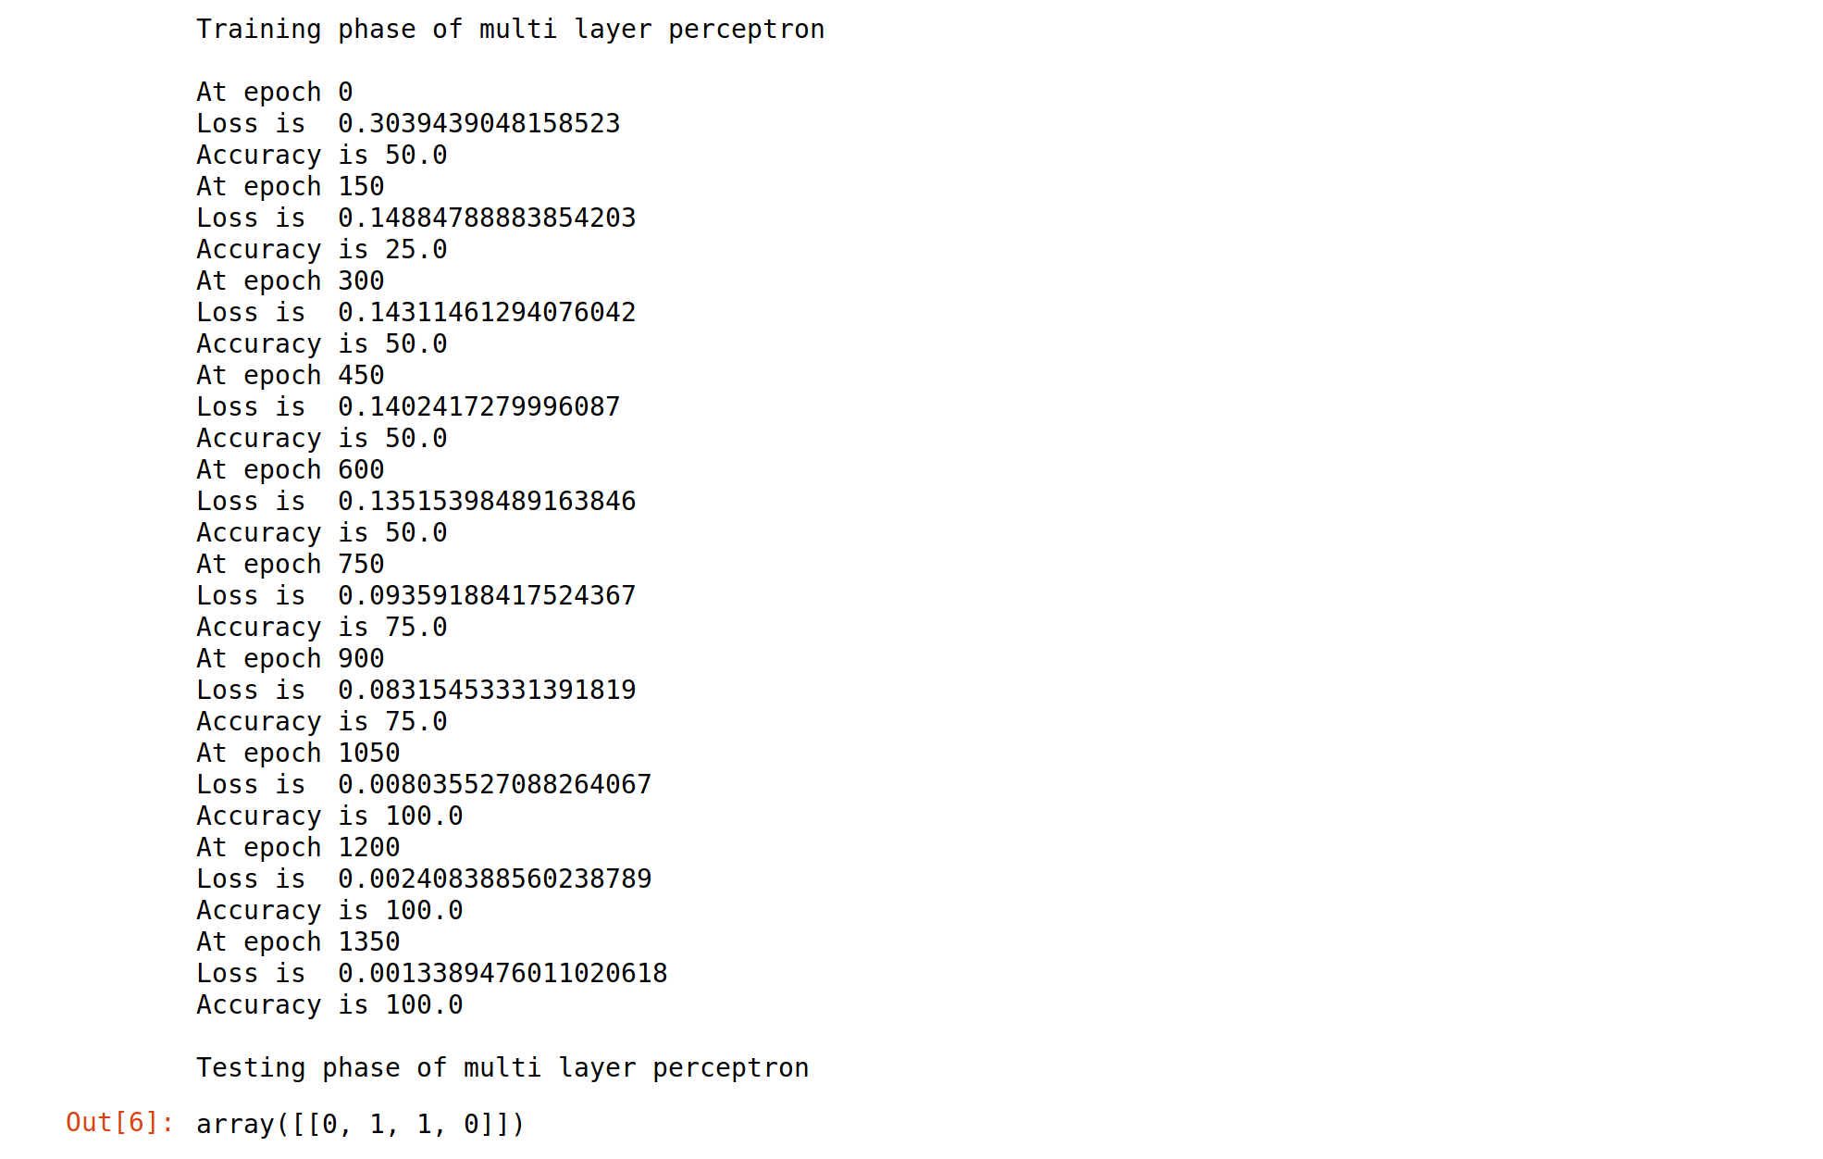

### **Question-2** : CNN

1. When CNN is run for 5 epochs the results are :

(a)Cost function :

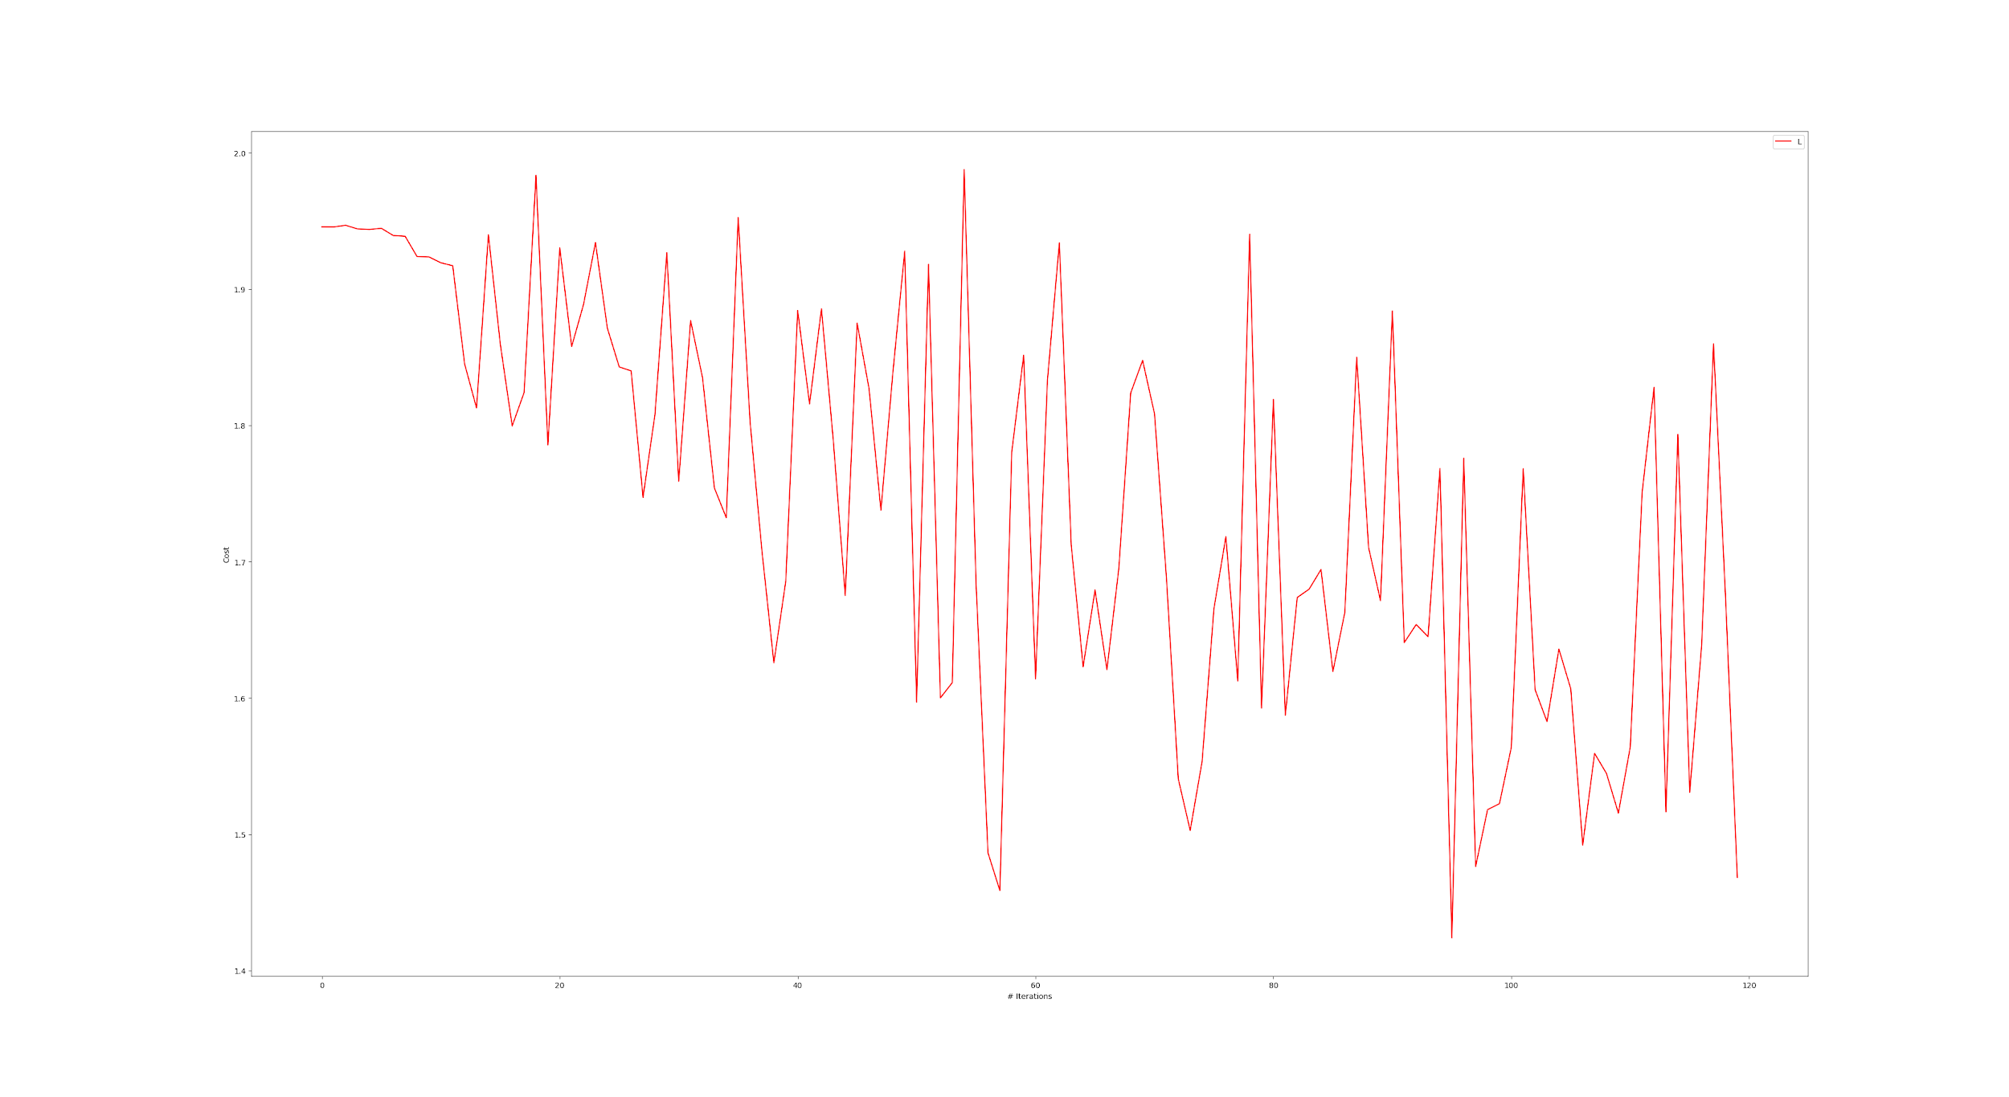

(b) Recall of all classes

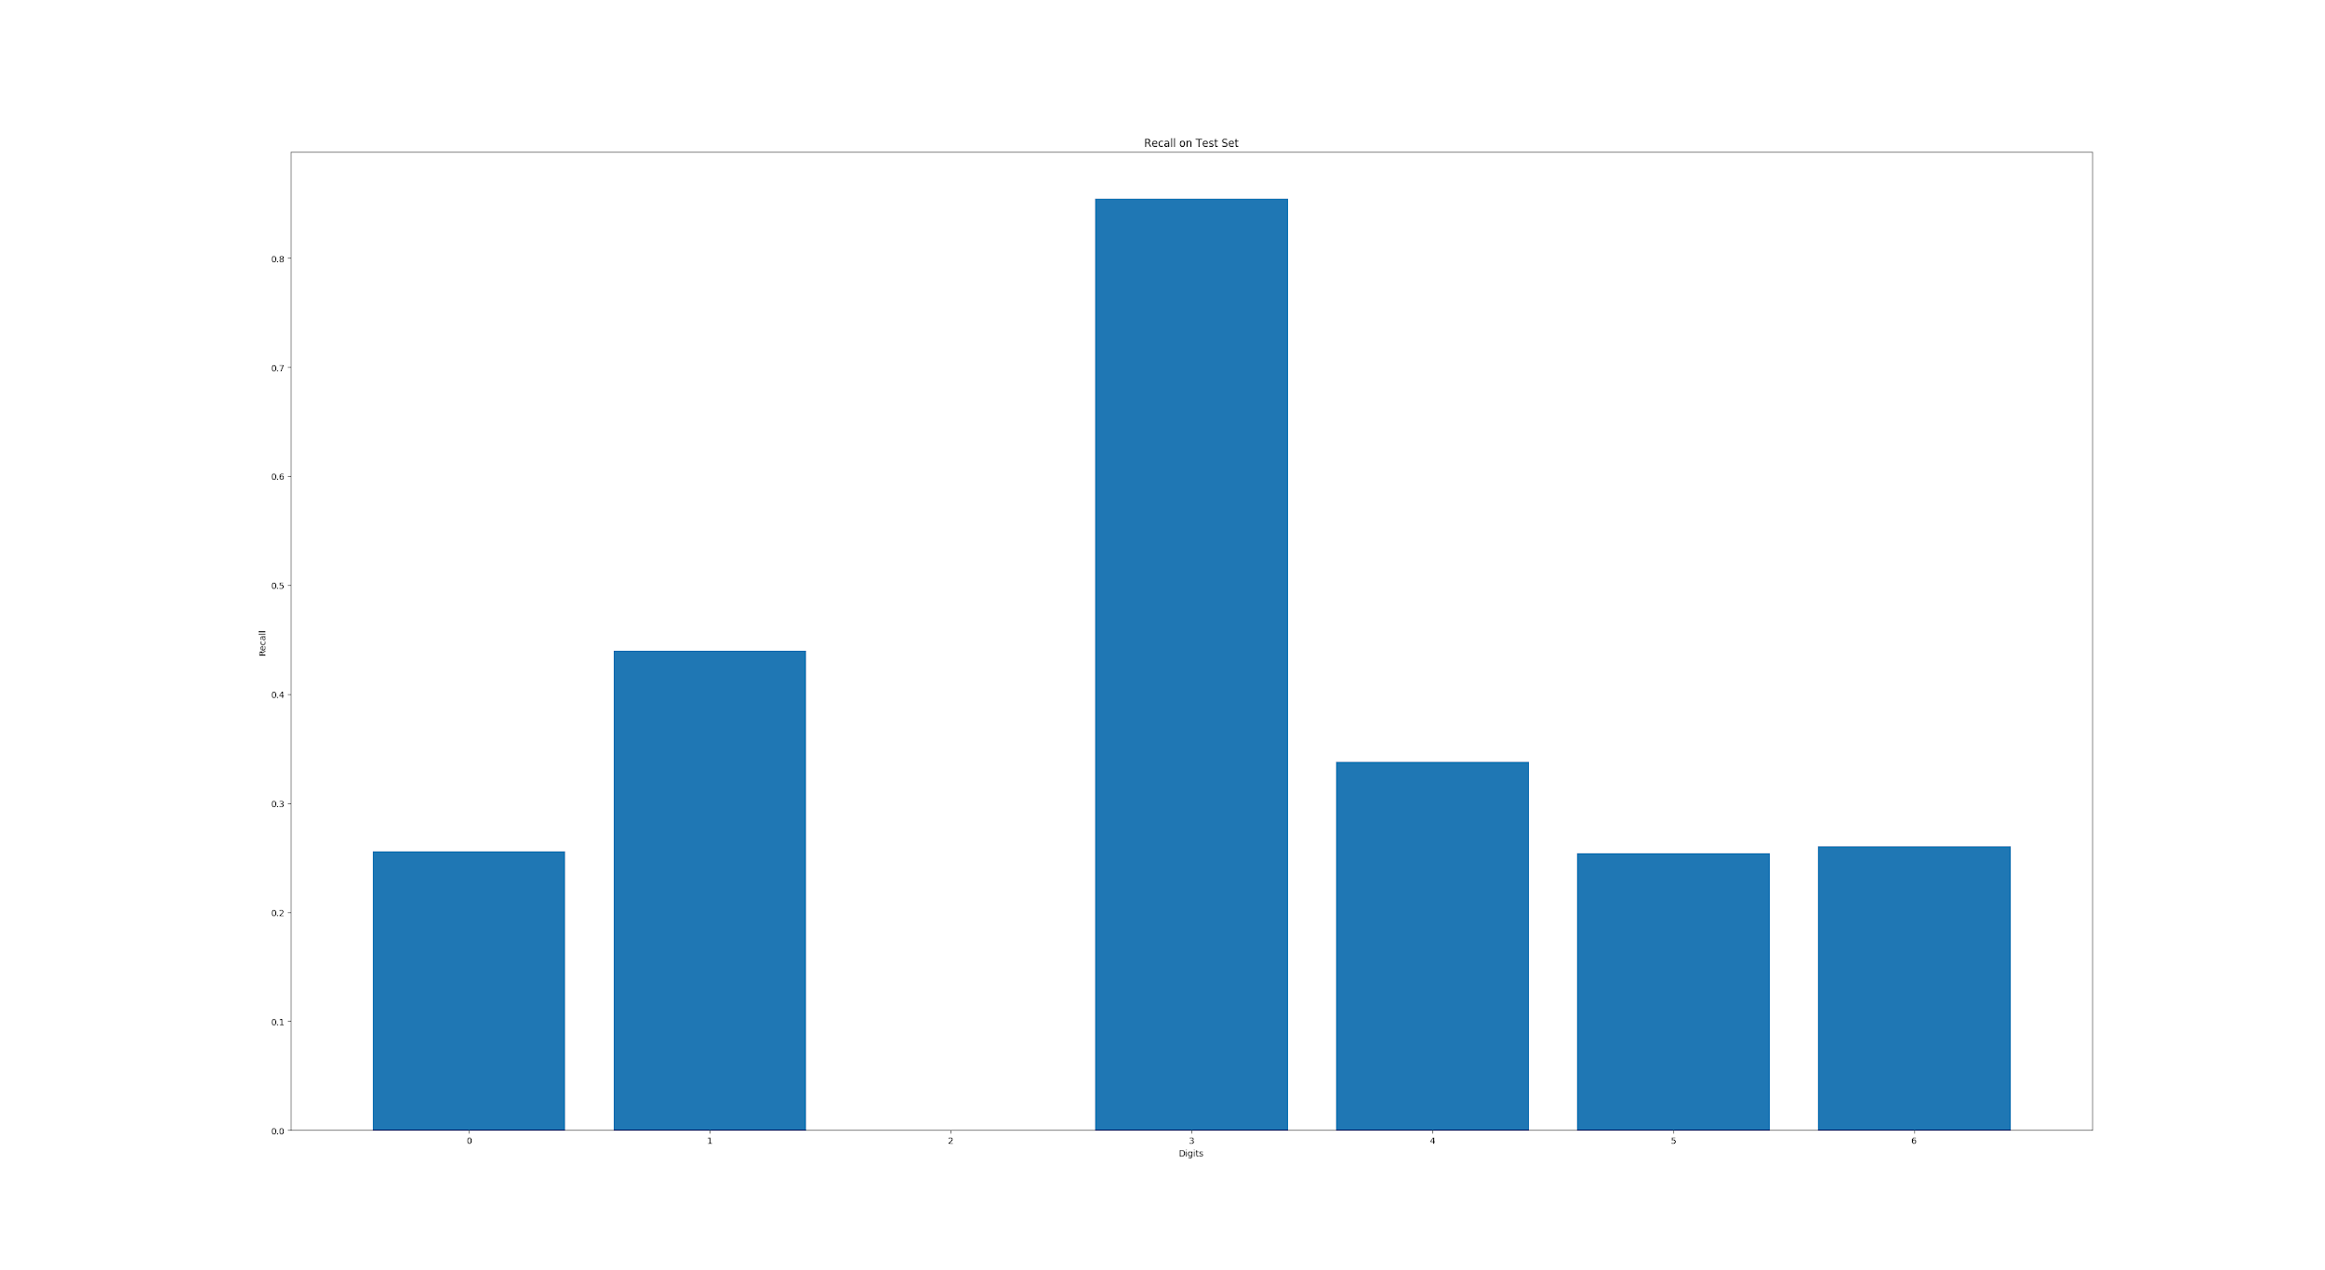

(c) Accuracy over test set : 41.25%

(2) When CNN is run for 7 epochs the results are :

1. Cost function :

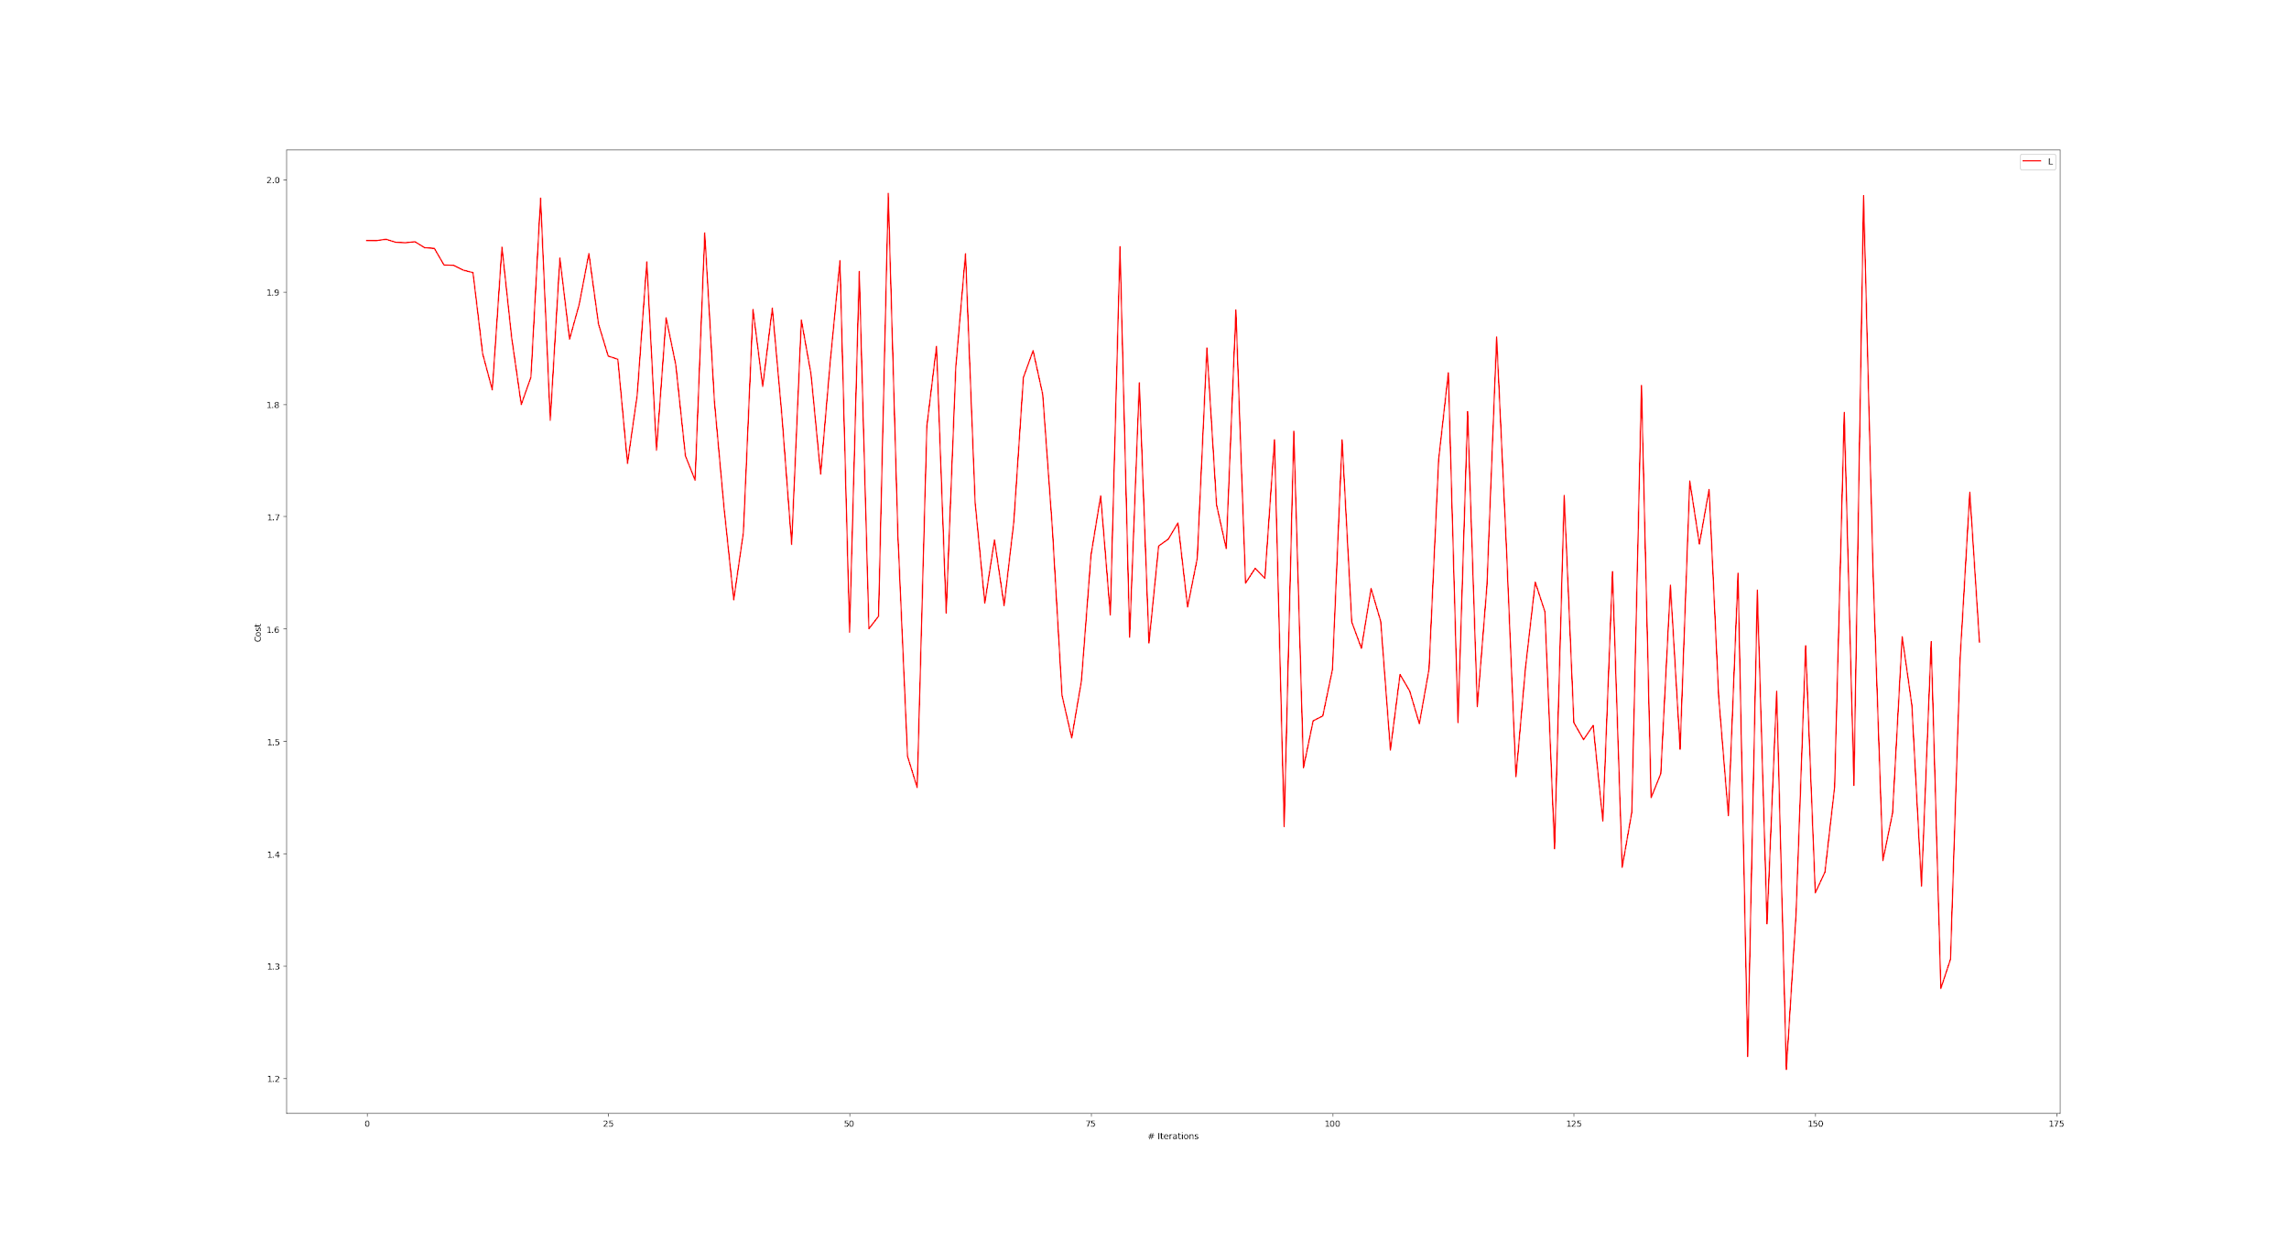

(b) Recall for 7 classes :

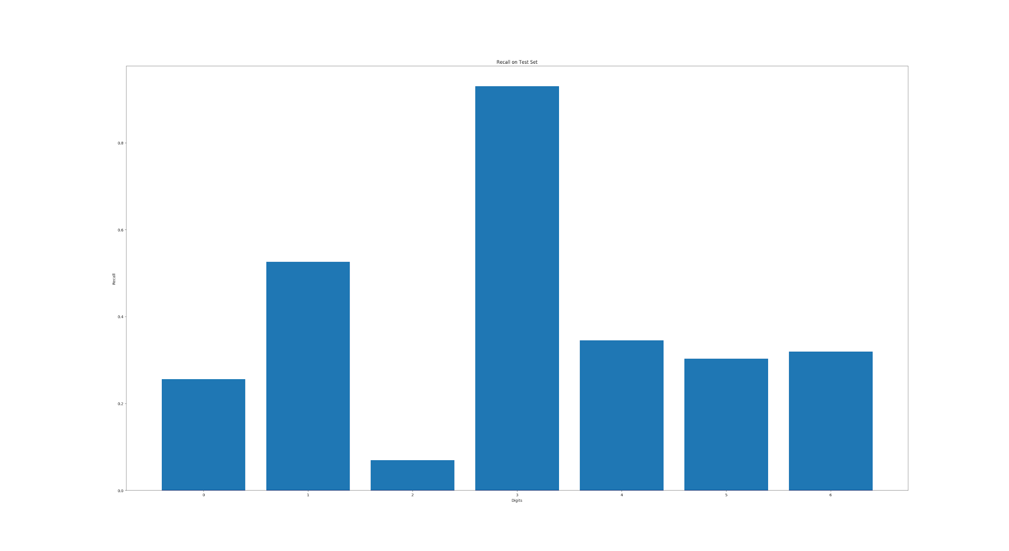

(c) Accuracy over test set : 46.25%

### **Question-3** : Sentimental analysis using lstm

1. When lstm is run for 2 epochs results are :

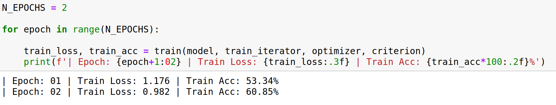

1. When lstm is run for 5 epochs results are :

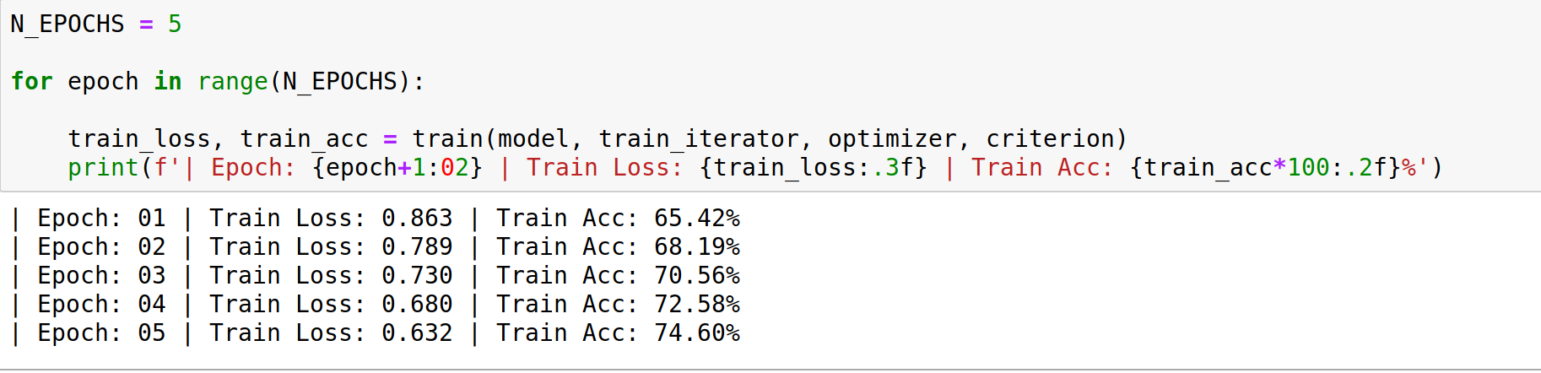

1. When lstm is run for 7 epochs results are :

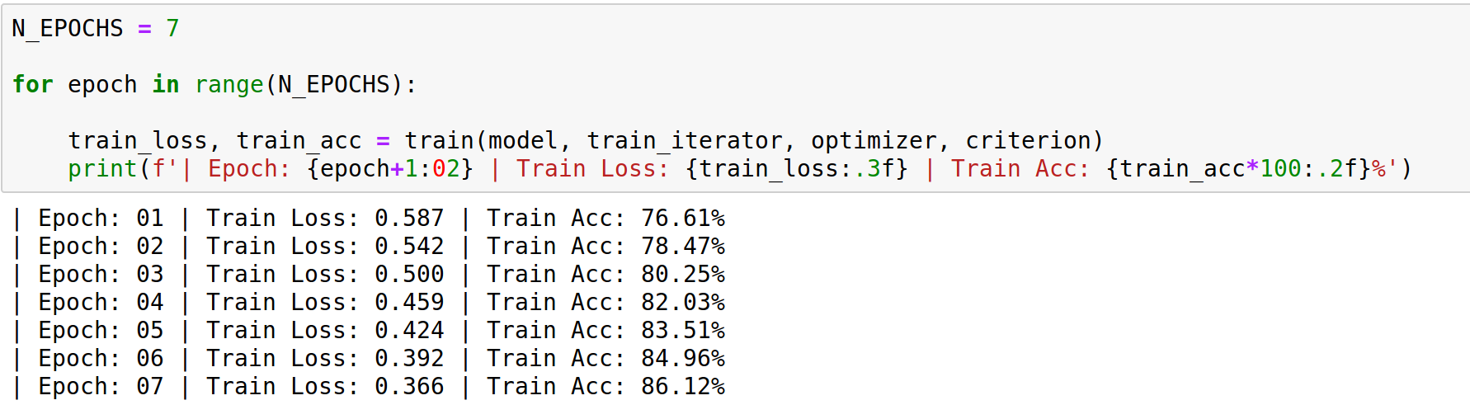

1. When code is run for 9 epochs results are :

