Sreeraaghav Raja
2/08/26

EE Design 1 Technical Report
Power Supply Design

Introduction
This module was an introduction to power regulation and power supply management. The goal of this module was to emphasize the importance of power supply management and its necessity in a variety of use-cases. The lab focuses on 2 different types of regulators, a linear and a switching regulator. This will be an important step in the implementation of the final project for this course.

Methods
Background Information:
This lab was an introduction to power regulation / management in many large-scale engineering projects. Power regulation happens in 2 ways: step-up or step-down. While there are different kinds of converters that can perform these operations, the Low-Dropout Linear Regulator (LDO) and the Switching Regulator were the ones that were focused on.
The Low-Dropout Regulator (LDO) is effectively a type of integrated circuit (IC) that is used to rectify the discrepancies between the input and output voltage [1]. The LDO is useful because it aligns with one of the dogmas of electrical engineering: reduce power consumption. The LDO always steps down voltage from the source to the destination which aligns with that principle. The power supply must be a high-fanout component which makes it especially noisy. Therefore, LDOs are required to regulate this noise and prevent crosstalk between many destinations and the source, the power supply, and the destinations, application-specific ICs [1]. Finally, the LDO is ostensibly superior to other linear regulators because it does not require a high voltage drop for voltage regulation, conserving power [2]. Other linear regulators require high voltage drops (e.g. 9V source requires the output voltage drop to be greater than 3V) whereas the LDO often requires less than 1V (e.g. the LM2940 which requires a voltage drop of less than 1V over the entire temperature range) [3].
The Switching Regulator is a different kind of IC that turns either fully on or fully off to conserve power. Regulator operation is handled by a control element that oscillates the current value at the base of the pass transistor (BJT) and energy is conserved through inductors, an energy storage element [4]. The switching regulator is more efficient and adaptable than the LDO for a multitude of reasons, but the primary one is that it can handle both step-up and step-down operation. However, this operation is all the cost of noise and part complexity [1]. Switching regulator circuits are larger and require a large difference between the input and output voltage than the LDO, so each circuit has its own place in design projects [1].
Reference Voltages are often required within the ICs of each of these regulators since they have a comparator inside them to output a specific output voltage. Thus, they require a reference voltage to maintain that consistent output as all comparators do. Moreover, the reference voltage is controlled using either a Zener diode or a bandgap reference voltage. The Zener diode offers a consistent breakdown voltage given a specific current value, providing a stable reference voltage for the comparator [5]. The bandgap reference is effectively an “active circuit that emulates a Zener” [5]. This topology works at lower voltages than a Zener and is ostensibly immune to temperature changes [6].

Design Steps and Specifications:

- Implement the regulator circuits on LTSpice after importing the necessary dependencies.
- These circuits were all found in the documentation for each regulator. The LM2940c IC was used for the linear regulator and the LM2576 IC was used for the switching regulator.
- Measuring the output voltage and currents for each scenario required a 1kΩ and 50Ω resistor at output node.
- Breadboard the LDO circuit according to the schematics with minor changes based on part availability. For example, the 22uF capacitor was difficult to make based on the part availability (required 4 capacitors in parallel), so the 47uF capacitor was used which would have slightly slower operation rate than the 22uF capacitor. However, this would be minimal for the basic operation of the LDO.
- Breadboard the Switching Regulator Circuit. The most difficult aspect of this circuit was attaching the LM2576 onto the breadboard (required soldering the IC onto a PCB with headers). Otherwise, component availability did not play a significant role in the creation of this circuit.
- Measured the output voltage and current for each scenario. However, the 50Ω resistor was not in the kit, so two 100Ω resistors were used in parallel. This could have caused minor noise discrepancies in the output voltage reading.

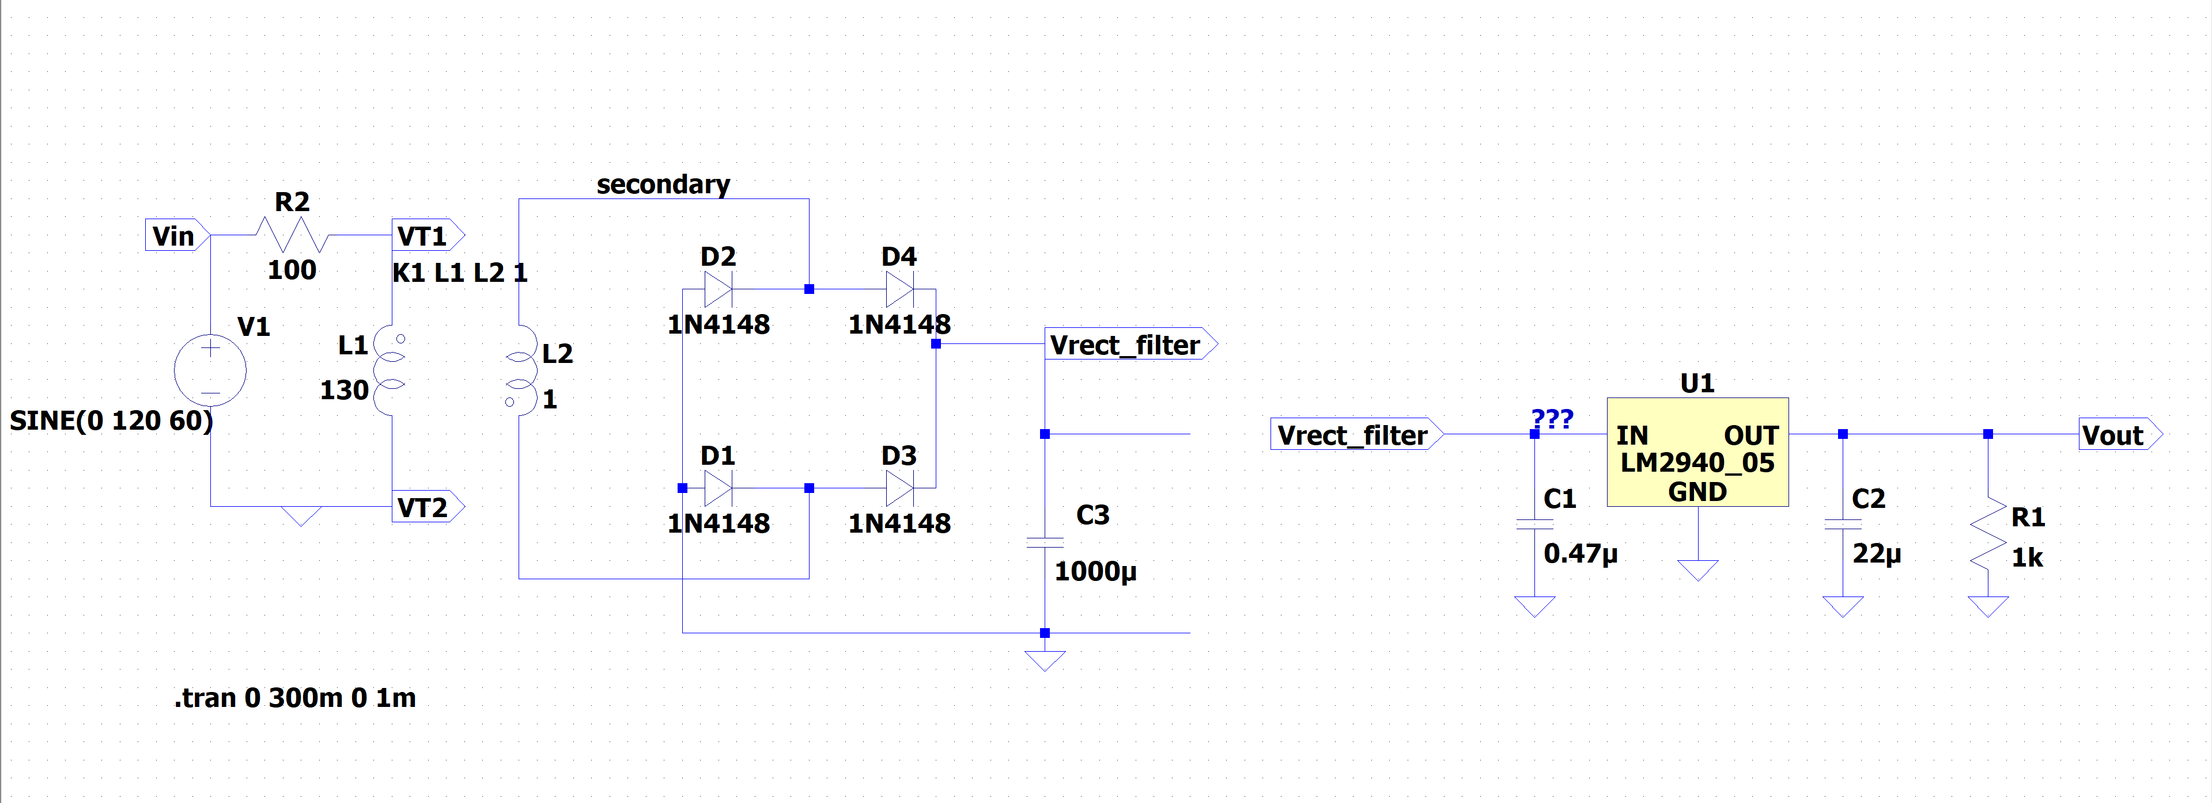
Figure 1: Linear (LDO) Voltage Regulator Schematic

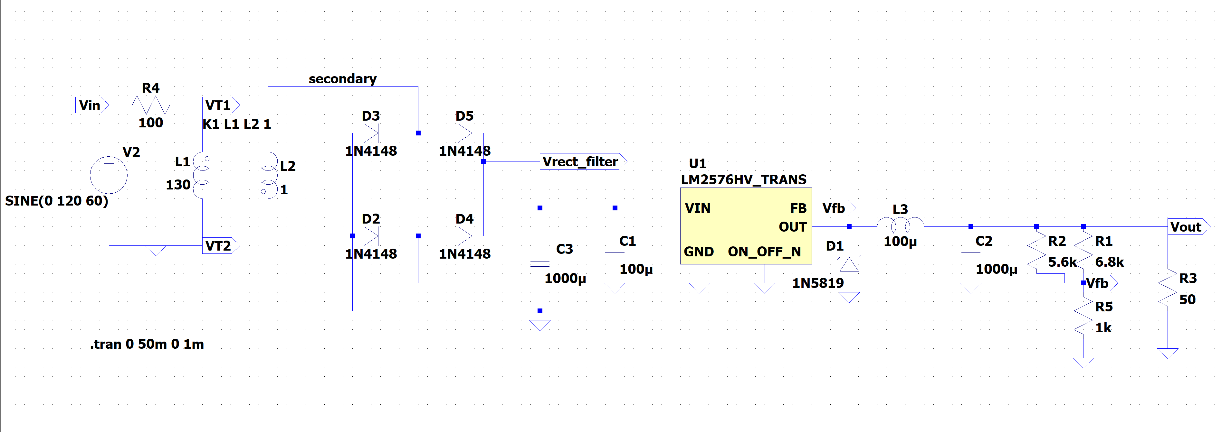
Figure 2: Switching Voltage Regulator Schematic

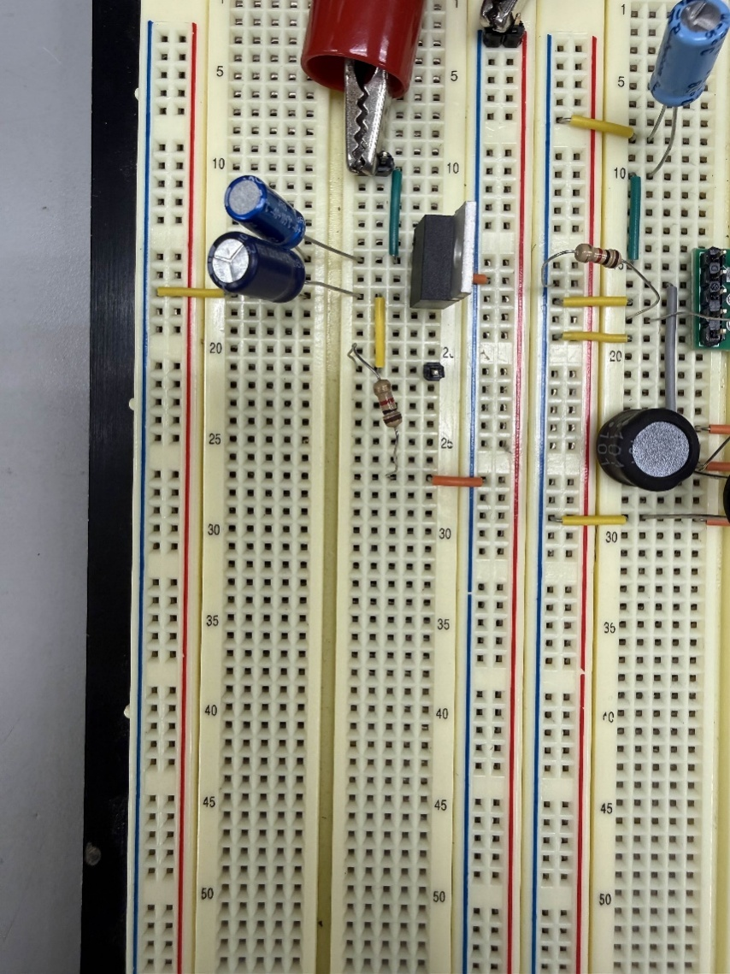
Figure 3: Low-Dropout Regulator Circuit on Breadboard

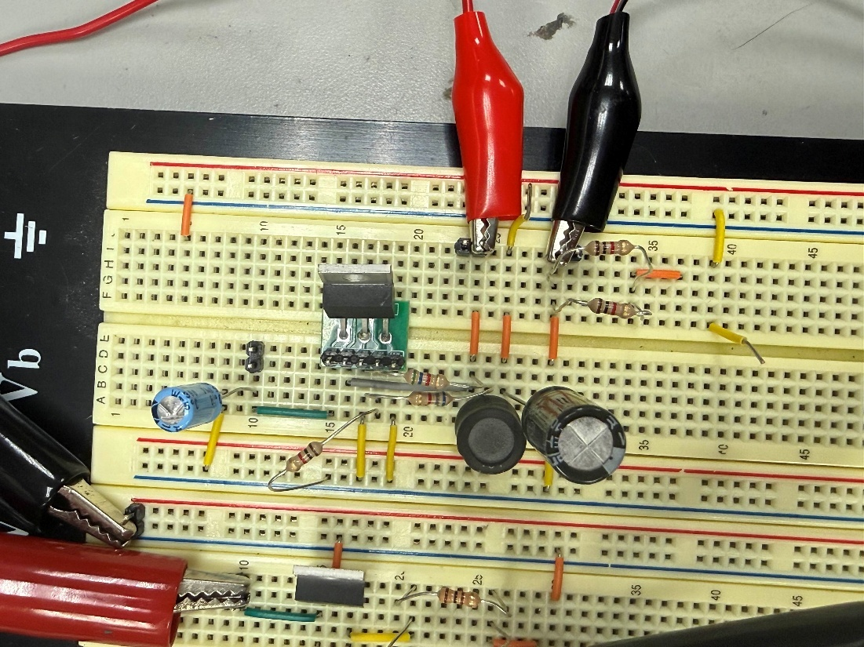
Figure 4: Switching Regulator Circuit on Breadboard
Results
LTSpice Readings:

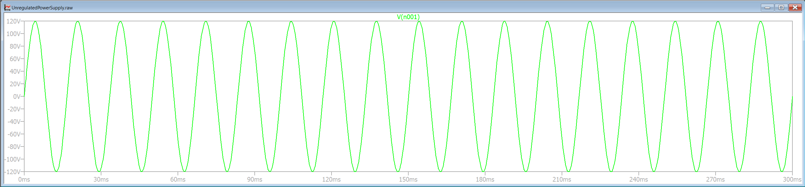
Figure 5: Input Voltage of Unregulated Voltage Circuit

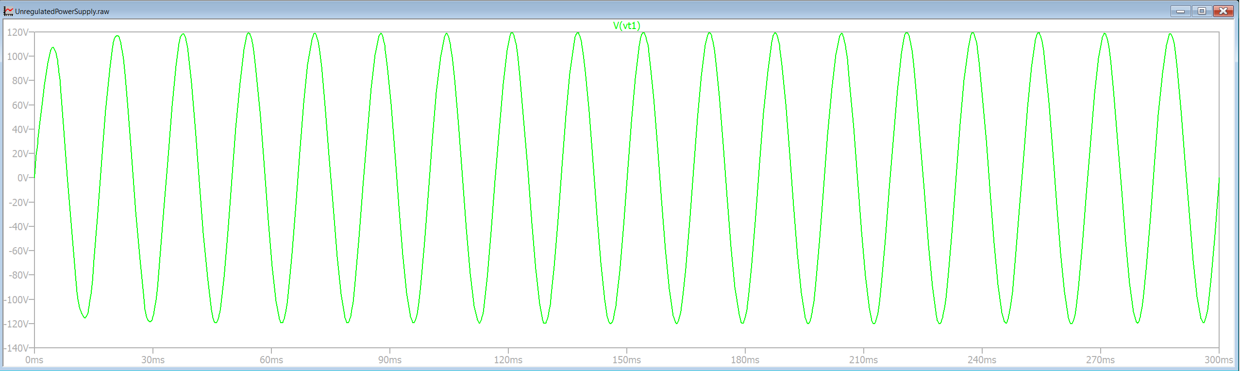
Figure 6: Simulation Output of Transformer Primary Stage

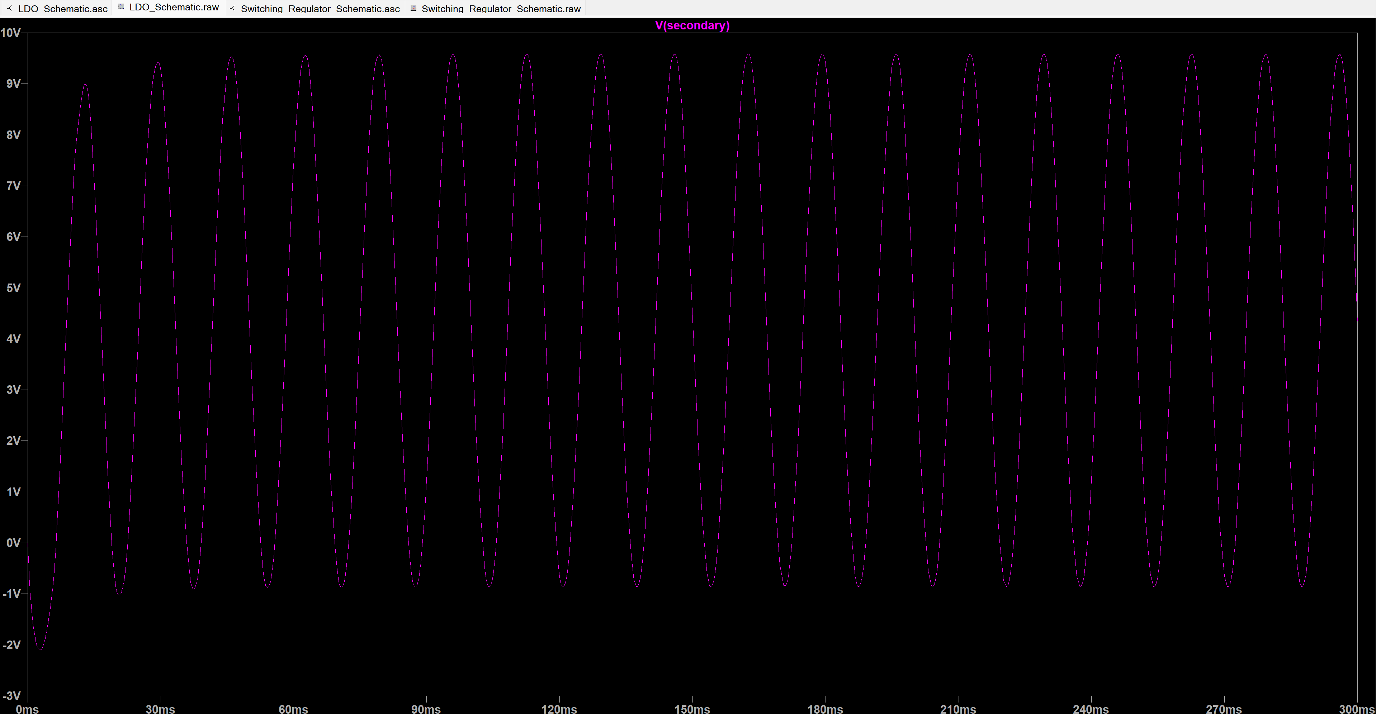
Figure 7: Simulation Output of Transformer Secondary Stage

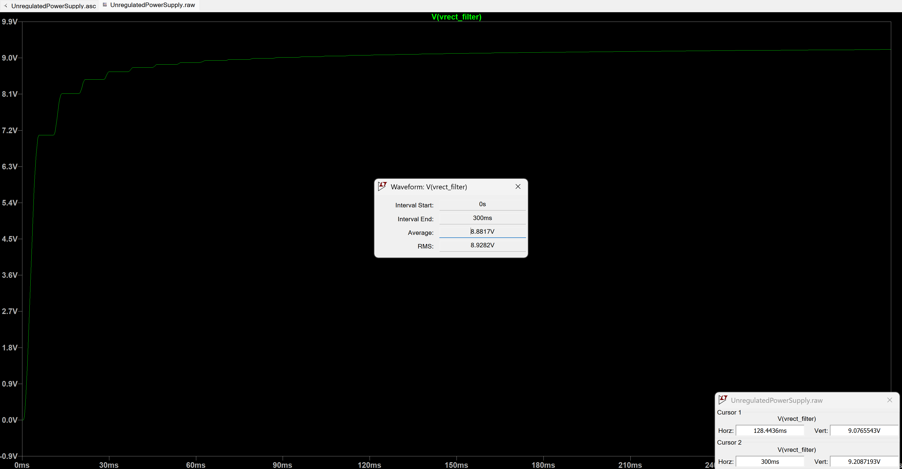
Figure 8: Unregulated Voltage Simulation Output (Rectifier and Filtering Stage)

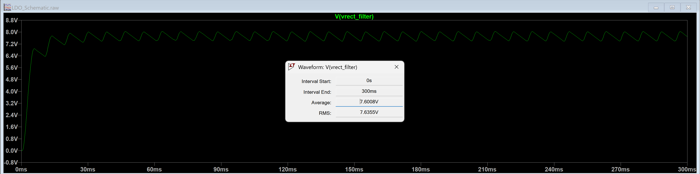
Figure 9: LDO Input Voltage for 100mA Output (Simulation)

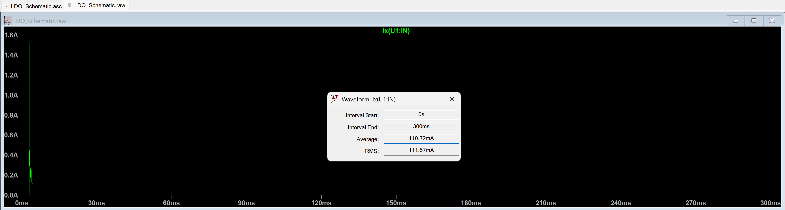
Figure 10: LDO Input Current for 100mA Output (Simulation)

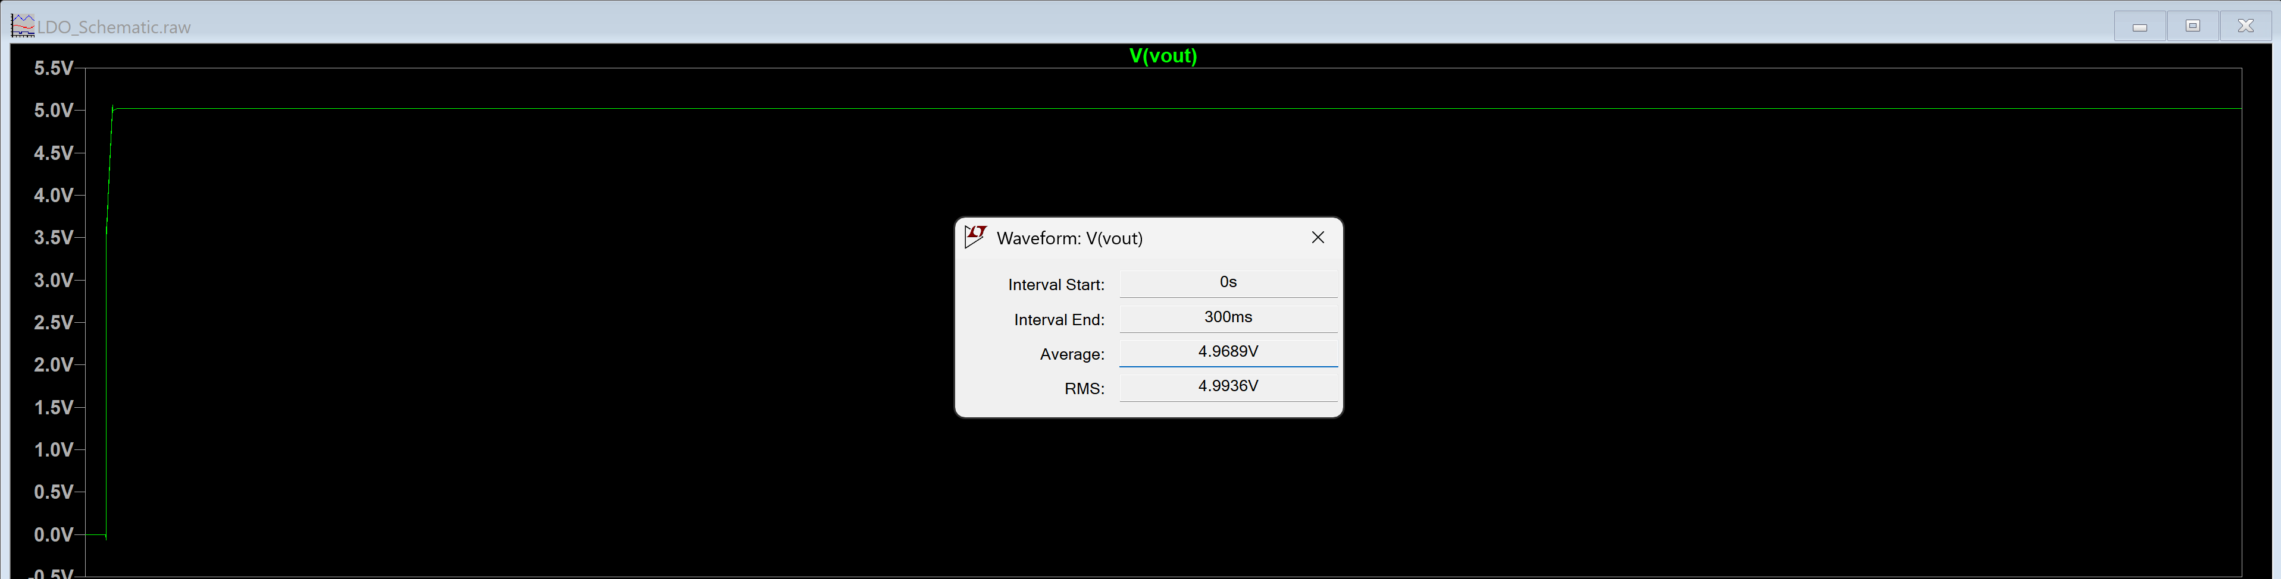
Figure 11: Regulated Voltage Output (LDO Output) of 100mA Output (Simulation)

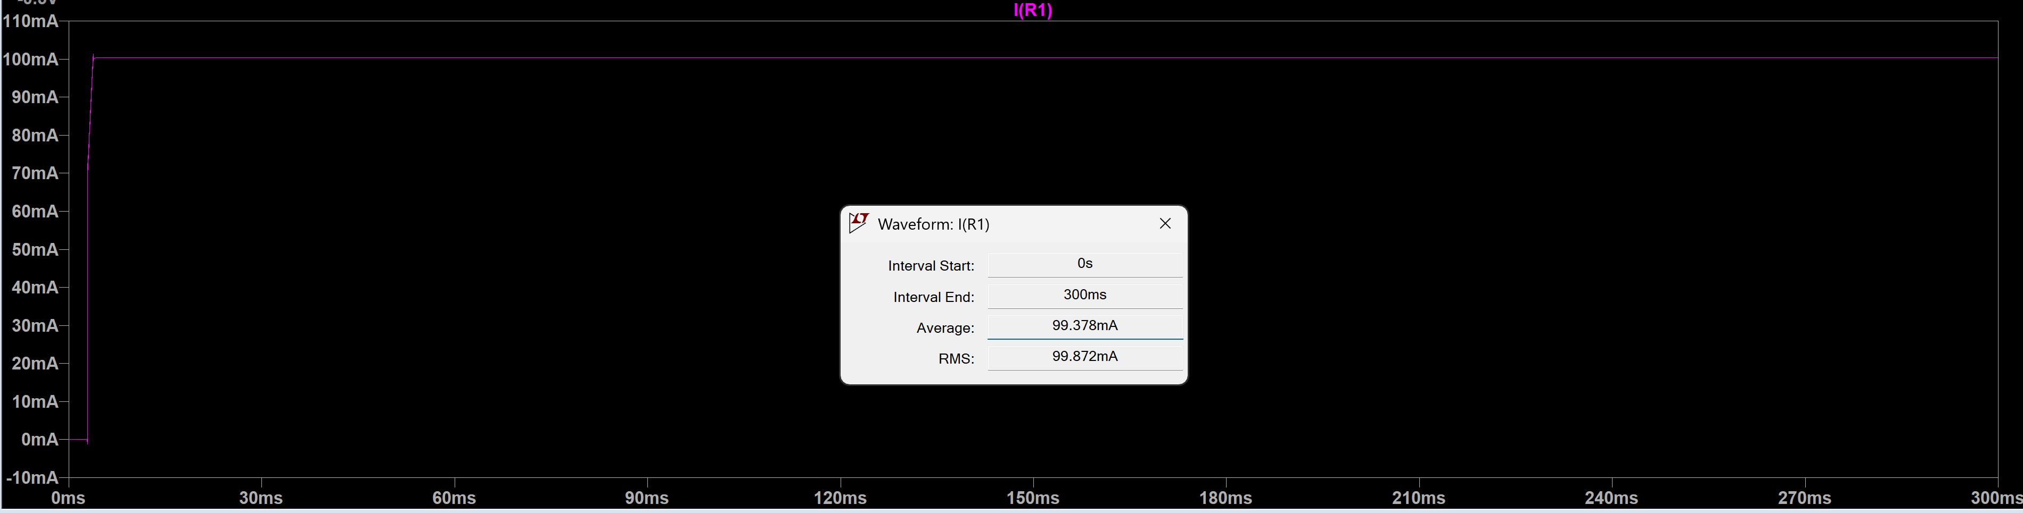
Figure 12: Regulated Current Output for 100mA (Simulation)

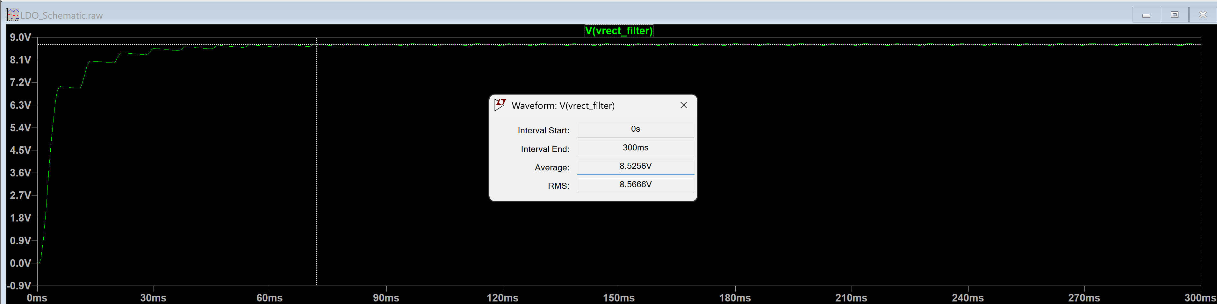
Figure 13: LDO Input Voltage for 5mA Output (Simulation)

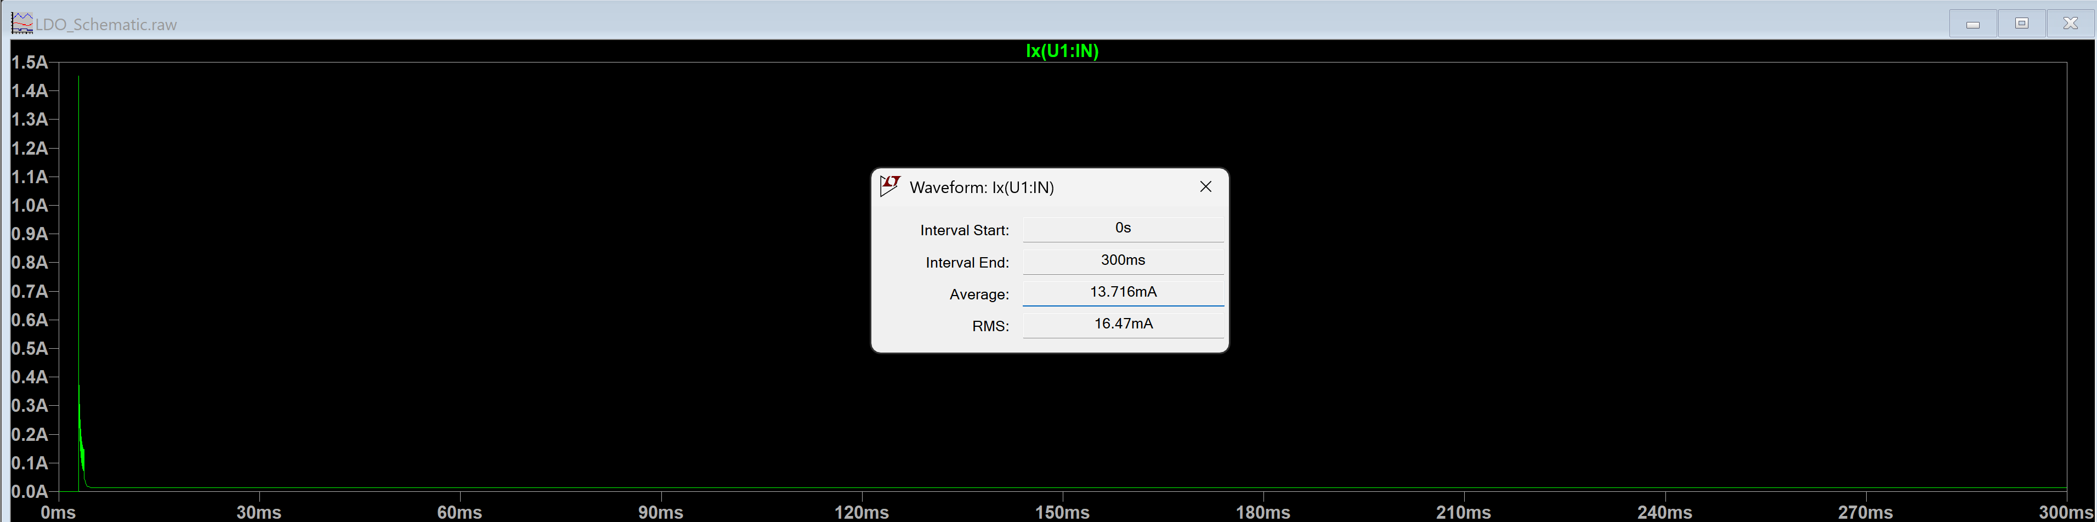
Figure 14: LDO Input Current for 5mA Output (Simulation)

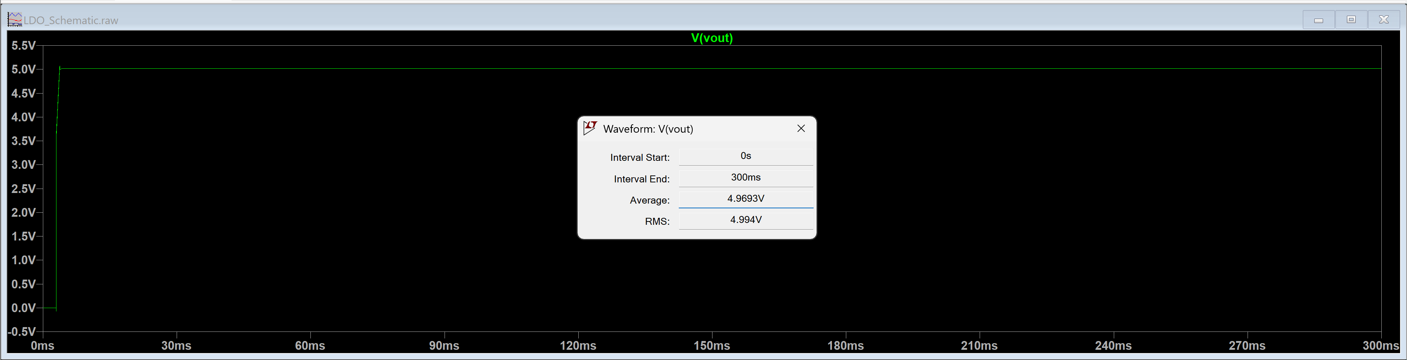
Figure 15: Regulated Output Voltage (LDO Output) of 5mA Output

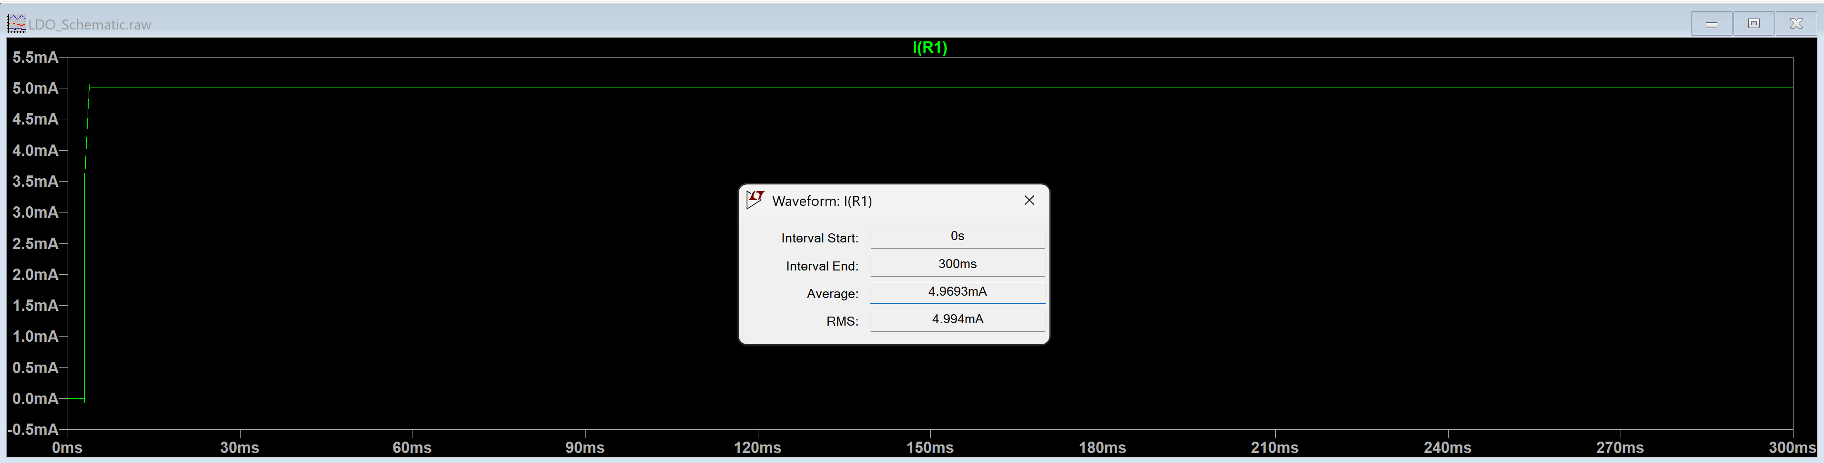
Figure 16: Regulated Current Output for 5mA (Simulation)

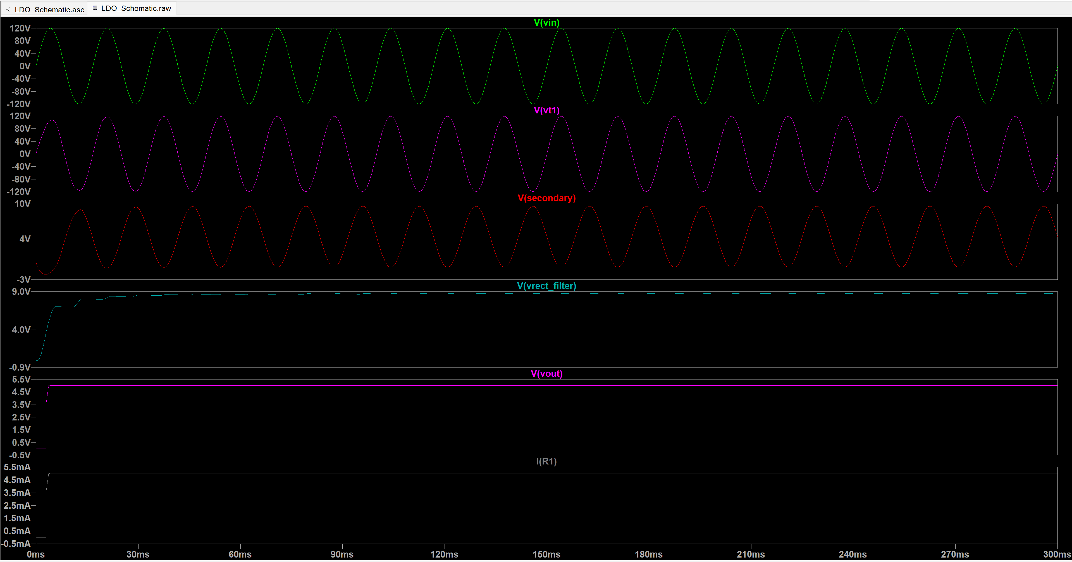
Figure 17: All Readings in the Same Plot for the LDO

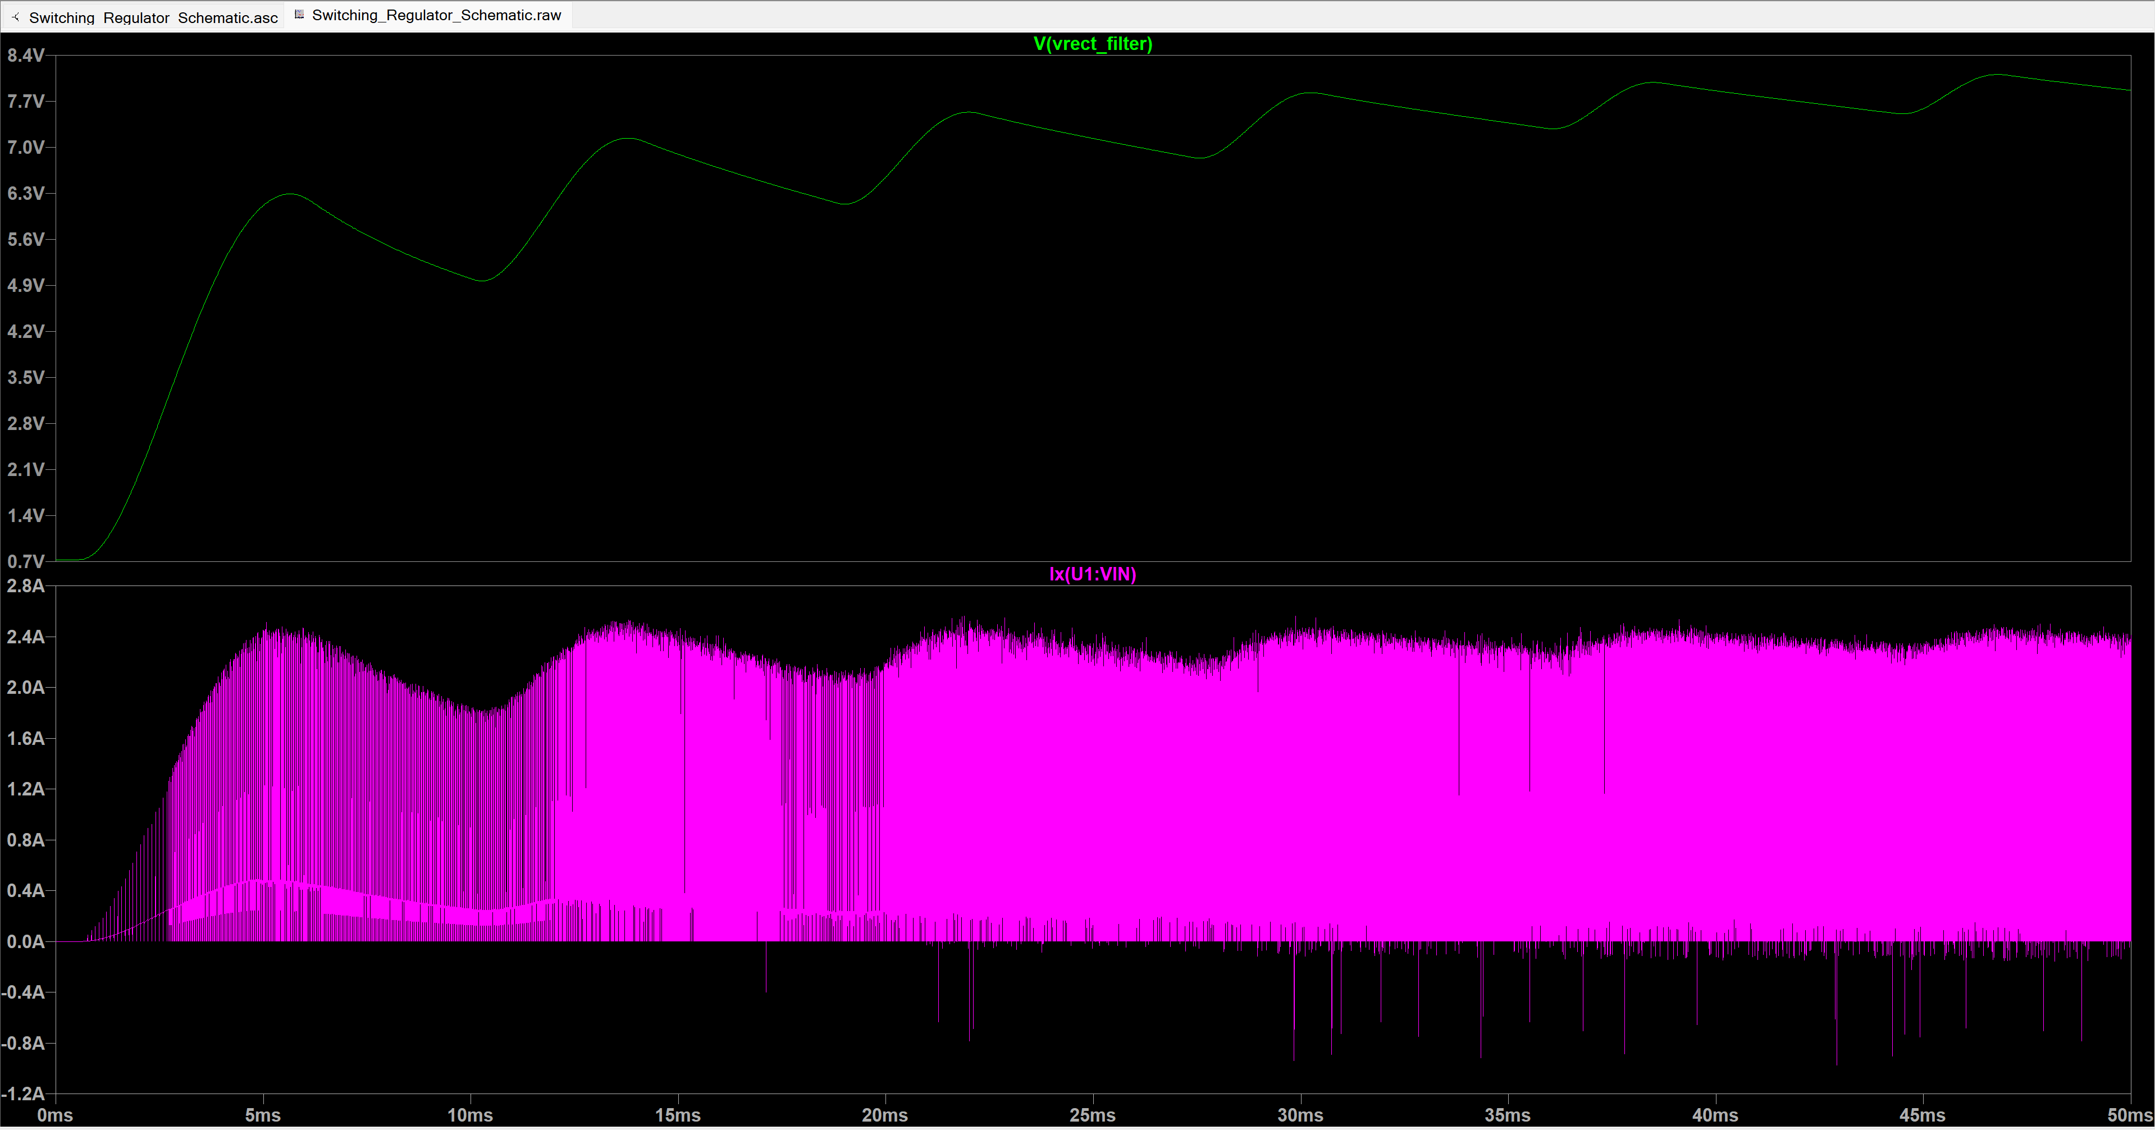
Figure 18: Switching Regulator Input Current and Input Voltage Plots for I = 100mA

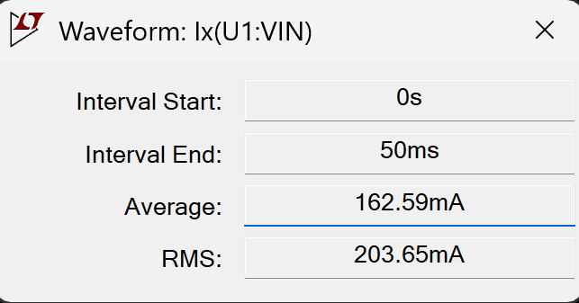
Figure 19: Image of Current Input for Switching Regulator (Simulation)

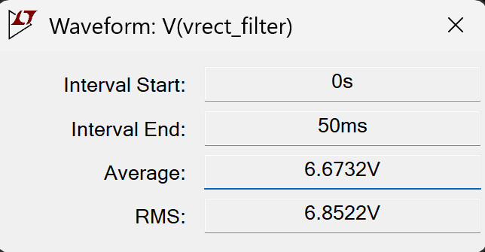
Figure 20: Image of Voltage Input for Switching Regulator (Simulation)

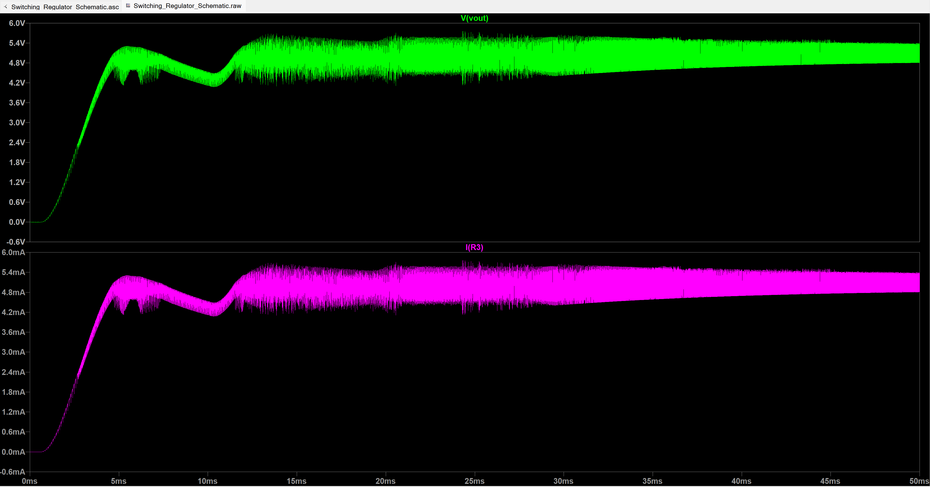
Figure 21: Switching Regulator Output Current and Output Voltage Plots for I = 100mA

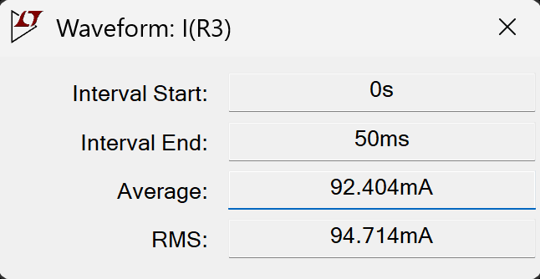
Figure 22: Image of Current Output for Switching Regulator (Simulation)

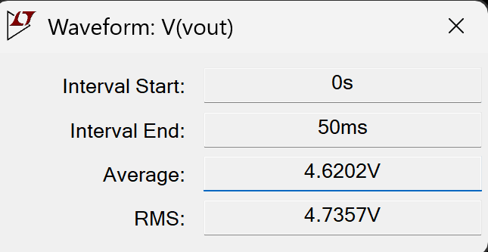
Figure 23: Image of Voltage Output for Switching Regulator (Simulation)

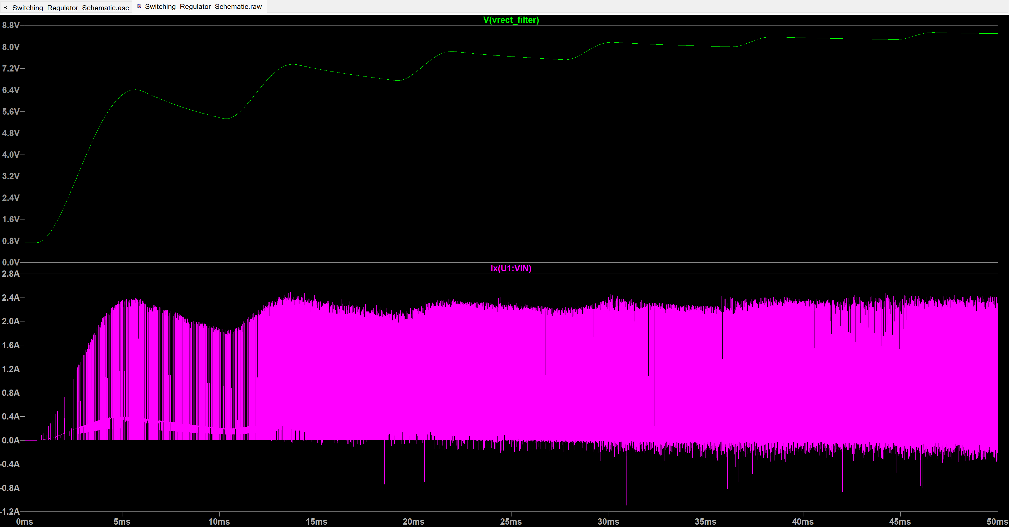
Figure 24: Switching Regulator Input Current and Input Voltage Plots for I = 5mA

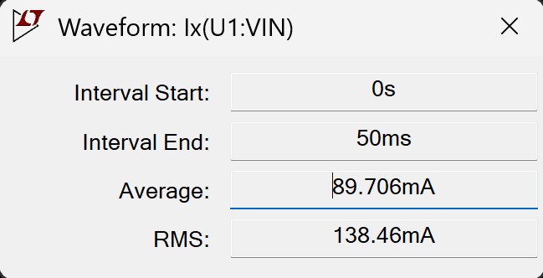
Figure 25: Image of Current Input for Switching Regulator
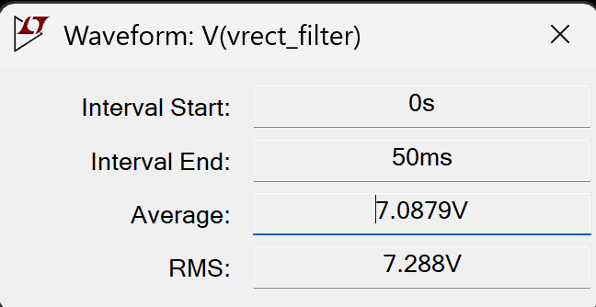
Figure 26: Image of Voltage Input for Switching Regulator

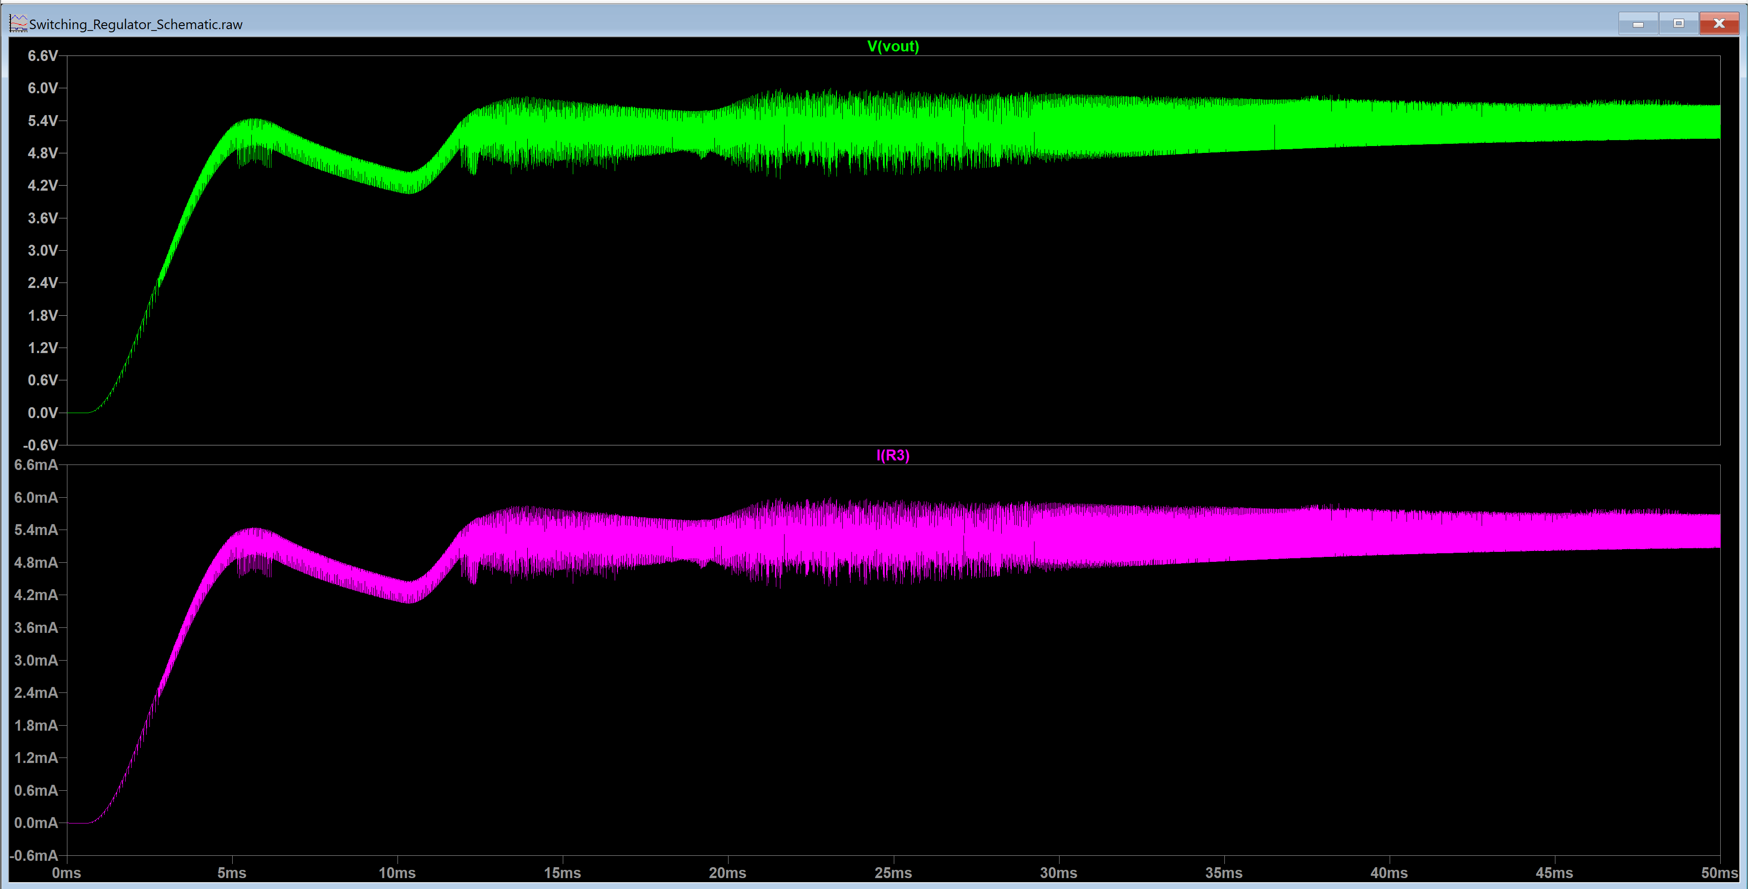
Figure 27: Switching Regulator Output Current and Output Voltage Plots for I = 5mA

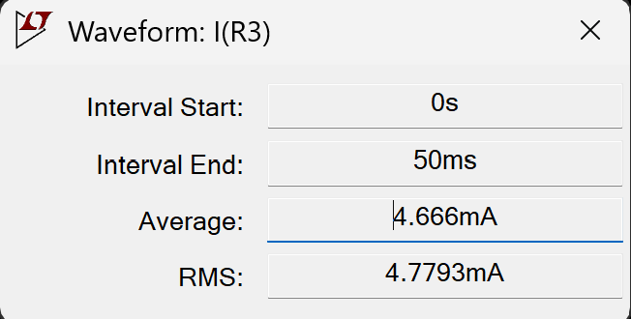
Figure 28: Image of Current Output for Switching Regulator

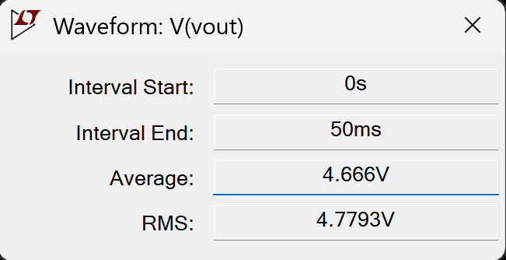
Figure 29: Image of Voltage Output for Switching Regulator

Breadboard Measurements: Voltage Measurements require DC Coupling Mode

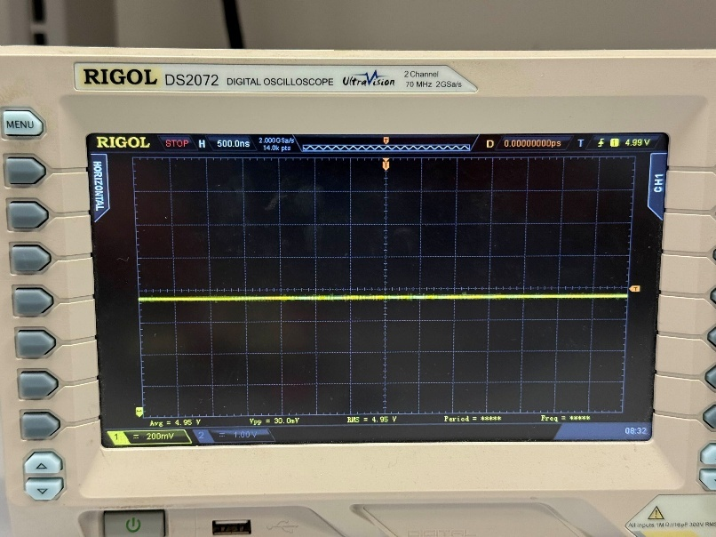
Figure 30: LDO Voltage Reading for 5V and 5mA Output

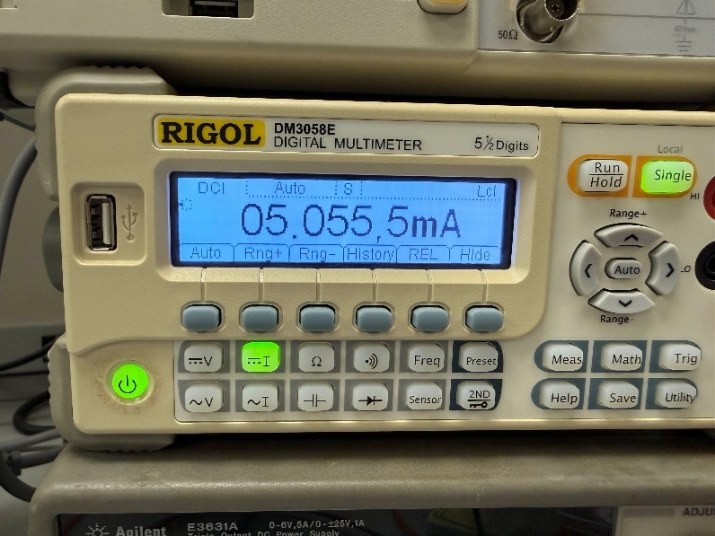
Figure 31: LDO Current Reading for 5V and 5mA Output

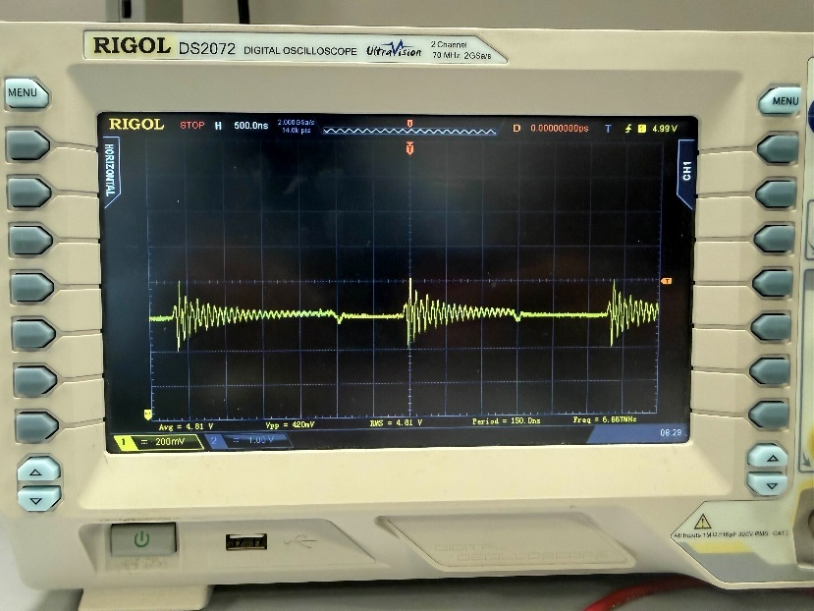
Figure 32: Switching Regulator Voltage Reading for 5V and 5mA Output

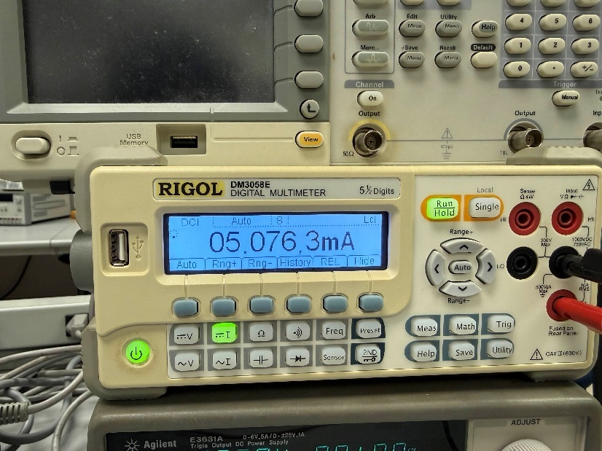
Figure 33: Switching Regulator Current Reading for 5V and 5mA Output

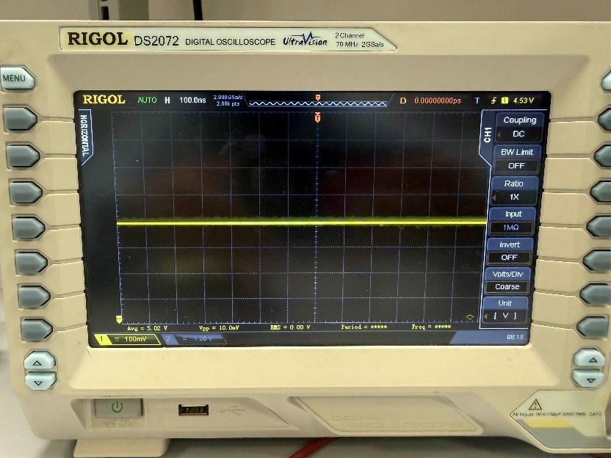
Figure 34: LDO Voltage Reading for 5V and 100mA Output

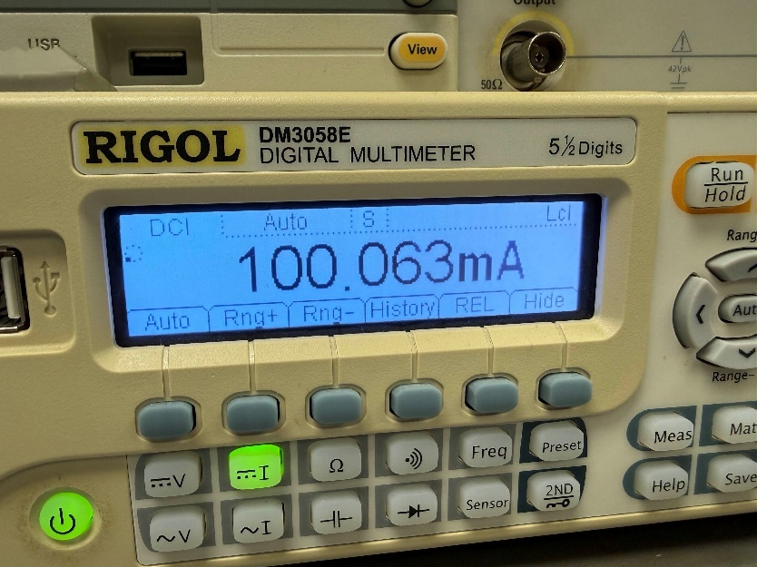
Figure 35: LDO Current Reading for 5V and 100mA Output

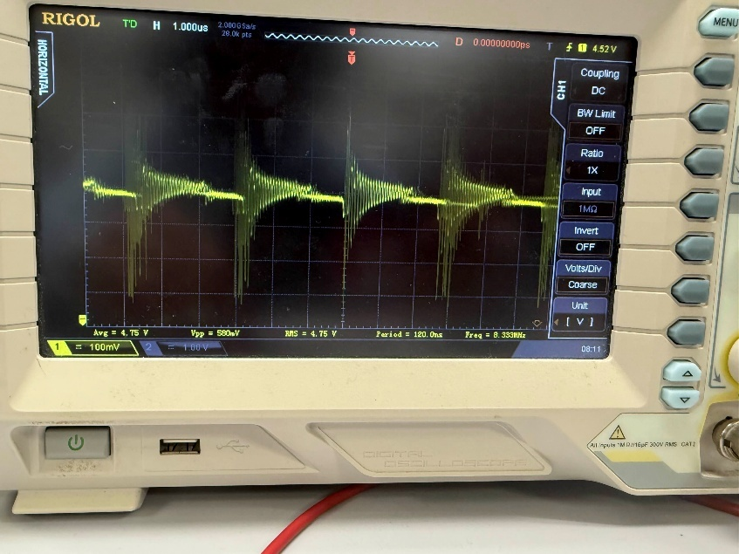
Figure 36: Switching Regulator Voltage Reading for 5V and 100mA Output

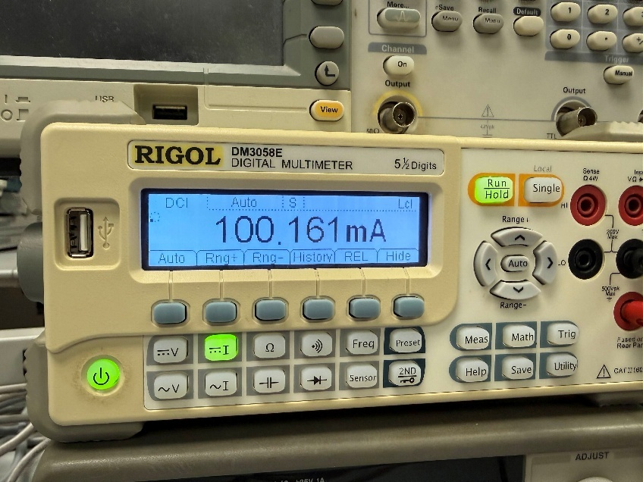
Figure 37: Switching Regulator Current Reading for 5V and 100mA Output

Noise Data: Requires AC Coupling Mode
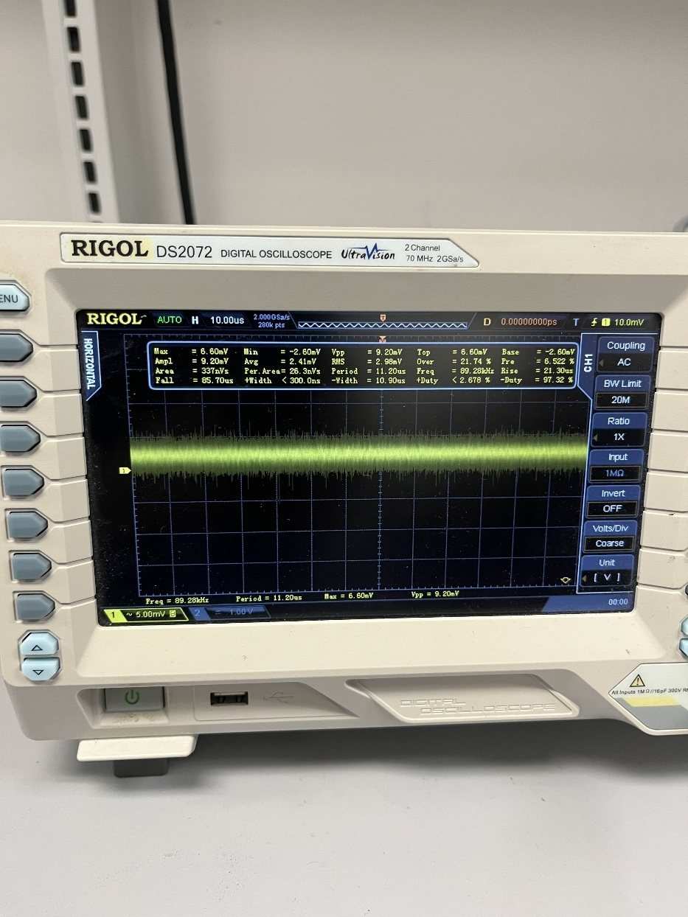
Figure 38: LDO 5V and 5mA

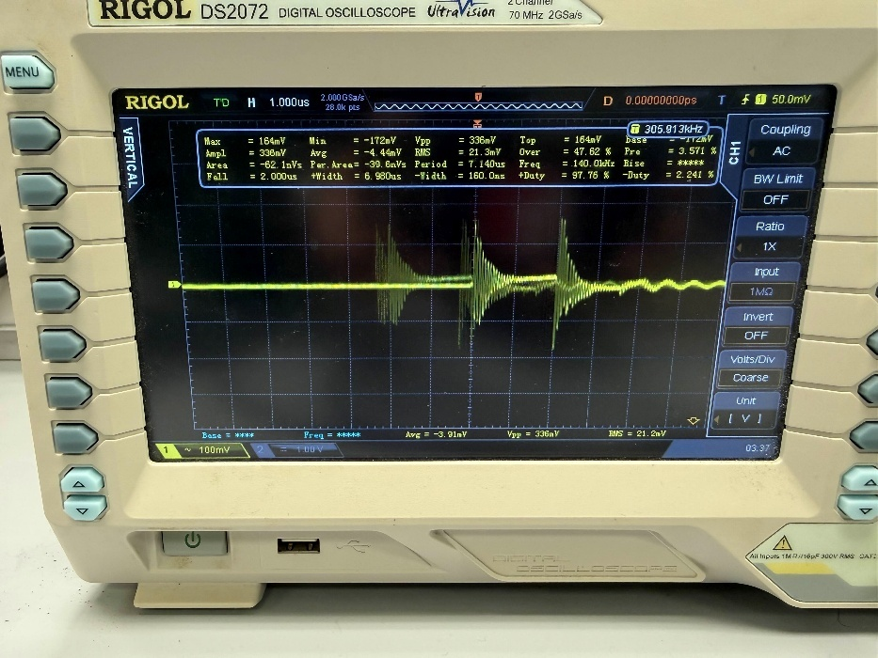
Figure 39: Switching 5V and 5mA

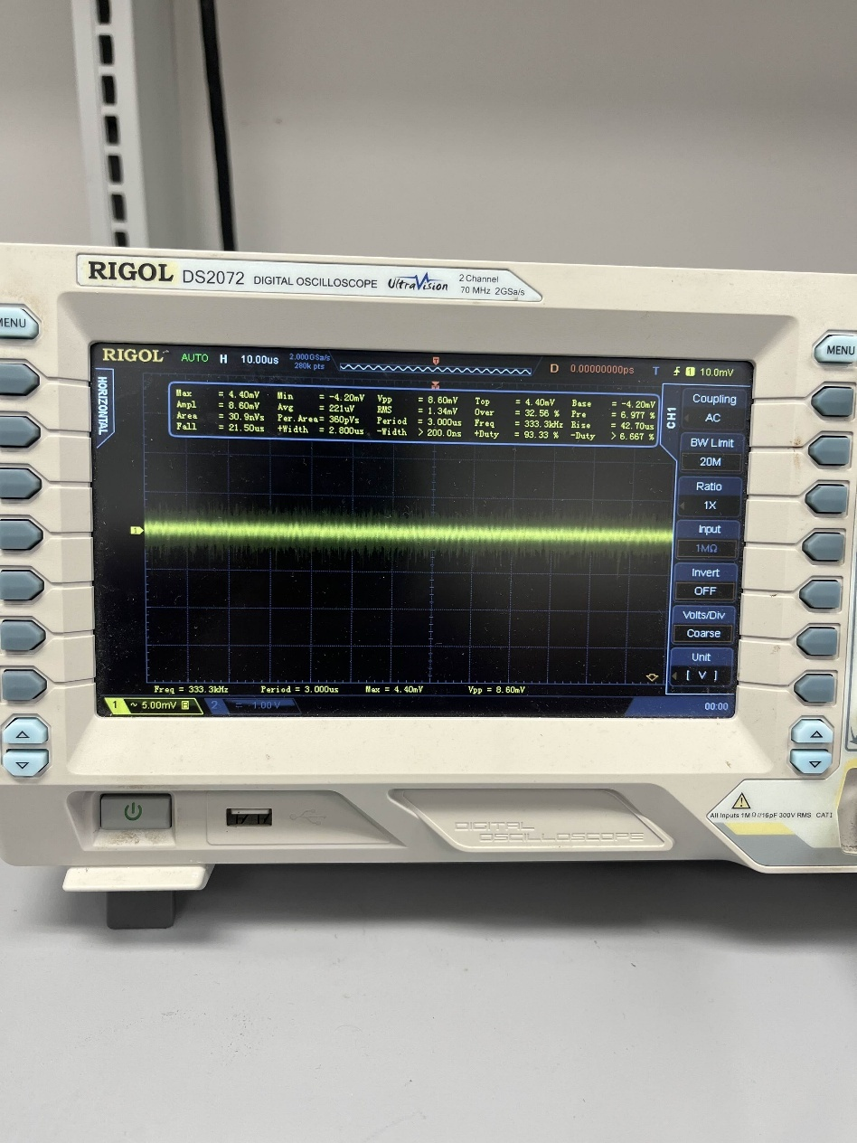
Figure 40: LDO 5V and 100mA

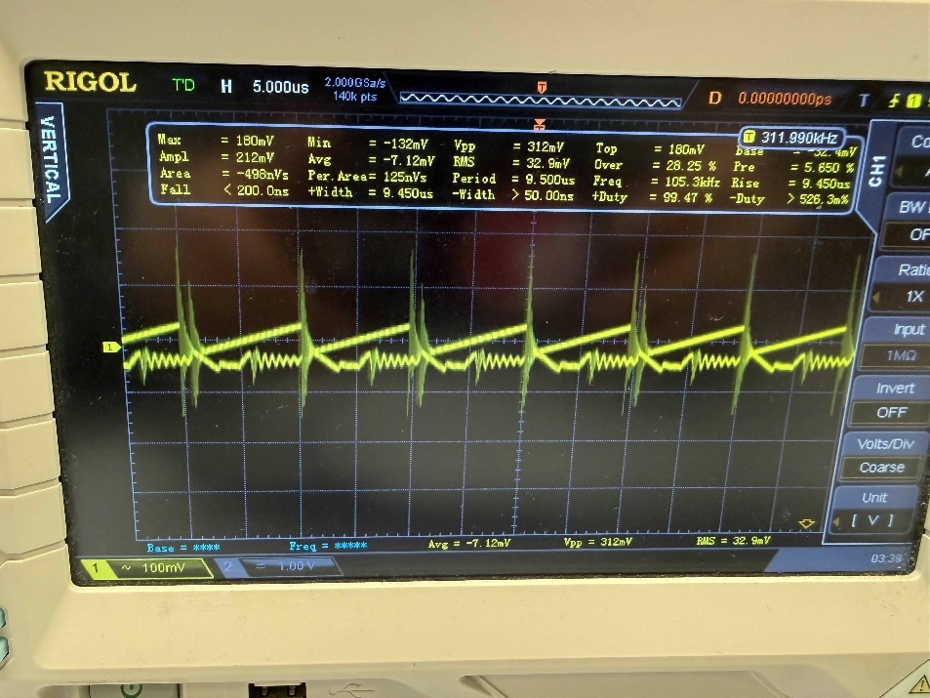
Figure 41: Switching Regulator 5V and 100mA

Measurement Analysis:

X = cannot be measured

LDO Regulator (LTSpice)
 | Input Voltage (V_{rms} as V) | Input Current (I_{rms} as mA) | Input Power  (P_{in} as W) | Output Voltage (V_{rms} as V) | Output Current  (I_{rms} as mA) | Output Power (P_{out} as W) | Power Efficiency (%) | Peak-to-Peak (V) | RMS Noise
1kΩ | 8.5666 | 16.47 | 0.141 | 4.994 | 4.994 | 0.0249 | 17.66 | X | X
50Ω | 7.6355 | 111.57 | 0.852 | 4.9936 | 99.872 | 0.448 | 49.87 | X | X

Switching Regulator (LTSpice)
 | Input Voltage (V_{rms} as V) | Input Current (I_{rms} as mA) | Input Power  (P_{in} as W) | Output Voltage (V_{rms} as V) | Output Current  (I_{rms} as mA) | Output Power (P_{out} as W) | Power Efficiency (%) | Peak-to-Peak (V) | RMS Noise
1kΩ | 7.288 | 138.46 | 1.009 | 4.779 | 4.779 | 0.0228 | 2.26 | X | X
50Ω | 6.8522 | 203.65 | 1.395 | 4.736 | 94.714 | 0.449. | 32.2 | X | X

LDO Regulator (Breadboard)
 | Input Voltage (V_{rms} as V) | Input Current (I_{rms} as mA) | Input Power  (P_{in} as W) | Output Voltage (V_{rms} as V) | Output Current  (I_{rms} as mA) | Output Power (P_{out} as W) | Power Efficiency (%) | Peak-to-Peak (mV) | RMS Noise  (mV)
1kΩ | 9.00 | 10.0 | 0.09 | 4.95 | 5.0555 | 0.0250 | 27.78 | 8.60 | 1.34
50Ω | 9.00 | 101.0 | 0.909 | 5.02 | 100.063 | 0.502 | 55.22 | 9.20 | 2.98

Switching Regulator (Breadboard)
 | Input Voltage (V_{rms} as V) | Input Current (I_{rms} as mA) | Input Power  (P_{in} as W) | Output Voltage (V_{rms} as V) | Output Current  (I_{rms} as mA) | Output Power (P_{out} as W) | Power Efficiency (%) | Peak-to-Peak (V) | RMS Noise
1kΩ | 9.00 | 13.0 | 0.117 | 4.81 | 5.0763 | 0.0244 | 20.85 | 312.0 | 32.9
50Ω | 9.00 | 108.0 | 0.972 | 4.75 | 100.161 | 0.476 | 48.97 | 336.0 | 21.3

Summary:
Both regulators met the voltage specifications of the output voltage +/- 5% with the switching regulator with a 50Ω load having exactly 5% error. That was the case with the more overall voltage error. However, the rest of the voltages: 4.81, 4.95, and 5.02 were all well within expectations.
There were issues with the results since the results did not match up with the logic that the LDO would be less efficient than the switching regulator. This could be a result of discrepancies in the multimeter or cable used, component error, or misinterpretation of the RMS result. Nevertheless, the efficiency values match relatively closely between both regulators.
The results did match theoretical expectations for the noise. The LDO should have a less noisy signal than the switching regulator because the LDO does not constantly switch between being on or being off. Moreover, the noise between both the 50Ω and 1kΩ loads for the switching regulator was within a range of 10mV, demonstrating that the regulator is consistent between different loads.

Conclusion
This module was a thorough introduction to the intricacies of power regulation in any project. The purpose of this module was to prove that switching regulators are more efficient than linear regulators. While that may not have been the case for these results, there could have been a myriad of reasons for this difference. Overall, the lab further solidified students’ understanding of laboratory equipment and its usefulness in testing the validity and efficiency of circuits and ICs.

References
[1] “Basics of Low-Dropout (LDO) Regulators,” 2022. Available: https://toshiba.semicon-storage.com/content/dam/toshiba-ss-v3/master/en/semiconductor/knowledge/e-learning/basics-of-low-dropout-ldo-regulators/ldo-basic-e.pdf
[2] “Linear Regulators vs Low Dropout Regulators Key Differences Explained,” Wonderful PCB, May 13, 2025. https://www.wonderfulpcb.com/blog/linear-vs-low-dropout-regulators-differences/ (accessed Feb. 08, 2026).
[3] “LM2940x 1-A Low Dropout Regulator,” Texas Instruments, Dec. 2014.
[4] E. Patrick, “Power Supply Module Lecture,” Ufl.edu, 2025. https://mediasite.video.ufl.edu/Mediasite/Play/85bf5124d3984b26bcd50254a046142b1d (accessed Sep. 14, 2025).
[5] Analog Devices, Inc, “Selecting the Optimum Voltage Reference,” Analog.com, Dec. 29, 2003. https://www.analog.com/en/resources/technical-articles/selecting-the-optimum-voltage-reference.html
[6] “Gemini,” Gemini, 2024. https://gemini.google.com/app/7aed0d6d3587910b (accessed Feb. 08, 2026).

