Sreeraaghav Raja
2/18/26
40990068

EE Design 1 Technical Report
Microcontroller ADC & LCD

Introduction
This lab was focused on learning how to use an Analog-to-Digital Convertor (ADC) to properly read analog values from a resistor ladder and print them out to a Liquid Crystal Display (LCD). However, we could not use any communication program to directly connect to the LCD, so we had to emulate our own communication protocol through a unique method. Moreover, this method made the resistance values unreliable, so we had to change the design until the output resistance values met the specifications.
Methods

Background Information:
The Analog-to-Digital Convertor (ADC)
The key to analyzing the ADC is to first understand why we require them. The most fundamental issue with any embedded device is that it struggles to read continuous values. The main challenge with digital devices is that they struggle to discretize continuous signals and the ADC is a fundamental asset in smoothing out this process.
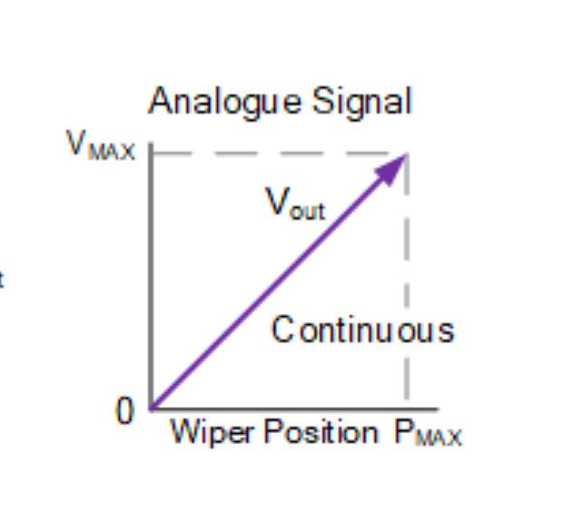
Figure 1: Potentiometer Circuit Vout Reading
Figure 1 is an example of the change in the voltage reading at the output node of a potentiometer [1]. The reading has no breaks in between any of the wiper positions. It is difficult to utilize any number of bits to perfectly match an analog value, so ADCs often have a resolution that is based on the number of bits that it can utilize. For instance, a 12-bit ADC will have a resolution of 2¹² - 1 = 4095, so the numbers it can read can range from 0 to 4095, unless they are normalized. Moreover, the resolution of the ADC corresponds to the number of steps that an ADC has between its entire range [1].
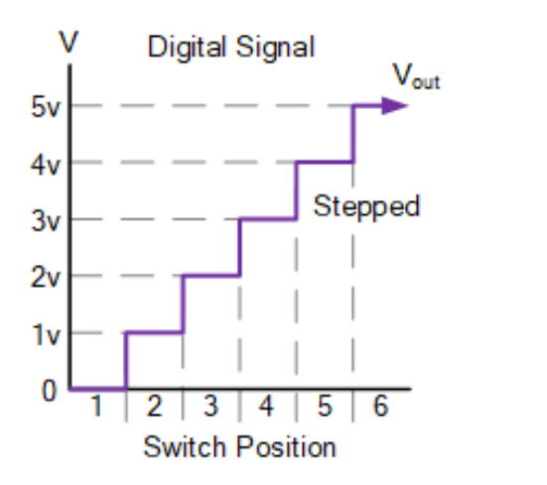
Figure 2 demonstrates the “same” functionality as the original potentiometer circuit but with a rotary switch. A rotary switch operates as complex switch that has multiple position besides the binary “On” and “Off” positions of a regular switch [2]. Figure 2 differs from Figure 1 based on the different readings for the same range of outputs. The only way to digitally replicate the analog wiper position is to have each rotary switch position act as bin, a range of values, for a certain amount of wiper positions. Therefore, Vout becomes discretized into 6 distinct voltages instead of a complete range of continuous values.
Figure 2: Rotary Switch Circuit Vout Reading

However, the issue of accuracy is trivial if we take the resolution into consideration. Accuracy is equivalent to span / resolution. Span is the range of voltage values that we are digitizing [3]. Therefore, a smaller span and larger resolution will result in greater accuracy. For instance, a 5V signal with a 5-bit ADC will have a span of 5V, a resolution of 32, and an accuracy of 156.25mV; the calculation is demonstrated by the following equation:

$$Accuracy=\frac{Span}{Resolution}=\frac{5}{32}=0.15625$$

The Liquid Crystal Display (LCD)
The LCD was the second component that I was unfamiliar with for this lab. It is a device that shows outputs on a display. An LCD works through the geometry and physics of its internal components. At its most fundamental level, an LCD is comprised of a pair of polarizing light filters that and electrodes that sandwich a layer of liquid crystal molecules. The liquid crystals change their orientation if electricity is applied, offering greater control over the display [4].

In this lab, the main way that Pico communicates with the LCD without a backpack is through Bit-Banging. Bit-Banging is a method where a device can imitate a communication protocol like UART, I2C, or SPI using pins without using the dedicated hardware for that communication protocol [5]. In this lab, we are imitating a Parallel 4-Bit Protocol with the LCD.py library that I used. However, it is often easier to communicate with LCDs using the Serial-Peripheral Interface Protocol (SPI) because it is faster than both I2C and UART, so the display can refresh faster. However, this was not an option for this lab.

Design Steps:

The most common methodology that I use for most labs that involve hardware is to design the circuit before writing any software. So, I laid out the circuit, mapped Pico’s pins to the LCD, and designed the resistor ladder before I wrote any code for the program. Therefore, I’ll go over each design decision listed below:

- Why a 33kΩ resistor as R1?
- Why 2 Capacitors?

I decided on the 33kΩ resistor because it was the most effective at keeping the resistance readings close to the expected values even if they were not within the specified error range. Initially, I used a 10kΩ resistor, but that proved to be more error prone in the higher ranges. This is a result of the voltage drop across the 10kΩ test resistor being much smaller than the drop across the larger resistor values when compared to the 33kΩ resistor which would reduce this effect by a factor of 3.3.

The next decision that I made was to add 2 capacitors to reduce noise on both the ADC and the output voltage reading. Capacitors are multi-faceted circuit components that have 2 primary uses: filtering and charge storage. The ADC on the Pico 2 has an internal resistor that draws current thereby reducing the voltage reading on the ADC by approximately 30mV [6]. I used a 0.1µF capacitor at the ADC0 input terminal to offset this internal current. This has the additional effect of reducing any high-frequency noise at that terminal as well. Moreover, I used this same principle in adding the 560pF capacitor at the Vout terminal of the circuit, where we read the output voltage and convert that to a measured resistance value. This capacitor’s primary purpose was to filter the noise on the output terminal and, to a lesser extent, reduce the effects that ADC’s internal current draw.

Figure 3 shows the basic circuit structure that I decided on for this lab. I added the potentiometer as an additional piece because it controls the contrast on the LCD. Based on the earlier physics explanation of the LCD, the potentiometer effectively controls the angle that the internal liquid crystals are aligned based on the applied voltage at the Vo terminal of the LCD.

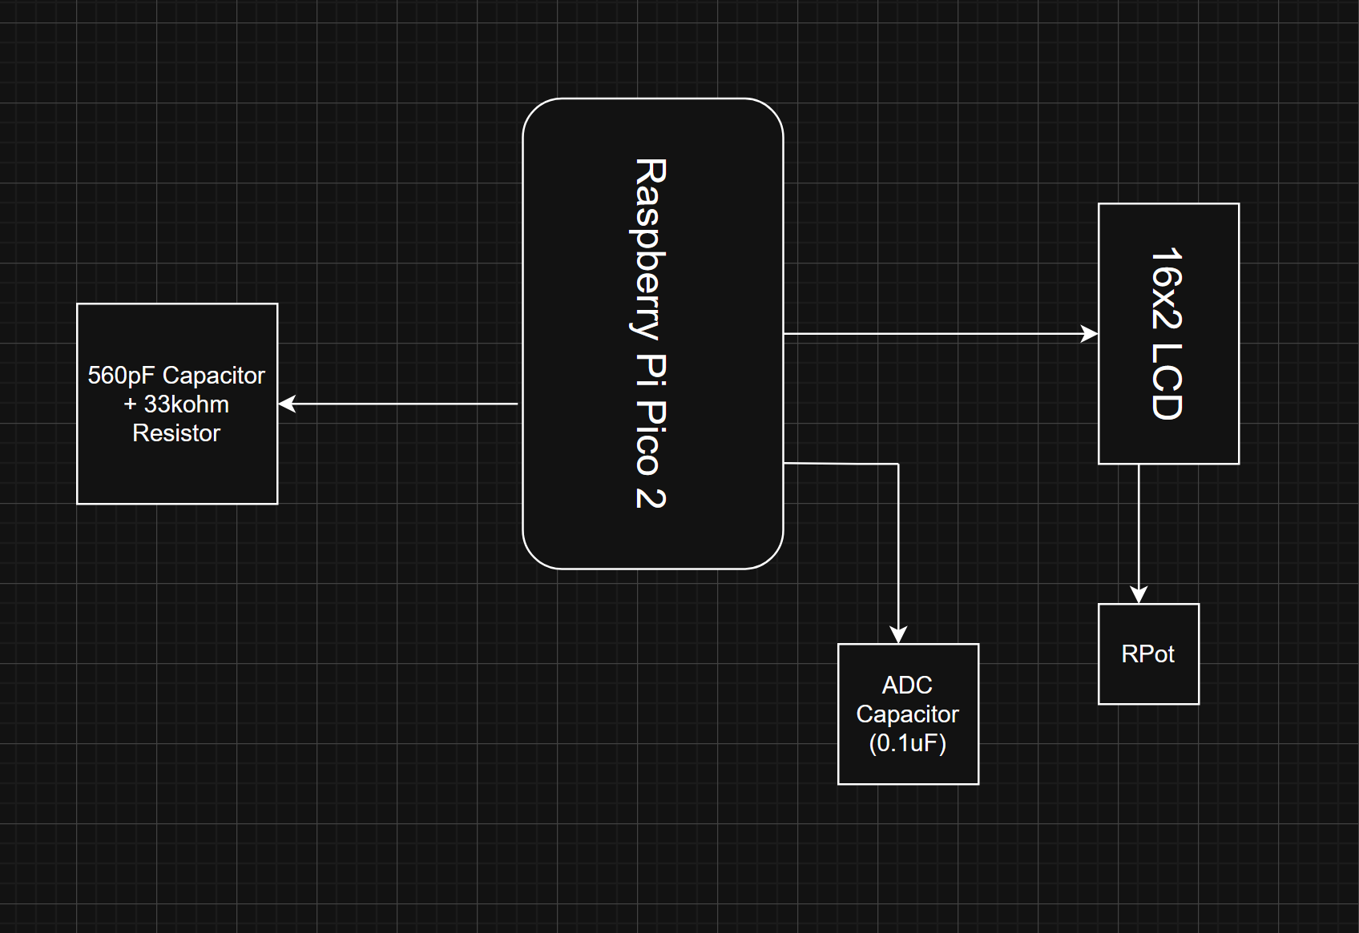
Figure 3: Hardware Block Diagram

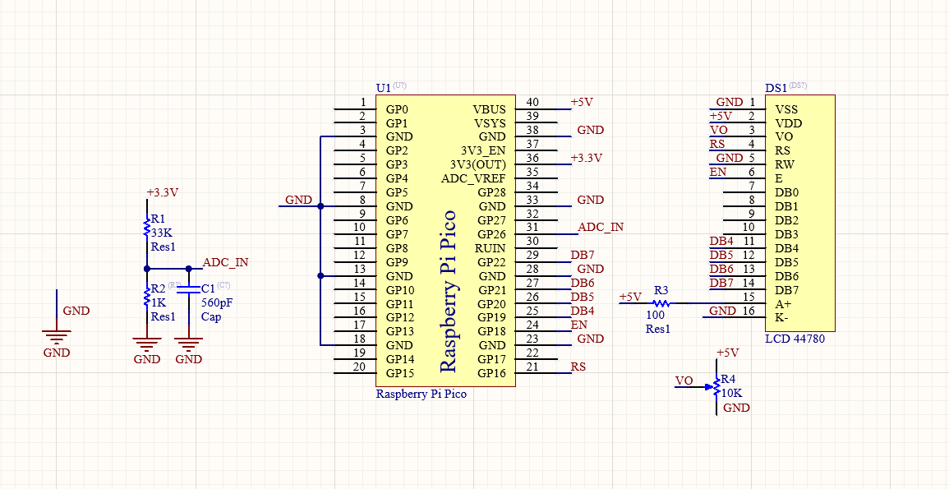
Figure 4: Altium Schematic

The next step of this process was deciding the logic behind the software. While I will not go through every line of my code block, I will go through the most vital ideas. Every embedded program needs to initialize the devices that it uses, so the LCD and ADC were initialized. Then, Pico reads the value from the resistor ladder and converts that to an ADC output. If that value is less than or equal to 0, then it is an error, so the Pico sets the measured resistance value, r2, to 10MΩ. Otherwise, r2 is calculated using the equation below:
$$R2=\frac{R1*Vo}{Vref-Vo}$$
- R1 is the test resistance value which is approximately 33kΩ
- Vo is the measured voltage value at the node between R1 and R2
- Vref is ADC’s reference voltage which is 3.3V

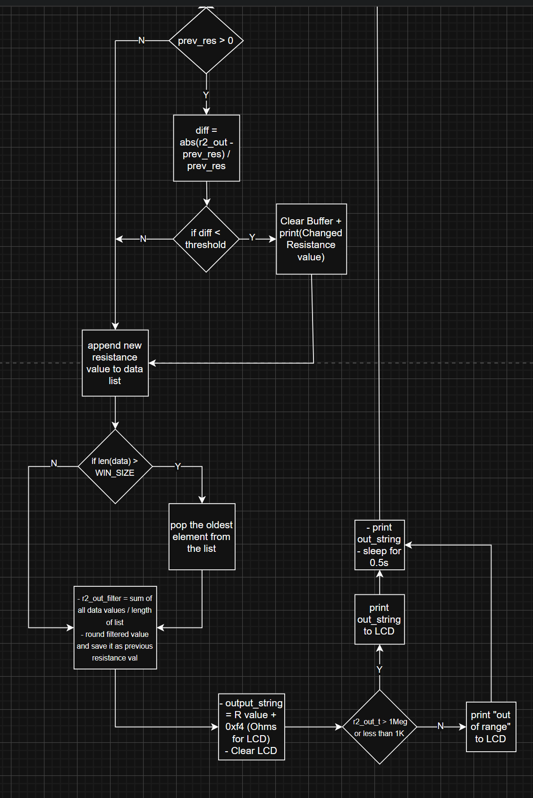
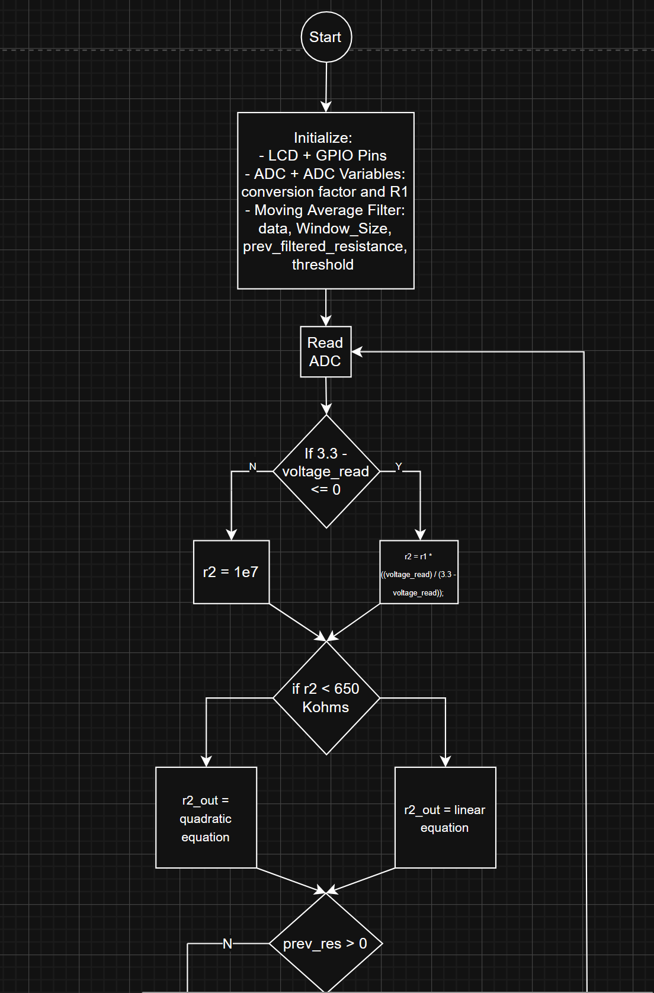
Then, I try to fit the resistance to either a linear or quadratic equation based on the converted r2 value. I used an experimentally derived threshold for that conditional so that the data will fit which spec. The effect of this conditional is visible in the table of the expected and measured resistance values.
Figure 5: SW Block 2
Figure 4: SW Block 1

The largest part of my code dealt with the rolling average filter which will be thoroughly explained in the Results section. On a basic level, this section saves the previous resistance value and uses that to determine whether to clear the rolling average buffer. Whether the list is cleared or not, the program appends the most recent resistance value to the data list. If that list is greater than a set size that we are looking at for the filter, then we remove the oldest element from the list. The application of the filter is that we take the average of all the values in the buffer for a specific resistance value and print that to the LCD. The only conditional for that print is that the Pico can only print the resistance value if the value is between 1kΩ and 1MΩ otherwise it prints “Out of Range” to the LCD. The sleep time is 0.5 seconds to account for the rolling average filter too else the program would be too slow. Finally, the program loops back to reading the ADC value again.
Table 1: Expected vs. Measured Resistance Pre-Correction
Expected Resistance Value (Ω) | Measured Resistance Value (Ω) | Difference | Percent Error
1000 | 1072.4046 | -72.4046 | 7.24046
5000 | 5084.26 | -84.26 | 1.6852
10000 | 10125.574 | -125.574 | 1.25574
15000 | 15131.353 | -131.353 | 0.875686667
20000 | 20231.574 | -231.574 | 1.15787
25000 | 25305.732 | -305.732 | 1.222928
30000 | 30422.998 | -422.998 | 1.409993333
35000 | 35573.188 | -573.188 | 1.63768
40000 | 40575.184 | -575.184 | 1.43796
45000 | 45628.72 | -628.72 | 1.397155556
50000 | 50744.524 | -744.524 | 1.489048
55000 | 55245.784 | -245.784 | 0.44688
60000 | 61131 | -1131 | 1.885
65000 | 66246.71 | -1246.71 | 1.918015385
70000 | 71544.57 | -1544.57 | 2.206528571
75000 | 76550.32 | -1550.32 | 2.067093333
80000 | 81663.06 | -1663.06 | 2.078825
85000 | 86956.14 | -1956.14 | 2.301341176
90000 | 92295.192 | -2295.192 | 2.550213333
95000 | 96996.34 | -1996.34 | 2.101410526
100000 | 103298.768 | -3298.768 | 3.298768
150000 | 156435.94 | -6435.94 | 4.290626667
200000 | 211226.82 | -11226.82 | 5.61341
250000 | 265161.54 | -15161.54 | 6.064616
300000 | 320565.86 | -20565.86 | 6.855286667
350000 | 377508.84 | -27508.84 | 7.859668571
400000 | 435933.33 | -35933.33 | 8.9833325
450000 | 494532.9 | -44532.9 | 9.8962
500000 | 567358.7 | -67358.7 | 13.47174
550000 | 622729.72 | -72729.72 | 13.22358545
600000 | 681708.436 | -81708.436 | 13.61807267
650000 | 738883.9 | -88883.9 | 13.67444615
700000 | 800823 | -100823 | 14.40328571
750000 | 879696.92 | -129696.92 | 17.29292267
800000 | 952975.8 | -152975.8 | 19.121975
850000 | 1030611.04 | -180611.04 | 21.24835765
900000 | 1092654.4 | -192654.4 | 21.40604444
950000 | 1173056.8 | -223056.8 | 23.47966316
1000000 | 1278437.5 | -278437.5 | 27.84375

This table is the expected and measured voltage readings for the circuit I designed before I added the data-fitting equations to the program. I used this table to create data-fitting equations for both a linear and quadratic line. Figure 6 shows both equations based on Table 1, interestingly the quadratic equation first better for all the data values, but it undershoots, demonstrating the effects that the non-idealities have on a circuit.

Figure 6: Measured vs. Expected Scatterplot

Results
While it took a few trials, all my results were within the 5% expected range for the resistances. Table 2 has the same categories as Table 1 but after I applied the rolling average filter. It is important to note that the most inaccurate values are 600kΩ and 650kΩ since that is one of the places where the linear and quadratic fitting equations significantly deviate. Therefore, it was necessary to switch between the linear and quadratic equations.

This is showcased even further with a random resistance value I chose after measuring all the values to demonstrate an accurate measurement. I used a 22kΩ for the LCD to display and it output 21.923924kΩ as the measured value which is within 0.38% of the expected value. However, I mentioned that the rolling average filter was important in my design since the original capacitors were still not giving me values that were nearly this accurate. Therefore, I will explain the theory and code for how I used the rolling average filter below.

Table 2: Expected vs. Measured Resistance Post-Correction
Expected Resistance Value (Ω) | Measured Resistance Value (Ω) | Difference | Percent Error
1000 | 1037.824 | 37.824 | 3.7824
5000 | 4991.454 | -8.546 | 0.17092
10000 | 9911.163 | -88.837 | 0.88837
15000 | 14848.003 | -151.997 | 1.013313333
20000 | 19858.93 | -141.07 | 0.70535
25000 | 24833.174 | -166.826 | 0.667304
30000 | 29727.1 | -272.9 | 0.909666667
35000 | 34747.964 | -252.036 | 0.720102857
40000 | 39653.46 | -346.54 | 0.86635
45000 | 44516.65 | -483.35 | 1.074111111
50000 | 47567.19 | -2432.81 | 4.86562
55000 | 54540.296 | -459.704 | 0.835825455
60000 | 59443.61 | -556.39 | 0.927316667
65000 | 64487.42 | -512.58 | 0.788584615
70000 | 69472.38 | -527.62 | 0.753742857
75000 | 74352.69 | -647.31 | 0.86308
80000 | 79311.26 | -688.74 | 0.860925
85000 | 84313.34 | -686.66 | 0.807835294
90000 | 89192.7 | -807.3 | 0.897
95000 | 94014.31 | -985.69 | 1.037568421
100000 | 99648.3 | -351.7 | 0.3517
150000 | 148860.67 | -1139.33 | 0.759553333
200000 | 197449.16 | -2550.84 | 1.27542
250000 | 246860.968 | -3139.032 | 1.2556128
300000 | 297785.56 | -2214.44 | 0.738146667
350000 | 344581.04 | -5418.96 | 1.548274286
400000 | 389496.5 | -10503.5 | 2.625875
450000 | 438467.96 | -11532.04 | 2.562675556
500000 | 483009.02 | -16990.98 | 3.398196
550000 | 533564.3 | -16435.7 | 2.988309091
600000 | 570338.7 | -29661.3 | 4.94355
650000 | 624234.2 | -25765.8 | 3.963969231
700000 | 677162.6 | -22837.4 | 3.262485714
750000 | 723728.9 | -26271.1 | 3.502813333
800000 | 787149.22 | -12850.78 | 1.6063475
850000 | 848560.7 | -1439.3 | 0.169329412
900000 | 900746.4 | 746.4 | 0.082933333
950000 | 968283.4 | 18283.4 | 1.924568421
1000000 | 1031624.3 | 31624.3 | 3.16243

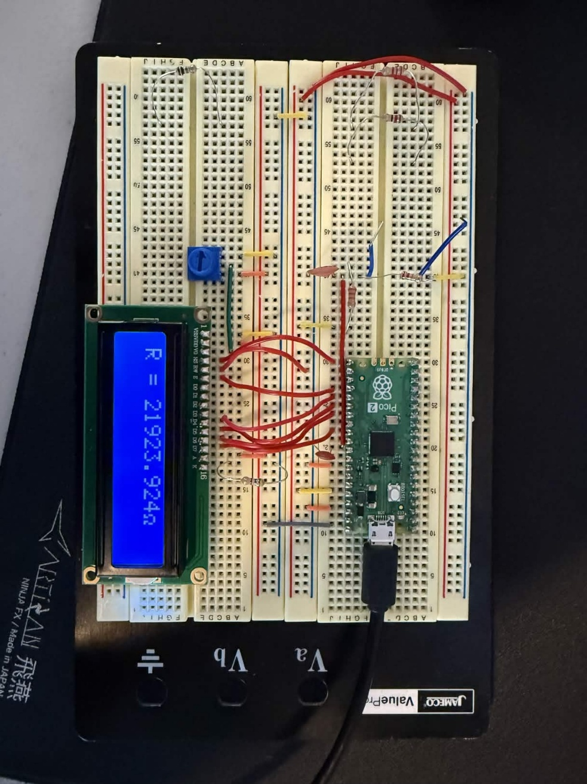
Figure 7: LCD Reading of 220kΩ Resistor

Implementation of the Rolling Average Filter
A rolling average filter is effectively a way to reduce the noise of an input by averaging a certain amount of input values defined by a Window Size and outputting that average. My implementation was not ideal since waiting for the ADC to read a Window Size number of values before outputting a single resistance would have a higher time complexity compared to just outputting the values and averaging them as the ADC collected more data. Therefore, the readings would become the most accurate after 25 seconds since my Window Size was set to 50 and the sleep time was 0.5 seconds. The ADC filled the initial data buffer in 25 seconds.
The most difficult part of my rolling average filter measurement was that I had to set a threshold value so that my input buffer would clear and not take in the previous resistance value into account. For example, if I read 100kΩ and then switched to 10kΩ, the LCD would take the 100kΩ values into account until the data buffer is filled with only readings from the 10kΩ resistor ladder. Therefore, by setting a threshold of 0.05, the Pico could effectively clear the list whenever I made large jumps between resistances. The difference had to be 0.05 because of the increments that I was measuring the data with:

- Jumps of 5kΩ for readings between 1kΩ and 100kΩ
- Jumps of 50kΩ for readings between 100kΩ and 1MΩ

If I measured with different increments, I could have made my threshold higher or lower depending on if I increased or decreased the jump size. Setting the logic to switch between resistances was only useful because of how I tested the different measurements: using a Resistance Decade Box. If I had manually interchanged resistors for the measurement phase it would have taken significantly longer to measure all the resistances, and I would have taken significantly longer to unravel the issue with the switching logic as.
Overall, this was the primary way that I got the desired resistance values for this lab using software. The hardware issues were uncovered early from reading the datasheet for the ADC, but the extra handling of software was much more difficult to solve. The linearization of the equations was another software improvement that I explained in the methodology, but that was more of a necessity rather than something extra that I had to fix with software.
Conclusion
In this lab, I deepened my understanding of communication protocols with Bit-Banging and internalized the importance of ADCs for microcontrollers as they allow microcontrollers to interact with the environment. This lab solidified concepts that were relatively new in earlier courses like Signals and Systems and Circuits II that are pertinent with this lab. This lab provided a way for me to apply the theory that I gleaned from those classes into an interesting project thereby improving my ability to solve issues as an engineer.

Appendix
import machine
import time
import math

from time import sleep
from LCD import LCD

# LCD Instantiation

# GPIO
lcd = LCD(enable_pin=18, # Enable Pin, int
reg_select_pin=16, # Register Select, int
data_pins=[19, 20, 21, 22] # Data Pin numbers for the upper nibble. list[int]
)

lcd.init()
lcd.clear()

# initialize ADC
voltage_adc = machine.ADC(26)
# 16-bits because micropython upscales the 12 bit value by padding the lower 4 bits with 0
conversion_factor = 3.3 / 65535
# resistor 1 value
r1 = 32978
# linearization equation
lin_eq = 8913 * math.exp(2.57) * 10**(-6)

# Rolling Average Filter
data = []
WIN_SIZE = 50
prev_filtered_resistance = 0
THRESHOLD = 0.05

while True:
# read the voltage and convert to adc value
voltage_read = voltage_adc.read_u16() * conversion_factor
# find r2 value

if(3.3 - voltage_read <= 0):
r2 = 1e7
else:
r2 = r1 * ((voltage_read) / (3.3 - voltage_read))

## convert the value using linearized equation (used exponential) for normal values and
if(r2 < 650e3):
r2_out = -16.263 + 0.9866 * (r2) - 2e-7 * (r2)**2
else:
r2_out = 0.821 * r2 + 15.477e3

if prev_filtered_resistance > 0:

diff = abs(r2_out - prev_filtered_resistance) / prev_filtered_resistance

if diff > THRESHOLD:
data.clear()
print("Resistance Changed!")

data.append(r2_out)

if len(data) > WIN_SIZE:
# remove the oldest sample if the length of the array is greater than the window size
data.pop(0)

# take the mean of the data values and the length
r2_out_filter = sum(data) / len(data)
r2_out_t = round(r2_out_filter, 3)
prev_filtered_resistance = r2_out_filter

# output the adc value to LCD display
out_string = "R = " + str(r2_out_t) + chr(0xf4)

# clear before printing
lcd.clear()

if (r2_out_t < 1e3 or r2_out_t > 1e6):
lcd.print("Out of Range")
else:
lcd.print(out_string)

# print out resistance value
print(out_string)

sleep(0.5)
References
[1] Electronics Tutorials, “Analogue to Digital Converter (ADC) Basics,” Basic Electronics Tutorials, Sep. 21, 2020. https://www.electronics-tutorials.ws/combination/analogue-to-digital-converter.html (accessed Feb. 26, 2026).
[2] “A Complete Guide to Rotary Switches,” uk.rs-online.com. https://uk.rs-online.com/web/content/discovery/ideas-and-advice/rotary-switches-guide (accessed Feb. 26, 2026).
[3] E. Patrick, “Microcontroller ADC+LCD Lecture,” Ufl.edu, 2026. https://mediasite.video.ufl.edu/Mediasite/Play/deec4effed574f24a5a6bd53d55f9b401d (accessed Feb. 26, 2026).
[4] Jeff Tyson, “How LCDs Work,” HowStuffWorks, Jul. 17, 2000. https://electronics.howstuffworks.com/lcd.htm (accessed Feb. 26, 2026).
[5] “Bit-Bang | Purdue SIGBots Wiki,” Purduesigbots.com, Jul. 05, 2020. https://wiki.purduesigbots.com/electronics/general/bitbang (accessed Feb. 26, 2026).
[6] “Raspberry Pi Pico 2 Datasheet,” Aug. 2024. Accessed: Feb. 26, 2026. [Online]. Available: https://datasheets.raspberrypi.com/pico/pico-2-datasheet.pdf
[7] “Moving Average Filter - an overview | ScienceDirect Topics,” www.sciencedirect.com. https://www.sciencedirect.com/topics/engineering/moving-average-filter (accessed Feb. 26, 2026).

