Sreeraaghav Raja
3/22/2026

EE Design 1 Technical Report
Analog Filter Design

Introduction
This lab was an introduction to the design of common filters. Filters have a variety of uses in the modern world so learning how to design them is a fundamental skill that all Electrical Engineers should develop. Moreover, this lab was also an introduction to external tools from companies like Analog Devices and Texas Instruments to help speed up the design process.

Methods
Background Information
It would be a travesty if I did not start the background information by first motivating why we need to design filters. When I asked Gemini with the prompt, “Why do we need filters and what are their uses?”, it explained that they are used for audio engineering, telecommunications, power supplies, and data conversion [1]. While these are the most common uses, filters are also used for space travel. Field-Programmable Gate Arrays are also used for space applications, and they have Digital-Signal Processing (DSP) blocks which is a direct application of filters.

Filters are aptly named because they directly specify their purpose. However, there are multiple aspects of filters that we must consider: the passband, the stopband, the -3dB cutoff frequency, and the phase response. Filters are designed to have a range of frequencies where they let signals pass through without reducing/attenuating the signals; this is the passband. The stop band is an ideal region where signals at these frequencies are completely attenuated to 0. However, ideal filters cannot exist, so the stop band becomes a steady reduction that is usually -20dB/dec meaning that for every tenfold increase in the frequency, the gain should decrease by 20db. The -3dB point and the cutoff frequency are technically different points, but for the sake of this explanation they are effectively the same. This point effectively separates the passband and the stopband and is also the point where the power of the signal halves. The phase response tracks the delay between the input and output signal and becomes vitally important when designing higher order filters. Figure 1 shows the different aspects of filters that I described above.

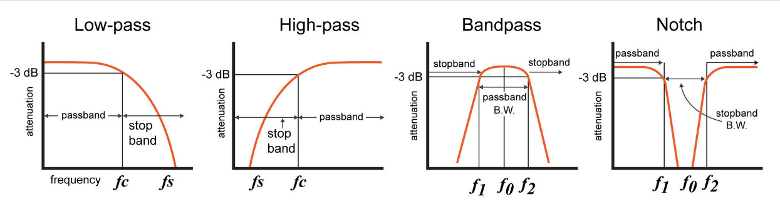
Figure 1: Basic Filter Types

There are 3 different eponymous filters that we could choose from named after 3 people who could model the LC response of a filter using the transfer function: the Butterworth, Bessel, and Chebyshev filters. The Butterworth filter, also known as a maximally flat filter, is best known for having minimal ripple (variation) in the passband while having a wider transition from the passband to the stopband [2]. The Bessel filter has a maximally flat phase response because it is trying to achieve a constant group delay, ensuring that all the frequencies in the filter’s passband will achieve the same delay in time. However, this filter struggles with maintaining a good magnitude response because it has a much wider transition band than the Butterworth filter [3]. Finally, the Chebyshev filter achieves a much faster roll-off in the transition band at the expense of “ripples in the passband” [4]. A filter that has “ripples in the passband” has inconsistent gains at different frequencies in the passband. Thus, the Bessel and Chebyshev optimize for something specific while the Butterworth filter tries to optimize the disadvantages of both of those filters.

Digital filters are an interesting type of filter too. While this part of the lab was optional, the theory behind these filters is interesting. Digital filters must deconstruct the input signal into binary values before performing the filtering and then reconstruct it into the output signal. Therefore, it is reasonable to assume that digital filters follow this path ADC -> Digital Filter -> DAC. Additionally, there are two different types of digital filters: the Finite Impulse Response (FIR) and the Infinite Impulse Response (IIR). The FIR filter decays each impulse of the input signal into 0, so they are non-recursive whereas the IIR filter uses recursion to never decay the output signal. The biggest advantage of digital filters is that they can achieve step transition bands and sharp cutoff frequencies. Anyone using a digital filter does not have to concern themselves with external components or non-ideal conditions, they just must deal with Direct Memory Access (DMA) instead. DMA is beyond the scale of an explanation of this filter, but needless to say it’s way more complicated than necessary for what we need to do for this lab [5].

Design Steps

- Simulate the Python Code using target frequency: 1000 + last 3 digits of UFID
- Use the Simulated Plots to determine the Ideal Filter
- Use TI Analog Filter Design Tool to determine the component values to use to build circuit
- Build and test the constructed circuit

The motivation behind this design was to convert an input square wave to a sine wave and we had to achieve this using a filter. I chose to use the Butterworth filter for this design based on the Python simulation results in the provided program. My cutoff frequency was 1068, take that for what you will, and I simulated the results using the provided Python code. Figure 2 shows the most important result of the simulation, the magnitude response of the filter and the input vs. output plot. In the magnitude response, the Butterworth filter rolls off right after at the cutoff frequency while the Bessel was too early and the Chebyshev was too late. In the transition band, the filter had the same roll-off as the Bessel. Additionally, Butterworth had the most similar magnitude in its output as the input signal while the Bessel attenuated too much and the Chebyshev did not attenuate enough. After all, we are trying to achieve a 0dB gain for this design.

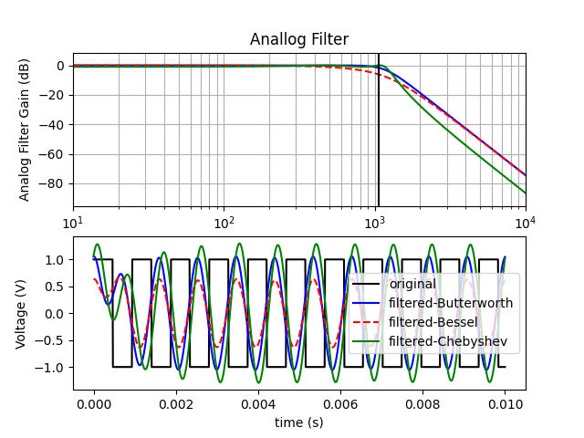
Figure 2: Python Simulation Ouptut
After choosing the filter type, I used the Texas Instruments Filter Design tool to design the filter. The filter had to be a 4th order filter, so it had to have a roll-off of -80dB/dec. The cutoff frequency had to be higher than the expected cutoff frequency to account for the non-idealities of the circuit. Therefore, I chose 1500 Hz as the cutoff frequency. Moreover, I also chose to use 10% tolerance for the resistors and 20% tolerance for the capacitors so that the tool will provide real resistor and capacitor values. Finally, the reason why I only accounted for resistors and capacitors is because I chose the Sallen-Key topology for the Low-Pass filter. The Sallen-Key topology is known for having a low-component count and being easy to implement. Figure 3 shows the full schematic of the design and emphasizes how easy it is to implement, having only 10 components to add to the circuit [6].

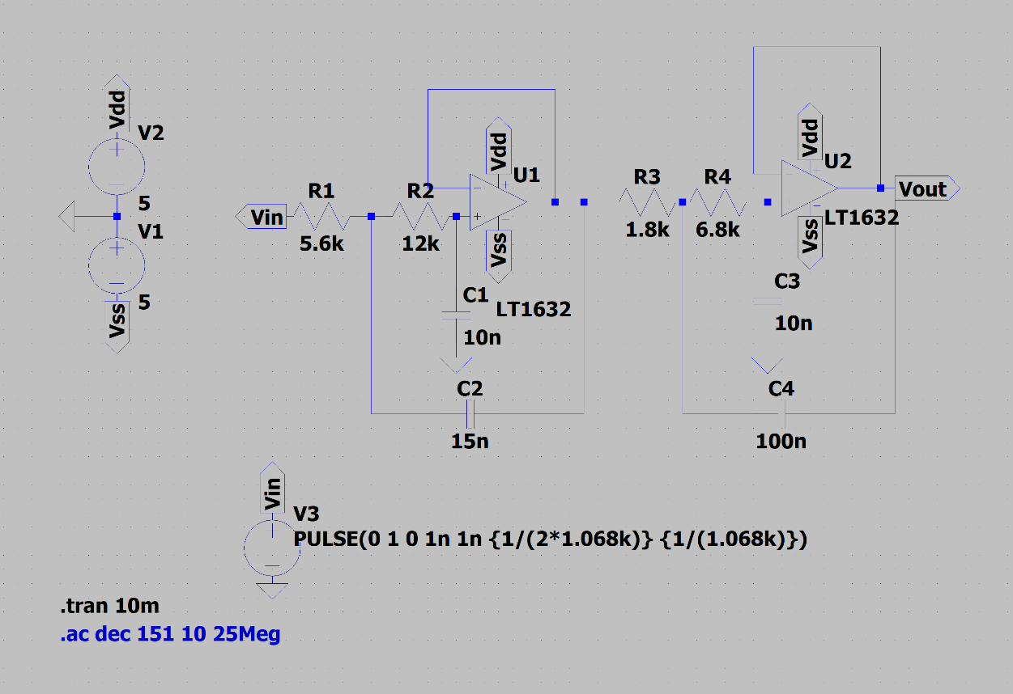
Figure 3: LTSpice Circuit of Analog Filter
The transfer functions for each stage of the filter are derived from the common equations for a Butterworth filter. Since this is a 4th order Butterworth filter, then each stage must be a 2nd order filter. Therefore, the primary means of solving it is by solving the 2nd order filter equation for each stage. I derived it for one stage and that was enough for the second stage which is symmetrical and then I combined them both for the total transfer function.

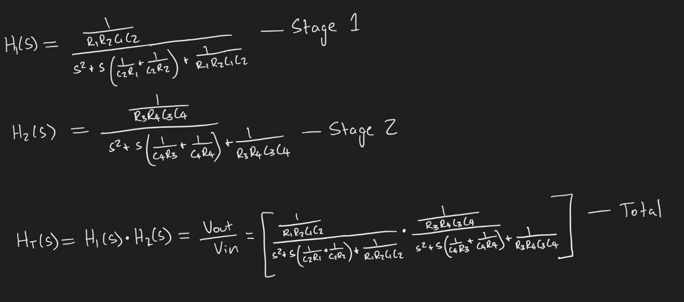
Figure 4: All Transfer Functions

Results
The results for this lab were difficult to obtain because I initially used a cutoff frequency that was too close to my value in my original design. Therefore, the amplitude would be heavily attenuated compared to the expected value. The initial cutoff frequency was 1100Hz, but that led to a heavily attenuated signal in practice whilst the simulation had a matching input and output magnitude. Therefore, I aimed to overshoot the magnitude of the output in simulation.

Figure 4 shows the LTSpice Magnitude vs. Frequency plot for LTSPice. A quick glance at the simulation output shows the cutoff frequency being at 1.5k, which aligns with the -3dB point as well. Additionally, there is 0dB gain in the passband showing that the design does not amplify the signal input in any way. Figure 5 shows the input vs. output signal, and it shows a significant overshoot and delay in the output signal, however these will be accounted for by the non-ideal resistances and capacitances of the components of the actual components.

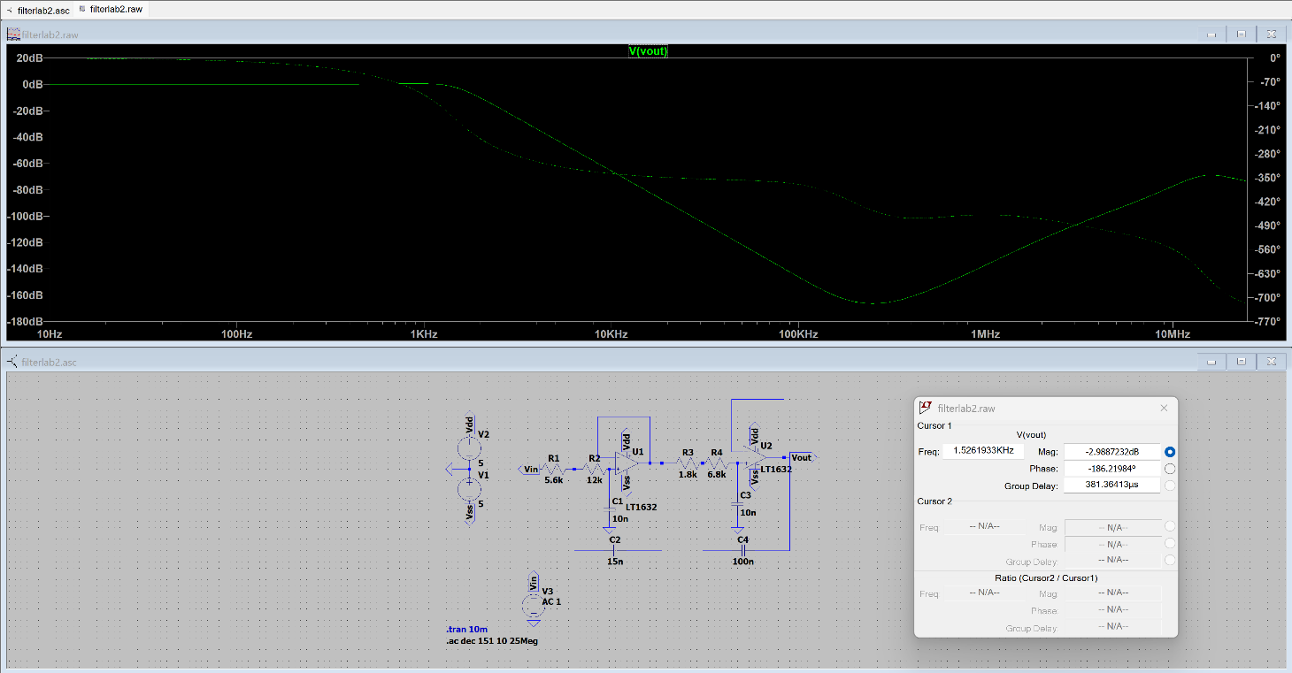
Figure 5: Magnitude vs. Frequency Simulated Plot

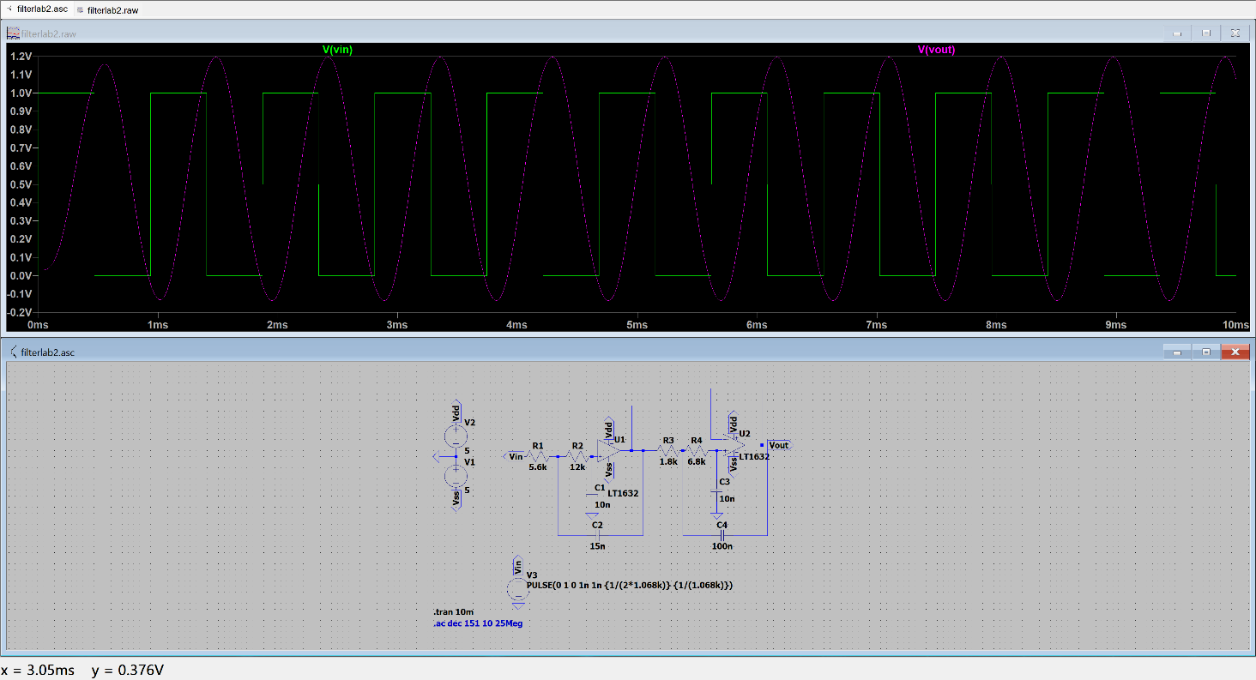
Figure 6: Input vs. Output Simulated Plot

The actual results are shown in Figures 6 and 7. Figure 6 shows the magnitude and phase response. The beginning of the magnitude response aligns with the simulation, but after 10kHz, the magnitude and phase response both have ripples. While it is trivial in the grand scheme of this lab, it is an interesting result of the circuit / op-amp’s design parameters affected the measurements.

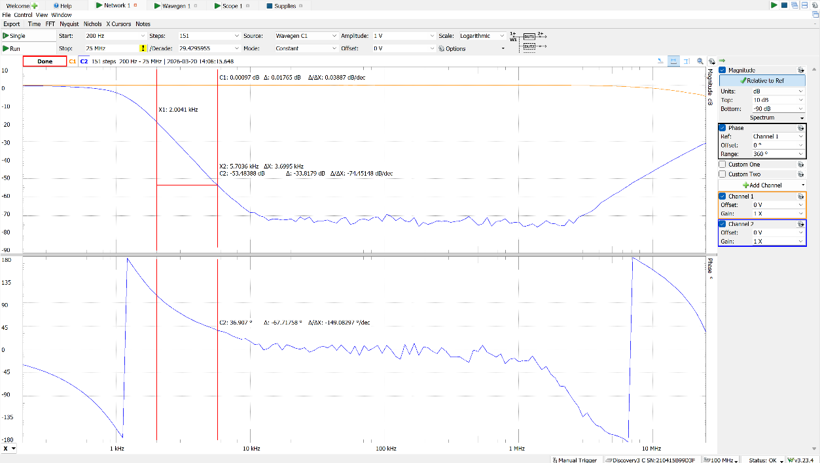
Figure 7: Magnitude vs. Frequency Plot

Figure 7 shows the Input vs. Output plot, and it resolves the overshoot and the delay in the output signal, proving that this design has merit. Interestingly, the output now undershoots rather than being slightly over or directly at 0dB gain. This demonstrates the fundamental flaw of the Sallen-Key topology: its senstivity to component tolerances. Therefore, the capacitors and resistors that I used had values that were quite different from the expected values. When debugging my circuit, I measured the resistances and capacitances of all the components that I used for the circuit. I noticed that the 10nF capacitors were actually closer to 15nF and the and 100nF capacitor was closer to 110nF. Even with such a small difference in the actual values of the component, the Sallen-Key topology has a vastly different output than the simulated output.
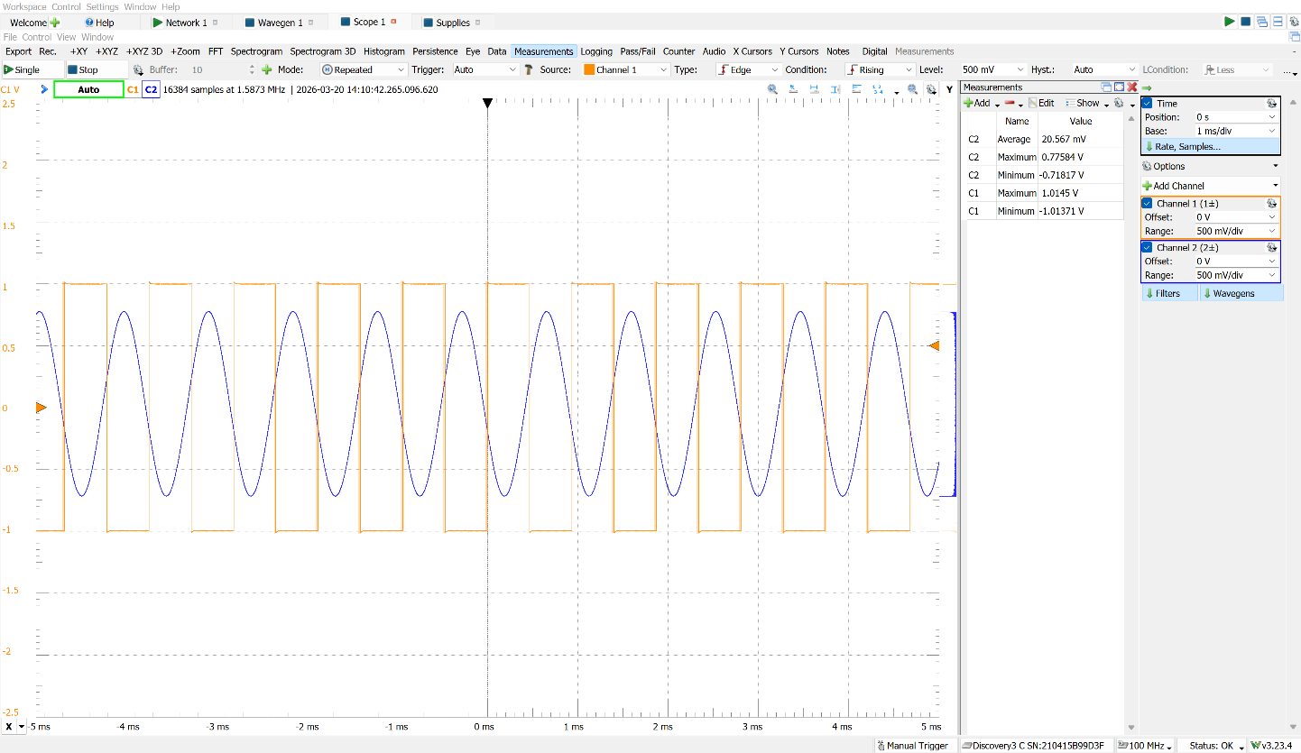
Figure 8: Input vs. Output Plot
Conclusion
This lab was fundamental in helping improve my understanding of the filter design process and refreshed me on the math behind filter design. Moreover, I learned about the effect of the non-ideal components on an ideal filters design and how to tune my design to adjust to those confounding conditions. The most important refresher was likely educating me on the different types of filters and each of their use cases. I wasn’t the best student in Circuits II, so this was more of learning opportunity than a refresher. I learned more about ripple, group delay, the meaning behind phase delay, and why circuits are 20dB/dec and not a different value. Overall, I needed this lab to motivate myself to learn more about something I’ve dreaded learning since Circuits II. The rest is history.

Refe rences
[1] Gemini, "Why do we need filters and what are their uses?," Mar. 20, 2026. [Online]. Available: https://gemini.google.com. [Accessed: Mar. 22, 2026].
[2] ScienceDirect, "Butterworth Filter - an Overview," www.sciencedirect.com, 2026. [Online]. Available: https://www.sciencedirect.com/topics/engineering/butterworth-filter. [Accessed: Mar. 22, 2026].
[3] ScienceDirect, "Bessel Filter - an Overview," www.sciencedirect.com, 2026. [Online]. Available: https://www.sciencedirect.com/topics/engineering/bessel-filter. [Accessed: Mar. 22, 2026].
[4] ScienceDirect, "Chebyshev Filter - an Overview," www.sciencedirect.com, 2026. [Online]. Available: https://www.sciencedirect.com/topics/engineering/chebyshev-filter. [Accessed: Mar. 22, 2026].
[5] ScienceDirect, "Digital Filter - an Overview," www.sciencedirect.com, 2026. [Online]. Available: https://www.sciencedirect.com/topics/engineering/digital-filter. [Accessed: Mar. 22, 2026].
[6] Electronics Tutorials, "Sallen and Key Filter Design for Second Order RC Filters," www.electronics-tutorials.ws, Jul. 11, 2019. [Online]. Available: https://www.electronics-tutorials.ws/filter/sallen-key-filter.html. [Accessed: Mar. 22, 2026].

