Sreeraaghav Raja
3/23/2026
40990068

EE Design 1 Technical Report
Amplifier Design

Introduction
This module was dedicated to explaining methods to create a design with amplification as the goal. In reality, this lab should have been included alongside the previous lab because the previous lab directly focused on active filters which required operational amplifiers. Amplification also requires operational amplifiers, so augmenting the previous lab to include this lab might be the play.
This lab also introduced different parameters for operational amplifiers that are useful guidelines for designs, namely the Gain-Bandwidth Product (GBP). This served to differentiate between two different Op-Amp ICs and choose the best one for a specific amplification guideline. Additionally, the filtering aspect of this lab was an effective refresher on the fundamentals of an Op-Amp’s internals, particularly the low-pass filtering effect from the transistors used to design the device.

Methods

Background Information
It would be a disservice to this lab if I did not start by explaining why amplification is so vital to the world. Amplification is process of converting a smaller input signal into a larger output signal. Therefore, it has uses in all electronics in some way: audio, contrast on a screen, medical technology, wireless communication, etc. [1]. I’d roll my eyes if someone started with an obvious explanation like that, but there’s a method behind this madness. If amplifiers increase signals the most reasonable question is “by how much.” That’s where the magic of the operational amplifier (Op-Amp) lies.
The Op-Amp is a device that can control how much we can amplify a signal by through a negative feedback loop. A negative feedback loop is best explained with an analogy. Imagine eating a donut, the body’s response to this increase in glucose is to try to decrease this in some way. Therefore, the pancreas will produce insulin to lower the blood glucose level to a stable amount called homeostasis [2]. This is exactly how the Op-Amp functions. The donut is the input signal, the increase in glucose levels is the output, and the feedback network is just the pancreatic insulin response.
The Op-Amp has multiple parameters that must be considered when designing an amplifier. Since it is an Active Circuit Component, it is important to consider the rail voltages since those provide the range for how far an Op-Amp can amplify a signal before saturating. Figure 1 shows how the maximum negative and positive voltage values are the V_{cc} and V_{ee} values. This lab has a constraint that we must only use a singular voltage source, so we had to ground the other rail. Therefore, the VTC would only go from 0 – 5V. To prevent this circuit from saturating, we had to shift the input signal by 2.5V so that it would not saturate. This operation is easily done by attaching a resistor ladder to positive terminal of an op-amp.

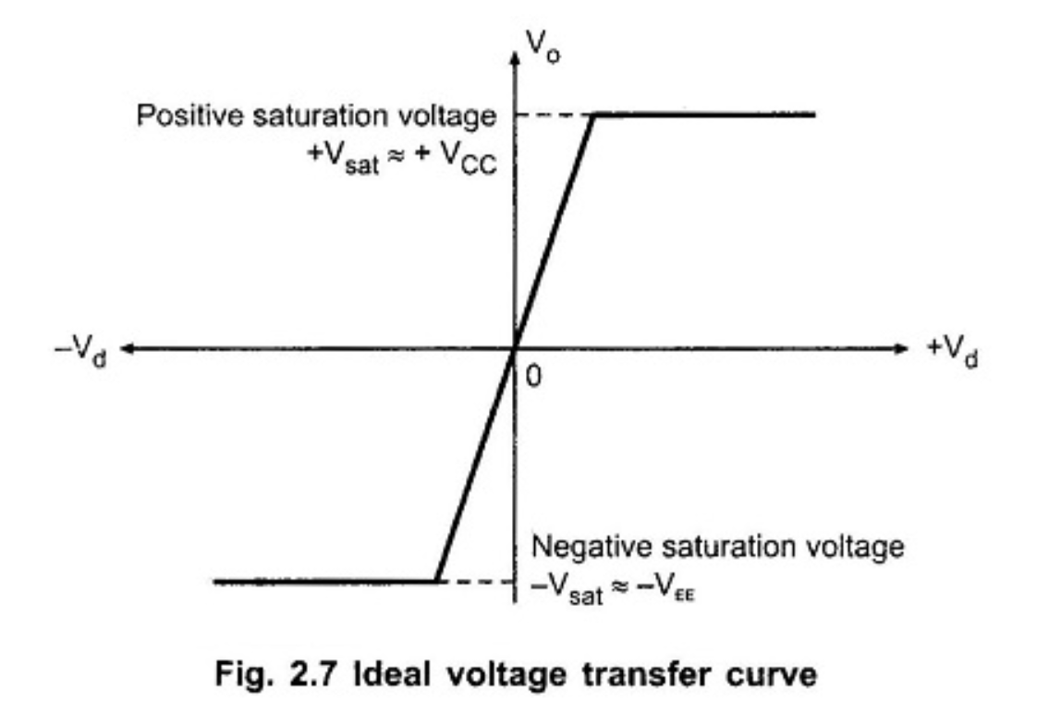
Figure 1: Op-Amp Voltage Transfer Curve (VTC)
The next reasonable question is what op-amp configuration? Op-Amps have multiple configurations, but the one that I chose was the Inverting Op-Amp Configuration. The reason behind this choice is that the inverting op-amp can be more easily designed for an exact gain whereas the non-inverting op-amp has a +1 term that makes values a lot more difficult to handle. The only caveat is that the input signal will have the opposite polarity of the output signal, which is the reason behind the name of the inverting op-amp. Figure 2 shows the exact schematic for an inverting op-amp. It is important to note that this only partially reflects the exact design for this since there is an extra capacitor at the input that blocks any incoming DC offset.
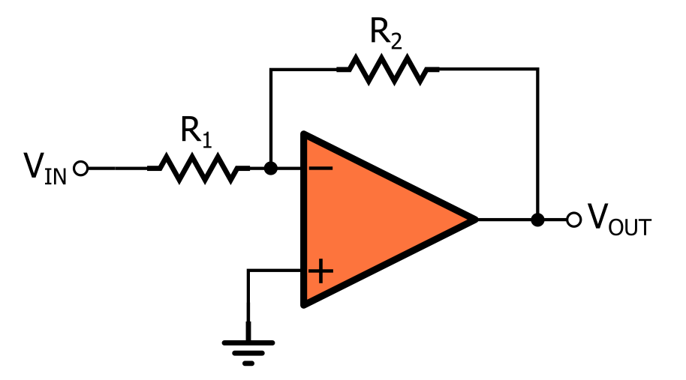
Figure 2: Inverting Op-Amp Configuration
Audio Amplifiers are more specialized versions of operational amplifiers. They already handle most of the intricacies of amplification that are manual for op-amps. For instance, they have predefined ways of handling the gain such as having a pre-set gain and they also offset the output signal by a certain amount like the LM386. A major advantage of adding specialized amplifiers to a design is that they help reduce the distortion created by external components while also reducing the complexity of an external design by removing the need for those external components [3]. However, this is at the cost of reducing how much we could modify the amplification parameters. It may be easier to design a circuit with a gain of 26 but if we wanted to change the gain or add another stage to the amplification, it would be much more difficult with a specialized amplifier.

Design Steps
The dogma behind this design was to focus on the Av, the voltage gain, and then the fc, the cutoff frequency. I completed the design by using those two values in tandem by looking at the provided resistor values in my lab kit. The primary steps that I used to complete this module are detailed below:
- Establish the f_{c} = 100Hz and the A_{v} = 20
- Find the Gain-Bandwidth Product at the f_{min} = 100Hz and f_{max} = 15kHz for the passband region
- Determine which Op-Amp IC was suitable for that by looking at the GBP parameters of both ICs
- Design the circuit based on the available components in the Lab Kit
- Test the circuit for both the cutoff / minimum frequency and a value at the passband region, 10kHz for the open circuit case and with the piezo speaker attached.
- Run the network analyzer for each case and see if both cases match the specified 26dB gain value
- Design the circuit for the amplifier and repeat steps 5 – 6.

Now outlining all those steps may have increased any normal reader’s cortisol, but reading the documentation really simplified the process. I chose the LT1632 because its Gain-Bandwidth Product (GBP) is 45MHz whereas the LT1490 had a GBP of 200kHz [3]. The maximum GBP required based on the design specifications was 20 * 15kHz = 300kHz. This value exceeds the maximum supported GBP for the LT1490, so the LT1632 seemed to be the obvious choice [4].
The hard part was finding the exact resistor and capacitor values and aligning that with whatever was provided in the Junior Design kit, which wasn’t much since my kit was ransacked before it even opened. Additionally, the “difficult” part was merely solving Equation 1 and 2 to achieve the proper values for those two components.

$$\text{Equation 1: }A_{v}=\frac{R_{f}}{R_{in}}$$

$$\text{ Equation 2: }f_{l}=\frac{1}{2πR_{in}C_{in}}$$

Equation 1 resolves as follows:

$$A_{v}=20=\frac{Rf}{Rin}=\frac{200kΩ}{10kΩ}$$

Therefore, I chose an arbitrary value of R_{in} = 10kΩ, so that R_{f} = 200kΩ could be achieved with values in my kit. Therefore, I needed 3 resistors for this circuit when it had an open load, where the R_{f} value is achieved by using two 100kΩ resistors.

Equation 2 resolves as follows:
$$C_{in}=\frac{1}{2πR_{in}f_{l}}=\frac{1}{2π\left(10kΩ\right)\left(100Hz\right)}=0.159µF$$
I solved this equation by using the R_{in} value from the prior equation and the low cutoff frequency defined in the project specifications. Moreover, if I were more optimistic, I would have chosen 0.159µF for my design. But, after spending hours looking over my breadboard for the Analog Filter Lab, I realized that choosing a cutoff frequency that is further from that cutoff frequency in a desired direction might be better for my sanity. Therefore, I opted for a 0.47µF capacitor that will resolve to a cutoff frequency of approximately 33Hz.
Results
For the results, I used 10kHz as the mid-band frequency along with testing the cutoff frequency of 100Hz. Additionally, this section will be split into three different sections. The first section will discuss the LTSpice simulations, the second section will discuss the WaveForms Outputs, and the final section will discuss the difference between either section.

LTSpice Simulations
The assignment only specified that we had to create a design of the LT1632’s schematic and simulate that on LTSpice, so this section will only comprise of simulation results for that component. Nevertheless, they should match the simulation results for the specialized audio amplifier because the purpose of this lab was to compare the two different ICs and emphasize the advantages and disadvantages of using either one in our design.

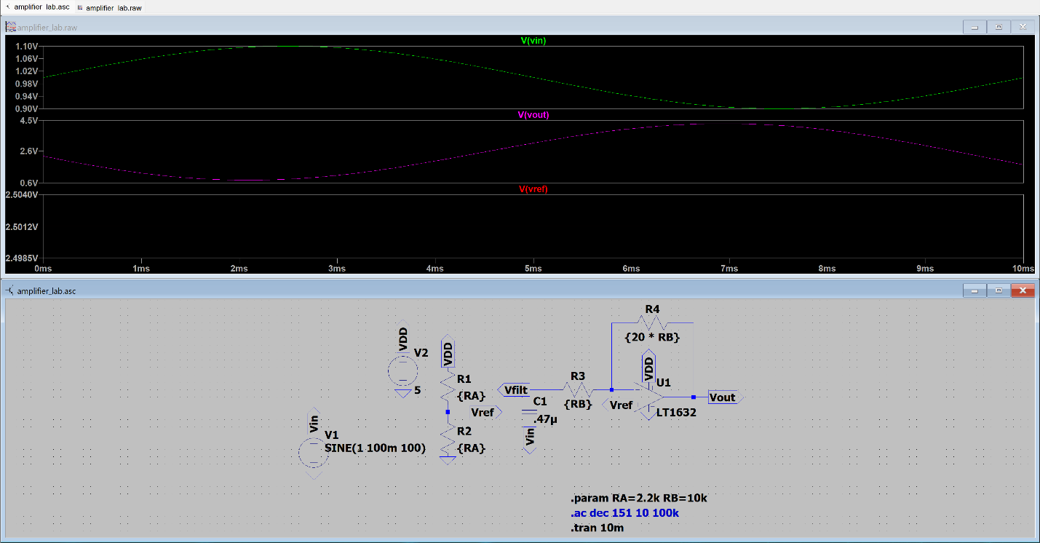
Figure 3: Transient Analysis at 100Hz
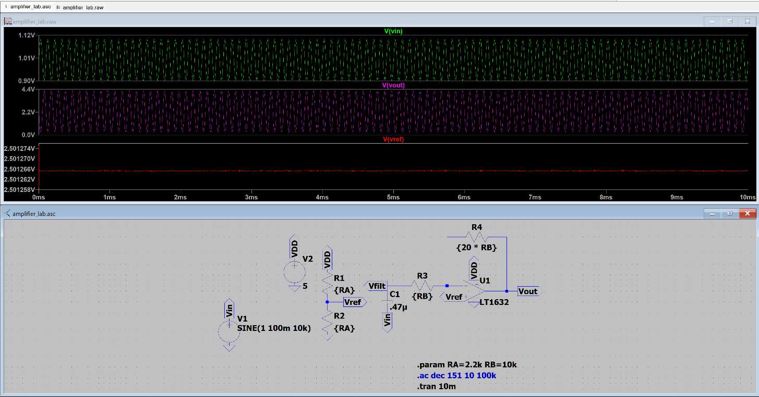
Figure 4: Transient Analysis at 10kHz
Figures 3 and 4 are the transient analysis of the amplifier circuit. It is important to note that I used 0.47µF for this design to mirror the breadboard. Otherwise, it would be difficult to accurately compare the two. Figure 5 shows the frequency response which has a cutoff frequency of approximately 34Hz, demonstrating the effect of increasing the input capacitance.

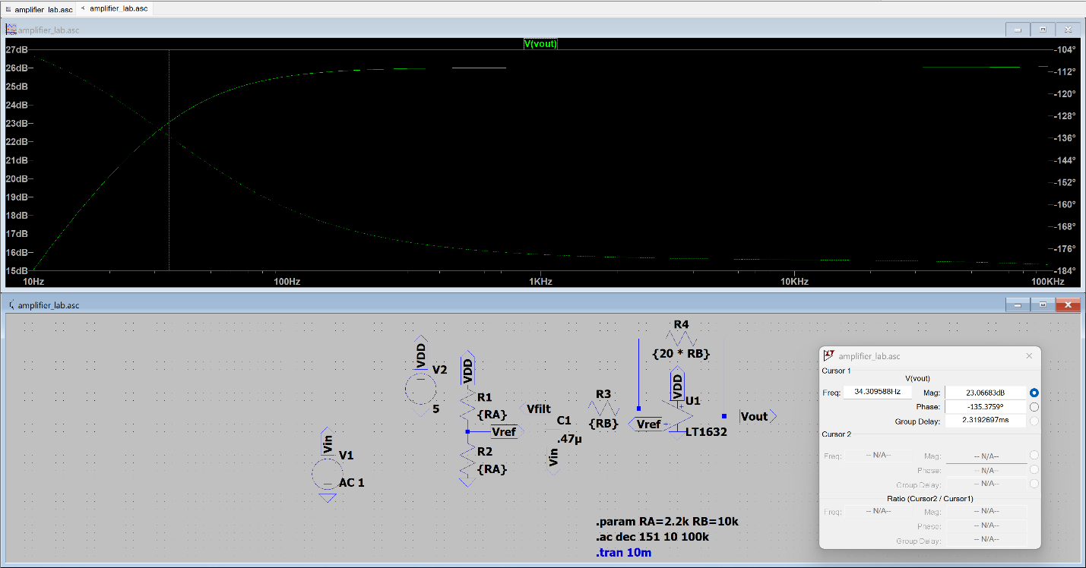
Figure 5: Frequency Response
WaveForms Measurements
There are quite a few measurements that we had to take for this lab, so I will separate it into 4 different sections. The first section will cover the LT1632 measurement with no load. The second section will cover the same IC with the 8Ω speaker at the output. The third and fourth sections are the same except with the LM386 IC instead.

Section 1: LT1632 Measurements with No Load (R_{out} = ∞)
The exact gain is very close to 20 with a few discrepancies between the two different frequencies. The 100Hz case has a gain of approximately 20.2 while the 10kHz case has a gain of approximately 20.2 as well. Therefore, the circuit is extremely stable for this situation as shown with Figures 6 and 7. Figure 8 is the frequency response of the circuit and GBP is 25.663, which is extremely close to the specified value of 26. Interestingly, this value was only achieved by adding an output buffer to the breadboarded circuit which could have been caused by a variety of reasons.
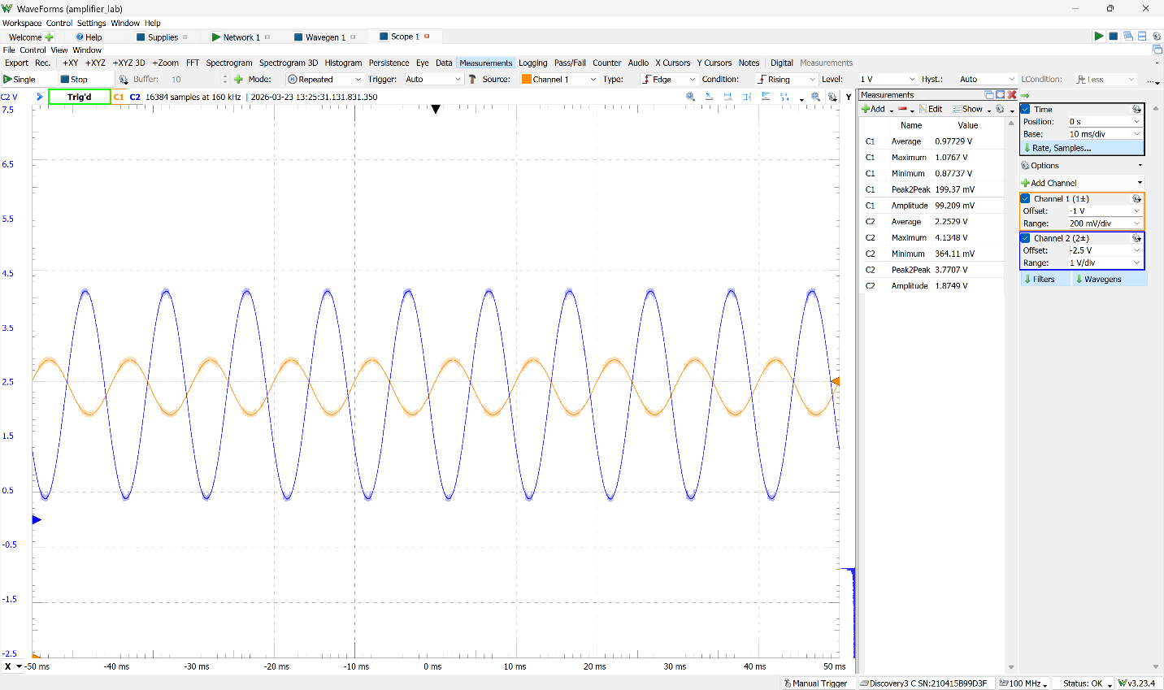
Figure 6: O-Scope Reading for 100Hz Input Signal
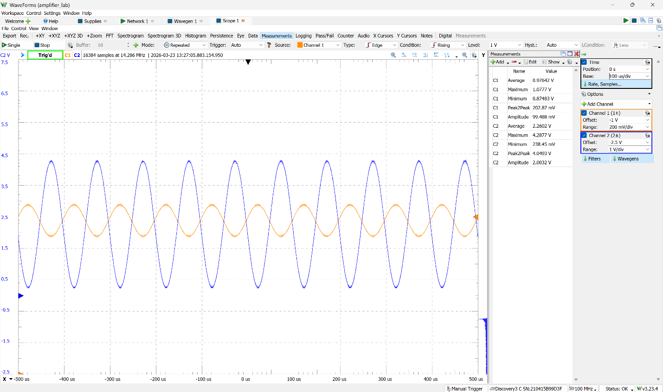
Figure 7: O-Scope Reading for 10kHz Input Signal

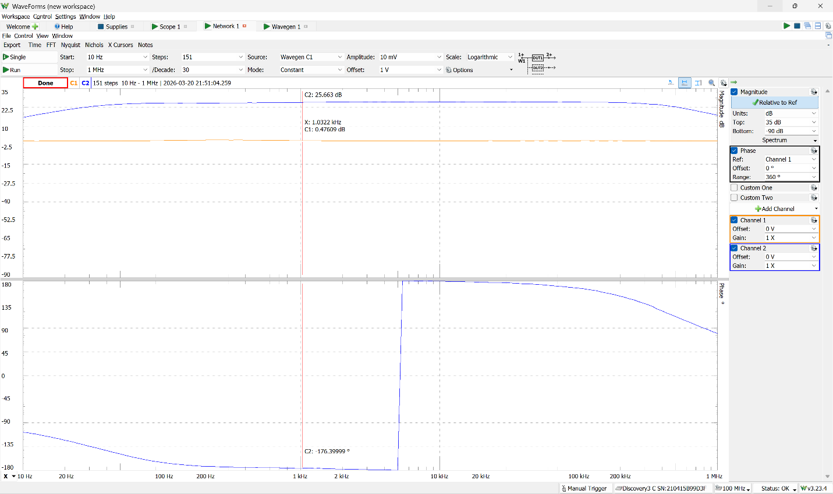
Figure 8: Frequency Response
Section 2: LT1632 Measurements with 8Ω Speaker Load (R_{out} = 8Ω)
The addition of an output load caused the output signal value to lower slightly. As a result, the output gain value for the circuit at 100Hz and 10kHz were 17.18 and 17.45 respectively. Each of these values was derived from using the input and output peak-to-peak voltages from Figures 9 and 10. While the gain wasn’t affected too much by the speaker, it does emphasize that a specialized IC may suit this situation better. Figure 11 is the frequency response of this scenario, and the GBP was slightly lower than the previous scenario too. The GBP is 25.2 in this situation. Moreover, the unity gain op-amp that I added to the output helped stabilize the output. The 270µF capacitor blocked any DC input coming from the output of the circuit and 100Ω resistor served to regulate the output current, which is ideally infinite for an op-amp, before it flows through the speaker.
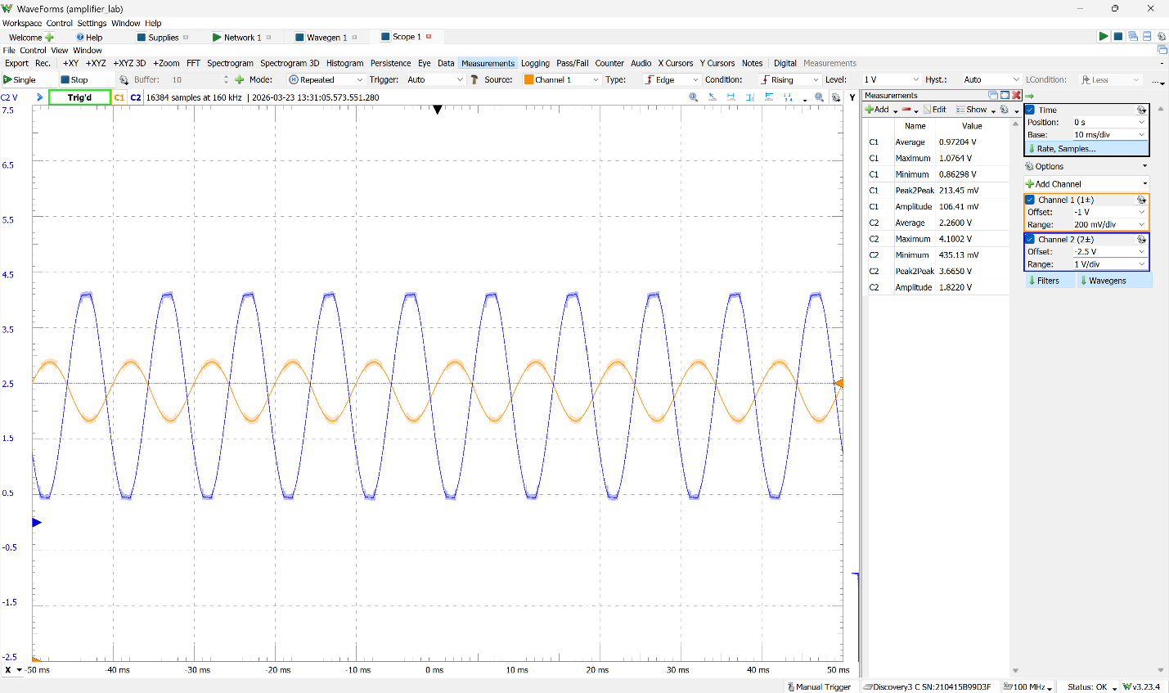
Figure 9: O-Scope Reading for 100Hz Input Signal

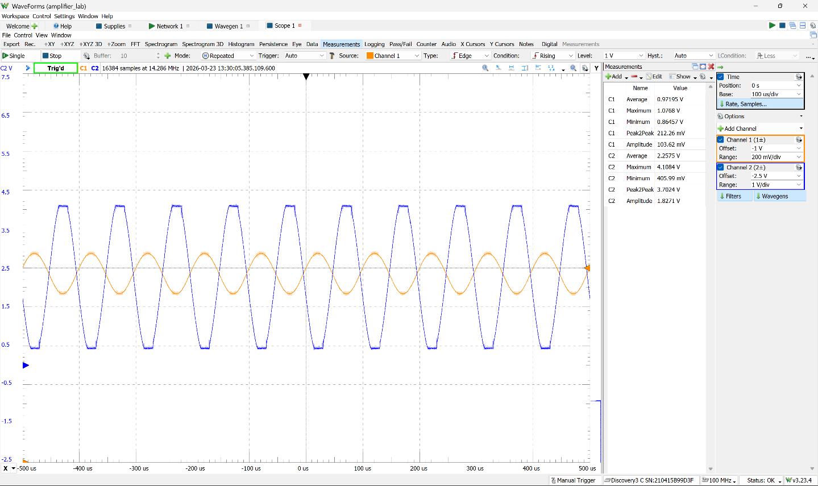
Figure 10: O-Scope Reading for 10kHz Input Signal

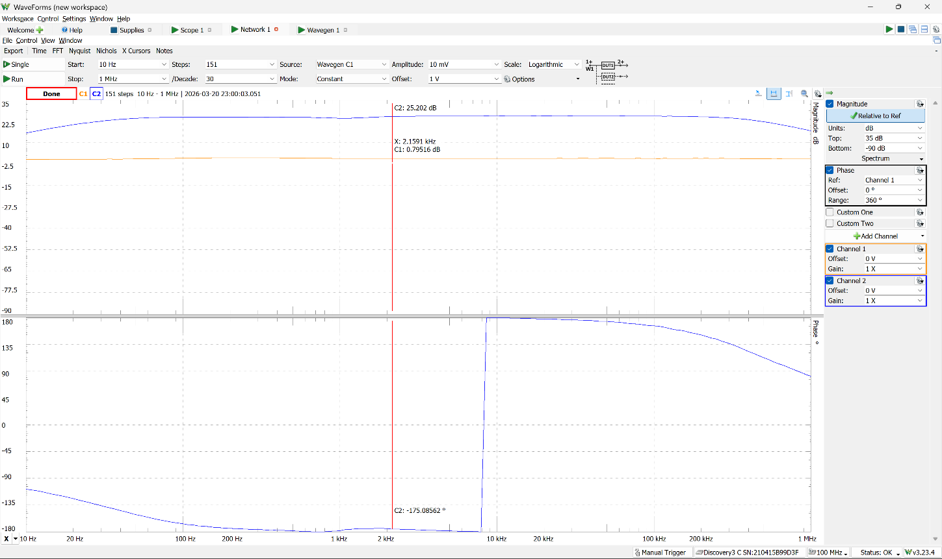
Figure 11: Frequency Response
Section 3: LM386 Measurements with No Load (R_{out} = ∞)
This scenario was much easier to breadboard because the LM386 handled a lot more of the design specifications that had to be integrated manually for the LT1632. The IC was designed to always have a GBP of 26 and the output will be offset by 2.5V, so the only part that I had to implement was adding the 0.47µF capacitor at the input pin to determine the cutoff frequency. The gain is slightly lower than 20 in this case too. For the 100Hz case, the gain is 18.89 and in the 10kHz case, the gain is 18.64. While this may not be a perfect amplifier according to the outputs from Figures 12 and 13, we don’t fully understand the situation until analyzing the frequency response in Figure 14. The GBP for this case is 26.128 which is much closer to 26 than in either of the previous scenarios. However, there is an inexplicable dip between approximately 150Hz and 3kHz. This could be a result of the internal design of the LM386. Additionally, I should have decreased the input capacitance so that I could see an increase from 10Hz to 100Hz on the Bode Plot but opted to not change the overall design for the sake of simplicity.

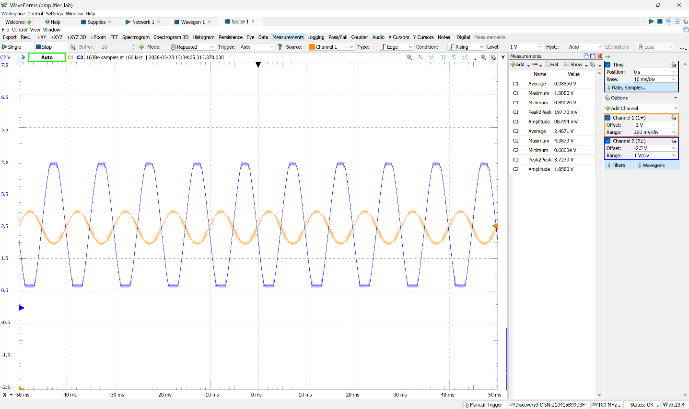
Figure 12: O-Scope Reading for 100Hz Input Signal

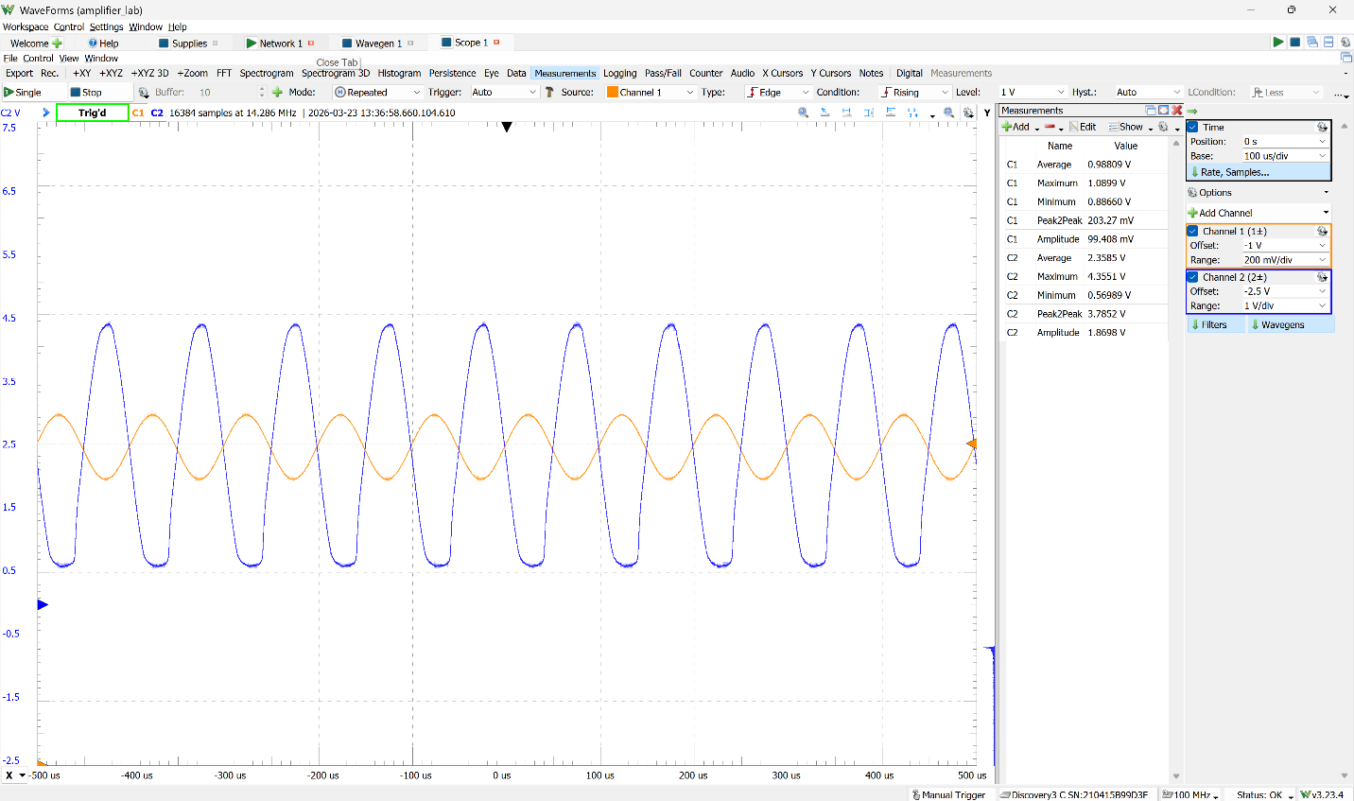
Figure 13: O-Scope Reading for 10kHz Input Signal

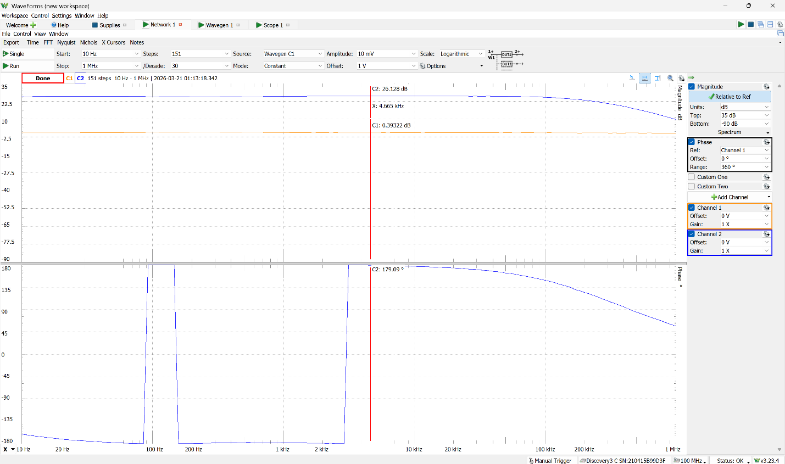
Figure 14: Frequency Response
Section 4: LM386 Measurements with 8Ω Speaker Load (R_{out} = 8Ω)
For this scenario, all I had to add at the output terminal was a 270µF capacitor and a 100Ω resistor alongside the speaker. The gain decreased even more in this scenario where the gain for the 100Hz situation is 17.09 and the 17.28 for the 10kHz situation. While the output signal has no visual distortion for the 100Hz situation, the 10kHz situation shows significant distortion in the output signal which is most likely caused by a bad LM386 chip. Nevertheless, the GBP is effectively the same as the previous situation with a GBP of 26.073. Therefore, the LM386 could be causing distortion in the output signal because it is trying to adjust the output to maintain the GBP at 26. Thus, the LM386 is much better at maintaining the same GBP than any op-amp since it is more specialized.

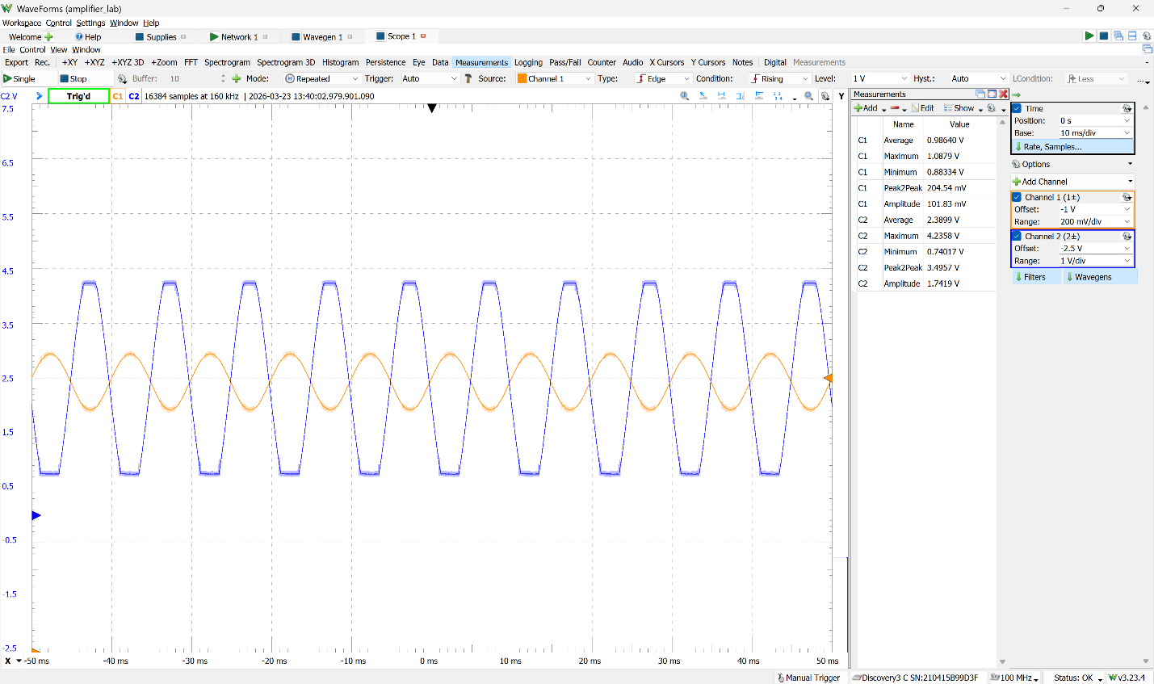
Figure 15: O-Scope Reading for 100Hz Input Signal

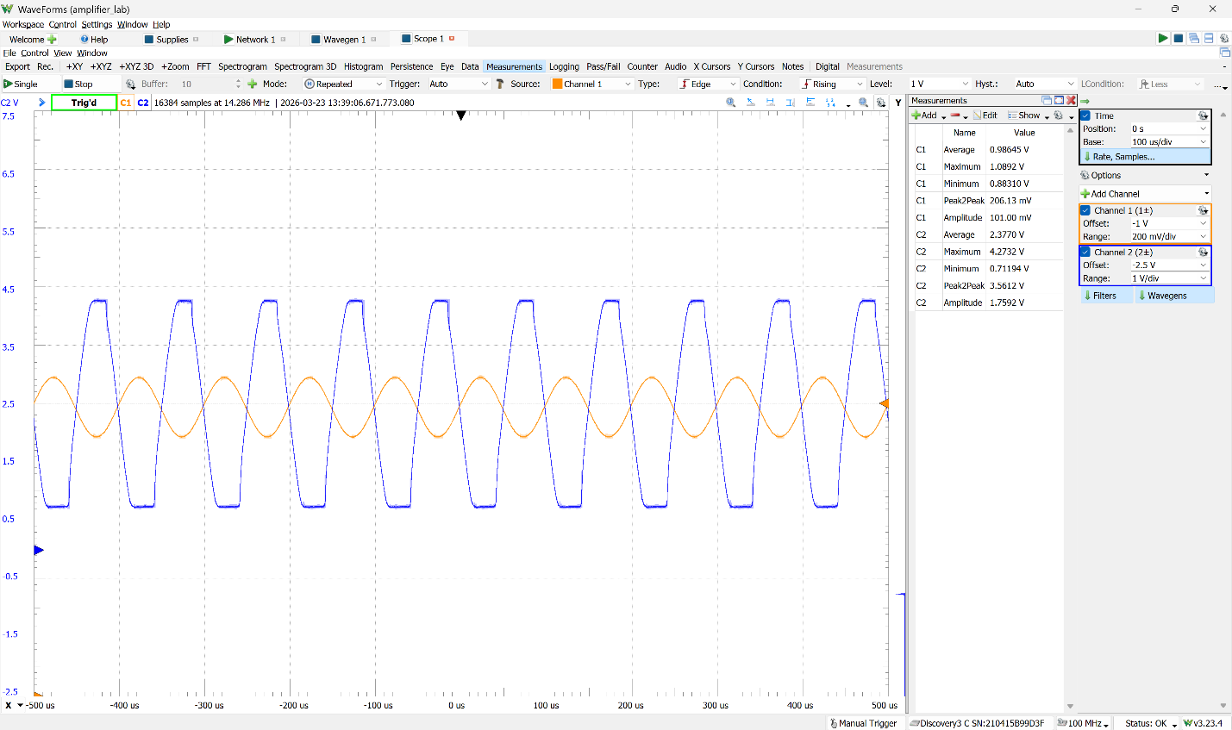
Figure 16: O-Scope Reading for 10kHz Input Signal

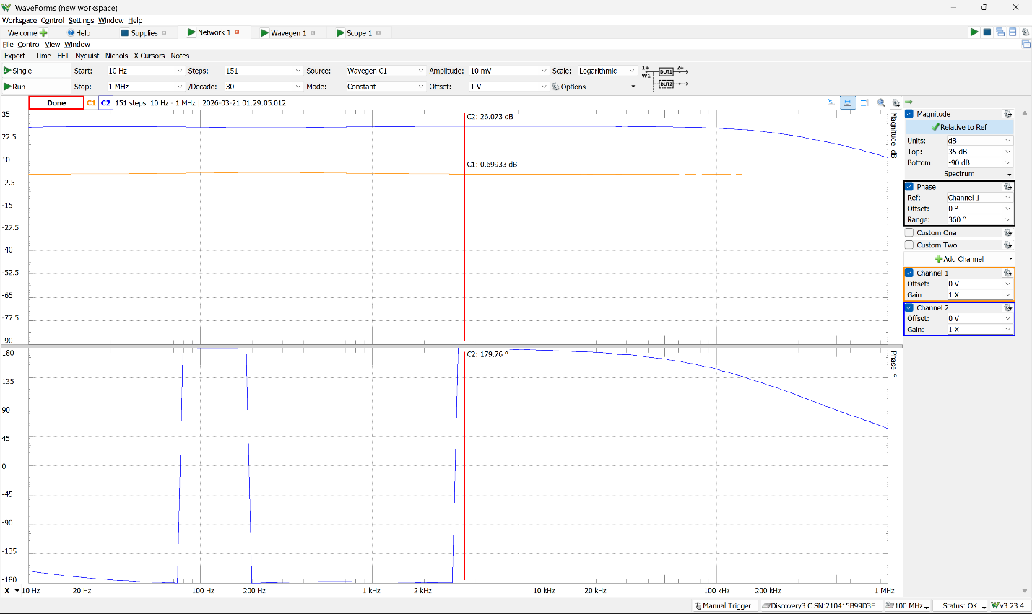
Figure 17: Frequency Response
Comparing the LM386 and LT1632
The voltage gain for the LM386 is the ratio between the input and output voltages whereas the power gain is the ratio between the input and output powers. However, the issue with the power gain is that it relies on a current at the output to calculate the gain. As a result, for each open-circuit case, the power gain (G) is 0. However, for the same open-circuit case the voltage gain is much better for the LT1632 which achieved a gain of 20.2 whereas the LM386 struggled while hovering at a gain value of 18.75. For the speaker situation, the voltage gains for each chip are around the same range at 17.1 – 17.5. Therefore, it is more optimal to pick the LM386 for any situation that requires attaching a load to the circuit. Moreover, the Power Gain for each case is 27,376 for the LT1632 where the RMS values of the voltage were used for the peak-to-peak voltages and 134,800. This reveals that the LM386 is more power efficient than the LT1632 because it is more specialized for audio amplification. The LM386 removes the headache of dealing with a lot of components and focuses more on designing the amplifier to work immediately. The only issues are that tuning it to the desired parameters I much harder because a lot of the specifications are hidden in the documentation. However, for small-signal amplification, the LT1632 offers not only more customization but also achieves a closer gain value as demonstrated by the open circuit case.
Conclusion
This module showed me how valuable specialized chips can be and why they are needed. I already knew that there were specialized chips in other fields. For example, Application-Specific ICs (ASIC) like the audio amplifier are often faster than FPGAs which are configured to do the same operation at the expense of customizability. Therefore, this lab reinforced the importance of different situations and presented more instances where I had to meet certain design criteria while making my design for a lab. Additionally, it was an important re-introduction to Group Delay, the Gain-Bandwidth Product, and Impulse Response, concepts that I had learned in Circuits II. Overall, I felt as though this was one of the more important labs for the final project as it provided more practice with debugging and testing an audio-based project, something that I was going originally implement in my own final project.

References
[1] ODG, “What are amplifiers used for? 5 common applications,” Origin-IC Blog, Jan. 8, 2026. [Online]. Available: https://www.origin-ic.com/blog/amplifier-definition-common-applications/48372. [Accessed: Mar. 28, 2026].
[2] B. L. Roland, “How negative feedback loops maintain homeostasis,” Verywell Health, Nov. 09, 2023. [Online]. Available: https://www.verywellhealth.com/what-is-a-negative-feedback-loop-3132878. [Accessed: Mar. 28, 2026].
[3] Sonos, “What is a speaker amplifier (and do you need one)?,” Sonos Blog. [Online]. Available: https://www.sonos.com/en-us/blog/what-is-an-amp. [Accessed: Mar. 28, 2026].
[4] Analog Devices, “LT1632/LT1633: 45MHz, 45V/µs, Dual/Quad Rail-to-Rail Input and Output Precision Op Amps,” LT1632 datasheet, July 2008. [Online]. Available: https://www.analog.com/en/products/lt1632.html. [Accessed: Mar. 28, 2026].
[5] ElectroSmash, “LM386 audio amplifier analysis,” ElectroSmash, [Online]. Available: https://www.electrosmash.com/lm386-analysis. [Accessed: Mar. 28, 2026].

