**EXP 2 EMPLOYEE DATABASE**

**Aim:**

Consider the employee database given below

**emp** (emp_id,emp_name, Street_No, city)

**works** (emp_id, company name, salary)

**company** (company name, city)

**manages** (emp_id, manager_id)

**Note: Emp_id should start with ‘E’ in Emp table and emp_id in works table must be the emp_id from emp table .emp_id and manager_id in manages table must be the emp_id from emp table.**

**EMP TABLE**

create table emp(emp_id varchar(20) primary key check(emp_id like 'E%'),emp_name varchar(30),street_no int,city varchar(20));

insert into emp values('E104','AMAL’,50, 'Kochi');

insert into emp values('E105',’SREEHARI’ ,50,’’);

insert into emp values('E106',’SEBIN’ ,50,’’);

insert into emp values('E107',’VISHNU ‘,50,’’);

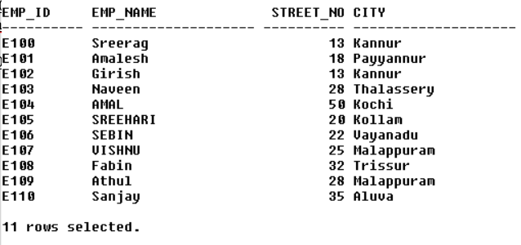

**COMPANY TABLE**

create table company(company_name varchar(25) primary key,city varchar(25));

insert into company values ('SBI','Kochi');



**WORKS TABLE**

create table works(emp_id varchar(20) references emp(emp_id),company_name varchar(25) references company(company_name),salary int);

insert into works values ('E101','SBI',40000);

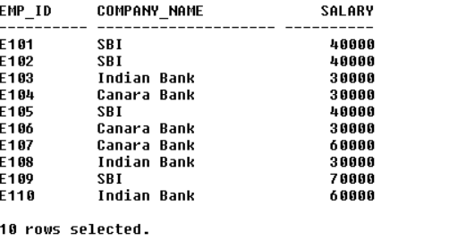

**MANGES TABLE**

create table manages(emp_id varchar(20) references emp(emp_id),manager_id varchar(20) references emp(emp_id));

insert into manages values ('E101','E109');

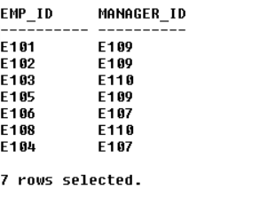

1. **Find the names of all employees who work for SBI.**

select emp_name from emp where emp_id in(select emp_id from works where company_name='SBI');



**b. Find all employees in the database who live in the same cities as the companies for which they work.**

select emp_name from emp e,works w,company c where e.emp_id=w.emp_id and e.city=c.city and w.company_name=c.company_name;



**c. Find all employees who earn more than the average salary of all employees of their company.**

select emp_name from emp e,works w where e.emp_id=w.emp_id and w.salary>(select avg(salary) from works s where w.company_name=s.company_name);

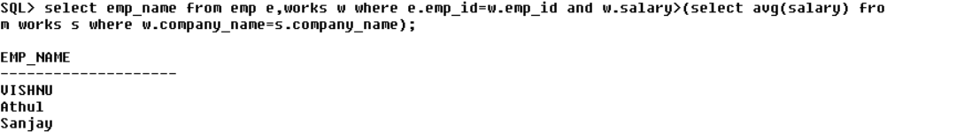

**d. Give all managers of SBI a 10 percent raise.**

update works set salary=salary*1.1 where company_name='SBI' and emp_id in(select manager_id from manages);

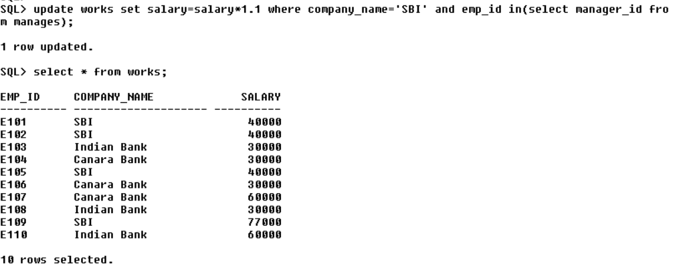

**e. Find the company that has the most employees.**

select company_name from works,emp group by company_name

having count(emp_name) = (select max(count(emp_name))from works,emp

group by company_name);



**f. Find those companies whose employees earn a higher salary, on average than the average salary at Indian Bank.**

select company_name from works group by company_name having avg(salary) > (select avg(salary) from works where company_name='Indian Bank');

