**PYTHON**

**CO-5 PROGRAMS**

**1. Write a Python program to read a file line by line and store it into a list**

f1=open("firstfile.txt","w")

f1.write("This is my first file in python.\nWant to work with files.\nThis is my third.")

f1.close()

f1=open("firstfile.txt","r")

f1.seek(0,0)

ff=f1.readlines()

*for* x *in* range(0,len(ff)):

    print(ff[x])

print()

print(ff)

f1.close()

**OUTPUT**

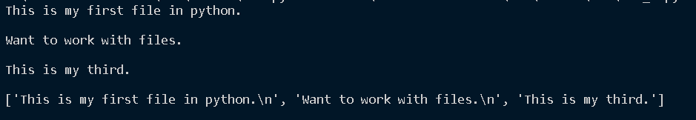

**2. Python program to copy odd lines of one file to other**

f1 = open("firstfile.txt","r")

*for* x *in* f1:

    print(x)

print("---------------")

f1.seek(0,0)

ff=f1.readlines()

print("Looping through the file using Readline\n")

print("---------------")

*for* x *in* range(0,len(ff)):

*if*(x%2==0):

        print(ff[x])

print("---------------")

**OUTPUT**

