1. What is software? What is software engineering?

2. Explain types of software

3. What is SDLC? Explain each phase of SDLC

4. What is DFD? Create a DFD diagram on Flipkart

5. What is Flow chart? Create a flowchart to make addition of two numbers

6. What is Use case Diagram? Create a use-case on bill payment on paytm.

Ans1:

Software refers to a set of instructions or programs that enable a computer to perform specific tasks. It includes applications, operating systems, and other programs. Software engineering is the systematic application of engineering principles to the design, development, maintenance, testing, and evaluation of software and systems.

Ans 2:

Types of Software:

1. System Software: Manages hardware and provides essential functionalities (e.g., operating systems).

2. Application Software: Performs specific tasks for users (e.g., word processors, web browsers).

3. Utility Software: Provides additional functionalities, like antivirus programs or disk cleanup tools.

4. Embedded Software: Part of a larger system (e.g., firmware in electronic devices).

Ans-3 SDLC (Software Development Life Cycle):

-Planning: Identifying goals, requirements, and constraints.

-Analysis: Understanding and defining the system's requirements.

-Design: Creating a blueprint for the software.

-Implementation: Actual coding and building of the software.

-Testing: Verifying that the software works as intended.

-Deployment: Launching the software for users.

-Maintenance: Ongoing support, updates, and improvements.

-DFD (Data Flow Diagram): A visual representation of how data flows through a system.

Ans-4

A Data Flow Diagram is a graphical representation of how data moves through a system. It shows the processes that transform data, the external entities that interact with the system, the data stores that hold information, and the data flows that connect them all.

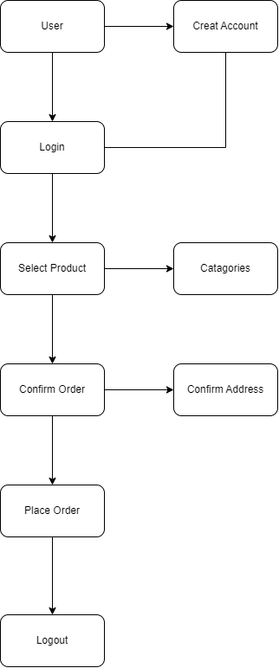

Ans 5:

A flowchart is a visual representation of a process or algorithm, using symbols and arrows to show the sequence of steps. It provides a clear and structured outline of the process flow, helping to understand its logic, decision points, and actions taken at each step.

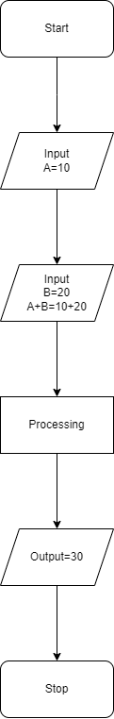

Ans 6:

A Use Case Diagram is a visual representation that depicts the interactions between users (actors) and a system. It illustrates the various use cases, or functionalities, of the system and how actors interact with those use cases to achieve specific goals or tasks. Essentially, it provides an overview of the system's functionality from a user's perspective, helping to understand the system's behavior and requirements.

