FLASK & MONGODB
Assignment Documentation

Name | Sreeraj Viswanathan
Tasks | Task 1 – JSON API | Task 2 – Form + MongoDB Atlas
Technology | Python, Flask, MongoDB Atlas, PyMongo

This document records the implementation, testing, and results of the Flask & MongoDB assignment.

1. Overview
The assignment was completed in two parts. Task 1 implements a Flask JSON API that reads data from a JSON file and returns it through an API route. Task 2 implements a frontend signup form, a separate Flask backend, and MongoDB Atlas storage with basic error handling.

Project Structure
Flask_and_MongoDB_Sreeraj/
├── task1/
│ ├── app.py
│ └── data.json
└── task2/
├── backend/
│ └── app.py
└── frontend/
├── app.py
└── templates/
└── index.html

2. Task 1 – Flask JSON API
The objective of Task 1 was to create a Flask application with an /api route. The route reads a list of records from a backend JSON file and returns the list as a JSON response.

Implementation
- Created a Flask application with an /api route.
- Stored sample records in data.json.
- Used Python's json module to read the file.
- Returned the loaded list through the Flask route.
- Ran the application on port 8001 and tested the endpoint in a browser.

Task 1 – Source Code and Running Application
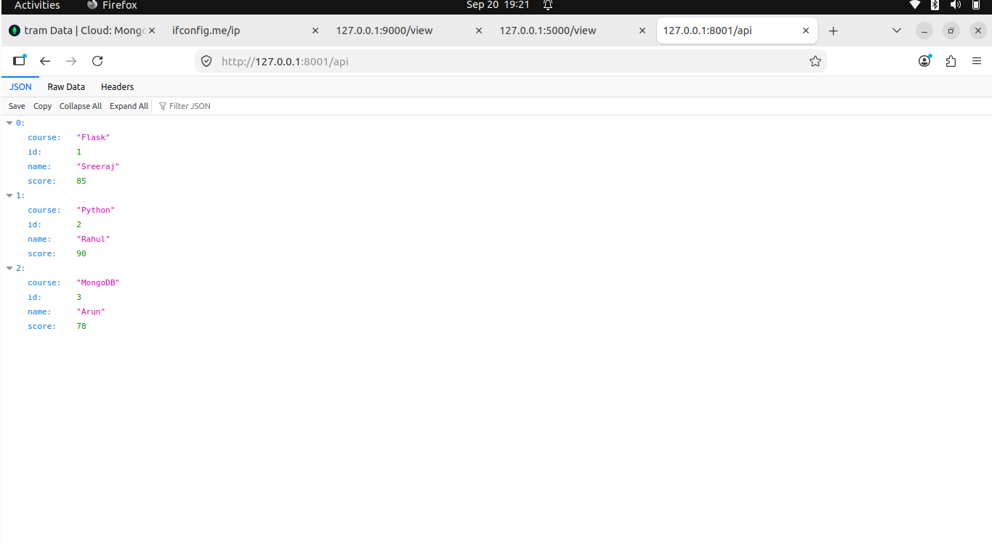
Figure 1: Task 1 Flask source code, data file, and running application.

Task 1 – API Result
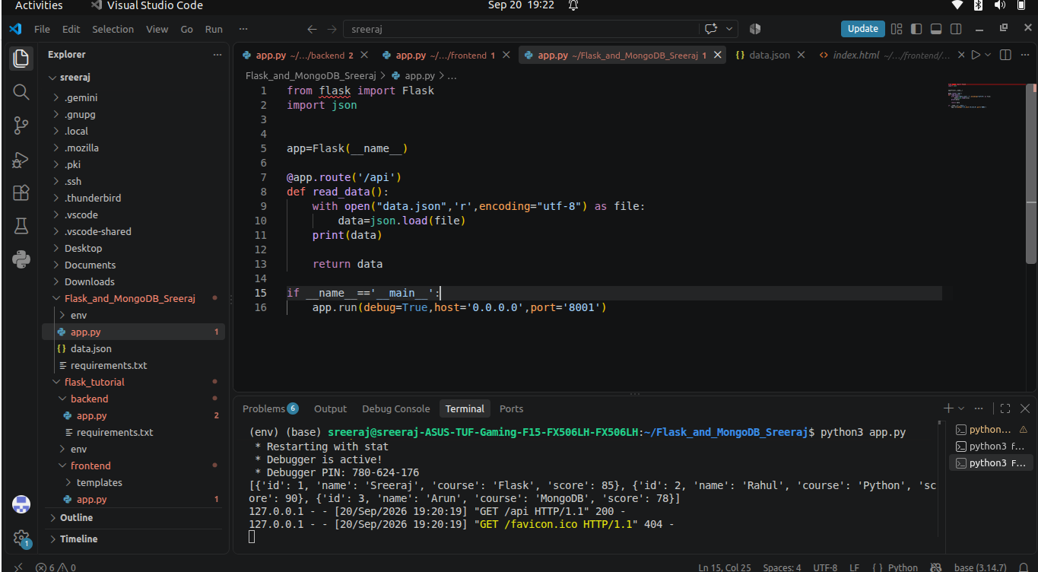
Figure 2: The /api endpoint returning the JSON list in the browser.
The browser response confirms that the JSON records were successfully read from the file and returned by the Flask API.

3. Task 2 – Flask Form and MongoDB Atlas
The objective of Task 2 was to create a frontend form that submits data to a Flask backend, stores the submitted data in MongoDB Atlas, and handles success and error cases.

Implementation
- Created a frontend Flask application containing the signup form.
- Created a separate backend Flask application.
- The frontend sends the submitted form data to the backend using an HTTP POST request.
- The backend receives the form data and inserts it into the MongoDB Atlas collection.
- Added a password/confirm-password check so a validation error is displayed on the same page when the values do not match.

Application Flow
Signup Form → Frontend Flask → Backend Flask → MongoDB Atlas

Successful Submission
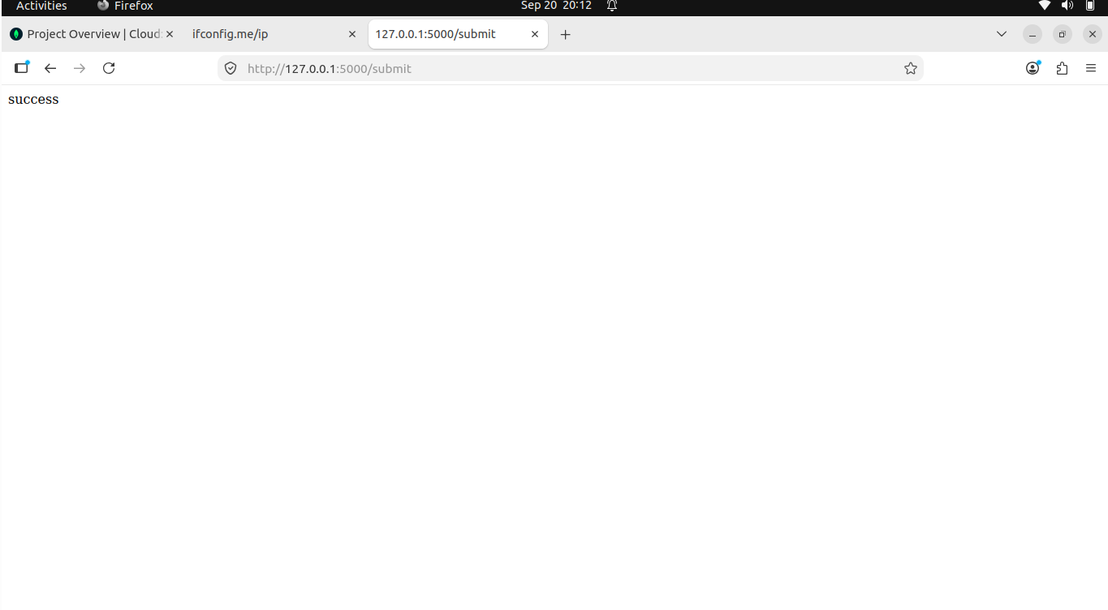
Figure 3: Successful form submission.

MongoDB Atlas Result
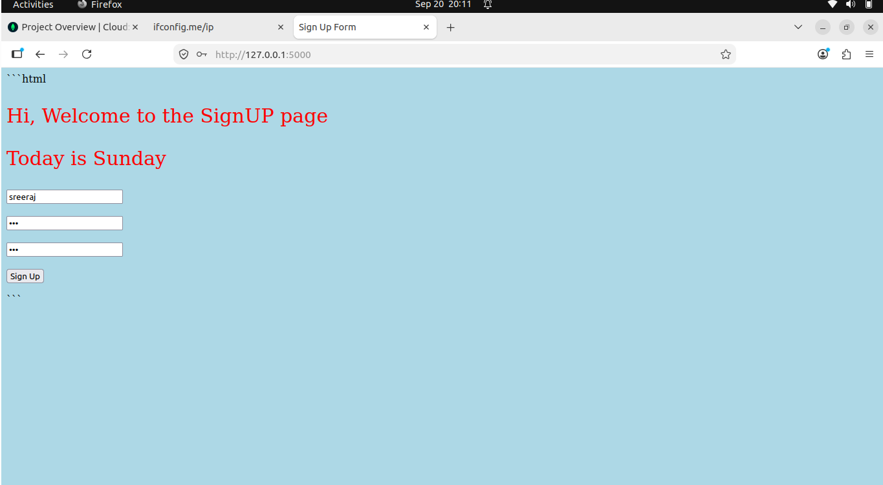
Figure 4: Submitted data stored and viewed through the MongoDB-backed application.
The result confirms that the submitted form data reached the backend and was stored in the MongoDB collection.

Error Handling
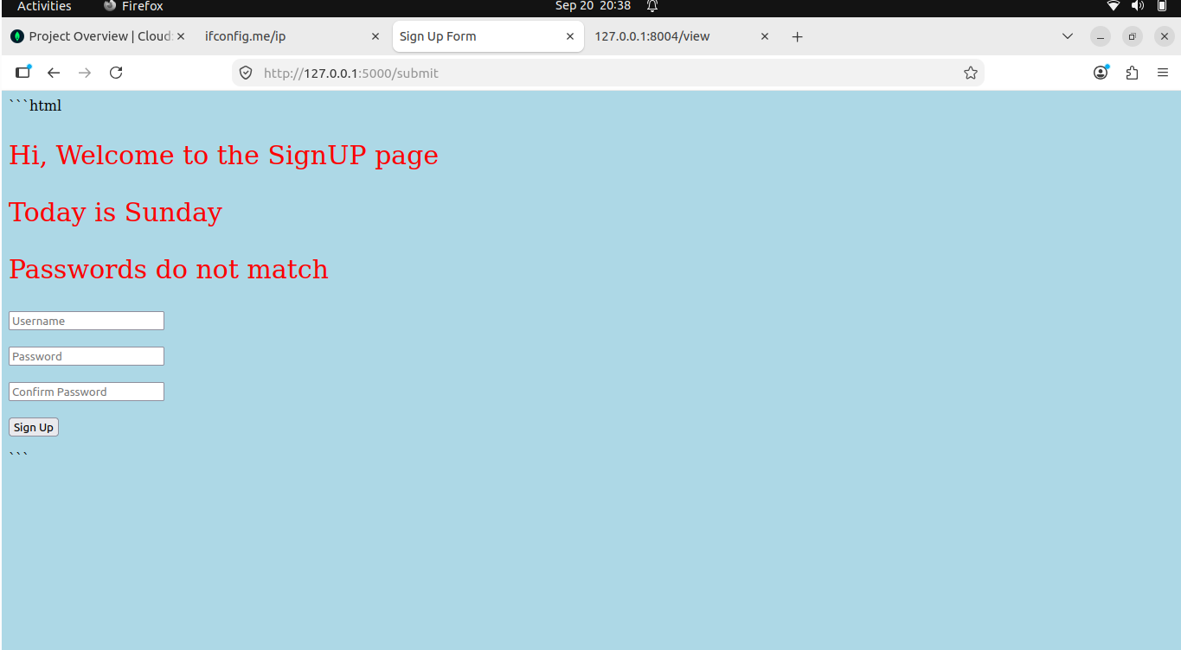
Figure 5: Validation error displayed on the same signup page when passwords do not match.
When the password and confirm-password fields do not match, the request is stopped before the database submission and the error message is displayed on the same page. No redirection occurs.

4. Completion Summary
Requirement | Status
Task 1 – Flask /api JSON API | Completed
Task 1 – Read data from JSON file | Completed
Task 2 – Frontend signup form | Completed
Task 2 – Store data in MongoDB Atlas | Completed
Task 2 – Successful submission | Completed
Task 2 – Error displayed on same page | Completed

5. GitHub Repository
GitHub Repository:https://github.com/Sreeraj-1999/Linux_Basics

