
Job Application Form
Date:
- Personal Information
Full Name（in English） |  | Sreeram Sadanandan |  |  |  | Gender | Male |  | （photo）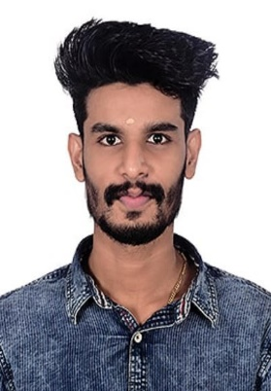
Date of Birth(D/M/Y) |  | 05/09/1999 |  |  |  | Nationality | Indian
Marital Status |  | Single |  |  |  | Religion | Hindu
Any Kids |  | No |  |  |  | Available OnboardDate | 19/06/2023
Highest Education Degree |  | B.Tech |  |  |  | Major | Mechanical Engineer
Current Address |  | Muchiruparambil house  Peringandoor P.O  Thrissur,680581 |  |  |  | Expected Work Location | Mumbai, Karur
English Level |  |  |  |  |  | Current Income | 15000
Tel |  | 9605027449 |  |  |  | Expected Income | 34000
Email |  | sreeramsreez4536@gmail.com |  |  |  | Skype
- Education Background
Time Period(M/Y) |  |  |  |  | College or University Name |  |  | Major & Degree | Minor (if applicable)
from | 2013 | to |  | 2015 | CBSE HIGH SCHOOL |  |  | 10th
from | 2015 | to |  | 2017 | HIGHER SECONDARY |  |  | 12th
from | 2017 | to |  | 2021 | KTU |  |  | B.Tech Mechanical
- Work Experience
Time Period（M/Y） |  |  |  |  | Company or Organization Name |  |  |  | Position
from | 2021 | to |  | 2022 | Steel And Industrial Forgings Ltd |  |  |  | Engineer Apprentice trainee
from |  | to
from |  | to
from |  | to
from |  | to
- Awards (if any)
Time |  |  | Awards |  |  |  |  | Remarks
- Family Member
Name |  |  | Relationship |  |  |  |  | Job Position
Sadanandan M K |  |  | Father |  |  |  |  | Retired government asst engineer
Sheela Sadanandan |  |  | Mother |  |  |  |  | Teacher
- Others
- What specific kinds of products are you familiar with regarding the quality control requirement or production process?

VSSC Company products, Aerospace Products, forged steel products
- Why are you looking to leave your current job? Can you provide the contact information of the former employer?
Current job is completed as 1 yr apprentice trainee
- What’s your career plan for the next three years?

To build experience in quality control of products
- Do you use English in your job? Can you finish an English inspection report without translation tools independently?
Yes I am familiar with english

- Working in an office or on a business trip, which working pattern do you prefer more? Can you accept a job with frequent business trips?
Yes I can prefer business trips

- What are your advantage and disadvantage?
Advantages: I am a fast learner
I have good quality of being positive
Good communication skill
Disadvantages: I need time to adapt with difficult situations
Taking over responsibilities

- Please describe your personality. What are your hobbies or special skills?
I am a self motivated person, and more enthusiastic to learn new things. My hobbies is dancing travelling etc. technical skills I have is knowledge in autocad solidworks also familiar with non destructive testing. My personal skills are multitasking and time management

- How did you hear about the position? (Please type yes or the specific channel)
From a friend or colleague: _____________
Facebook: _____________
LinkedIn: _____________
Job Website: (Please elaborate which specific website) __indeed__________________

I hereby declare that the above information is correct and the best of my knowledge.
Signature:
Date:

