

Student Name: Yanikepalli Sri Sekhar

Student Id Number: A000325769

Course: Masters in Data Analytics

Title of Assignment: Relational Database Report

Date: 11 December 2024

Declaration
I hereby certify that the material, which is submitted in this report towards the award of MSc. in Data Analytics, is entirely my own work and has not been submitted for any academic assessment other than part fulfilment of the above named award.

Signed Y.Sri Sekhar____________________ Date 11/12/2024______________

Table of Contents

Heading | Page no
- Introduction | 4
- Entities and Attributes | 5
- Entity Relationship Diagram (ERD) | 6
- Creating Queries (Creating the Tables) | 7-8
- Insert Queries (Inserting the values into tables) | 9-10
- Analytic Functions | 11-33
- You tube Links | 34

Introduction
The dataset contains two primary entities Hotel and Inspection providing a clear view of hotel operations, facilities and their compliance with health and safety standards. Thses tables are connected with a “Hotel_Id” attribute which is the common identifier in both Hotel and Inspection tables, “Hotel_Id” is the primary key (PK) in Hotel table and foreign key (FK) in Inspection table.

Hotel Table
The Hotel table contains some attributes which defines the critical information about the hotel. The attributes in which Hotel table contains are:
(Hotel_Id (PK), Name, Town, County, Web_Site, Year_Opened, Grade (3 Star, 4 Star, 5 Star), Num_Bedrooms, Cost, Specialism (one of Weddings, Concerts, Exhibitions), Num_Events (total number of events in a typical year - Weddings, Concerts etc) Market_Value)

Inspection Table
The Inspection table contains some attributes which defines the critical information about the hotel inspection. The attributes in which Inspection table contains are:
(Inspection_Id (FK), Hotel_Id, Visit_Date, Overall_Score (value between 1 and 100), Outcome (One of Pass or Fail), Storage (i.e Quality of Storage Facilities for food – one of Poor, Fair, Adequate, Superb), Fine_Imposed(the amount of money the hotel was fined for failing a test, otherwise Null), Food_Prep_Area (Poor, Good, Excellent), Hygiene (Very Dirty, Satisfactory, Very Clean), Atmosphere (Poor, Good, Excellent), Staff_Expertise ( i.e. how well the hotel staff understand Health and Safety one of - Fair, Satisfactory, Excellent), Hotel_Id)

Purpose of the Dataset
The dataset gives the result by combining operational data with inspection outcomes. The outcomes may useful to stakeholders can make informed decisions about investments, regulatory interventions, and service improvements in the hospitality industry.

Entities and Attributes
Entities
There is only two entities in these two table that is Hotel and Inspection.
Attributes
There are total 12 attributes in Hotel table, they are
Hotel_Id Number(3)
Name Varchar(35)
Town Varchar(15)
County Varchar(9)
Web_Site Varchar(131)
Year_Opened Number(4)
Grade Varchar(26)
Num_Bedrooms Number(2)
Cost Number(6)
Specialism Varchar(11)
Num_Events Number(1)
Market_Value Varchar2(12)

There are total 11 attributes in Inspection table, they are
Inspection_Id Number(4)
Hotel_Id Number(3)
Visit_Date Date
Overall_Score Number(2)
Outcome Varchar(4)
Storage Varchar(8)
Fine_Imposed Number(4)
Food_Prep_Area Varchar(9)
Hygiene Varchar(12)
Atmosphere Varchar(9)
Staff_Expertise Varchar(12)
Entity Relationship Diagrams (ERD)

Entity Relationship Diagram with attributes

Hotel Inspection
Inspection_Id (PK)
Hotel_Id
Visit_Date
Date
Overall_Score
Outcome
Storage
Fine_Imposed
Food_Prep_Area
Hygiene
Atmosphere
Hotel_Id (FK)
Staff_Expertise

Hotel_Id (PK)
Name
Town
County
Web_Site
Year_Opened
Grade
Num_Bedrooms
Cost
Specialism
Num_Events
Market_Value

Subjected to

Lot of

Entity Relationship Diagram without attributes

Subjected to
Hotel
Inspection

Lot of

Creating Queries (Creating the table)
Set SQLPrompt A00325769_SQL>
Set Pagesize 60
Set Linesize 180
Set Echo On
Set Feedback On
Set Termout On
Set Verify On
Create Table Hotel(
Hotel_Id Number(3), Hotel_Id (PK)
Name Varchar(35),
Town Varchar(15),
County Varchar(9),
Web_Site Varchar(131),
Year_Opened Number(4),
Grade Varchar(26),
Num_Bedrooms Number(2),
Cost Number(6),
Specialism Varchar(11),
Num_Events Number(1),
Market_Value Varchar2(12),
Constraint Hotel_Hotel_Id_PK Primary Key (Hotel_Id),
Constraint Hotel_Grade Check(Grade In( '3 Star', '4 Star', '5 Star')),
Constraint Hotel_Specialism Check(Specialism In('Weddings', 'Concerts', 'Exhibitions')));
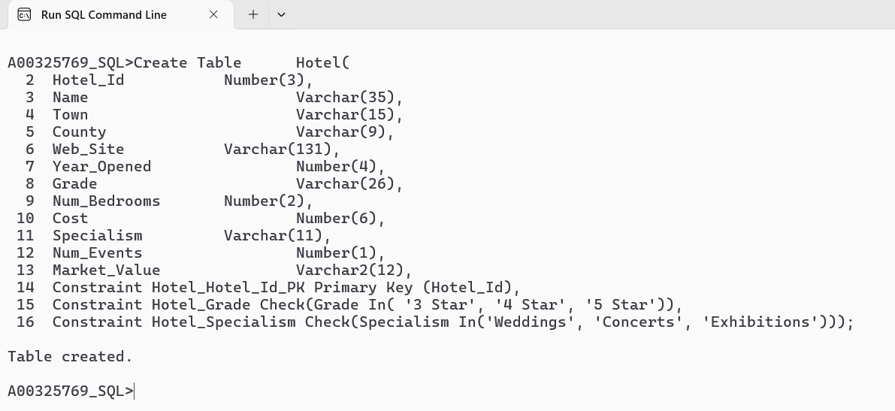

Create Table Inspection(
Inspection_Id Number(4), Inspection_Id(PK)
Hotel_Id Number(3),
Visit_Date Date,
Overall_Score Number(2),
Outcome Varchar(4),
Storage Varchar(8),
Fine_Imposed Number(4),
Food_Prep_Area Varchar(9),
Hygiene Varchar(12),
Atmosphere Varchar(9),
Staff_Expertise Varchar(12),
Constraint Inspection_Hotel_Id_Fk Foreign Key (Hotel_Id) References Hotel(Hotel_Id),
Constraint Inspection_Inspection_Id_PK Primary Key (Inspection_Id),
Constraint Inspection_Overall_Score Check(Overall_Score Between 1 And 100),
Constraint Inspection_Outcome Check(Outcome In('Pass', 'Fail')),
Constraint Inspection_Storage Check(Storage In('Poor', 'Fair', 'Adequate', 'Superb')),
Constraint Inspection_Food_Prep_Area Check(Food_Prep_Area In('Poor', 'Good', 'Excellent')),
Constraint Inspection_Hygiene Check(Hygiene In('Very Dirty', 'Satisfactory', 'Very Clean')),
Constraint Inspection_Atmosphere Check(Atmosphere In('Poor', 'Good', 'Excellent')),
Constraint Inspection_Staff_Expertise Check(Staff_Expertise In('Fair', 'Satisfactory', 'Excellent')));
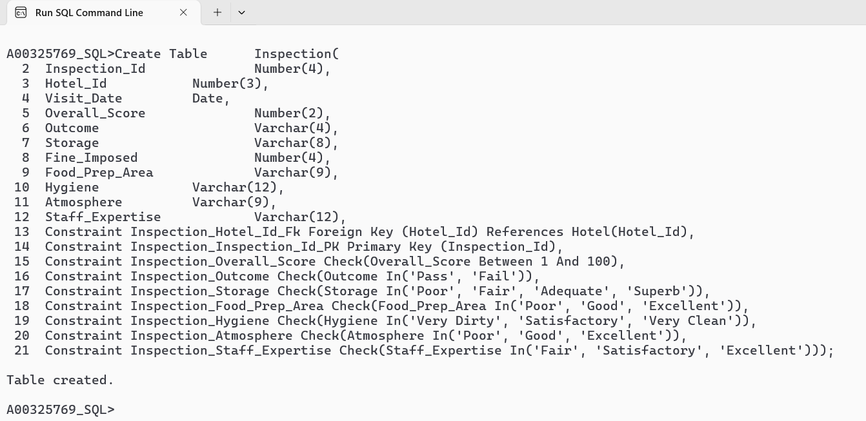
Insert Queries (Inserting the values into tables)
insert into Hotel values(100,'Step House Hotel','Graiguenamanagh','Carlow','https://www.stephousehotel.ie/',2007,'4 Star',20,170.59,'Weddings',5,' 1.6 million');
insert into Hotel values(101,'Woodford Dolmen Hotel','Clonegal','Carlow','https://www.woodforddolmenhotel.ie/',1976,'4 Star',81,81,'Weddings',3,'1.5 million');
insert into Hotel values(102,'Borrow View Bread and Breakfast','Borris','Carlow','http://www.barrowviewbedandbreakfast.com/',2005,'4 Star',10,86,'Concerts',3,'1.8 million');

same insert Queries for 30 entries to Hotel Table
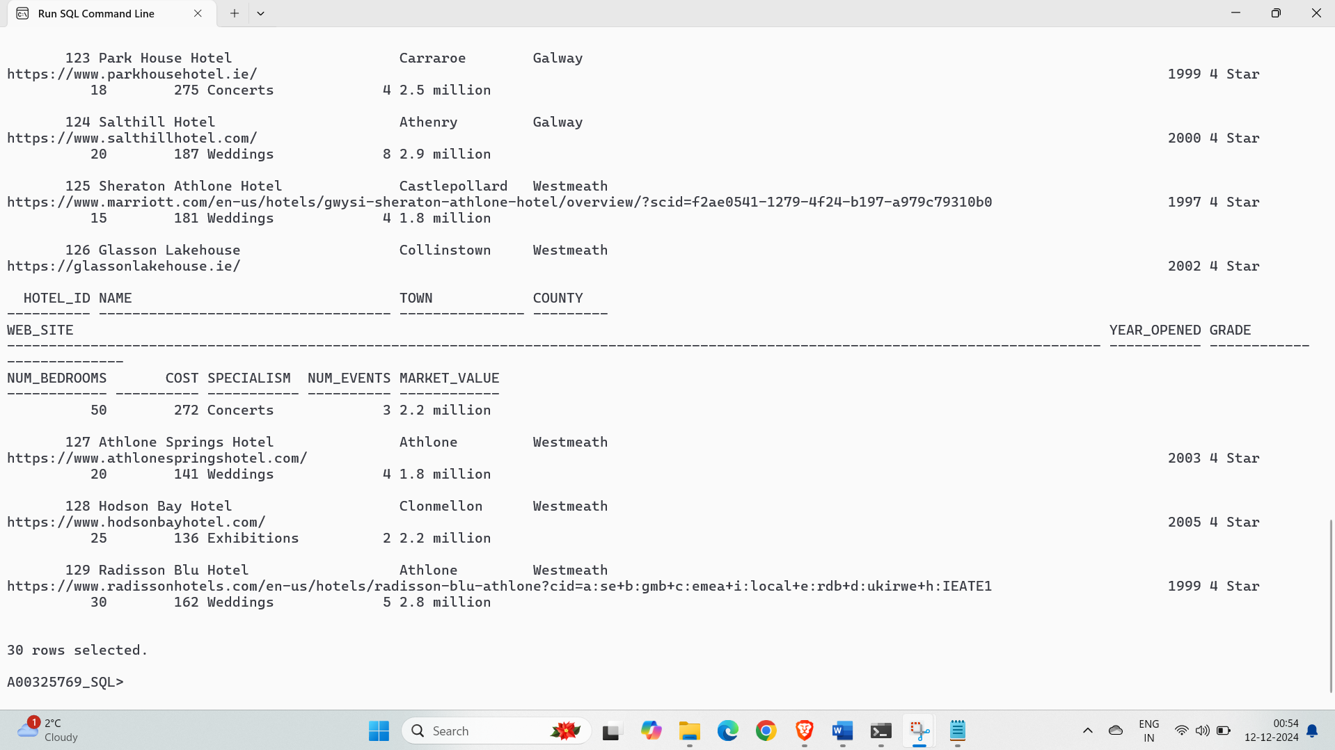

Insert Into Inspection Values(3935,100,'17-Jul-2024',81,'Fail','Adequate',200,'Excellent','Very Clean','Good','Satisfactory');
Insert Into Inspection Values(9763,101,'05-Jun-2024',78,'Pass','Poor',300,'Good','Very Dirty','Poor','Excellent');
Insert Into Inspection Values(6426,102,'15-Apr-2024',65,'Pass','Poor',100,'Good','Very Clean','Excellent','Excellent');
Insert Into Inspection Values(1566,103,'17-Oct-2024',53,'Pass','Fair',null,'Good','Very Clean','Poor','Fair');
Insert Into Inspection Values(5029,104,'10-Mar-2024',82,'Pass','Poor',200,'Good','Satisfactory','Good','Excellent');

same insert Queries for 70 entries to Inspection Table

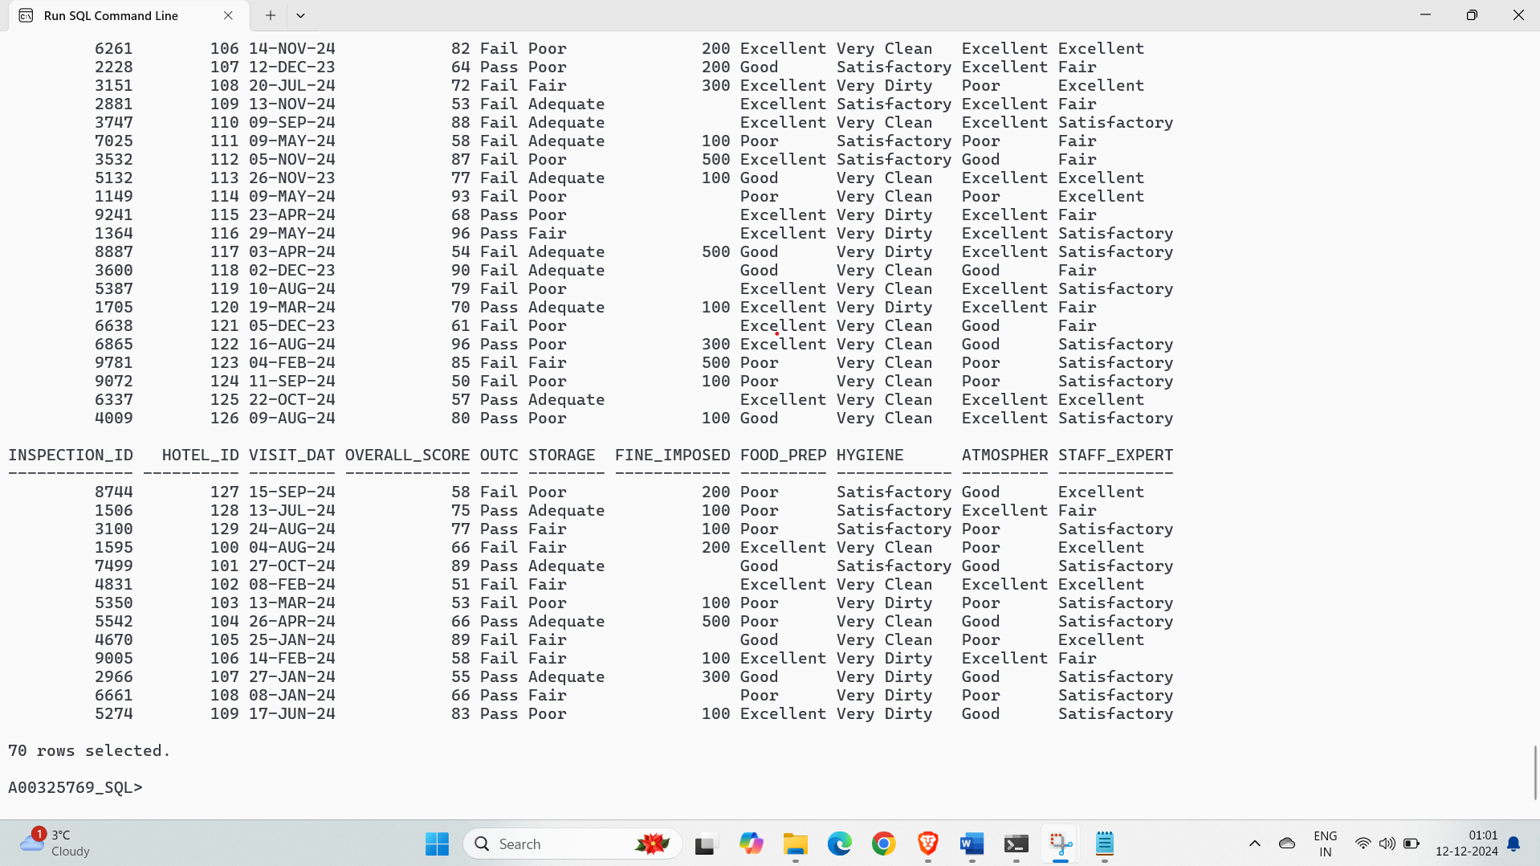

Oracle SQL_Analytic Functions
1.List the name, hotel id, and cost for each individual hotel plus the overall total cost for all hotels. Where specialism is weddings. Sort the results by hotel name, hotel id.
Cl scr
Select Name, Hotel_Id, Cost,
Sum(Cost) Over () Total_Cost
From Hotel
Where Specialism = ('Weddings')
Order By Name, Hotel_Id;

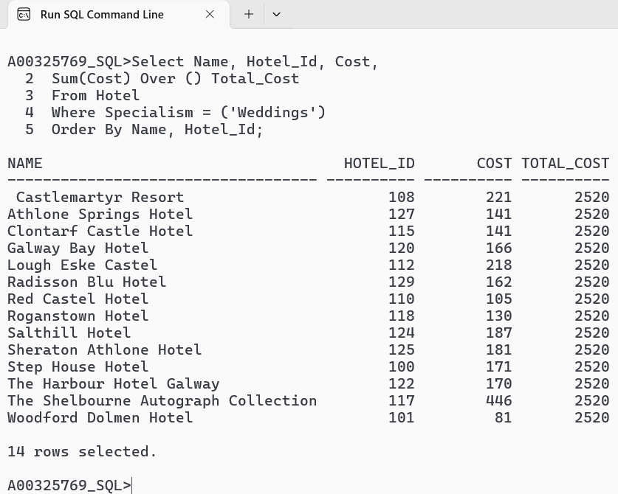

2. List the name, Hotel id, and cost for each individual hotel plus the largest cost among the hotels where specialism is in concert. In addition, calculate and display the amount each individual cost falls short of the largest cost. Sort the results by hotel id and name.
CI scr
Select Name, Hotel_Id, Cost,
Max(Cost) Over () Top_Cost,
Max(Cost) Over () – Cost Less_Cost
From Hotel
Where Specialism = ('Concerts')
Order By Hotel_Id, Name;

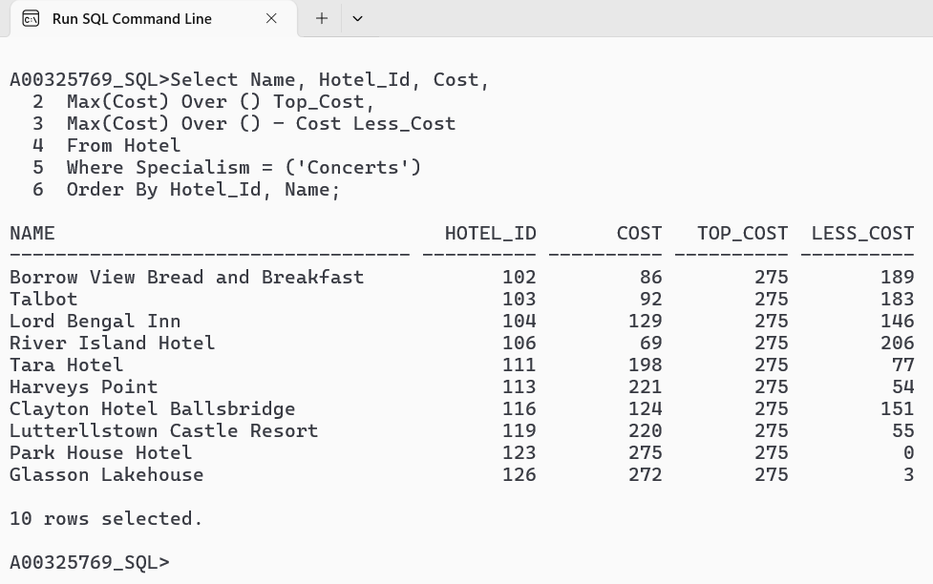

3. List the name and cost for each individual hotel plus the largest and smallest costs among hotels. [In addition, calculate and display the amount each individual cost falls Short of the largest cost, and the amount each individual cost exceeds the smallest cost. Whose hotel name starts with L, Sort the results by hotel id, and then by hotel name.
Cl scr
Select Name, Cost,
Max(Cost) Over () Top_Cost,
Min(Cost) Over () Worst_Cost,
Cost - Min(Cost) Over () Excess
From Hotel
Where Name Like 'L%'
Order By Hotel_Id, Name;

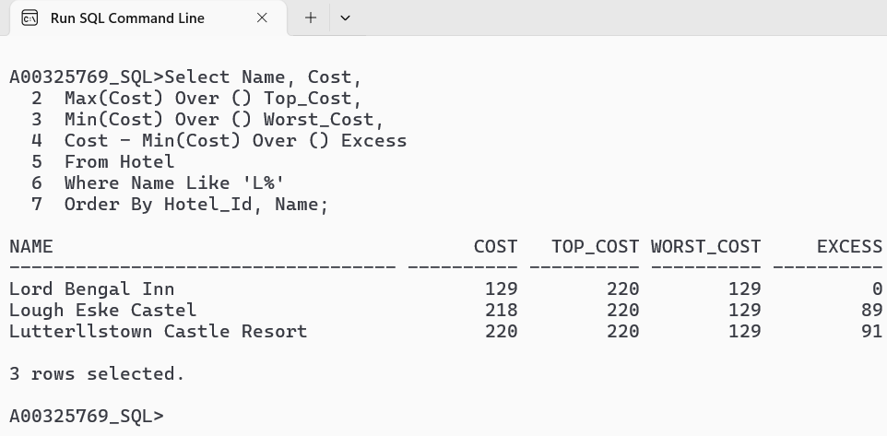

4. List the name, hotel id, and cost for each individual hotel plus the lowest, highest, average, and overall total cost for all hotels and the county is cork. Sort the results by hotel id, and then by hotel name.
Cl scr
Select Name, Hotel_Id, Cost,
Max(Cost) Over () Top_Cost,
Min(Cost) Over () Bottom_Cost,
Avg(Cost) Over () Avg_Cost,
Sum(Cost) Over () Total_Cost
From Hotel
Where County = ('Cork')
Order By Hotel_Id, Name;

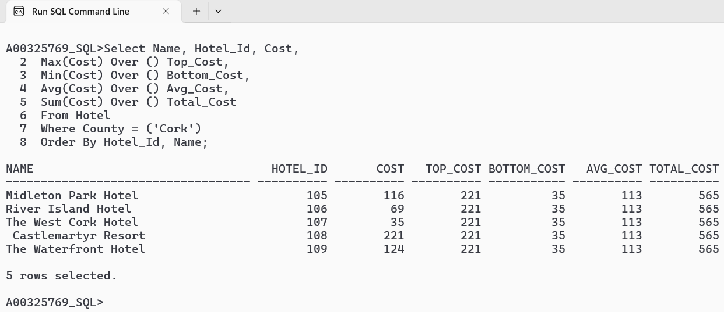

5. List name, hotel id, and cost for each 'individual hotel plus the lowest, highest, average, and cost for hotels and the hotel opened between 1999 and 2005. Sort the results by hotel id (ascending order) and then by hotel name.
Cl scr
Select Name, Hotel_Id, Cost,
Max(Cost) Over (Order By Hotel_Id) Top_Cost,
Min(Cost) Over (Order By Hotel_Id) Bottom_Cost,
Avg(Cost) Over (Order By Hotel_Id) Avg_Cost,
Sum(Cost) Over (Order By Hotel_Id) Total_Cost
From Hotel
Where Year_Opened Between 1999 And 2005
Order By Hotel_Id, Name;

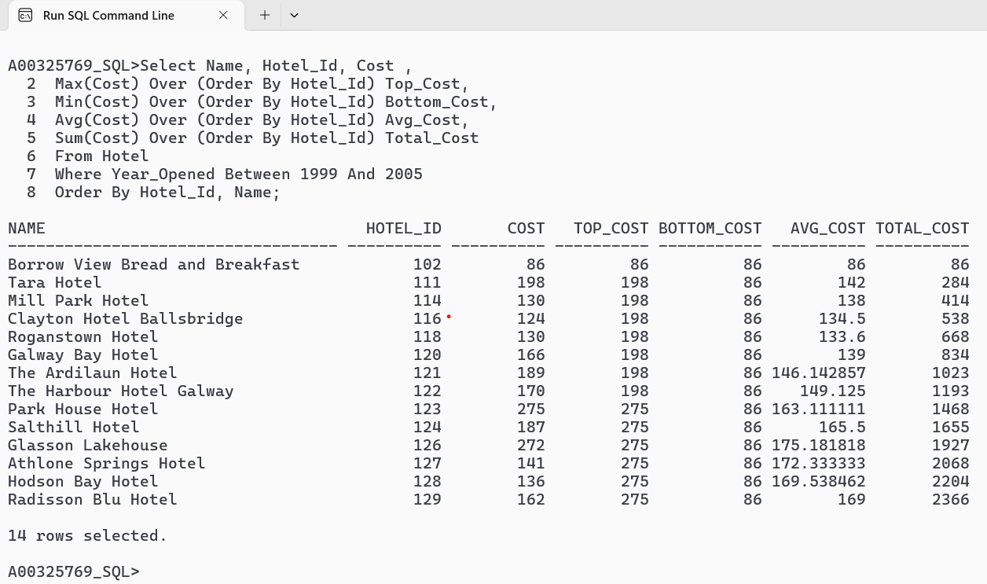

6. List name, hotel id, and cost for each individual hotel plus the lowest, highest, average, and cost for hotels and the hotel opened between 1999 and 2005. Sort the results by hotel id (descending order) and then by hotel name.
Cl scr
Select Name, Hotel_Id, Cost,
Max(Cost) Over (Order By Hotel_Id Desc) Top_Cost,
Min(Cost) Over (Order By Hotel_Id Desc) Bottom_Cost,
Avg(Cost) Over (Order By Hotel_Id Desc) Avg_Cost,
Sum(Cost) Over (Order By Hotel_Id Desc) Total_Cost
From Hotel
Where Year_Opened Between 1999 And 2005
Order By Hotel_Id Desc, Name;

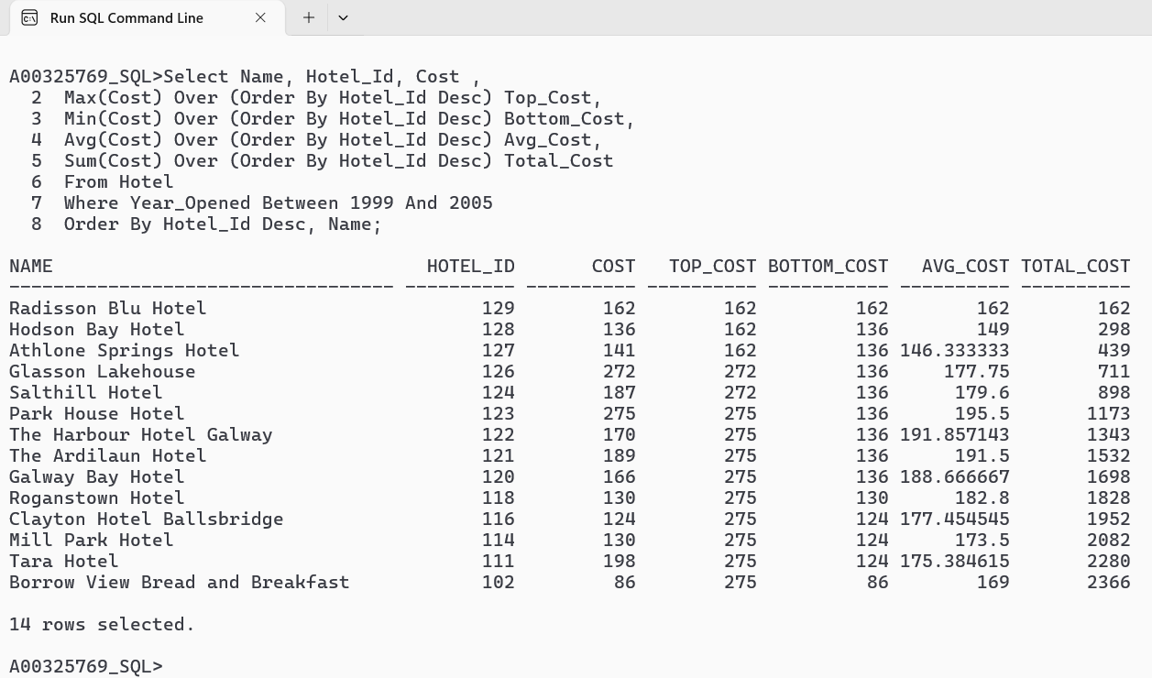

7. List name, hotel id, and cost for each individual hotel plus the lowest, highest, average, and total cost for hotels and name starts with T. Sort the results by Name.
Cl scr
Select Name, Hotel_Id, Cost,
Max(Cost) Over (Order By Name) Top_Cost,
Min(Cost) Over (Order By Name) Bottom_Cost,
Avg(Cost) Over (Order By Name) Avg_Cost,
Sum(Cost) Over (Order By Name) Total_Cost
From Hotel
Where Name Like 'T%'
Order By Name;

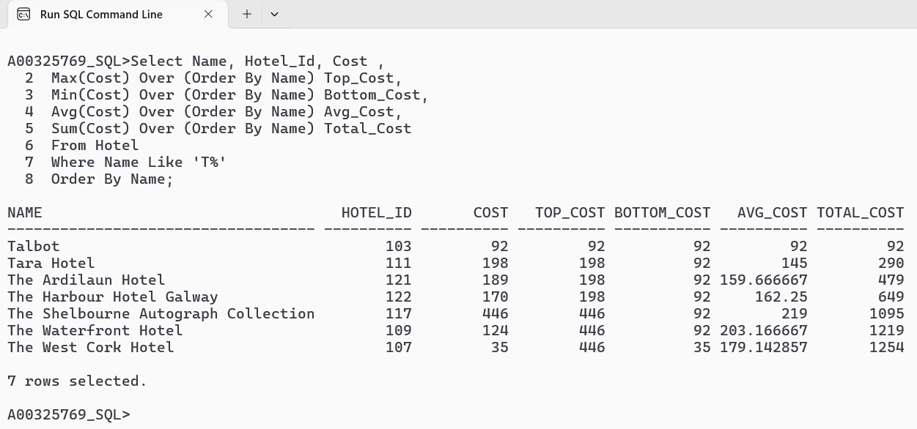

8. List name, hotel id, and cost for each individual hotel plus the lowest, highest, average, and total cost for hotels and bedrooms must be 10 . Sort the results by Hotel id and Name
Cl scr
Select Name, Hotel_Id, Cost,
Max(Cost) Over (Order By Name) Top_Cost,
Min(Cost) Over (Order By Name) Bottom_Cost,
Avg(Cost) Over (Order By Name) Avg_Cost,
Sum(Cost) Over (Order By Name) Total_Cost
From Hotel
Where Num_Bedrooms = 10
Order By Hotel_Id, Name;

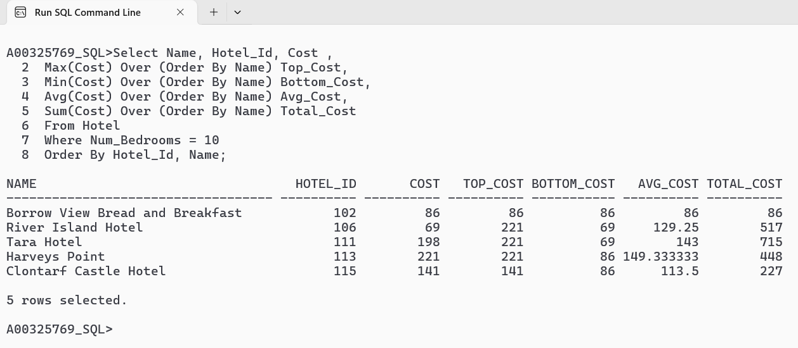

9.List name, hotel id, and cost for each individual hotel as well as the number of bedrooms In each hotel and cumulative running cost total for hotels at the county cork and carlow. Sort the results by hotel id and then by hotel name.
Cl scr
Select Name, Hotel_Id, Cost,
Sum(Cost) Over (Partition By Specialism) Specialism_Total,
Count(*) Over (Partition By Specialism) Num_Bedrooms
From Hotel
Where County In ('Cork', 'Carlow')
Order By Hotel_Id, Name;

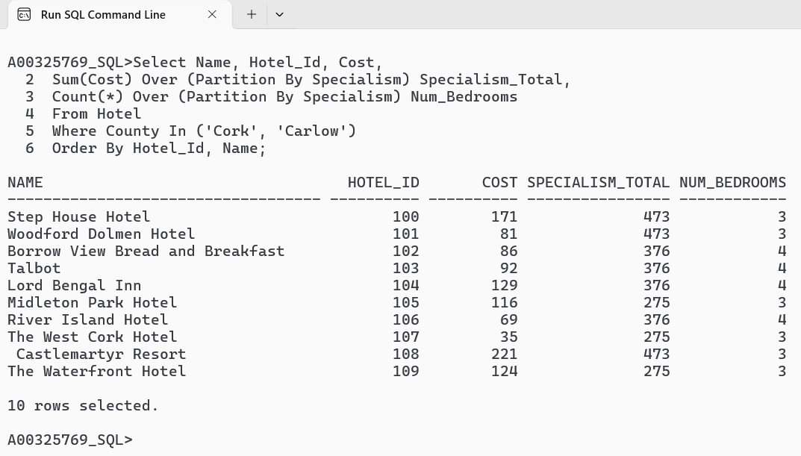

10.List name, hotel id, and cost for each individual hotel as well as the number of bedrooms In each hotel and cumulative running cost total for hotels at the county cork and carlow. Sort the results by hotel id and then by hotel name.
Cl scr
Select Name, Hotel_Id, Cost,
Sum(Cost) Over (Partition By Specialism Order By Hotel_Id, Name) Specialism_Total,
Count(*) Over (Partition By Specialism Order By Hotel_Id, Name) Num_Bedrooms
From Hotel
Where County In ('Cork', 'Carlow')
Order By Hotel_Id, Name;

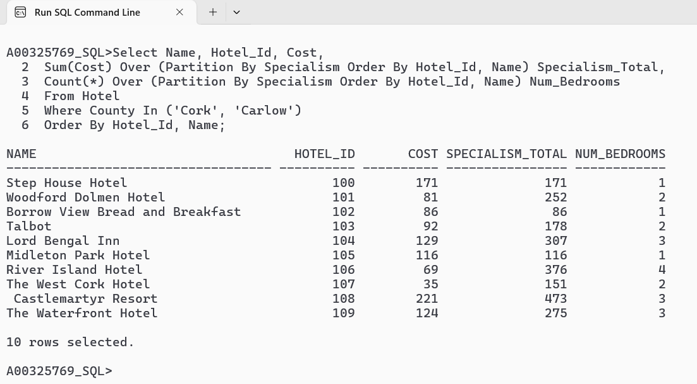

11. List name, Grade, hotel id, and cost for each individual hotel as well as a cumulative running cost total for hotels at the county cork and dublin. Sort the results by hotel id and then by hotel name
Cl scr
Select Name, Grade, Hotel_Id, Cost,
Sum(Cost) Over (Partition By Specialism) Specialism_Total,
Max(Cost) Over (Partition By Specialism) Specialism_Max,
Min(Cost) Over (Partition By Specialism) Specialism_Min
From Hotel
Where County = 'Dublin'
Order By Hotel_Id, Name;

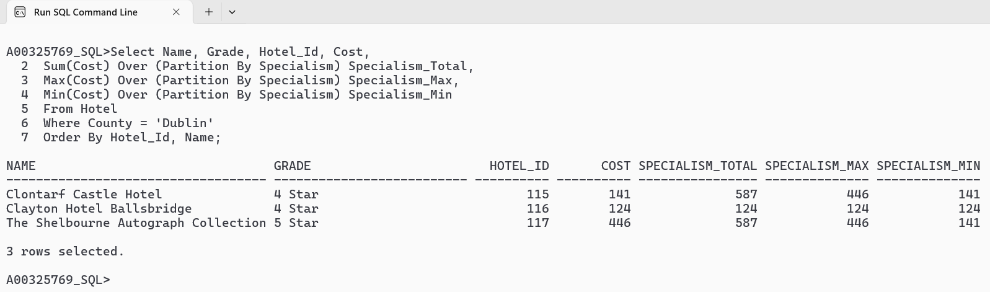

12. List the name, Grade, hotel id, and cost for each individual hotel located in galway as well as a cumulative running cost total and average cost for hotels broke down by grade. Sort the results by Grade and then by hotel name
Cl scr
Select Name, Grade, Hotel_Id, Cost,
Sum(Cost) Over (Partition By Grade Order By Name) Grade_Total,
Avg(Cost) Over (Partition By Grade Order By Name) Grade_Avg
From Hotel
Where County = 'Galway'
Order By Grade, Name;

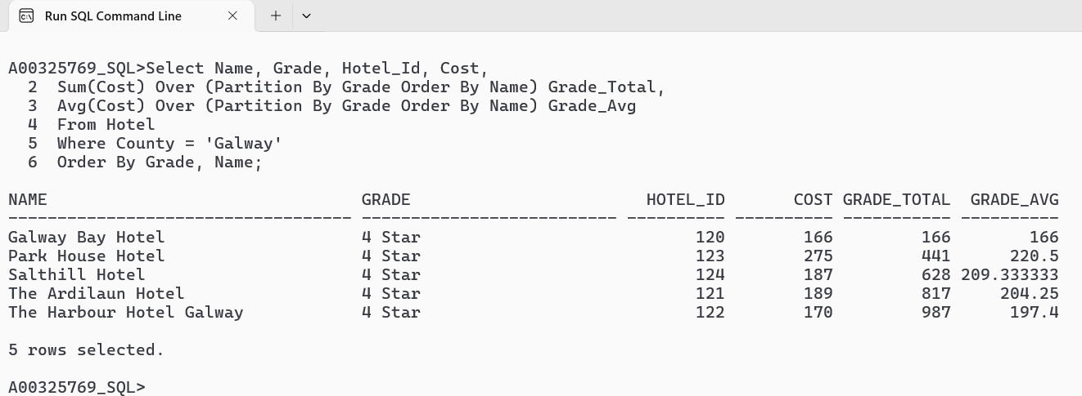

13.List the Name, cost, county, hotel id, cost for each hotel as well as a cumulative running cost for the current hotels plus the two earlier/ previous hotels processed at the name (i.e there should be no overlap between names) where specialism in concerts. Sort the output by county and then hotel name.
Cl scr
Select Name, Cost, County, Hotel_Id,
Sum(Cost) Over (Partition By County Order By Name Rows 2 Preceding) Cost_Total
From Hotel
Where Specialism = 'Concerts'
Order By County, Name;

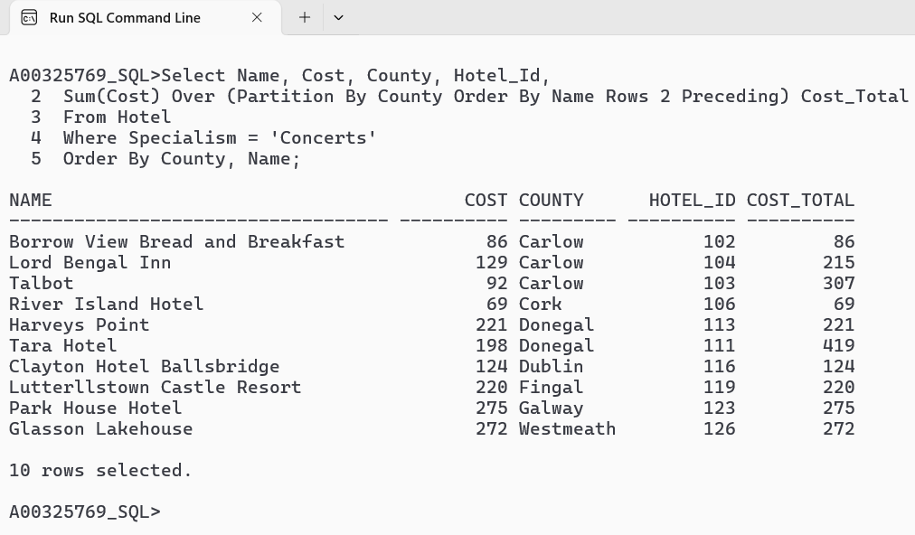

14. List the Atmosphere, visit date, storage, and fine imposed, and what is the cumulative total of fines imposed over the past 90 days for each atmosphere category, for inspections where the storage condition was Poor.
Cl scr
Select Atmosphere, Visit_Date, Storage, Fine_Imposed,
Sum(Fine_Imposed) Over (Partition By Atmosphere Order By Visit_Date Range 90 Preceding) Fine_Imposed_Total
From Inspection
Where Storage = 'Poor'
Order By Atmosphere, Visit_Date;

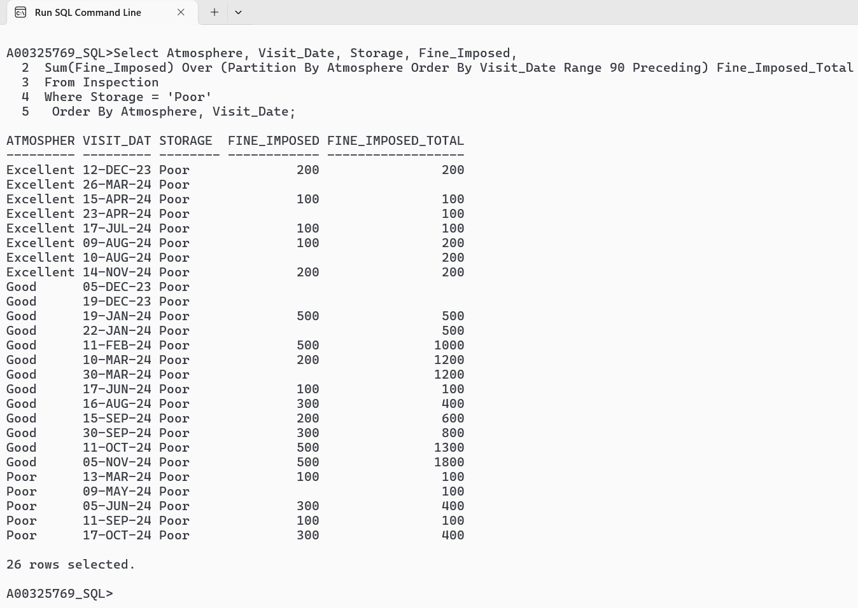

15.List the Atmosphere, visit date, storage, and fine imposed, and what is the cumulative total of fines imposed at any time during the year before and the year after the individual under consideration (i.e +365 days or -365 days) for each atmosphere category, for inspections where the storage condition was Poor.
Cl scr
Select Atmosphere, Visit_Date, Storage, Fine_Imposed,
Sum(Fine_Imposed) Over (Partition By Atmosphere Order By Visit_Date Range Between 365 Preceding And 365 Following) Fine_Imposed_Total
From Inspection
Where Storage = 'Poor'
Order By Atmosphere, Visit_Date;

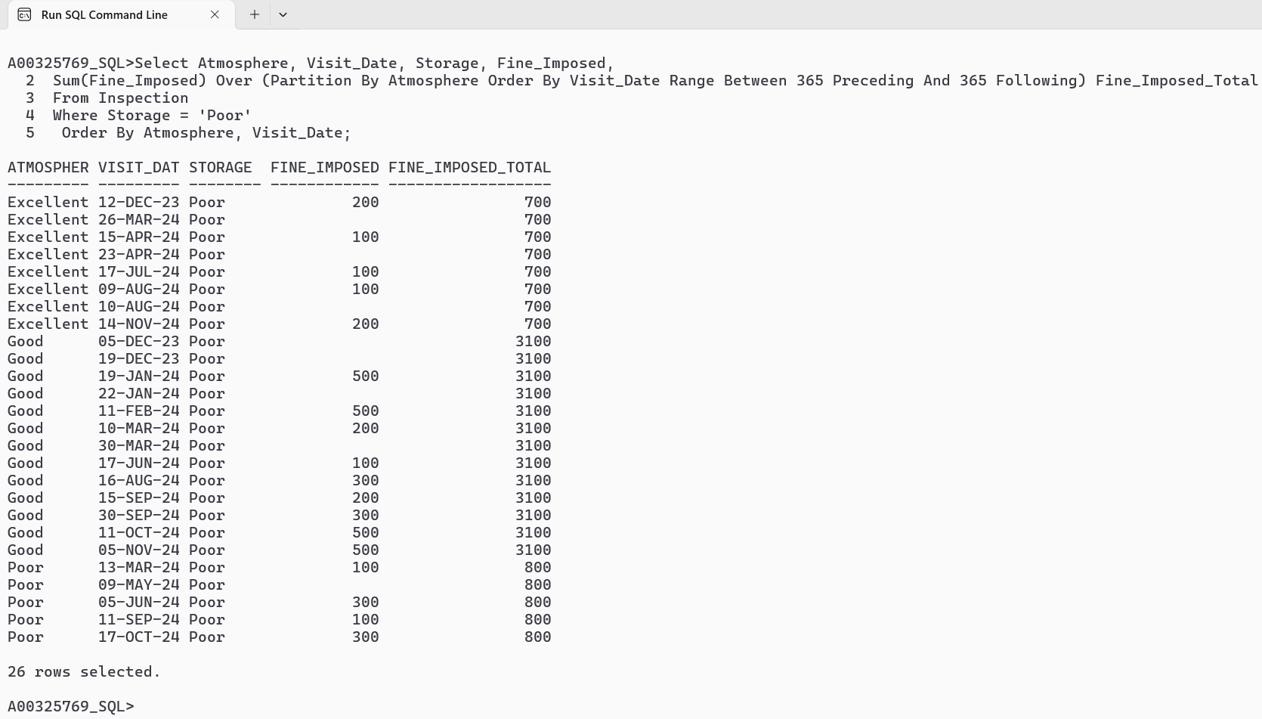

16.List the storage, outcome visit date recorded within a 100-day range for inspections that failed between January 1, 2024, and May 30, 2024, Arrange the results by visit date.
Cl scr
Select Storage, Visit_Date, Outcome, Visit_Date-100 Wind100_Dys,
First_Value(Storage) Over (Order By Visit_Date Asc Range 100 Preceding) Storage_1^{st,}
^{First_Value(Visit_Date)} Over (Order By Visit_Date Asc Range 100 Preceding) Vdate_1st
From Inspection
Where Outcome = 'Fail'
And Visit_Date Between '01-Jan-2024' And '30-May-2024'
Order By Visit_Date Asc;

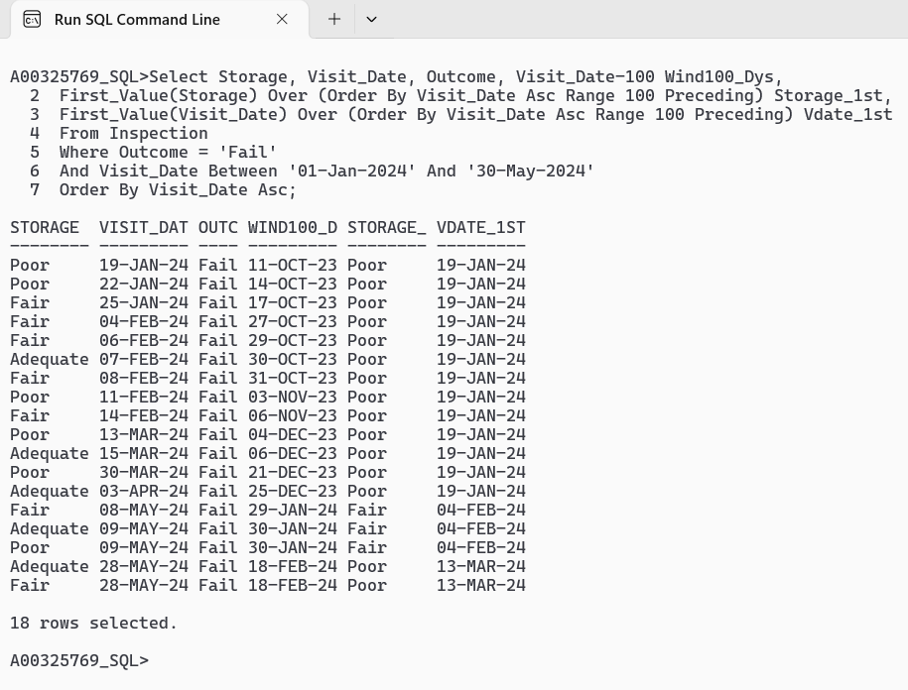

17.List the Storage, visit date,outcome, and fines imposed 30 days before and 30 days after each failed inspection between February 1, 2024, and March 30, 2024, and outcomes is fail, arrange the results by visit date.
Cl scr
Select Storage, Visit_Date, Outcome, Visit_Date-30 "30DyEar", Visit_Date + 30 "30DyLst",
Avg(Fine_Imposed) Over (Order By Visit_Date Asc Range 30 Preceding) Avg_Fine_Imposed_30Dy_Before,
Avg(Fine_Imposed) Over (Order By Visit_Date Desc Range 30 Preceding) Avg_Fine_Imposed_30Dy_After From Inspection
Where Outcome = 'Fail'
And Visit_Date Between '01-Feb-2024' And '30-Mar-2024'
Order By Visit_Date;

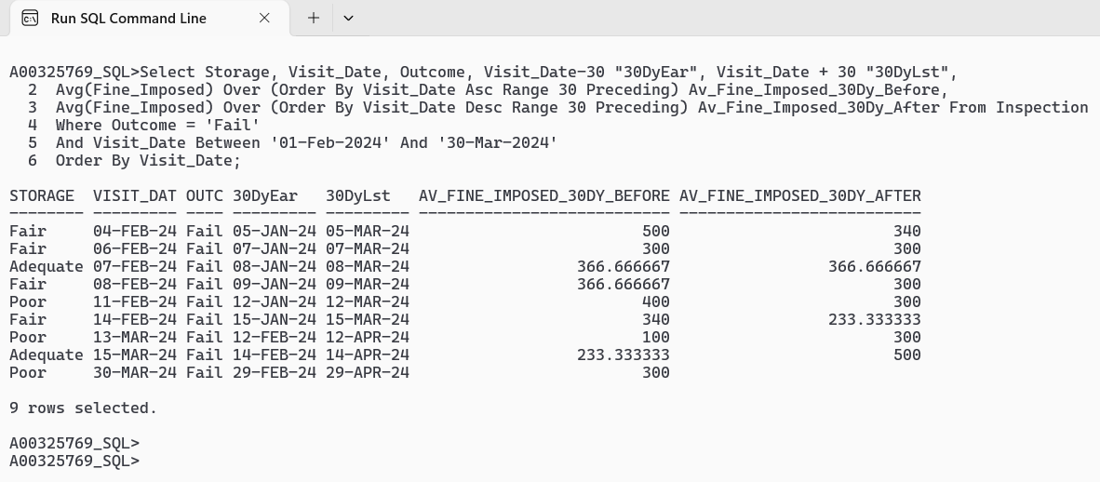

18. List the name, town, hotel id, county and cost from hotel and the total and average costs for hotels specializing in weddings, grouped by hotel, town, and county, arrange the results in hotel id.
Cl scr
Select Name, Town, Hotel_Id, County, Cost,
Sum (Cost) Over (Partition By Hotel_Id) Hotel_Id_Total,
Avg (Cost) Over (Partition By Town) Town_Total,
Sum (Cost) Over (Partition By County) County_Total
From Hotel
Where Specialism = 'Weddings'
Order By Hotel_Id;

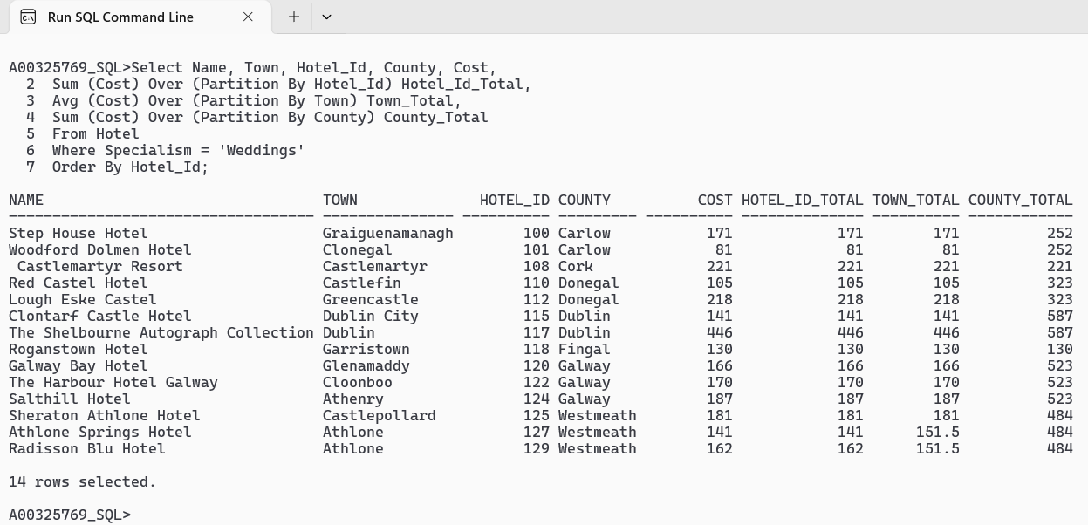

19. list the hotel name, town, cost, grade and number of for all the hotels with a Grade of 4 Star and at least 20 bedrooms, along with a running total of cost across all hotels, the total cost by town, and a sequential number for each hotel within the same town, sorted by town and name.
Cl scr
Break On Town Skip 1
Select Name, Town, Cost, Grade, Num_Bedrooms,
Sum(Cost) Over
(Order By Town, Name) Run_Total_All_Hotels,
Sum(Cost) Over
(Partition By Town) Total_By_Town,
Row_Number() Over
(Partition By Town Order By Name) Seq
From Hotel
Where Grade = '4 Star'
And Num_Bedrooms >= 20
Order By Town, Name;

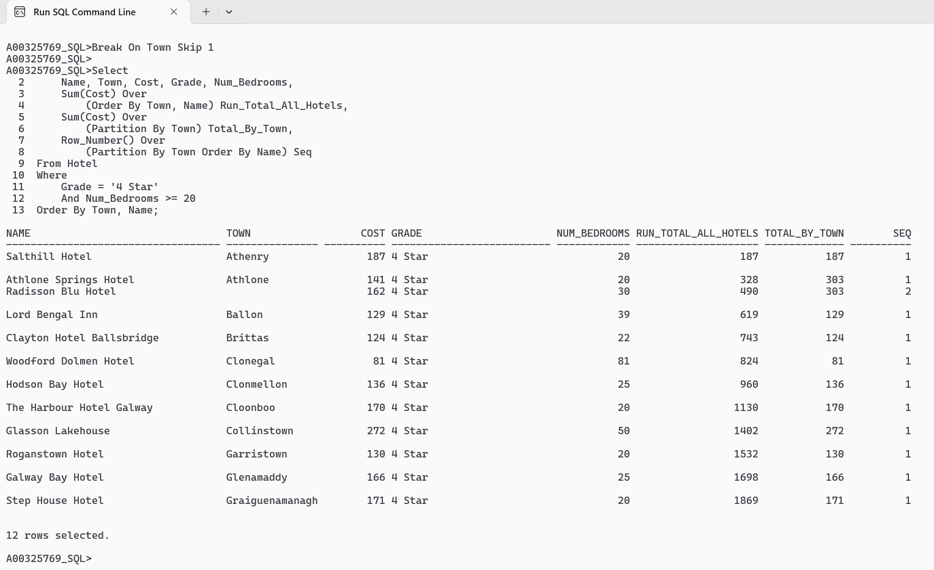

20. list the Inspection id, hotel id and visit date for the inspections where the Overall Score is greater than 80 and imposed a Fine Imposed. Additionally, display the first Outcome and Visit Date from the previous 5 rows ordered by Visit Date, and sort the results by Visit Date in ascending order.
Cl scr
Select Inspection_Id, Hotel_Id, Visit_Date,
FIRST_VALUE(Outcome)
OVER (ORDER BY Visit_Date ASC ROWS 5 PRECEDING) AS Outcome_Prec,
FIRST_VALUE(Visit_Date)
OVER (ORDER BY Visit_Date ASC ROWS 5 PRECEDING) AS VisitDate_Prec
FROM
Inspection
WHERE
Overall_Score > 80
AND Fine_Imposed > 0
ORDER BY
Visit_Date ASC;

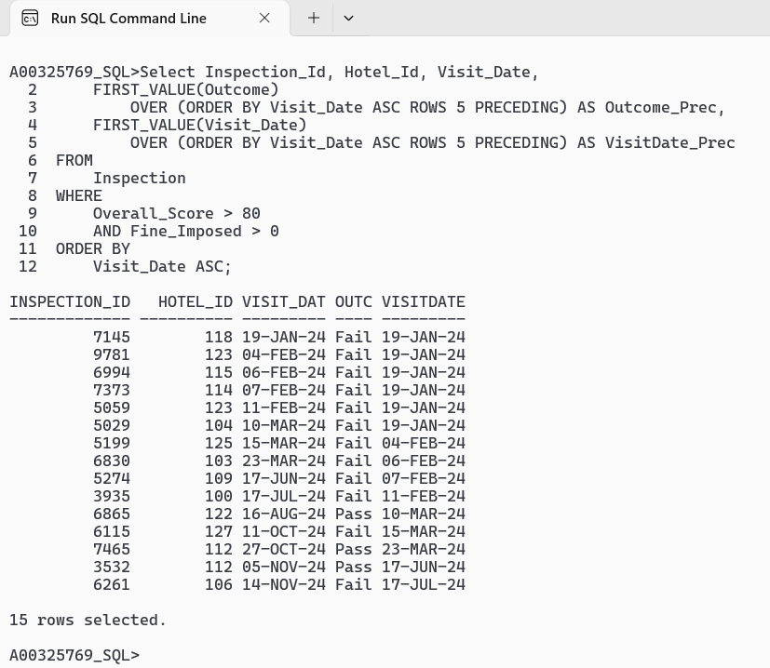

21. List the name, county and the year open of the hotels. Calculate the cumulative total of year opened for all hotels in the location of cork, sort the results by county and name.
Cl scr
Select Name, County, Year_Opened,
Sum(Year_Opened) Over
(Partition By County
Order By Name)County_Total
From Hotel
Where County = 'Cork'
Order By County, Name;

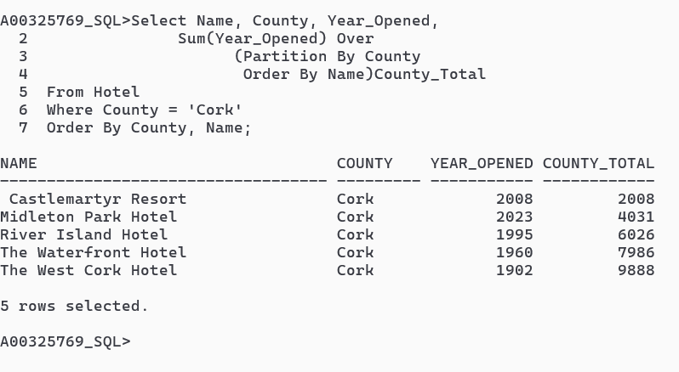

22. List the name, county, cost and the year open of each hotel. Insert the new column called running total that include cost of all hotels that located in the same or earlier county sort it by hotel name and county. And insert the new column called county hotel count where the hotels located in same county sort this by using hotel name, filter the hotels that located in the county called cork and Dublin sort the results with county and hotel name.
Cl scr
Select Name, County, Cost, Year_Opened,
(Select Sum(Cost)
From Hotel H2
Where H2.County < Hotel.County
Or(H2.County = Hotel.County AND H2.Name <= Hotel.Name))
Running_Total,
(Select Sum(Cost)
From Hotel H3
Where H3.County = Hotel.County
And H3.Name <= Hotel.Name)
County_Hotel_Count
From Hotel
Where County In ('Cork', 'Dublin')
ORDER BY County, Name;

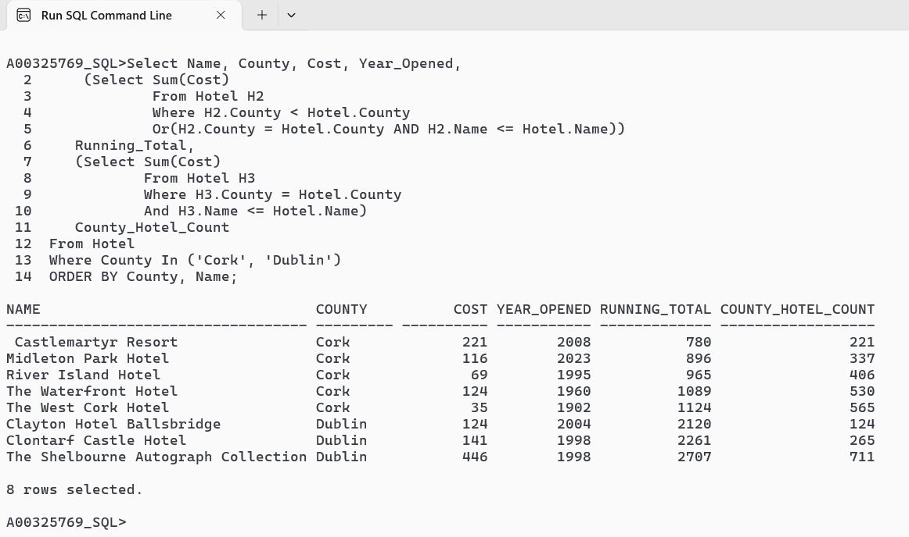
23. list the name and average cost of the hotels with multiple hotel names
Cl scr
Select Avg(Cost)
From Hotel
Where Name = 'Step House Hotel';
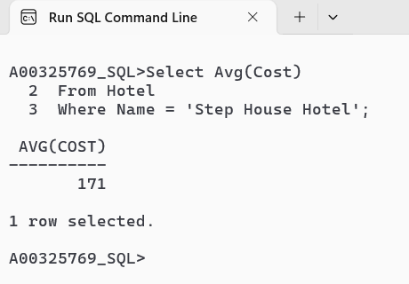
Cl scr
Select Avg(Cost)
From Hotel
Where Name In ('Step House Hotel', 'Woodford Dolmen Hotel');
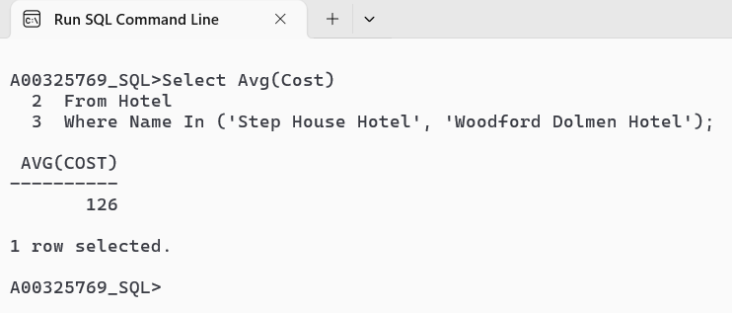
Cl scr
Select Avg(Cost)
From Hotel
Where Name In ('Step House Hotel', 'Woodford Dolmen Hotel', 'Borrow View Bread and Breakfast', 'Talbot');
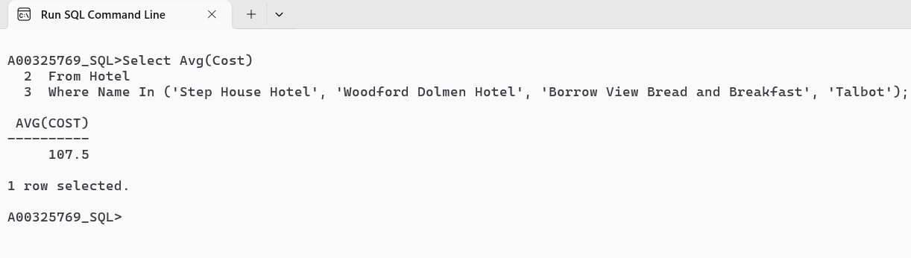
You tube Links

Video 1: https://youtu.be/O-3PR-J7ZMA?si=766Kgf26OYpwF7Lg
Video 2 : https://youtu.be/nfUlNh1_9mc?si=jkrtA_Y40TEs_4xC

