3/25/2026
Comparative Analysis of Scheduling Rules in a Single Machine System Using a Hybrid Approach
PRESENTED BY
M. Sreeshanth(23MEB0B58)

OPERATION PLANNING AND CONTROL-ME354
MINI PROJECT:
1.ABSTRACT
In the fast-paced world of manufacturing, keeping the production line moving without missing deadlines is a constant juggling act. This study examines the critical challenge of single-machine job scheduling, where the primary objective is to balance high operational throughput with strict adherence to delivery dates. While traditional dispatching heuristics such as Shortest Processing Time (SPT) and Earliest Due Date (EDD) are industry staples, they often prioritize one metric at the expense of another. To address this, a hybrid rule and a normalized hybrid rule were developed and tested to seek a more integrated performance profile.
Using simulation data generated in Excel to mimic the stochastic nature of real-world processing times and varying deadlines, the study evaluated these rules based on mean flow time and maximum tardiness. The results highlight a classic trade-off: SPT is highly effective at reducing the average time a job spends in the system, whereas EDD is superior for minimizing delivery delays. However, the proposed normalized hybrid rule consistently outperformed both by achieving a more robust balance between speed and reliability. These findings suggest that a flexible, integrated approach to scheduling is better suited for handling the competing pressures of modern production environments than traditional, single-criterion methods.
KEY WORDS: Scheduling, SPT, EDD, Hybrid Rule, Tardiness, Flow Time.

2.INTRODUCTION
The story of efficient manufacturing begins in the heart of a busy workshop, where the primary challenge is not just the act of creation, but the mastery of time. At the centre of this environment is a single machine—a critical bottleneck through which every order must pass. Each job arriving at the station carries two defining characteristics that dictate its priority: the Processing Time, representing the physical effort required for completion, and the Due Date, the deadline that represents a promise made to a customer. When these jobs accumulate, the sequence in which they are handled becomes the deciding factor between a smooth operation and a chaotic backlog.
The quest for the perfect sequence is built upon the classic foundations of operations management, most notably the pioneering work of Jackson and Smith. In 1955, J.R. Jackson demonstrated through the Earliest Due Date (EDD) rule that prioritizing jobs based on their deadlines is the optimal way to minimize maximum lateness and tardiness, ensuring that the most urgent commitments are met. Just a year later, W.E. Smith proved that the Shortest Processing Time (SPT) rule serves as the gold standard for efficiency, as it minimizes the mean flow time and reduces the average wait for the majority of jobs. While these rules offer mathematical certainty for single objectives, the modern workshop rarely has the luxury of choosing just one goal.
In a real-world setting, focusing solely on Jackson’s urgency can lead to long queues and inefficient machine use, while focusing solely on Smith’s efficiency can cause long-duration jobs to miss their deadlines entirely. This creates a significant research gap: the need for a scheduling approach that does not force a choice between speed and punctuality. To address this, we move toward a methodology that seeks a balanced, hybrid solution. By normalizing these parameters—ensuring that a short processing time and an urgent deadline are weighted on a comparable scale—we can develop a unified scheduling rule that optimizes both flow time and tardiness, transforming the machine from a bottleneck into a balanced engine of productivity.

Block Diagram:
Jobs → Scheduling Rule → Machine Processing → Completed Jobs → Performance Evaluation
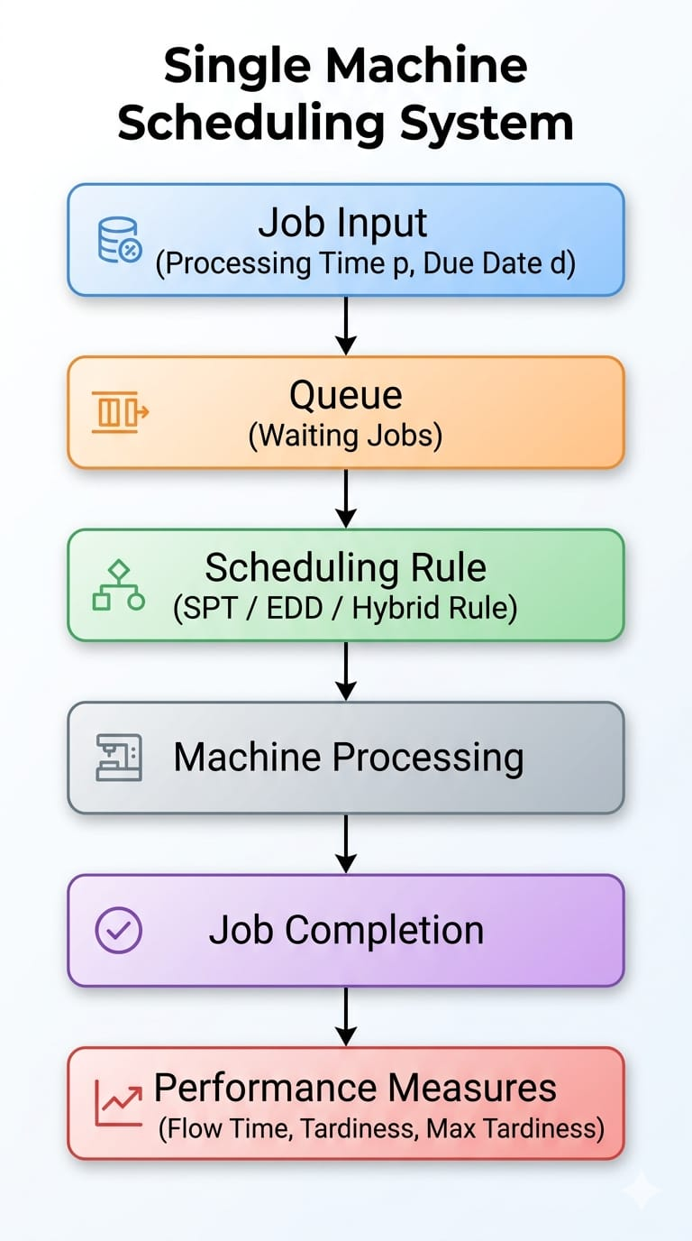
3.METHODOLOGY

To simulate a real operational environment, this study generated a dataset of 30 jobs using Excel random functions, with processing times ranging from 10 to 20 and due dates between 30 and 65. Operating under a single-machine system assumption where all jobs are available at time zero without interruptions, the methodology compares four scheduling rules: Shortest Processing Time (SPT), Earliest Due Date (EDD), a weighted Hybrid Rule combining processing time and slack, and a Normalized hybrid rule.

The calculation procedure begins by determining the slack for each job, followed by sequencing the jobs according to the selected rule to establish completion times. Performance is then quantified by calculating the flow time, lateness, and tardiness for each job, with the final effectiveness of each scheduling rule evaluated based on mean flow time and maximum tardiness

Category | Rule/Metric | Formula
Hybrid Score | Weighted Combination | Score=αp+(1−α)(d−p)
Normalized Hybrid | Scaled Comparison | $$Score=α\frac{p}{p_{max}}+(1-α)\frac{slack}{slack_{max}}$$
Performance | Completion Time | C_{i}= C_{i}-1+ p_{i}
Performance | Lateness | L_{i} = C_{i}- d_{i}
Performance | Tardiness | $$T_{i}=max\left(0,L_{i}\right)$$

This study has a few key limitations. First, it only looks at a single-machine system, which doesn't account for the complexity of factories with multiple machines. Second, assuming all jobs are ready at time zero ignores the fact that, in real life, new jobs often arrive at different times throughout the day. Finally, because the model assumes perfect conditions with no machine breakdowns or delays, it may not fully reflect the unpredictable nature of a real working environment.
4. RESULTS AND DISCUSSION
RULE | MEAN FLOW TIME | MAXIMUM TARDINESS | OBSERVATION
SPT | 216.67 | 408 | Minimum Flow time but higher Tardiness
EDD | 250.77 | 407 | Lower Tardiness but higher Flow time
HYBRID | 250.77 | 468 | Balanced Performance
NORMALIZED HYBRID | 237.87 | 407 | Best balance between Flow time and Tardiness

FIGURE-1-Mean flow time for Different scheduling Rules

FIGURE-2-Maximum Tardiness for different Scheduling rules

FIGURE-3- Comparison of Scheduling Rules based on Flow Time and Tardiness

When comparing different ways to schedule tasks, there is usually a trade-off between how fast jobs get done and whether they finish on time. The Shortest Processing Time (SPT) rule is the best for speed; by finishing quick tasks first, it keeps the average wait time low (216.67), but it often results in more late jobs. On the other hand, the Earliest Due Date (EDD) rule focuses on deadlines. While this helps finish jobs on time (reducing the maximum lateness to 407), it makes the overall process slower, with a higher average completion time of 250.80.
The normalized hybrid rule offers the best of both worlds. Instead of focusing on just one goal, it looks at both the job length and the deadline at the same time. By balancing these two factors fairly, it prevents one from ignoring the other. This "middle-ground" approach reduces lateness while still keeping the workflow fast and efficient. Because it handles these competing priorities so well, it is often the most practical choice for solving real-world scheduling problems.

5.CONCLUSION
This study analyzed different scheduling rules for a single-machine system. Traditional rules such as SPT and EDD optimize individual performance measures but fail to provide a balanced solution. The proposed normalized hybrid rule effectively balances flow time and tardiness, making it a suitable approach for real-world applications. The method is flexible and can be adapted based on operational priorities.

7. REFERENCES
- Blackstone, J. H. (1982). "State-of-the-art survey of dispatching rules."
  - https://www.tandfonline.com/doi/abs/10.1080/00207548208947745
- Smith, W. E. (1956). "Various optimizers for single-stage production."
  - https://onlinelibrary.wiley.com/doi/abs/10.1002/nav.3800030106
- Springer. "Normalized Priority Rules in Single-Machine Systems."
  - https://link.springer.com/journal/10951
- Pinedo, M. L. (2016). Scheduling: Theory, Algorithms, and Systems.
  - https://link.springer.com/book/10.1007/978-3-319-26580-3
- ScienceDirect. "Single-Machine Scheduling with General Learning Functions."
  - https://www.sciencedirect.com/science/article/pii/S089812210800271X
- ScienceDirect. "Single-Machine Scheduling with Time-Dependent Learning Effect."
  - https://www.sciencedirect.com/science/article/pii/S030504830800115X
- IEEE Xplore. "Multi-Objective Scheduling Rules for Manufacturing Workshops."
  - https://ieeexplore.ieee.org/xpl/recent_issue.jsp?punumber=70
- Springer. "Normalized Priority Rules in Single-Machine Systems."
  - https://link.springer.com/journal/10951
- Microsoft. "Excel documentation for RAND function."
  - https://support.microsoft.com/en-us/office/rand-function-4e015d26-3023-4554-93e1-5e74d156637e
- Law, A. M. (2014). Simulation Modeling and Analysis.
  - https://www.mheducation.com/highered/product/simulation-modeling-analysis-law/M9780073401324.html
- Panwalkar, S. S., & Iskander, W. (1977). "A Survey of Scheduling Rules."
  - https://pubsonline.informs.org/doi/abs/10.1287/opre.25.1.45
- Moore, J. M. (1968). " One machine sequencing algorithm."
  - https://pubsonline.informs.org/doi/abs/10.1287/mnsc.15.1.102
- Conway, R. W., et al. (1967). Theory of Scheduling.
  - https://archive.org/details/theoryofscheduli0000conw
- Du, J., & Leung, J. Y. T. (1990). "Minimizing total tardiness on one machine is NP-hard."
  - https://pubsonline.informs.org/doi/abs/10.1287/moor.15.3.483
- Koulamas, C. (1994). "The total tardiness problem: Review and extensions."
  - https://pubsonline.informs.org/doi/abs/10.1287/opre.42.6.1025
- French, S. (1982). Sequencing and Scheduling: An Introduction.
  - https://www.google.com/books/edition/_/3S9RAAAAMAAJ
- Potts, C. N. (1991). "Single machine scheduling to minimize total tardiness."
  - https://pubsonline.informs.org/doi/abs/10.1287/opre.39.1.177
- Graham, R. L., et al. (1979). "Optimization and approximation in deterministic sequencing."
  - https://www.sciencedirect.com/science/article/abs/pii/S016750600870356X
- Lenstra, J. K., et al. (1977). "Complexity of machine scheduling problems."
  - https://www.sciencedirect.com/science/article/abs/pii/0304020877900115
- Ho, J. C., & Chang, Y. L. (1991). "Heuristic for the n-job, single-machine tardiness problem."
  - https://www.sciencedirect.com/science/article/abs/pii/0377221791901117
- Vepsalainen, A. P., & Morton, T. E. (1987). "Priority rules for weighted tardiness costs."
  - https://pubsonline.informs.org/doi/abs/10.1287/mnsc.33.8.1035
- Raghu, T. S., & Rajendran, C. (1993). "Dynamic dispatching rule for scheduling."
  - https://www.sciencedirect.com/science/article/abs/pii/092552739390005M
- Jain, A. S., & Meeran, S. (1999). "Deterministic job-shop scheduling survey."
  - https://www.sciencedirect.com/science/article/abs/pii/S037722179800113X
- Blackstone, J. H. (1982). "State-of-the-art survey of dispatching rules."
  - https://www.tandfonline.com/doi/abs/10.1080/00207548208947745
- Haupt, R. (1989). "A survey of priority rule-based scheduling."
  - https://link.springer.com/article/10.1007/BF01582046
- Lee, C. Y., & Choi, J. Y. (1995). "Genetic algorithm for job shop scheduling."
  - https://www.sciencedirect.com/science/article/abs/pii/0360835294000305
- Kim, S. C., & Bobrowski, P. M. (1994). "Impact of due-date determination rules."
  - https://www.sciencedirect.com/science/article/abs/pii/0272696394900043
- Hata, S. (2025). "Optimization of hybrid flow shop scheduling."
  - https://journal.ump.edu.my/jmes/article/view/10045
- Alshaikhli, K. (2024). "Algorithms for Multicriteria Scheduling."
  - https://www.scirp.org/journal/paperinformation.aspx?paperid=131250
- Yuan, J. J. (2014). "Single machine scheduling for weighted tardiness."
  - https://www.sciencedirect.com/science/article/pii/S030505481300222X
- Baker, K. R., & Kanet, J. J. (1983). "Job shop scheduling and due dates."
  - https://www.sciencedirect.com/science/article/abs/pii/0272696383900057
- Ovacik, I. M., & Uzsoy, R. (1997). Decomposition Methods for Factory Scheduling.
  - https://link.springer.com/book/10.1007/978-1-4615-6119-4
- T'kindt, V. (2006). Multicriteria Scheduling: Models and Algorithms.
  - https://link.springer.com/book/10.1007/3-540-30528-9
- Lourenço, H. R. (2003). "Iterated Local Search."
  - https://link.springer.com/chapter/10.1007/0-306-48056-5_11
- Sen, A., & Mathur, A. (2016). "Artificial bee colony for dynamic dispatch."
  - https://www.frontiersin.org/articles/10.3389/fenrg.2016.00032/full
- Ahmed, A. (2021). "Evaluation of dispatching rules using simulation."
  - https://scholarsphere.psu.edu/resources/6008740b-741c-4b95-a745-983804810784
- Buzacott, J. A. (1993). Stochastic Models of Manufacturing Systems.
  - https://archive.org/details/stochasticmodels0000buza
- Dhamala, P. K. (2015). "A survey on single machine scheduling."
  - https://www.nepjol.info/index.php/NJST/article/view/14358
- ScienceDirect Topics. "Dispatching Rules."
  - https://www.sciencedirect.com/topics/engineering/dispatching-rule
- TandfOnline. "International Journal of Production Research."
  - https://www.tandfonline.com/toc/tprs20/current

