EKAGRAM
Logo System & Brand Asset Documentation
Dark-mode-first modular identity system
Charcoal Navy  #101923 | Deep Blue  #355DB7 | Soft Sky  #799AE3 | Accent Purple  #5B73D7
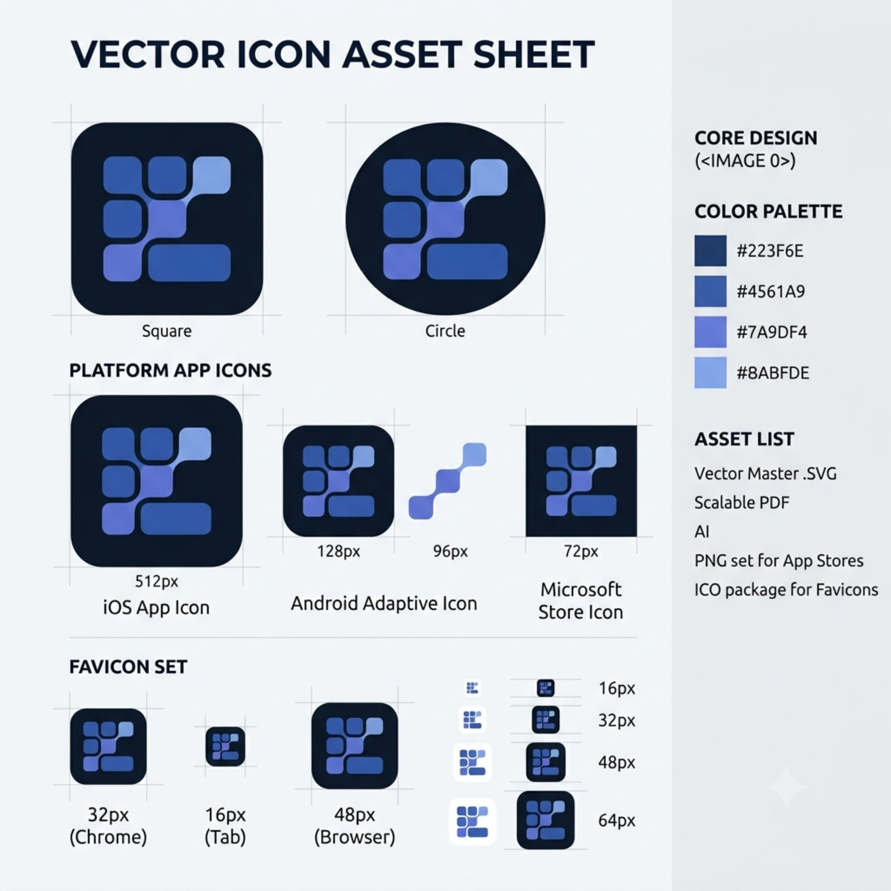
Reference asset sheet supplied for the Ekagram modular logo direction.

1. Brand & Logo Concept
Core idea. The Ekagram symbol is a modular geometric mark built from rounded tiles. The arrangement creates an abstract E through structure and negative space rather than drawing a conventional letter.
- E → Ekagram
- Modules → organized information and systems
- Connected tiles → community and communication
- Grid → digital platform and technology
- Individual blocks → people, ideas and conversations
- Unified structure → one ecosystem
- Rounded geometry → approachable, human technology
Design principle. The negative spaces between the modules are part of the logo. The symbol should remain recognizable without relying on the wordmark.
2. Core Symbol Construction
The master symbol should be designed as a compact modular grid, approximately based on a 3 × 3 construction. The preferred reference direction uses seven primary visual units with varied horizontal lengths.
- Three upper modules
- Two middle modules
- Two lower modules
- One visually distinctive central/focal tile
- Consistent rounded corners and visual weight
- Controlled negative-space gaps
- No outlines, shadows or decorative effects
Construction parameter | Recommended specification
Master canvas | 1000 × 1000 units
Standard module | ≈ 150 × 150 units
Extended module | ≈ 300 × 150 units
Module gap | ≈ 20–30 units
Corner radius | ≈ 35–45 units
Safe area | ≈ 100 units
Overall symbol | ≈ 600–650 units wide/high
Note: These are construction guidelines. Optical balance takes priority over rigid mathematical measurements.
3. Color System
Color | Hex | Primary role
Charcoal Navy | #101923 | Dark-mode background
Deep Blue | #355DB7 | Primary logo structure
Soft Sky | #799AE3 | Secondary/supporting modules
Accent Purple | #5B73D7 | Signature focal tile
Near White | #F8F9FB | Wordmark and light artwork
Recommended color hierarchy: Deep Blue 60–70% · Soft Sky 20–30% · Accent Purple 5–10%.
Purple should be a signature point rather than a competing primary color. The wordmark should remain a single near-white tone.
4. Logo Modes & Application Variants
Mode | Composition | Recommended applications
01 — Primary Lockup | Icon + Ekagram | Website, product, marketing, presentations, email
02 — Symbol | Icon only | Product UI, profile image, watermark, app shortcut
03 — App Icon | Symbol on rounded-square canvas | iOS, Android, desktop and launcher icons
04 — Favicon | Simplified symbol | Browser tabs, bookmarks, web app
05 — Stacked Lockup | Icon above Ekagram | Social posts, posters, splash screens
06 — Monochrome White | White symbol/wordmark | Dark or photographic backgrounds
07 — Monochrome Navy | Navy symbol/wordmark | Light documents/backgrounds
08 — Single Blue | Entire symbol in Deep Blue | Print, technical and constrained reproduction
09 — Small Icon | Simplified geometry | 16–64px digital contexts
10 — Adaptive App Icon | Platform-specific foreground/background | Android/iOS platform exports
5. Primary Horizontal Lockup
Structure: [ Modular Icon ] Ekagram
- Place the symbol to the left of the wordmark.
- Use a modern rounded geometric sans-serif.
- Use near-white (#F8F9FB) for the wordmark in dark mode.
- Vertically center the wordmark against the optical center of the symbol.
- Use approximately 0.5–0.75× the icon visual height as the icon-to-wordmark spacing.
- Do not recolor individual letters; the icon carries the color expression.
6. Icon-Only & App Icon
The icon-only mark is the most important secondary asset. It should be able to stand independently and become the recognizable Ekagram signature.
Asset | Recommended master/export | Notes
Master icon | 1000 × 1000 SVG/vector | Primary source artwork
iOS App Store | 1024 × 1024 | No wordmark
Android Play Store | 512 × 512 | No wordmark
PWA icon | 192 × 192 / 512 × 512 | Web application
Social avatar | Square master | Icon only
Favicon | 16 / 32 / 48px + ICO | Use simplified construction
App-icon rule. The symbol should occupy approximately 60–70% of the canvas, with enough negative space to remain clean at small sizes.
7. Responsive / Small-Size System
Size/context | Treatment
1000px+ | Full master geometry and detail
512px | Full icon
128px | Full icon
64–96px | Simplified icon if needed
32px | Simplified but recognizable modular arrangement
16–24px | Micro mark; remove unnecessary secondary detail
Do not merely scale the master artwork indefinitely. Small-size variants should be optically redrawn so gaps, tile weight and the E-like negative space remain legible.
8. Wordmark Specification
- Name: Ekagram
- Style: bold rounded geometric sans-serif
- Personality: modern, intelligent, approachable and confident
- Dark-mode color: #F8F9FB
- Avoid decorative modifications and excessive letter spacing
- The capital E should visually relate to the symbol without literally reproducing it
9. Alternate Color & Production Modes
Variant | Treatment | Use
Dark-mode primary | Background #101923 + full color icon | Default brand presentation
Light-background | Background #F8F9FB + brand colors | Situations where background is controlled externally
White knockout | Symbol/wordmark #F8F9FB on transparent | Dark surfaces, video, sponsorships
Navy knockout | Symbol/wordmark #101923 on transparent | Light surfaces
Single-color blue | All artwork #355DB7 | Print/technical constraints
Outline | Optional geometric outline | Illustration, diagrams, empty states
10. Clear Space & Minimum Size
Define clear space using the width of one standard modular tile as the base unit (1X). Keep at least 1X of empty space around the complete lockup wherever practical.
Asset | Recommended minimum
Full digital lockup | ≈ 120px wide
Full print lockup | ≈ 25–30mm wide
Icon | 16px technical minimum; 32px preferred
App icon | Designed and tested at 32 × 32px
11. Brand Usage Rules
Always:
- Maintain module proportions and corner radii.
- Preserve the designed negative spaces.
- Use the approved color hierarchy.
- Use the icon-only mark where the display size is too small for the wordmark.
- Keep the logo optically centered.
Never:
- Use gradients.
- Add drop shadows.
- Apply 3D, bevel, gloss or glass effects.
- Randomly rearrange or recolor tiles.
- Distort the proportions.
- Add unnecessary outlines or decorative elements.
- Place the wordmark inside the app icon.
- Use excessive colors at once.
12. Product & UI Applications
Context | Suggested treatment
Loading state | Sequential tile appearance/activation
Notification state | Subtle emphasis on the purple focal tile
Active state | Accent Purple #5B73D7
Inactive state | Deep Blue with reduced visual emphasis
Community state | Full approved three-color icon
Empty states | Optional outline/simplified mark
Watermark | Monochrome or low-emphasis single-color mark
13. Recommended Asset Package
Category | Files / deliverables
Master vector | Ekagram_Master.svg
Editable source | AI / Figma source
Scalable print | PDF / SVG
Raster master | PNG at 1024px or larger
Favicon | 16px, 32px, 48px, ICO
Web/PWA | 180px, 192px, 512px
iOS | 1024px App Store icon + source
Android | 512px Play icon + adaptive foreground/background
Desktop | ICO / platform-specific PNG/SVG
Social | Square icon-only exports
Color variants | Full color, white, navy, single blue
Responsive variants | Full, simplified, micro
14. Final Brand Recommendation
Recommended core identity: Adopt the modular-grid symbol as the official Ekagram core mark. It offers the strongest balance of community, technology, organization and E recognition among the explored directions.
For the production system, normalize the reference sheet's colors to the Ekagram palette (#101923, #355DB7, #799AE3, #5B73D7) so the identity remains consistent across the product, website, social media and app ecosystem.
The ultimate success criterion is standalone recognition: the modular symbol should become identifiable as Ekagram even when the wordmark is absent.

