MAP COLORING TO IMPLEMENT CSP

AIM: To implement a python program for Map Coloring to implement CSP.

OBJECTIVES:
- To understand the concept of Constraint Satisfaction Problems.
- To represent a map using variables, domains, and constraints.
- To use backtracking for finding a valid color assignment.
- To ensure that neighboring regions have different colors.
- To find a valid solution efficiently using CSP logic.
ALGORITHM:
- Define the regions of the map as variables.
- Define the available colors as the domain.
- Define which regions are neighbors using constraints.
- Select an uncolored region.
- Try assigning each available color.
- Check whether the color conflicts with its neighboring regions.
- If there is no conflict, assign the color and continue.
- If a conflict occurs, try another color.
- If no color works, backtrack to the previous region.
- Continue until all regions are colored.
SYSTEM-ARCHITECTURE:


PROGRAM:
colors = ["Red", "Green", "Blue"]

map = {
"A": ["B", "C"],
"B": ["A", "C", "D"],
"C": ["A", "B", "D"],
"D": ["B", "C"]
}

result = {}

def valid(region, color):
for neighbor in map[region]:
if result.get(neighbor) == color:
return False
return True

def solve():
if len(result) == len(map):
return True

region = next(r for r in map if r not in result)

for color in colors:
if valid(region, color):
result[region] = color

if solve():
return True

del result[region]

return False

if solve():
print("Map Coloring Solution:")
for region, color in result.items():
print(region, "->", color)
else:
print("No solution")

OUTPUT:
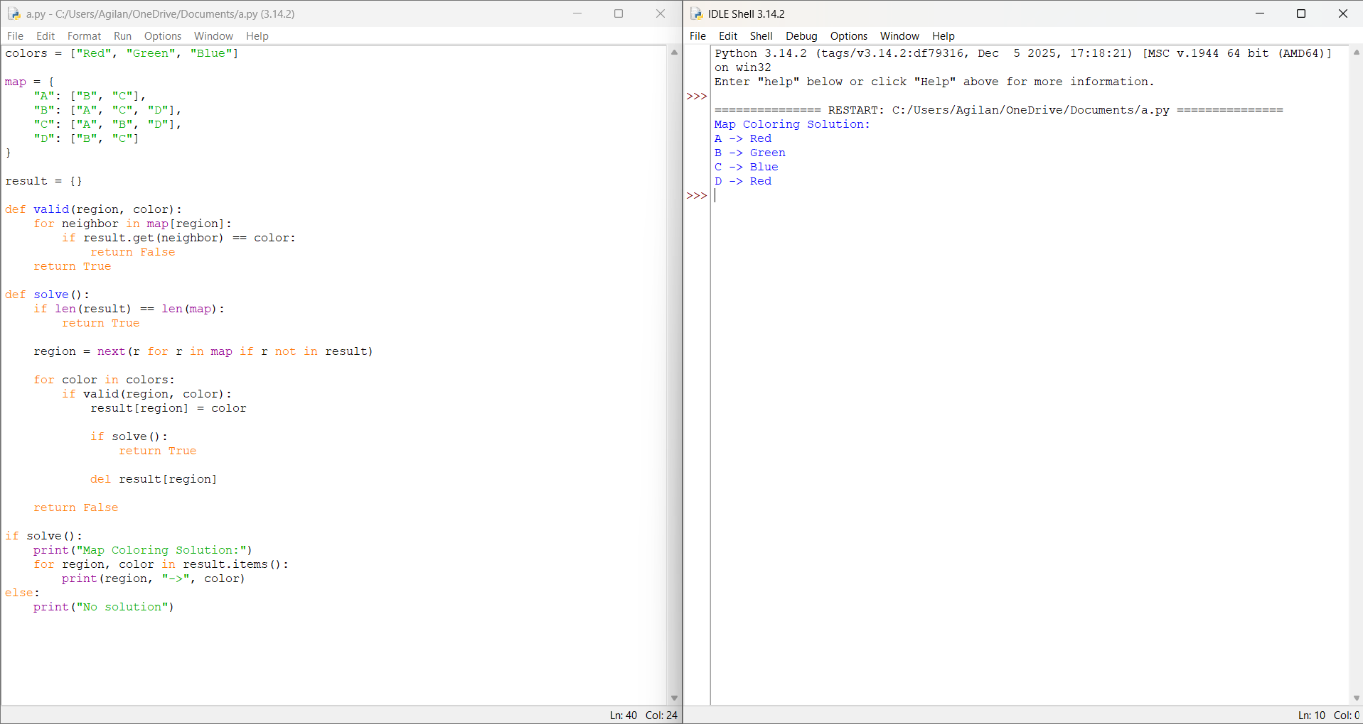

RESULT: Thus the Map Coloring to implement CSP is implemented successfully using python language.

