PRO. STUDENT-TEACHER-SUB-CODE

AIM: To implement a prolong program for STUDENT-TEACHER-SUB CODE.

OBJECTIVES:
To write a Prolog program that represents the relationship between students, teachers, and subject codes and allows users to find which teacher teaches a particular subject to a student.

ALGORITHM:
- Start the program.
- Define facts representing the subjects and their corresponding subject codes.
- Define facts representing which teacher teaches each subject.
- Define facts representing which subjects are taken by each student.
- Create rules to establish the relationship between student, teacher, and subject code.
- Query the database using a student's name.
- Display the corresponding teacher and subject code.
- Stop the program.

SYSTEM-ARCHITECTURE:
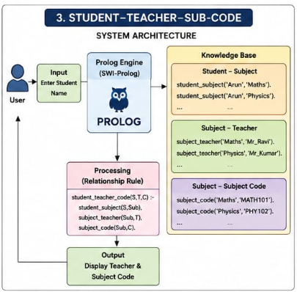

PROGRAM:
% Student - Teacher - Subject Code Database

% Student and Subject relationship
student_subject('Arun', 'Mathematics').
student_subject('Arun', 'Physics').
student_subject('Bala', 'Computer Science').
student_subject('Bala', 'Mathematics').
student_subject('Chitra', 'Physics').
student_subject('Chitra', 'Computer Science').

% Subject and Subject Code relationship
subject_code('Mathematics', 'MATH101').
subject_code('Physics', 'PHY102').
subject_code('Computer Science', 'CS103').

% Subject and Teacher relationship
subject_teacher('Mathematics', 'Mr_Ravi').
subject_teacher('Physics', 'Mr_Kumar').
subject_teacher('Computer Science', 'Ms_Priya').

% Rule to find Student, Teacher and Subject Code
student_teacher_code(Student, Teacher, Code) :-
student_subject(Student, Subject),
subject_teacher(Subject, Teacher),
subject_code(Subject, Code).

OUTPUT:
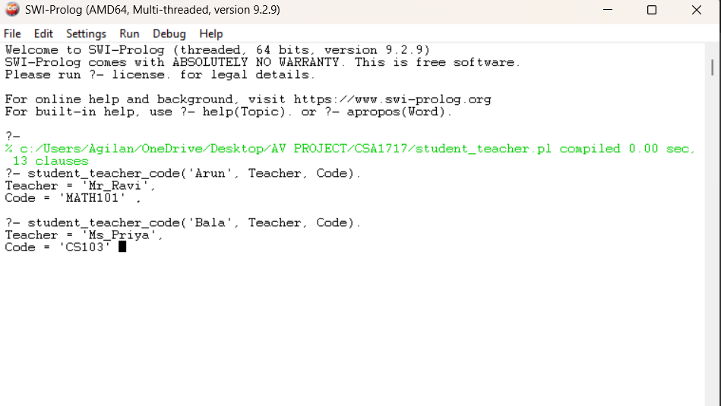

RESULT: Thus the STUDENT-TECHER-SUB-CODE is implemented successfully using Prolong program.

