8-QUEENS PROBLEM

AIM: To implement a python program for 8-Queens Problem.

OBJECTIVES:
- To place 8 queens on an 8×8 chessboard such that no two queens attack each other.
- To ensure that no two queens are placed in the same row, column, or diagonal.
- To implement a backtracking algorithm to find a valid arrangement.

ALGORITHM:
- Start with an empty 8×8 chessboard.
- Place a queen in the first row.
- Check whether the current position is safe (no queen attacks another queen).
- If the position is safe, move to the next row.
- If no safe position is found, backtrack to the previous row and move the queen.
- Repeat the process until all 8 queens are placed.
- Display the final chessboard arrangement.

SYSTEM-ARCHITECTURE:
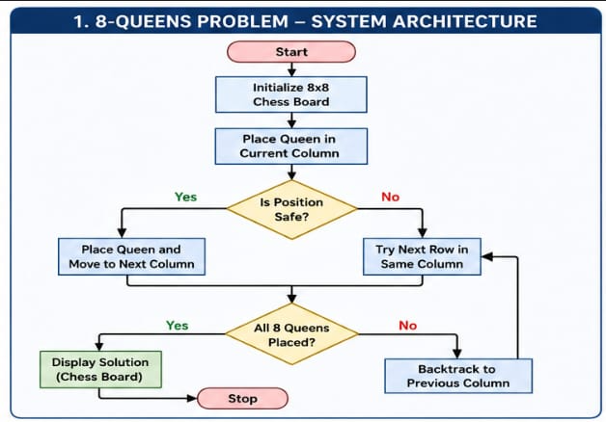

PROGRAM:
N = 8
board = [-1] * N

def safe(row, col):
for i in range(row):
if board[i] == col or abs(board[i] - col) == abs(i - row):
return False
return True

def solve(row):
if row == N:
for i in range(N):
for j in range(N):
if board[i] == j:
print("Q", end=" ")
else:
print(".", end=" ")
print()
return True

for col in range(N):
if safe(row, col):
board[row] = col
if solve(row + 1):
return True
return False
solve(0)

OUTPUT:
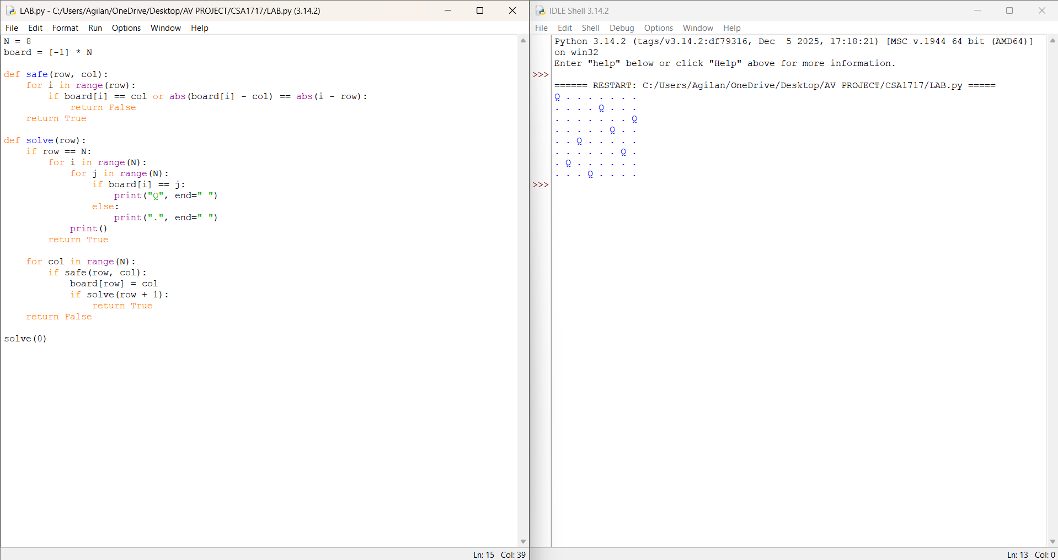

RESULT: Thus the 8-Queens problem is implemented successfully using python language.

