DFS

AIM: To implement a python program for BFS.

OBJECTIVES:
- To traverse all nodes of a graph by exploring one branch completely before moving to another.
- To visit each node only once.
- To perform graph traversal using a stack.

ALGORITHM:
- Create a graph using a dictionary.
- Create an empty list for visited nodes.
- Create a stack and insert the starting node.
- Remove the top node from the stack.
- If it is not visited, print it.
- Push all its neighbours into the stack.
- Repeat until the stack becomes empty.

SYSTEM-ARCHITECTURE:
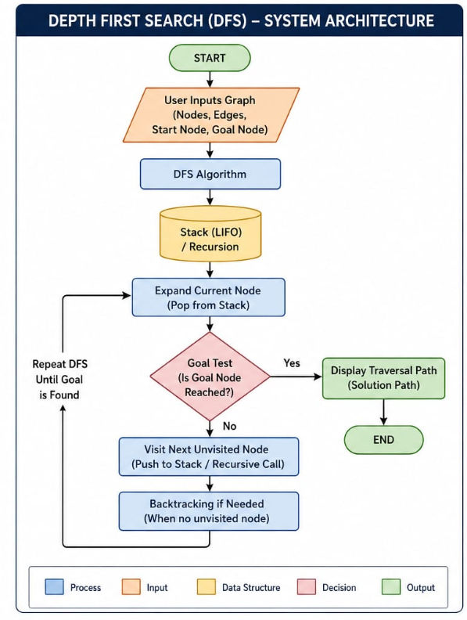

PROGRAM:
graph={'A':['B','C'],'B':['D'],'C':['E'],'D':[],'E':[]}
visited=[]
stack=['A']
while stack:
node=stack.pop()
if node not in visited:
print(node,end=" ")
visited.append(node)
stack.extend(graph[node])

OUTPUT:
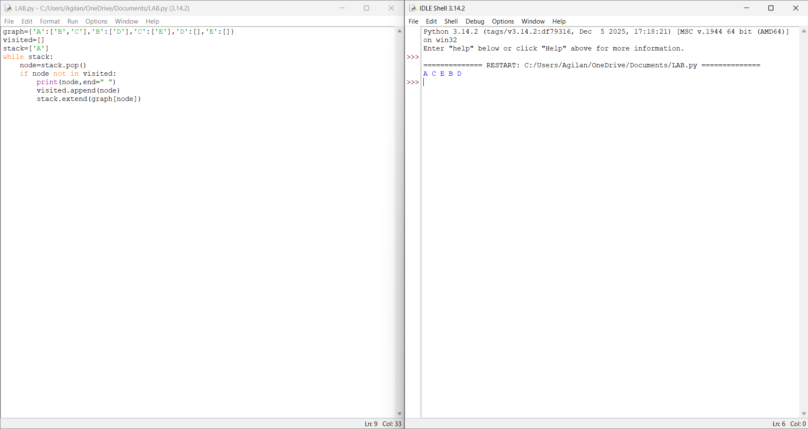

RESULT: Thus the DFS is implemented successfully using python language.

