***SMART PUBLIC REST ROOM***

**Introduction** :

Define what a Smart Public Restroom is and its significance.

Mention the importance of data visualization in this context.

Smart Public Restroom Components:

Discuss the various components of a smart public restroom, including sensors, IoT devices, and data collection systems.

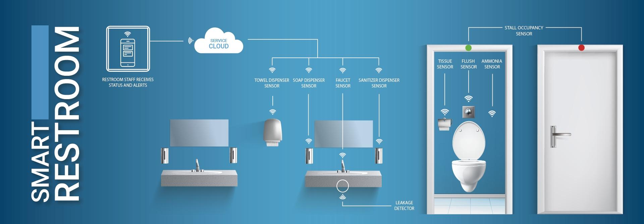

Data Collection and Sensors:

Explain how data is collected through sensors, like occupancy, temperature, and water usage sensors.

Highlight the role of IoT devices in transmitting this data.

**Data Storage and Management**:

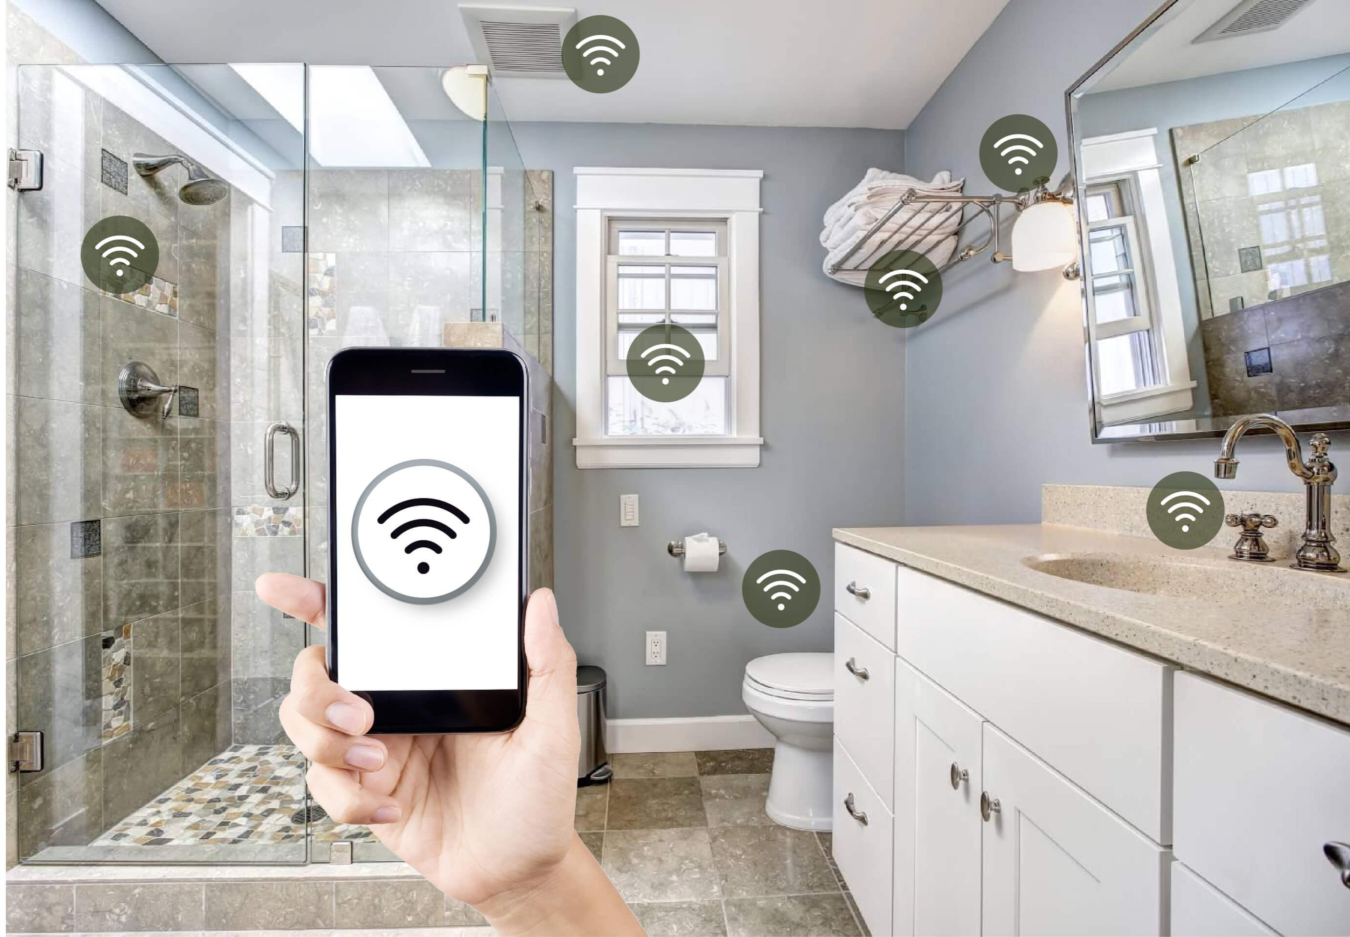

Describe how the collected data is stored and managed.

Mention the importance of real-time data processing for smart restrooms.

**Visualizat Data ion Tools**:

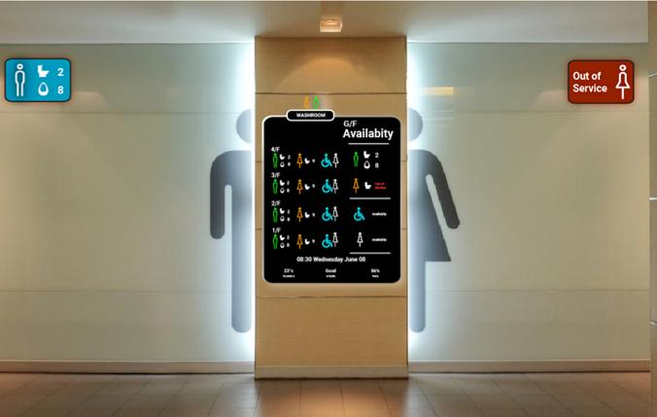

Introduce data visualization tools like Tableau, Power BI, or custom solutions.

Explain their role in turning raw data into meaningful insights.

Visualizing Restroom Usage:

Use data visualization to show restroom occupancy trends throughout the day.

Create charts or graphs to illustrate peak usage times.

Efficiency and Resource Management:

Showcase how data visualization can help optimize resource usage, such as water and electricity.

Use visuals to demonstrate water consumption patterns.

User Experience Enhancement:

Discuss how data visualization can improve the user experience in smart restrooms.