* 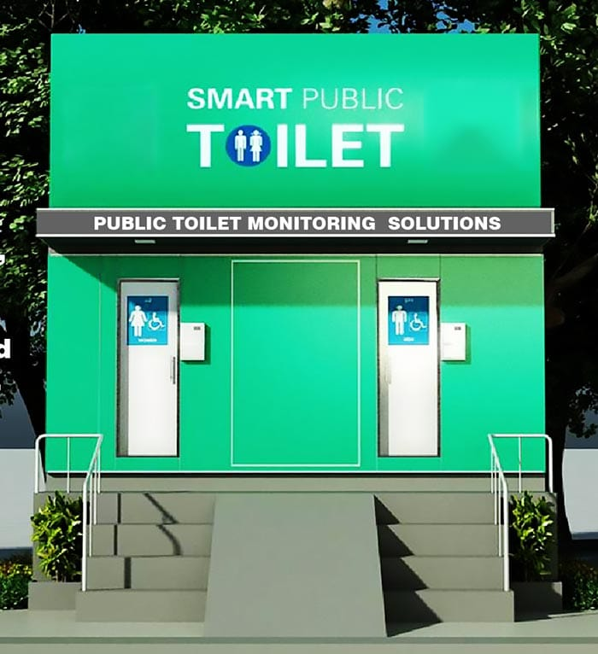 Smart Restroom IoT Innovation

**Problem Definition:**

Begin by identifying the current problems associated with public restrooms. These may include cleanliness issues, maintenance inefficiencies, or accessibility challenges.

Conduct surveys, gather data, and involve stakeholders to gain insights into the specific pain points and requirements of users and facility managers.

Define the scope of the problem and the key metrics that will be used to measure success.

**Design Thinking:**

Embrace a user-centric approach. Understand the needs, behaviors, and preferences of restroom users.

Create user personas to empathize with different user groups (e.g., travelers, families, individuals with disabilities).

Ideate and brainstorm solutions to address the identified problems. Encourage creative thinking and consider both high-tech and low-tech options.

Prototype and iterate on potential restroom designs and features, involving users and stakeholders in the feedback process.

Use techniques like journey mapping to visualize the user experience from entry to exit.

**Innovation and Problem Solving on IoT Platform:**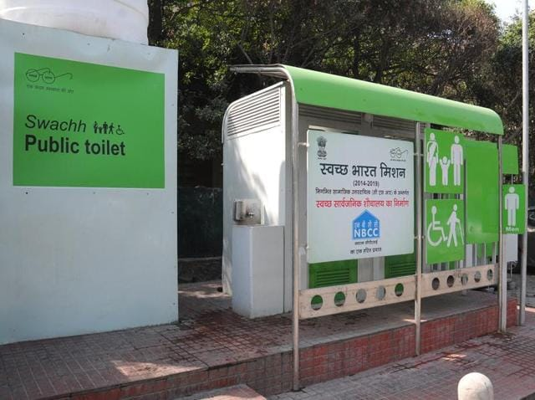

Explore how IoT (Internet of Things) can be integrated to enhance restroom functionality.

Identify IoT sensors and devices that can monitor restroom conditions (e.g., occupancy, cleanliness, water usage).

Implement real-time data collection and analytics to detect issues promptly.

Develop a centralized control system that can automate tasks like maintenance requests, restocking supplies, and adjusting lighting and ventilation based on occupancy.

Ensure data security and privacy measures are in place, especially when dealing with sensor data from public spaces.