Movie Review Website (Silver Screen Review)

⚡️ Introduction
Silver Screen Review is a MERN-based web application that enables users to explore movies, read community reviews, and share their own experiences. The goal is to provide a transparent and interactive platform for movie enthusiasts to discuss and rate films.
⚡️ System Overview
✅ Frontend: React + Tailwind CSS for a responsive and aesthetic interface.
✅ Backend: Node.js + Express for REST API development.
✅ Database: MongoDB for managing users, reviews,Feedback and movie data.
✅ Authentication: JSON Web Token (JWT)-based system to secure user access.

Project Scope🚀
💡 The project aims to build a full-stack movie review system where:
💡 Users can create accounts, log in, and add review and rate the movies.
💡 Admins can manage movies, monitor reviews, and gather feedback.
💡 Key Features
📌 For Users:
🌱 Sign up / Login / Logout
🌱 View movie listings and average ratings
🌱 Add, edit, or delete personal reviews
🌱 View other users’ reviews and ratings
🌱 Check the average rating along with the number of reviews for each movie.
🌱 Add feedback about the website
📌 For Admins:
🌱 Sign up / Login / Logout
🌱 Add new movies with details and images
🌱 Edit and delete movies
🌱 View and manage all user reviews and feedback

System Workflow🚀

User Workflow
User Actions:
- Authentication
  - Register / Login
  - Token or session-based authentication
- Browse Movies
  - View list of movies
  - Click on a movie to see details, average rating, and reviews
- Reviews
  - Add a review & rating for a movie
  - Edit or delete their own review
  - View reviews added by other users
- Feedback
  - Submit feedback about the website/platform

User
│
├─ Login/Register (Auth Route)
│
├─ View Movies (User Route)
│ ├─ Movie Details
│ ├─ Average Rating & Reviews
│
├─ Add/Edit/Delete Review and rating(User Route)
│
└─ Submit Feedback (User Route)

Admin Workflow

Admin Actions:

- Authentication
  - Login as admin
- Movie Management
  - Add new movies
  - Edit existing movie details
  - View all movies they added
- Review Management
  - View all user-submitted reviews
  - delete inappropriate reviews
- User Feedback
  - View feedback submitted by users

Admin
│
├─ Login (Auth Route)
│
├─ Manage Movies (Admin Route)
│ ├─ Add Movie
│ ├─ Edit Movie
│ └─ View Movies
│
├─ Manage Reviews (Admin Route)
│ ├─ View All Reviews
│ └─ Delete Reviews
│
└─ View User Feedback (Admin Route)
┌──────────────┐
│ USER │
│ - Login/Register
│ - Add/Edit/Delete Review
│ - View Movies & Reviews
│ - Give Feedback
└──────┬───────┘
│
▼
┌──────────────┐
│ ADMIN │
│ - Login/Register
│ - Add/Edit/Delete Movies
│ - Manage Reviews & Users
│ - View Feedback
└──────┬───────┘
│
▼
┌──────────────┐
│ FRONTEND │
│ (React+Tailwind)
│ - UI & API Calls
│ - Displays Movies/Reviews
│ - Admin Dashboard
└──────┬───────┘
│
▼
┌──────────────┐
│ BACKEND │
│ (Node+Express)
│ - Auth (JWT)
│ - Admin/User Routes
│ - Movie & Review CRUD
│ - Feedback Handling
│ - Role-based Access
└──────┬───────┘
┌──────▼───────┐
│ MONGODB │
│ - Movies, Users
│ - Reviews, Feedback
│ - Admin Actions
└──────┬───────┘
┌──────▼────────┐
│ DOCKER COMPOSE│
│ - Run Frontend, Backend, Database
└──────────────┘
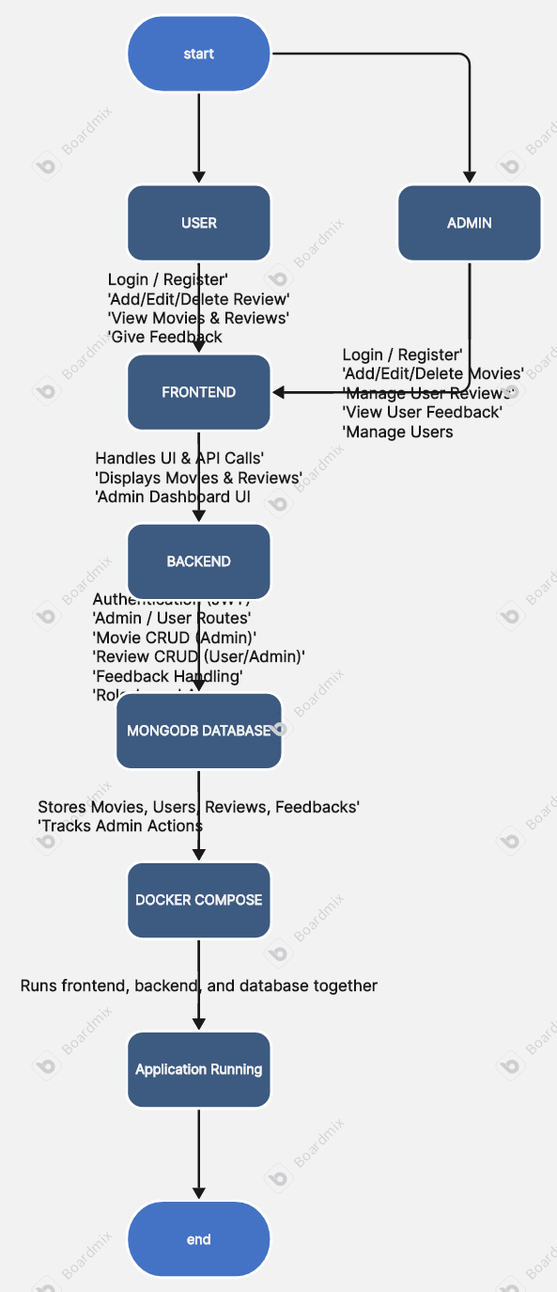

Future Enhancements🚀

💫 Implement role-based access with advanced analytics (for admin).
💫 Add AI-based sentiment analysis for reviews.
💫 Enable social login (Google, GitHub).
💫 Deploy on cloud (AWS/GCP).
💫 Add email notifications for new reviews or feedback.

📈 Conclusion
The Silver Screen Review project demonstrates the integration of full-stack development with containerized deployment. It showcases secure authentication, data handling with MongoDB, and a clean UI for seamless user interaction.
Summary 🧑‍💻
✅ Technologies: React, Node.js, MongoDB, Docker
✅ Achievements: Built a dynamic, scalable, containerized review system
✅ Goal: Enable easy deployment and maintainability across environments

