# KrishiGrow: An Expert System Based Macro and Micronutrient Visualization System for Smart Crop Management

## Sayanton Mondal1, Sreetam Ganguly1,3, Debarshi Roy2, Rubi Bhowmick1,4, Debamita Sutar1,7, Rithwick Sethi1,5, Santanu Banerjee1,6

1SystemOnSilicon Corporation, TX, USA

2Alcorn State University, MS, USA

3Indian Institute Of Engineering Science and Technology (IIEST), India

4Shri Shikshayatan College, India

5Delhi Technological University (DTU), India

6Chaudhary Charan Singh Post Graduate College

7Sarsuna College, India

## Abstract

Macro and micronutrient management of agricultural land is a problem that requires constant monitoring and planning, which is absent in the current Indian agricultural landscape. Farmers often balance the risk of biomagnification and nutrient depletion with maximizing profits, which is not done properly in most cases. Continuous depletion of macro and micronutrients from the farming land would lead to poor soil fertility, reduced crop production, and will negatively impact human and animal health as well. In this article, we propose KrishiGrow, an expert monitored smart system that utilizes open-source data from agricultural extension information outlets and geological surveys across India and presents the farmer with the most accurate and up-to-date advice on the strain and type of crop that should be planted for a particular plot of land. Our solution would also enable the farmers with the most updated data on soil quality and fertility across India. We believe that KrishiGrow and its implementation will aid small and mid-level farmers to obtain the highest possible productivity for their land.

## Introduction

Agriculture is the core sector in the economy of a developing and emerging country like India. The overall growth of the agricultural sector has faced a recession since the year 1990 [5]. Studies have shown that 60% of the Gross domestic product(GDP) has been accounted for by the service sector, which further led to the recession of the shares of agriculture[5,6]. It is found that India is the second-largest producer of farm output, and is the largest producer of milk, major spices, fruits and vegetables, and several other crops such as jute, castor oil seed, and millets (IBEF, 2020). Moreover, it is also the second-largest producer of rice and wheat[7]. The commercial crops have the potential to elevate the exports of agricultural commodities, this will result in the rapid growth of the agro-based industries. The agricultural sector is known as an inclusive sector as it not only reduces poverty but also provides employment to the majority of the Indian population[11]. With the increasing population and the growing demands of agricultural commodities, we are placing unprecedented demands on natural resources and agriculture. In this 21st century, the high consumption rate of the growing population is evidently a challenge to farmers and scientists.[12]. The world population is estimated to reach 9.5 billion by the year 2050, to cope with the increased demand of this population, present food production will be required to double what it is now[13]. Monocrops of species like wheat, rice, corn, and soybean are cultivated in around 80% of the arable land, this subsides the genetic diversity of global agriculture[14]. Moreover, climate change has decreased agricultural productivity and increased the number of malnourished people from 40 to 170 million[15]. In order to alleviate poverty, malnutrition and cope with the demand of the growing population, depleting natural resources, and global climate change, the farmers have turned to diverse agricultural practices in India[8]. With the need to feed the growing population, came the need to increase the yield as well as to produce quality yield. This increased the need to use fertilizers, pesticides, and fungicides and adopt practices like monocropping, poly cropping, etc. In the long run, it produced a green revolution but led to resource degradation[9,10].

In India, the green revolution started around the 1960s, the major goal was to increase food production and feed the malnourished people, it pioneered the new era of agricultural technology. It employed the use of high-yielding chemical fertilizers and bioengineered seeds. The small farmers who wanted to implement the technologies of the green revolution took out loans and sold lands to afford it, but were left impoverished and many suicides were reported. Farmers were pushed into this vicious cycle, where they were buying large amounts of fertilizers to counteract the effects of monocropping[17]. Moreover, it resulted in low water tables, soils deprived of micro and macronutrients in areas where huge amounts of fertilizers were used, nutrients including boron, zinc, molybdenum, magnesium, etc[17,18].

The small farmers in India face lots of obstacles that make cultivation and farming harder for them and push them to commit suicide, they face issues such as the absence of infrastructure in their village, increasing cost of cultivation, the availability of credit for small farmers, little or no financial support by government for the small farmers, the unfair use of natural resources, repugnant international policies, repetitive or monocropping increase the risk of crop failure, lack of funds, etc[16]. Moreover, the small farmers in India, allocate the overall or the major part of their land to grow high-value crops, such as fruits and vegetables, wheat, and rice[11]. In this paper, we focus on discussing KrishiGrow, which is an expert system, that will use the available open-source data from agricultural extension information outlets and geological surveys and presents the farmer with the most accurate and up-to-date advice on the strain and type of crop that should be planted for a particular plot of land.

Macro and micronutrient management of agricultural land is a problem that requires constant monitoring and planning, which is absent in the current Indian agricultural landscape. Farmers often balance the risk of bio-magnification and nutrient depletion with maximizing profits, which is not done properly in most cases.

Currently, farmers are facing several issues like decreased productivity, decrease in profit, rising quality competitiveness as a result of globalization, the poor link between farms and Market, a wide information gap that exists between farmers and analysis practices labs, low knowledge of agricultural input. To properly address these challenges, competent human resources in sufficiently giant numbers would be needed. KrishiGrow will help in providing information on the weather forecast, farmers-related news, when what and how these pesticides, herbicides, insecticides extra need to be used, according to your location and weather forecast what crop varieties would be most suitable for the respective land.

## Previous Works

[1] et al. presents an automated system that assists farmers in gathering data about their crops through sensors and then growing the crops accordingly. Different soil parameters such as temperature, humidity, climatic condition (rain), and moisture present in the soil are collected and transferred to the cloud known as ThingSpeak Cloud to control and check the scale of fertilizers whether the fertilizers present in the soil are in the right amount or not. In this system, sensors are used to gather these parameters, which are connected to a node MCU microcontroller, and that node MCU microcontroller is connected to a cloud storage system, thingSpeak, through Wi-Fi. The cloud data is reviewed using an Android application, and several Machine Learning algorithms are applied to the obtained data. After this procedure, data stored on ThingSpeakCloud are analyzed, and conclusions are made on which crops will be ideal for that particular area where farmers would water the crops. Farmers can use ThingSpeakApplications to analyze and visualize parameter results.

[2] et. al. creates a stand-alone method that is used to evaluate soil macronutrients in the laboratory. However, photodiodes, light-emitting diodes, analog-to-digital converters (ADC), and FPGAs are used to test the color of the soil. This equipment saves time since fresh soil samples are instantly placed in test tubes, chemicals are added, and the solution color changes. It is also a low-cost solution that farmers can afford. It benefits farmers by saving them time, money, and the hassle of going to a lab and evaluating the soil. Fertilizers are advised to boost production based on the data obtained.

To the best of our knowledge, no studies have experimentally examined these multiple goals simultaneously using micronutrients [3]. There is no one technology that can entirely close the gaps in crop-human nutrition interfaces that exist in nations where they exist. Certain technologies, some new and others improved, can, nevertheless, be used to begin to close the gap. Due to the huge regional variations in soil properties, the temporal demands for various nutrients by crops, and the negative nutrient interactions that occur, it would be impossible, if not impossible, to have a balanced composition with all 14 elements in a single fertilizer product. As a result, nutrient omission and/or addition studies that reveal the relative effect of each nutrient under specific crop and agroecological conditions should lead to advancements in fertilizer product design and formulation. This ensures that only the appropriate nutrient combinations are employed for the appropriate crop, in the appropriate location, and at the appropriate time. The basic lesson is that most farmers' fertilizer use should extend beyond the big three (N, P, K) to include micronutrients, but only on a case-by-case basis.

## Problem Statement

Based on our in-depth domain research, landscape exploration, and competitive analysis, we observed an absence of commercially available software that presents small and mid-level farmers with advisory regarding the strain and kind of crop that can be grown in their location, keeping in mind the micronutrient and macronutrient profile of their respective farmland. The advisory provided to farmers using existing extension infrastructure, tele-recommendations, and peer forums, is at best slow, and at worst, grossly inaccurate, leading to mismanagement and serious long-term problems such as loss of nutrients, biomagnification, and crop failure.

## Proposed Solution

To provide farmers with timely recommendations regarding cropping cycles, we propose *KrishiGrow*, a context-aware expert system that aids small and mid-level farmers to view available options on the type and strain of crop to grow, and their expected yield versus cost ratio. Unlike traditional solutions currently in use in the agricultural sector, KrishiGrow is fast, accurate, and easy to use, making it easy to integrate across a wide range of linguistic sectors. Due to its inherent autonomous structure, it can seamlessly enhance the current soil testing facilities provided by extension services worldwide by filling in the gaps in human-based soil-testing and crop consultancy services.

KrishiGrow is composed of three major parts:

1. Database: The database is composed of Geo-Spatial data as a fully-connected, undirected, acyclic graph G. Graph G can be also interpreted as a tree. In graph G, the root is the major region (country, continent, subcontinent, economic zones, etc.). The various levels below the root represent increasingly finer sub-regions. The leaves of the tree represent the smallest subdivision (typically districts, blocks, or sub-divisions). Each leaf li contains three data fields:
   1. Key-value of li.
   2. Geo-location vector Li where Li = [latitude of li, longitude of li].
   3. Nutrient vector ni where ni is a matrix that stores the macro and micronutrient and average rainfall received for the region described by li. Typically ni = [N P K S Zn Fe Cu Mn B (Average rainfall)] where the figures are established in kg/ha. The average annual rainfall is converted into the same units assuming standard temperature and pressure.

The Database also has a separate lookup table T with the shape (n, p+1) where n is the number of leaves in G and p is the number of data points in ni. The additional field is reserved for the key value of li, thus serving as the primary key to aid in faster lookup times.

1. Prediction module for Spatio-temporal data gaps: To accumulate the absent datapoints, the raw 2D representation as described by the graph G and lookup table T subjected to average filling and Gaussian Blurring

The Gaussian blurring smoothens out the imperfections and possible noise in the data to provide a more accurate description of real word agricultural lands. The Gaussian blurring is applied to each of the elements in ni. Since those elements taken together over the complete 2D region of interest creates a p-channel 2D image, the blur can be applied using standard Python libraries. To accumulate larger gaps in data, Polynomial regression is used instead of Average filling, coupled with the standard Gaussian blurring.

1. Risk to profit factor calculation engine: We define the risk as to the average investment a farmer has to make taking into account the financial and opportunity cost. To represent this, we have estimated the cost of fertilizers to be a linear function of macro and micronutrient deficiencies when expressed in p-dimensional space.

Nutrient requirement matrix rc for crop c = [N P K S Zn Fe Cu Mn B (Average rainfall)] where the values are the requirements expressed in kg/ha assuming standard temperature and pressure.

Cost matrix Dci for crop c and region i is defined as: Dci = ReLu(rc - ni)

Since we accept only the nutrients to be added, we ignore the nutrients already present. ReLu simplifies this function.

The Risk to profit factor Jci for crop c and region i is expressed as:

Jci = 10 x sigmoid(||Dci|| / ||ni||)

To aid in the comprehensiveness of J, it is expressed in a points or “star” system, providing the most profitable crop with most “stars” and the least profitable crop with least “stars”. This ensures that the recommendation will surpass language and educational barriers.

The dataset for the KrishiGrow database is collected from open-source GIS & GPS Based Soil Fertility Maps of 11 states published by The Indian Council of Agricultural Research (ICAR). The data was autonomously tabulated using Python image processing and optical character recognition (OCR) modules. The module continuously scrapes and updates the data from the available sources and is integrated into the technology stack of KrishiGrow. The average rainfall is collected from satellite feeds and updates from India Meteorological Department (IMD) website using automated scrapers and a ReGEX based compiler.

## Results and Discussion

We have simulated a scenario where we have varied only the nitrogen concentration and have calculated the J value based on simulated yield.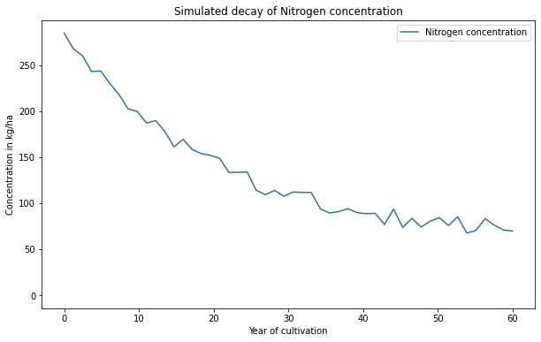

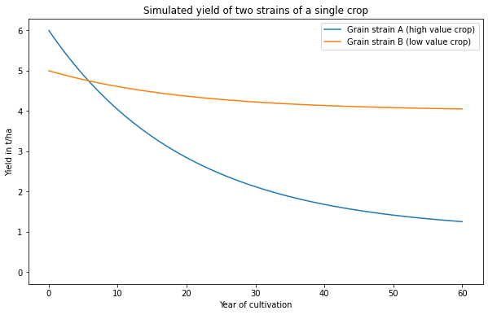

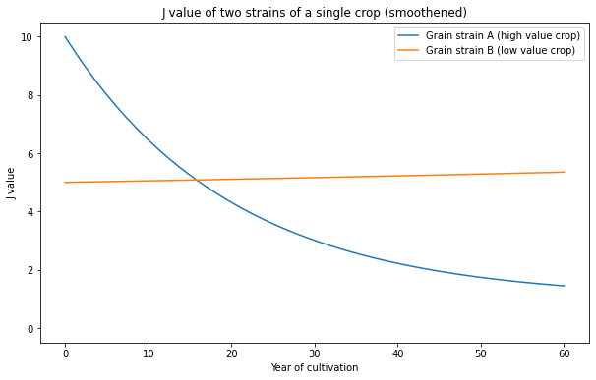

Based on the above results, in spite of the low yield on the high-value strain A, the farmer should switch to strain B at around year 16 of cultivation, instead of at year 7 if he follows the recommendations of KrishiGrow.

It can help the small farmers by accumulating open-source data from outlets providing agricultural information and providing farmers with accurate data about the strains or type to plant, in order to increase productivity, it will help reduce expenditure on organic and inorganic fertilizers, irrigation facilities, and agricultural products, help reduce waste production and insurance liabilities, it will implement agricultural practices in order to reduce environmental pollution and promote the efficient use of natural resources and it will also encourage practices to utilize the agricultural subsidies in an efficient manner. Farmers will be able to meet the demand of the present generation, without compromising the demand of the future generations. Moreover, the app will confer a better insight in order to understand the market. As a result, farmers will be able to increase the annual percentage yield, which will improve soil fertility.

## Conclusion

KrishiGrow is an expert system that uses open-source data from agricultural extension information outlets and geological surveys to provide small and medium farmers with accurate and time-sensitive guidance on the type and strain of crops that can be planted with relatively short latency when compared to more traditional human-involved systems. Based on studies on simulations, it performed impressively and provided accurate recommendations regarding the type and strain of the crop that needs to be planted. In the future, the system can be tested using real-world data and has the potential to be integrated into Edge computing frameworks.

## References

[1] Sonal S Udapudi, Sonika R, Aravind E M, Prasad Shivam, Anoop G L, “Automatic soil nutrients and crop detection management system using IOT”, IJARIIE, 2021.

[2] Vaibhav Ingale, Rashmi Vaidya, Amol Phad, Pratibha Shingare, “A Sensor Device for Measuring Soil Macronutrient Proportion using FPGA”, IEEE, 2016.

[3] Christian O. Dimkpa, Prem S. Bindraban, “Fortification of micronutrients for efficient agronomic production: a review”, INRA, 2016.

[4] Hongkun Tian, Tianhai Wang, Yadong Liu, Xi Qiao, Yanzhou Li, “Computer vision technology in agricultural automation —A review”, INPA, 2020.

[5] Mathur, A. S., Das, S., & Sircar, S. (2006). Status of agriculture in India: trends and prospects. Economic and political weekly, 5327-5336.

[6] Latha, C. M., & Shanmugam, V. (2014). Growth of service sector in India. Journal of Humanities and Social Science, 19(1), 08-12.

[7]Dhawan, V. (2017, January). Water and agriculture in India. In Background paper for the South Asia expert panel during the Global Forum for Food and Agriculture (Vol. 28).

[8]Bhan, S., & Behera, U. K. (2014). Conservation agriculture in India – Problems, prospects and policy issues. International Soil and Water Conservation Research, 2(4), 1–12. doi:10.1016/s2095-6339(15)30053-8

[9]Abrol, I. P., & Sangar, S. (2006). Sustaining Indian agriculture–conservation agriculture the way forward. Current Science, 1020-1025.

[10]Ghosh, N. (2004). Reducing dependence on chemical fertilizers and its financial implications for farmers in India. Ecological Economics, 49(2), 149–162. doi:10.1016/j.ecolecon.2004.03.01

[11]Mahendra Dev, S. (2014). Small farmers in India: Challenges and opportunities.

[12]Foley, J. A., Ramankutty, N., Brauman, K. A., Cassidy, E. S., Gerber, J. S., Johnston, M., ... & Zaks, D. P. (2011). Solutions for a cultivated planet. Nature, 478(7369), 337-342.

[13]Godfray, H. C. J., Beddington, J. R., Crute, I. R., Haddad, L., Lawrence, D., Muir, J. F., ... & Toulmin, C. (2010). Food security: the challenge of feeding 9 billion people. science, 327(5967), 812-818.

[14]Adams, M. W., Ellingboe, A. H., & Rossman, E. C. (1971). Biological uniformity and disease epidemics. BioScience, 21(21), 1067-1070.

[15]Altieri, M. A., Nicholls, C. I., Henao, A., & Lana, M. A. (2015). Agroecology and the design of climate change-resilient farming systems. Agronomy for sustainable development, 35(3), 869-890.

[16]Deshmukh, P. V. (1940). Farmers suicides in India. age, 3450(2140), 2704-2705.

[17]Sebby, K. (2010). The green revolution of the 1960s and its impact on small farmers in India.

[18]Bowonder, B. (1979). Impact analysis of the green revolution in India. Technological Forecasting and Social Change, 15(4), 297-313.