Tableau Homework

Citi-Bike-Analysis:

This is the analysis for the New York Citi Bike Program, which is responsible for overseeing the largest bike sharing program for 200,000+ data points in the United States in order to generate business insights in terms of visualize the peak time in both summer and winter period and the top start location in New York City and Jersey City, New Jersey.

The link for Tableau Visualizations and dashboard is here:

<https://public.tableau.com/profile/sreeteja#!/vizhome/CitiBikeAnalytics_15873348522870/totalnumberoftrips2017>

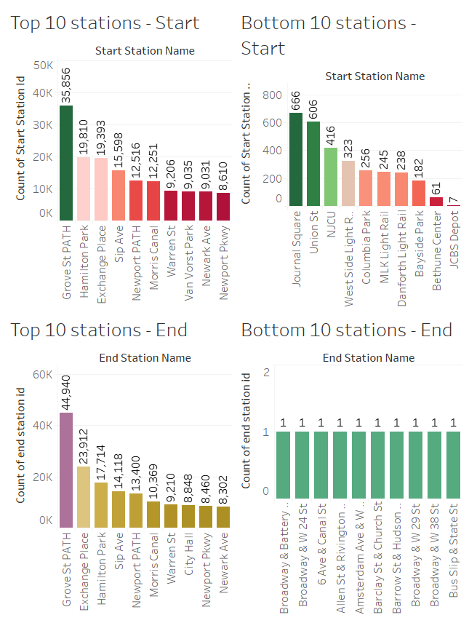

The Dataset is here : <https://www.citibikenyc.com/system-data>

Limitation:

There were 7% users who did not provide gender information and most of them (14%) are weekend users so we will not be able to tell if female are more willing to ride on the weekend than they do on weekdays, but we may still determine that male user are the dominant customer at all time.

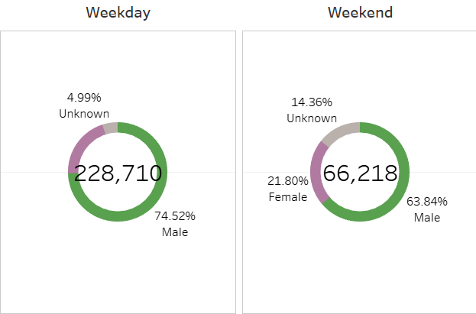

Findings:

1. The current major Citi bike riders fall into young male group between 18 -20 but number of female riders increases over time as they are showing interest to start riding during the weekend.

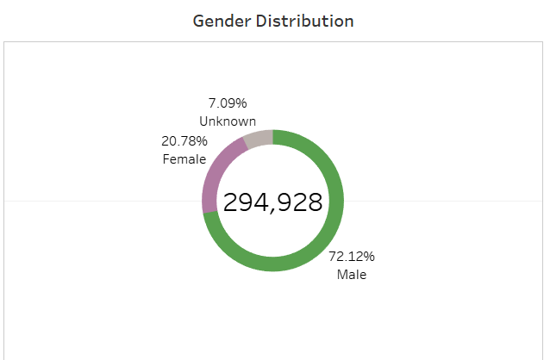

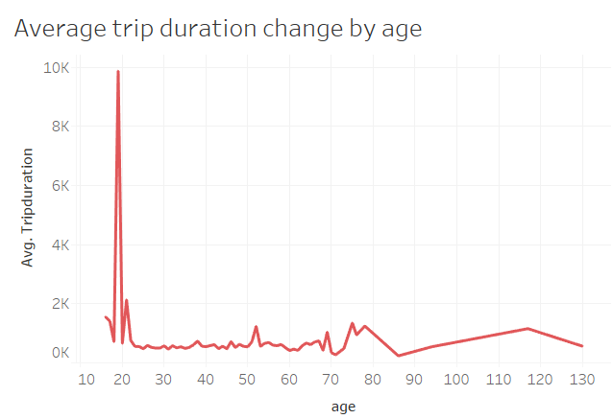

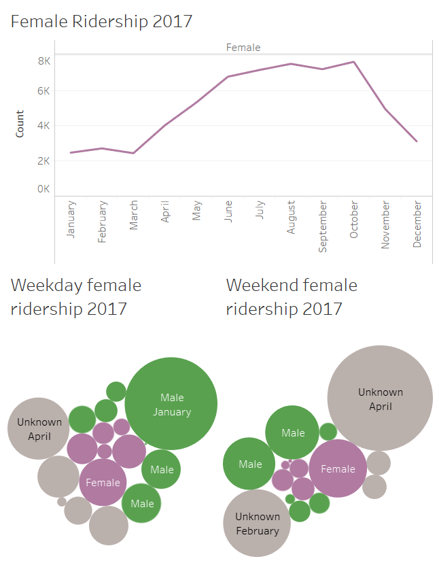

1. The 1st and 2nd peak hours during a day would usually be 7-8 AM and 5-6 PM season-regardless.

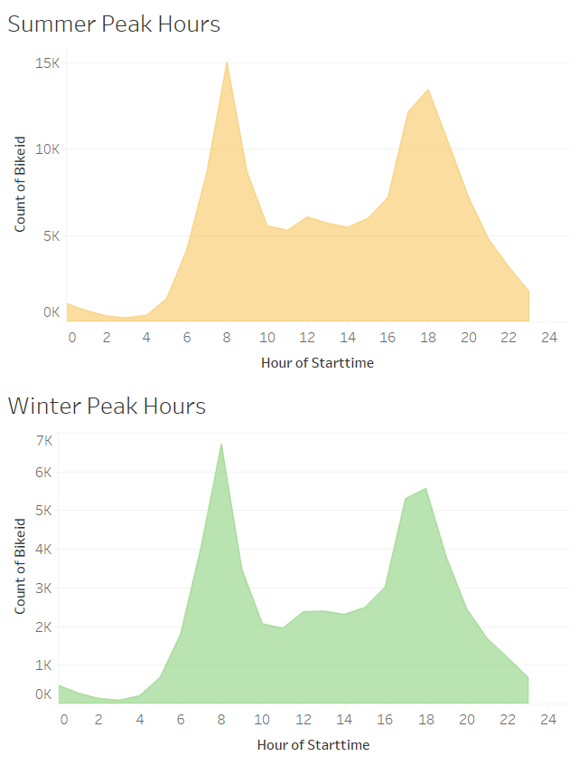

1. As the temperature gets cold as winter begins, people tend not to ride as well because of the lack of comfort individuals face when riding in low temperatures. Therefore, at some point the ridership does not grow. However, the total amount of annual members have been kept increased over time in 2017.

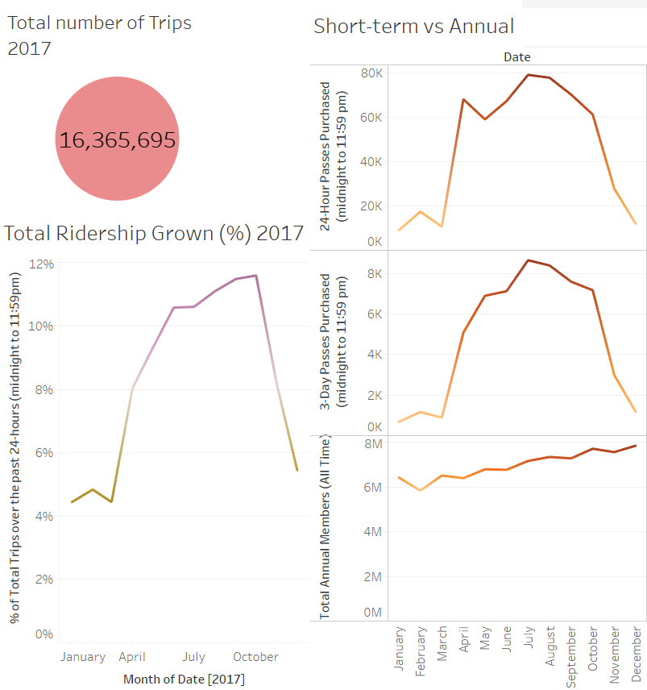

Map visualization for city officials:

More and more people choose to live in Jersey City and work in Manhathan.

