SETTING UP EPICS, FEATURES, AND USER STORIES FOR PROJECT PLANNING

EXP NO: 3
Aim:
Create Epic, Features, User Stories, Task
To learn about how to create epics, user story, features, backlogs for your assigned project.

Create Epic, Features, User Stories, Task
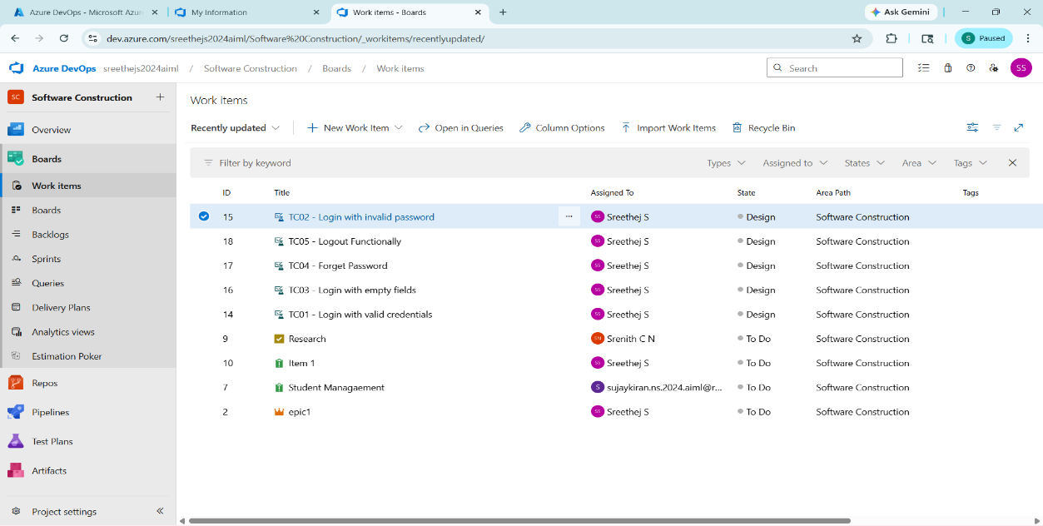
- Fill in Epics
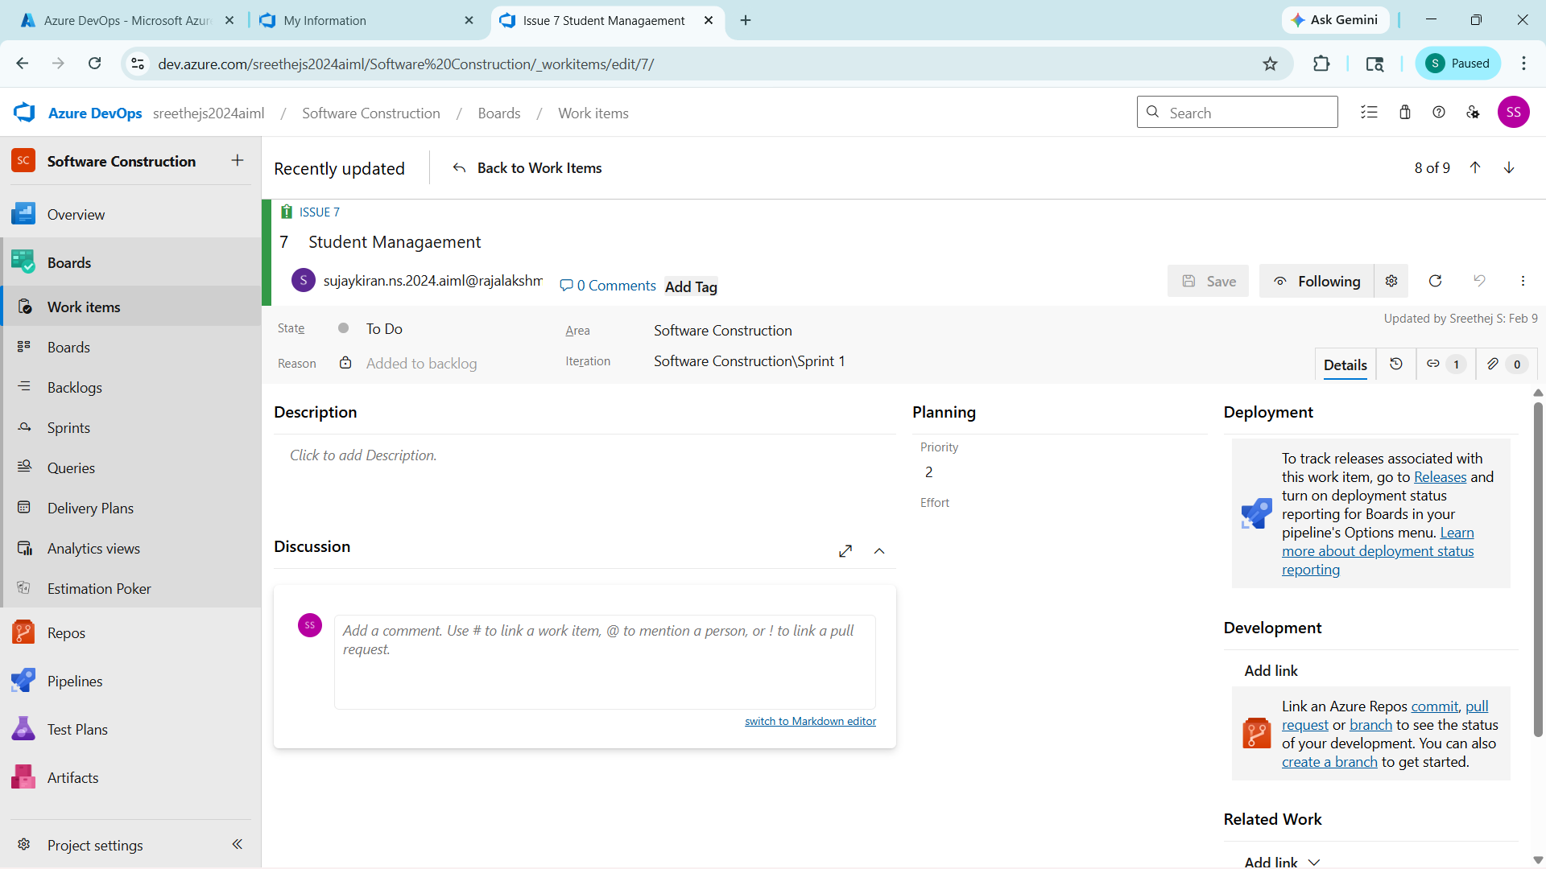

- Fill in Features
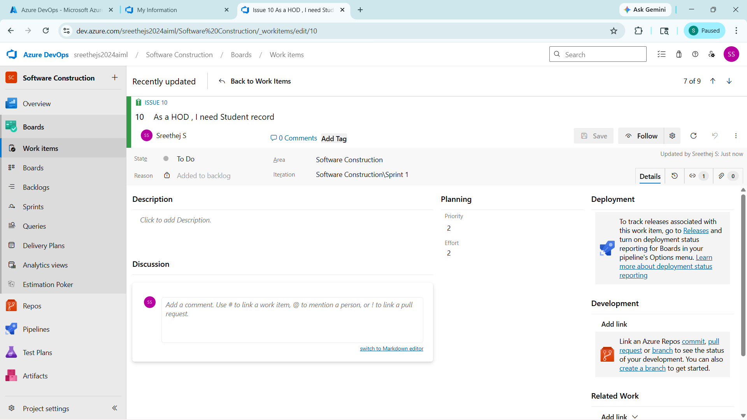

- Fill in User Story Details
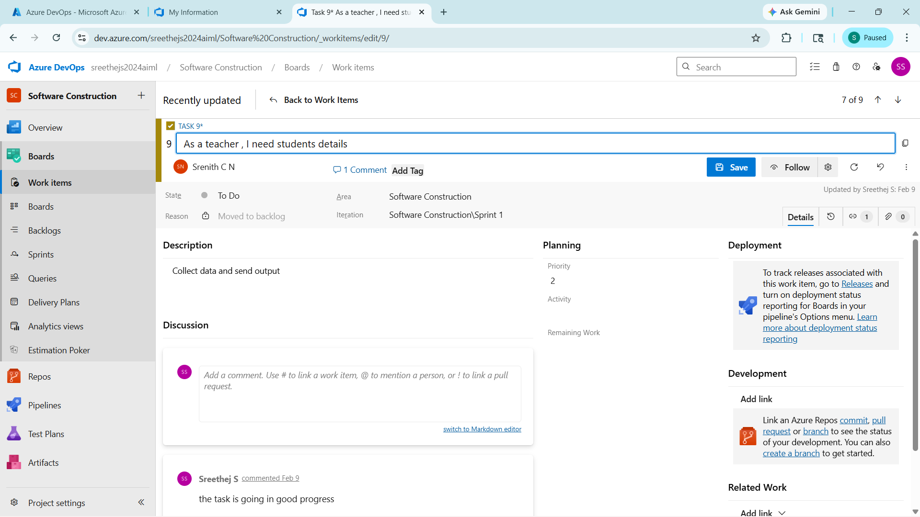

Result:
Thus, the creation of epics, features, user story and task has been created successfully.

