SPRINT PLANNING

EXP NO: 4

Aim:
Create Epic, Features, User Stories, Task
To assign user story to specific sprint for the Music Playlist Batch Creator Project.

Sprint Planning Sprint 1
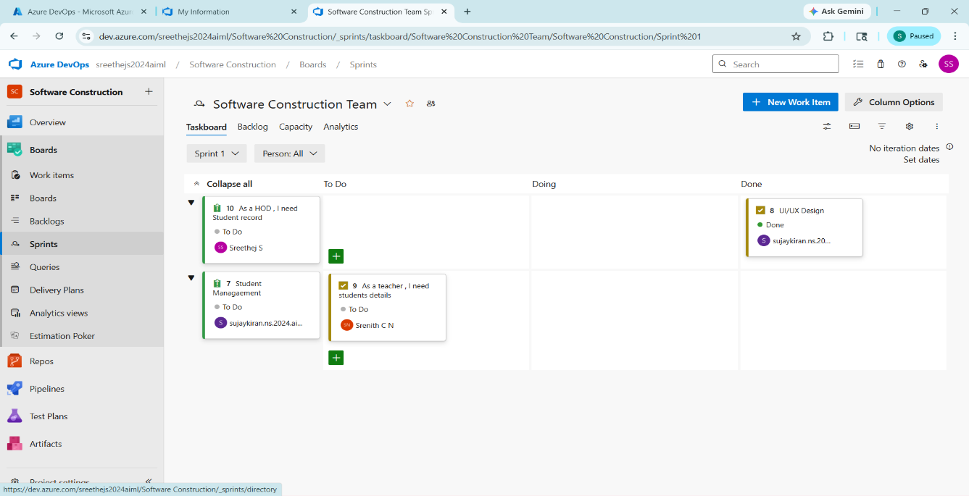
Sprint 2
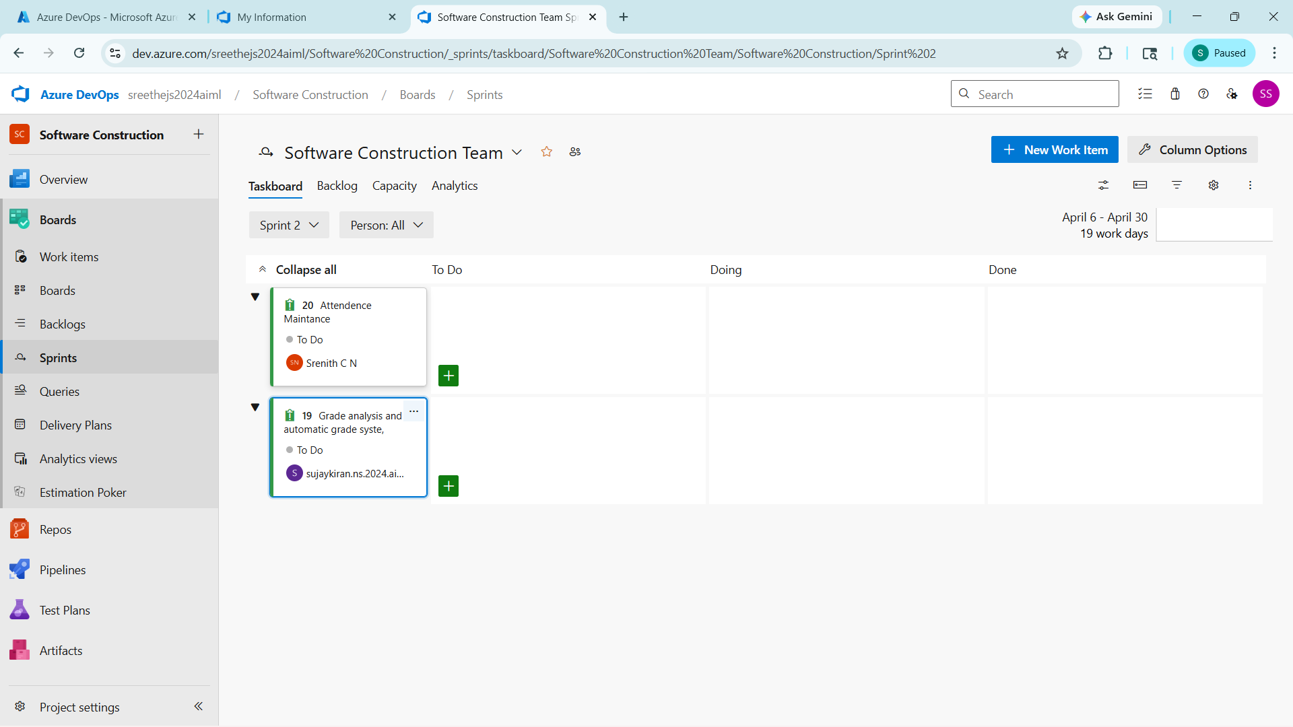

Sprint 3
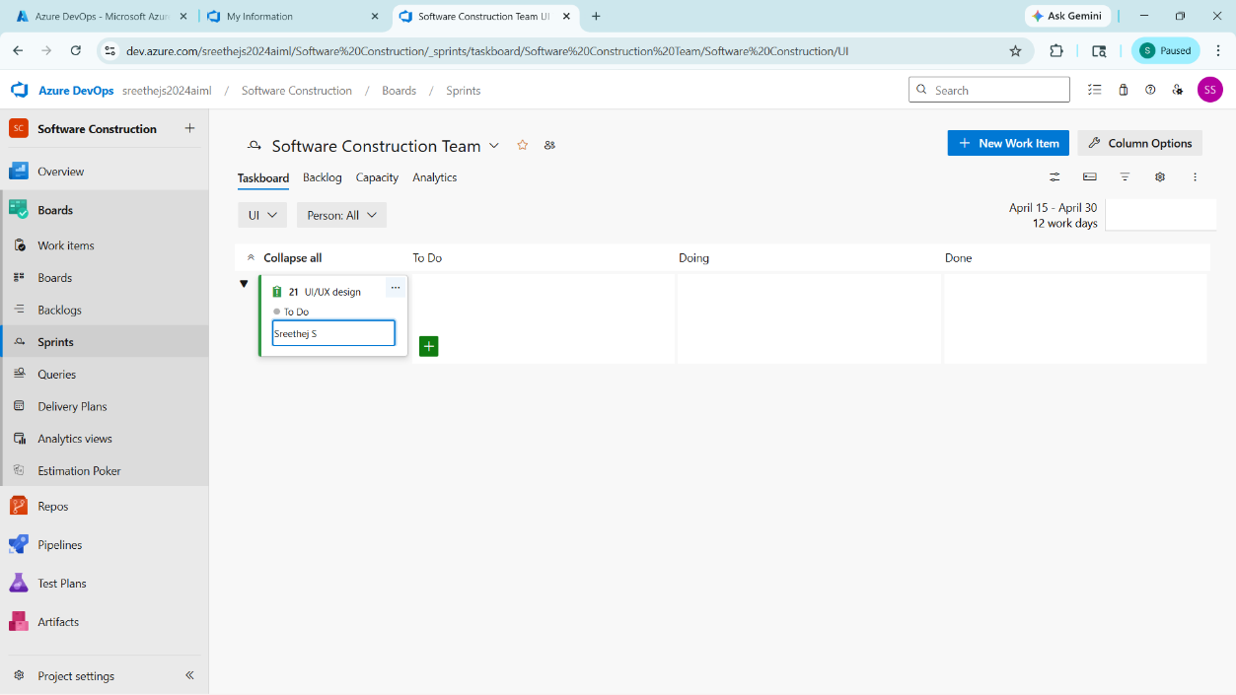
Sprint 4

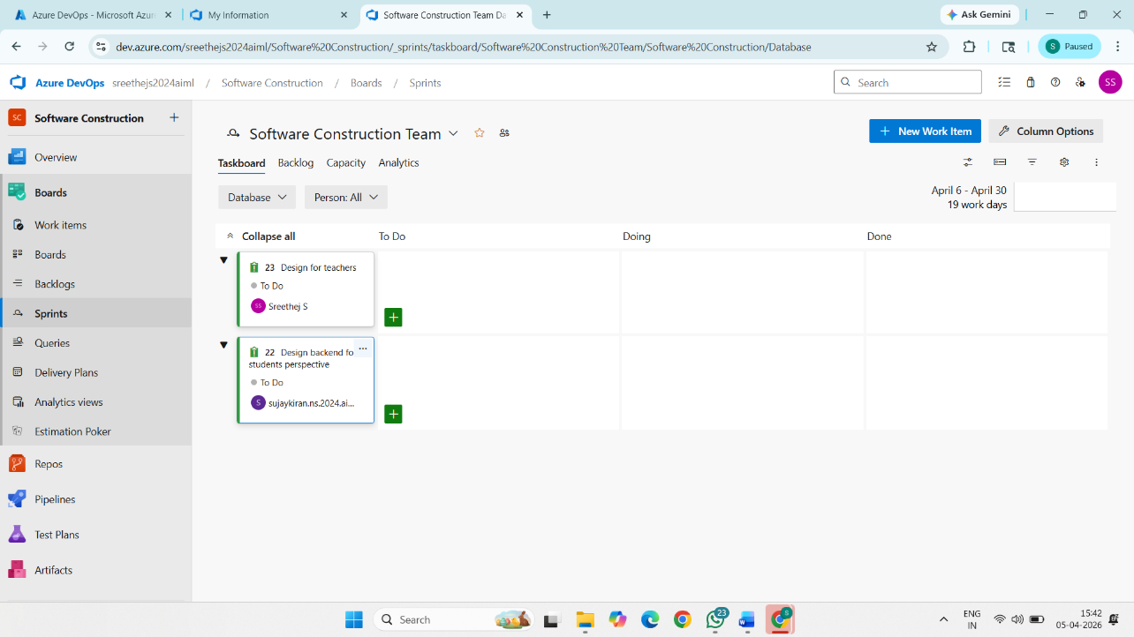

Result:

The Sprints are created for the Music Playlist Batch Creator Project.

