POKER ESTIMATION

EXP NO: 5
Create Epic, Features, User Stories, Task

Aim:
Create Poker Estimation for the user stories - Music Playlist Batch Creator Project.

Poker Estimation
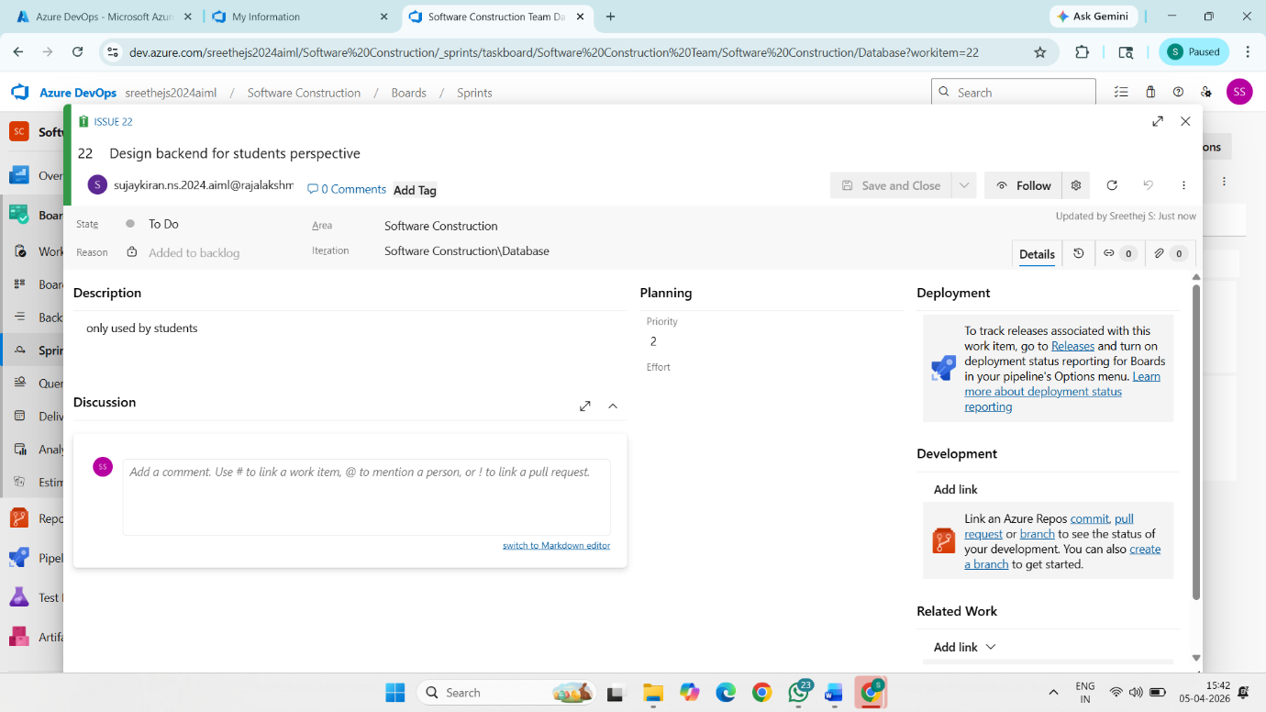

Result:

The Estimation/Story Points is created for the project using Poker Estimation.

