DESIGNING CLASS AND SEQUENCE DIAGRAMS FOR PROJECT ARCHITECTURE

EXP NO: 6
Create Epic, Features, User Stories, Task

Aim:
To Design a Class Diagram and Sequence Diagram for the given Project.

6A. Class Diagram
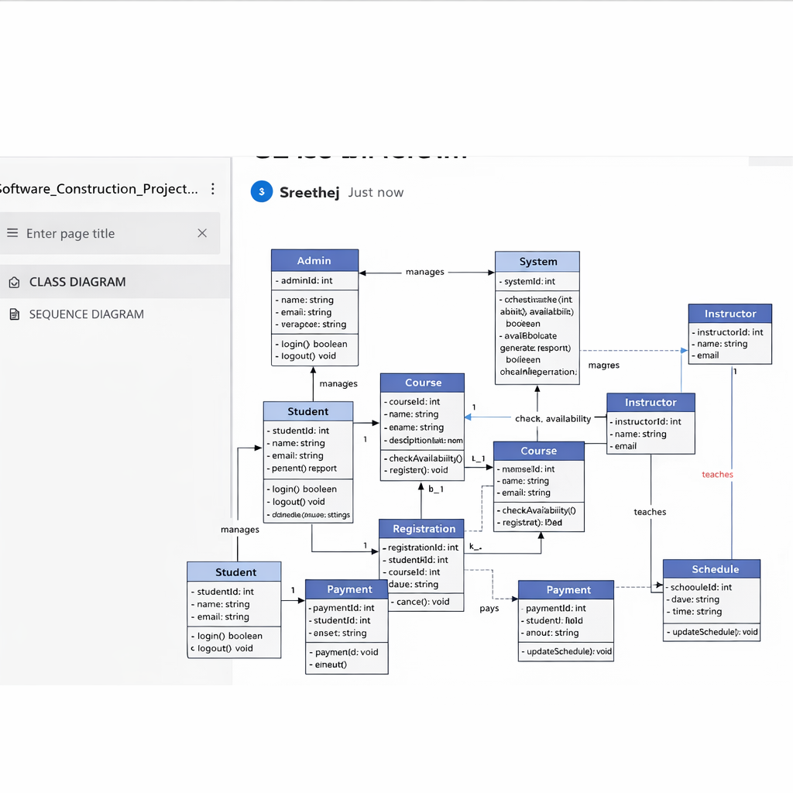

6B. Sequence Diagram

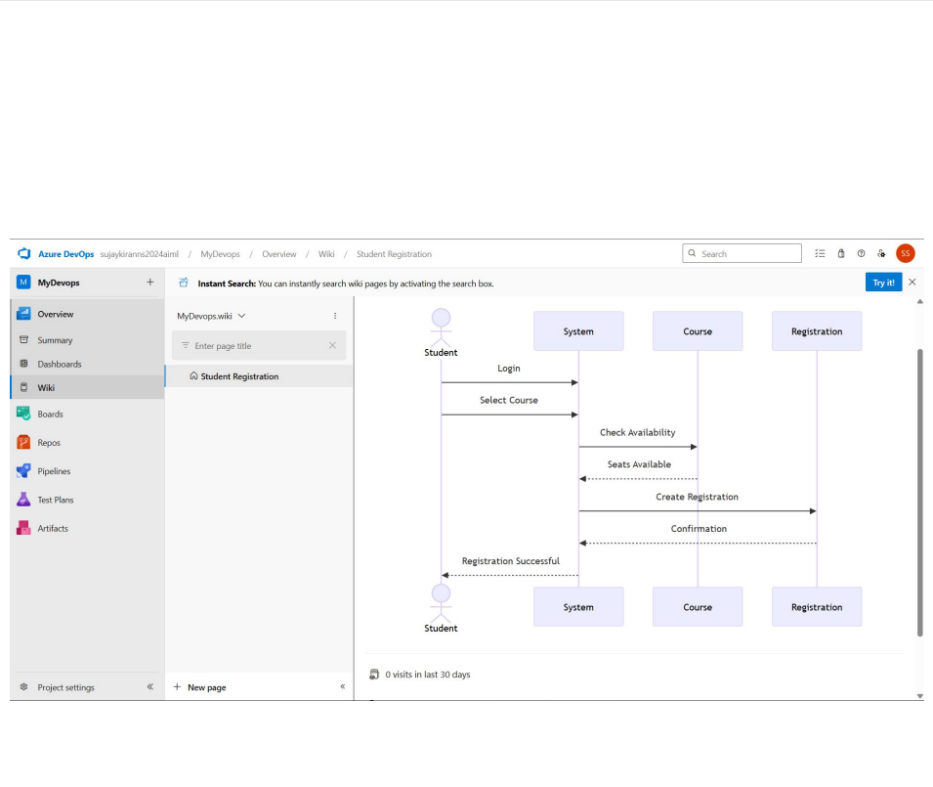

Result:
The Class diagram and sequence diagram is designed successfully for the Student Management System.

