AZURE DEVOPS PROJECT SETUP AND USER STORY MANAGEMENT

EXP NO: 2

Aim:
Create Epic, Features, User Stories, Task
To set up an Azure DevOps project for efficient collaboration and agile work management.

- Create An Azure Account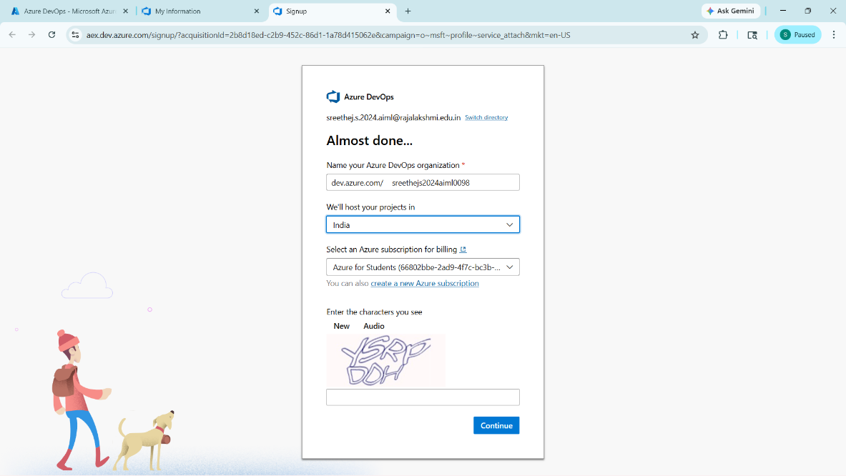

- Create the First Project in Your Organization
  - After the organization is set up, you’ll need to create your first project. This is where you'll begin to manage code, pipelines, work items, and more.
  - On the organization’s Home page, click on the New Project button.
  - Enter the project name, description, and visibility options:
Name: Choose a name for the project (e.g., LMS).
Description: Optionally, add a description to provide more context about the project. Visibility: Choose whether you want the project to be Private (accessible only to those invited) or Public (accessible to anyone).
  - Once you’ve filled out the details, click Create to set up your first project.

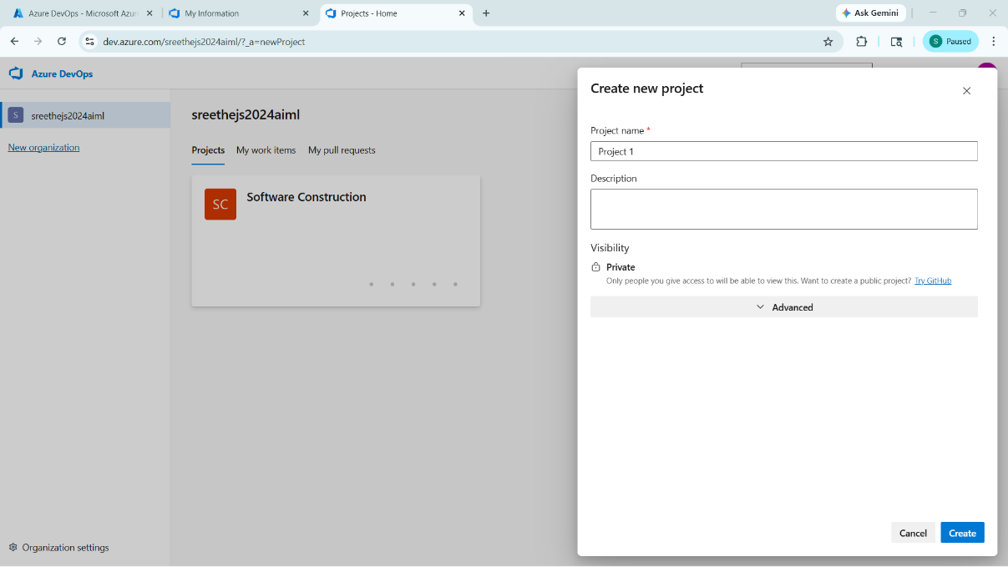

- Once logged in, ensure you are in the correct organization. If you're part of multiple organizations, you can switch between them from the top left corner (next to your user profile). Click on the Organization name, and you should be taken to the Azure DevOps Organization Home page.

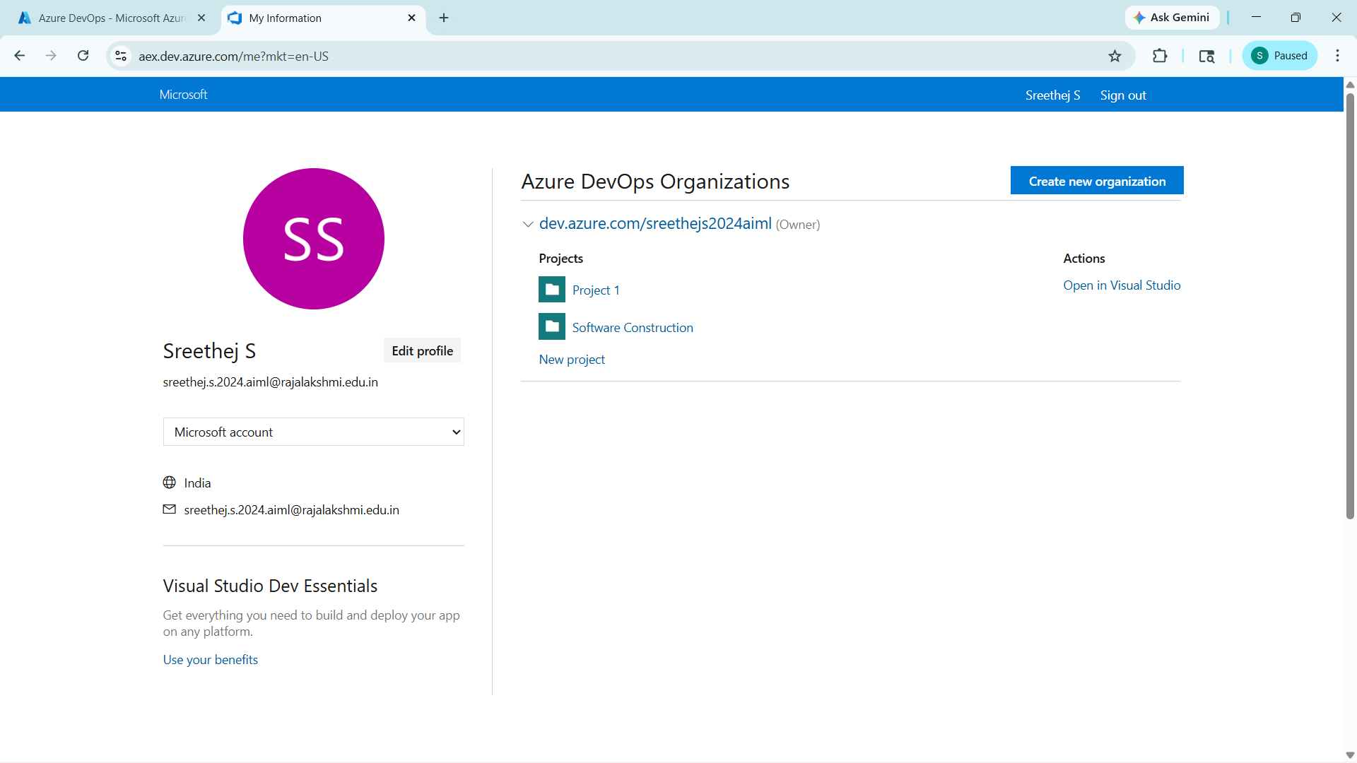

- Project dashboard

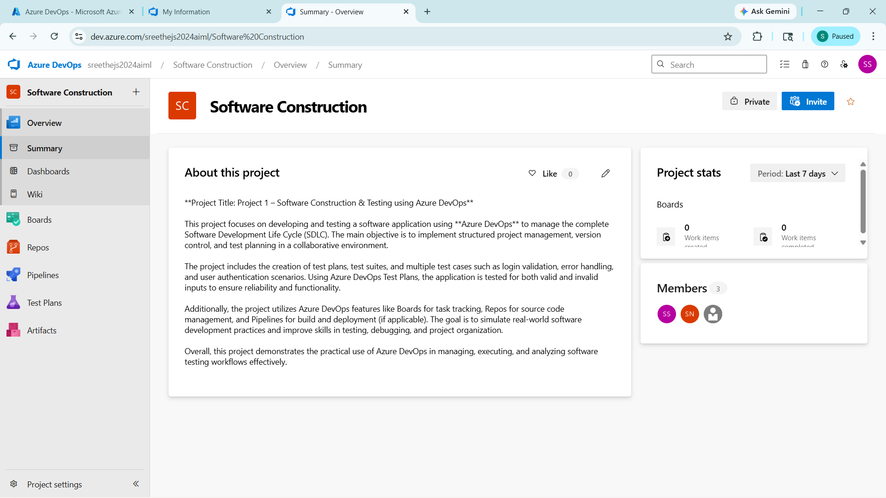
- To manage user stories:
  - From the left-hand navigation menu, click on Boards. This will take you to the main Boards
page, where you can manage work items, backlogs, and sprints.
  - On the work items page, you'll see the option to Add a work item at the top. Alternatively, you can find a + button or Add New Work Item depending on the view you're in. From the Add a work item dropdown, select User Story. This will open a form to enter details for the new User Story.
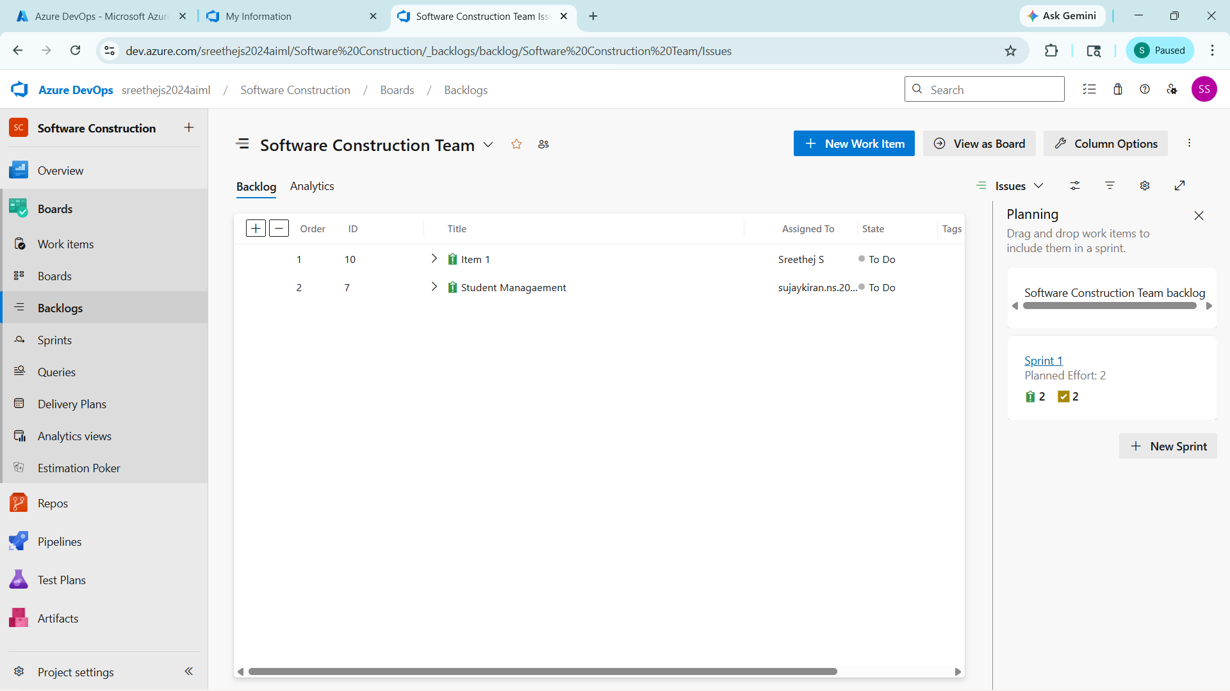

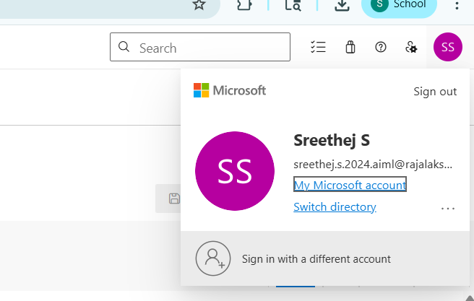

Result:
Successfully created an Azure DevOps project with user story management and agile workflow
setup.

