Create Epic, Features, User Stories, Task
DESIGNING ARCHITECTURAL AND ER DIAGRAMS FOR PROJECT STRUCTURE

EXP NO: 7

Aim:

To Design an Architectural Diagram and ER Diagram for the given Project.

7A. Architectural Diagram
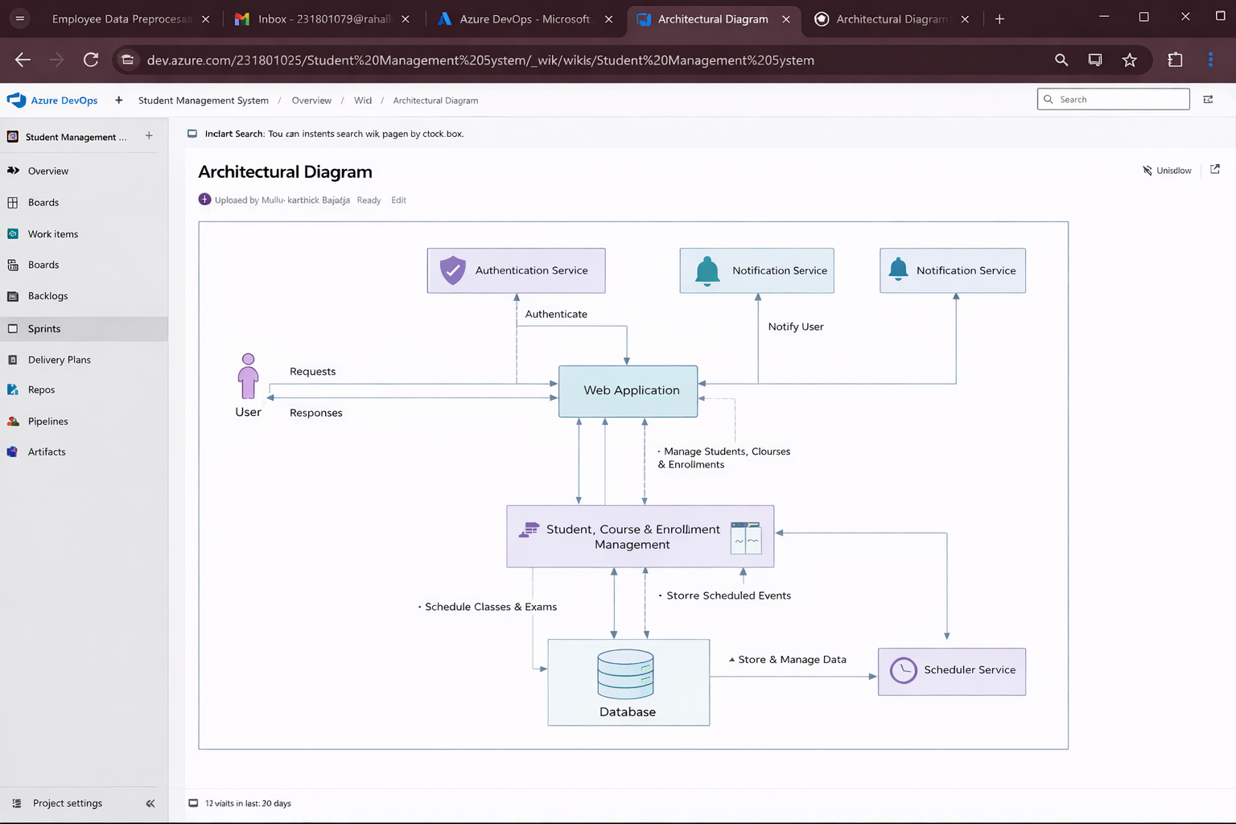

7B.ER Diagram

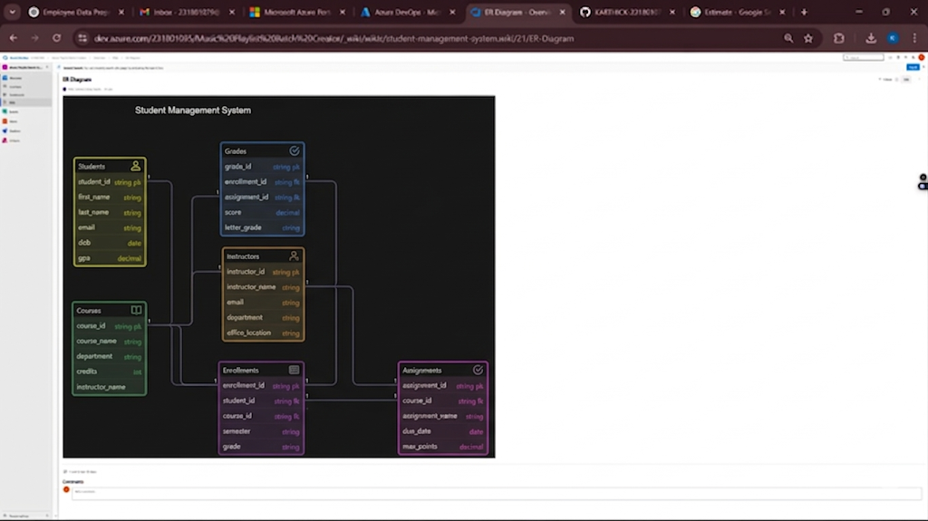

Result:

The Architecture Diagram and ER Diagram is designed Successfully for the Music Playlist Batch

Creator

