TESTING – TEST PLANS AND TEST CASES

EXP NO: 8

Aim:
Create Epic, Features, User Stories, Task

Test Plans and Test Case and write two test cases for at least five user stories showcasing the

happy path and error scenarios in azure DevOps platform.

Test Planning and Test Case Test Case Design Procedure
- Understand Core Features of the Application
  - User Signup & Login
  - Viewing and Managing Playlists
  - Fetching Real-time Metadata
  - Editing playlists (rename, reorder, record)
  - Creating smart audio playlists based on categories (mood, genre, artist, etc.)
- Define User Interactions
  - Each test case simulates a real user behaviour (e.g., logging in, renaming a playlist, adding a song).
- Design Happy Path Test Cases
  - Focused on validating that all features function as expected under normal conditions.
  - Example: User logs in successfully, adds item to playlist, or creates a category-based playlist.
- Design Error Path Test Cases
  - Simulate negative or unexpected scenarios to test robustness and error handling.

  - Example: Login fails with invalid credentials, save fails when offline, no recommendations found.
- Break Down Steps and Expected Results
  - Each test case contains step-by-step actions and a corresponding expected outcome.
  - Ensures clarity for both testers and automation scripts.
- Use Clear Naming and IDs
  - Test cases are named clearly (e.g., TC01 – Successful Login, TC10 – Save Playlist Fails).
  - Helps in quick identification and linking to user stories or features.
- Separate Test Suites
  - Grouped test cases based on functionality (e.g., Login, Playlist Editing, Recommendation System).
  - Improves organization and test execution flow in Azure DevOps.
- Prioritize and Review
  - Critical user actions are marked high-priority.
  - Reviewed for completeness and traceability against feature requirements.

- New test plan
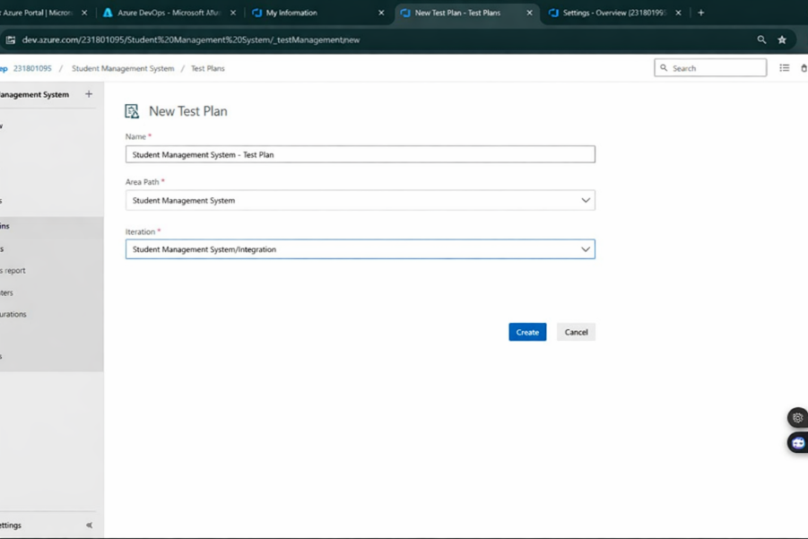

- Test suite

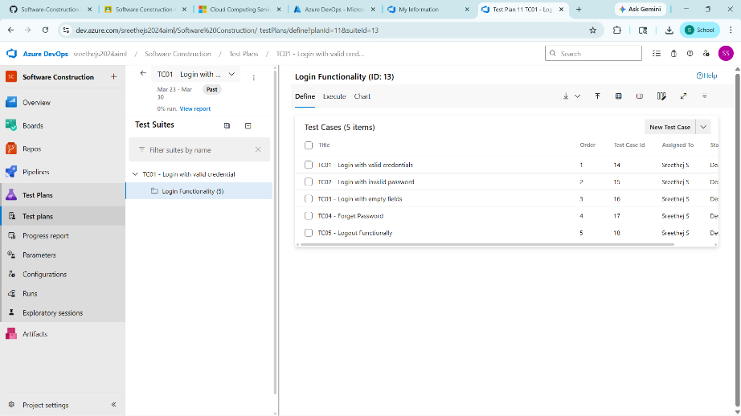

- Test case
Give two test cases for at least five user stories showcasing the happy path and error scenarios in azure DevOps platform.
Music Playlist Batch Creator – Test Plans
USER STORIES
  - As a user, I want to sign up and log in securely so that I can access my playlists (ID: 79).
  - As a user, I need to see my playlist in one place (ID: 76).
  - As a user, I should be able to create an audio playlist as needed (ID: 73).
  - As a user, I should be able to rename, record, and change the playlist (ID: 68).
  - As a user, I need to have real-time metadata (ID: 65).
Test Suites
Test Suit: TS01 - User Login (ID: 86)
- TC01 – Successful Sign Up
  - Action:
    - Go to the Sign-Up page.
    - Enter valid name, email, and password.
    - Click "Sign Up".
  - Expected Results:
    - Sign-Up form is displayed.
    - Fields accept values without error.
    - Account is created, and the user is redirected to the dashboard.
  - Type: Happy Path

- TC02 – Secure Login
  - Action:
    - Go to the Login page.
    - Enter valid email and password.
    - Click on "Login".
  - Expected Results:
    - Login form is displayed.
    - Fields accept data without error.
    - User is logged in and redirected to the dashboard.
  - Type: Happy Path

- TC03 – Sign Up with Existing Email
  - Action:
    - Go to the Sign-Up page.
    - Enter a name and an already registered email.
    - Click on "Sign Up".
  - Expected Results:
    - Fields accept data.
    - Error message "Email already registered" is displayed.
  - Type: Error Path
- TC04 – Login with Wrong Password
  - Action:
    - Go to the Login page.
    - Enter valid email and incorrect password.
    - Click on "Login".
  - Expected Results:
    - Input is accepted.
    - Error message "Invalid username or password" is shown.
  - Type: Error Path

Test Suit: TS02 - View Playlists (ID: 87)
- TC05 – View Playlist Page
  - Action:
    - Log in successfully.
    - Navigate to "My Playlists" section.
  - Expected Results:
    - All created playlists are displayed clearly.
  - Type: Happy Path
- TC06 – Playlist Loading Failure
  - Action:
    - Disconnect from the internet.

    - Navigate to "My Playlists".
  - Expected Results:
    - Network is offline.
    - Error message "Unable to load playlists" is shown.
  - Type: Error Path

Test Suit: TS03 - Real-Time Metadata (ID: 88)
- TC07 – Real-Time Metadata Display
  - Action:
    - Play a song.
    - Observe the metadata panel.
  - Expected Results:
    - Metadata (title, artist, album, duration) is displayed and updates in real time.
  - Type: Happy Path
- TC08 – Metadata Not Updating
  - Action:
    - Play a different song.
    - Observe the metadata panel.
  - Expected Results:
    - Metadata remains static or shows default/fallback message.
  - Type: Error Path

Test Suit: TS04 - Playlist Editing (ID: 89)
- TC09 – Rename Playlist Successfully
  - Action:
    - Navigate to "My Playlists".
    - Click "Rename" next to a playlist.
    - Enter a new name and click "Save".
  - Expected Results:
    - Playlist name updates successfully.
  - Type: Happy Path
- TC10 – Rename with Blank Name
  - Action:
    - Click "Rename" on a playlist.
    - Leave the field blank.
    - Click "Save".
  - Expected Results:
    - Error message "Playlist name cannot be empty" is shown.
  - Type: Error Path
- TC11 – Change Playlist Order
  - Action:
    - Open a playlist.

    - Drag and drop songs to reorder.
    - Click "Save".
  - Expected Results:
    - Playlist order is updated and saved.
  - Type: Happy Path
- TC12 – Change Playlist Order Fails
  - Action:
    - Login and go to “My Playlists”.
    - Select a playlist.
    - Go offline or simulate server error.
    - Reorder songs and click “Save Order”.
  - Expected Results:
    - Error message: "Failed to update order. Please check your connection".
  - Type: Error Path

Test Suit: TS05 - Smart Playlist Creation (ID: 90)
- TC13 – Generate Playlist Based on Various Categories
  - Action:
    - Login with valid credentials.
    - Click on "Generate Playlist".
    - Select categories.
    - Click "Generate Playlist".
  - Expected Results:
    - Playlist is generated based on selected mood and categories.
  - Type: Happy Path
- TC14 – Fail to Generate Playlist Due to Missing Category Selection or Invalid Input
  - Action:
    - Login with valid credentials.
    - Click on "Generate Playlist".
    - Select categories.
    - Click "Generate Playlist".
  - Expected Results:
    - Error message: "Please select at least one valid category" or "No recommendations found for the selected filters".
  - Type: Error Path

Test Cases

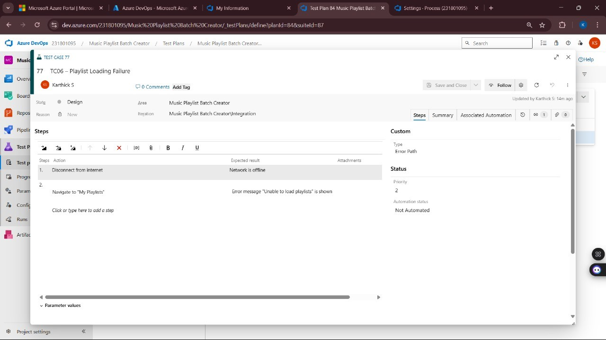
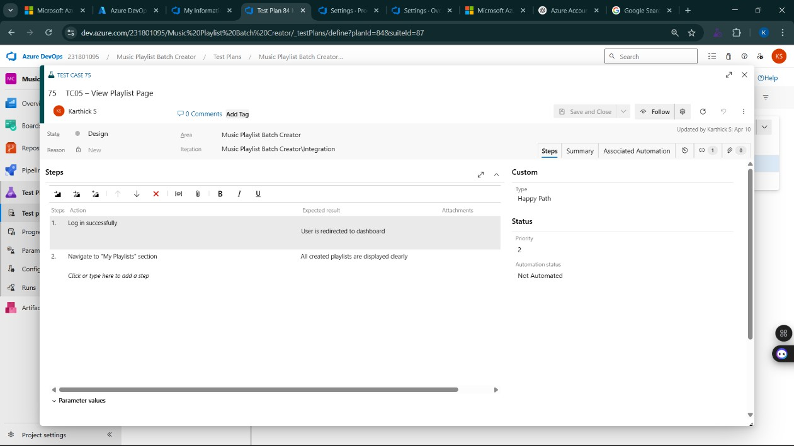
- Installation of test

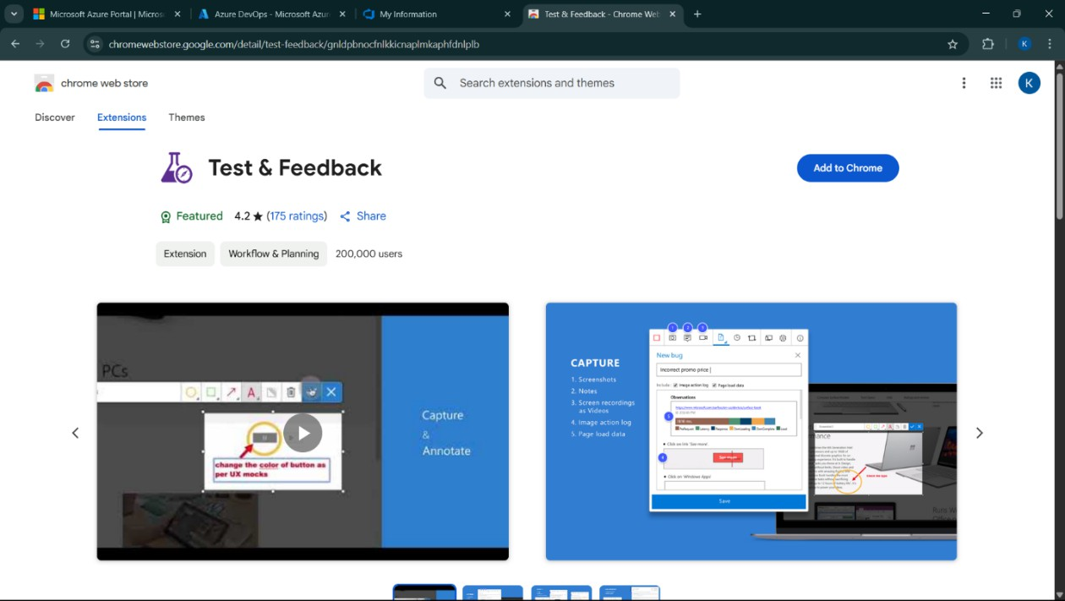
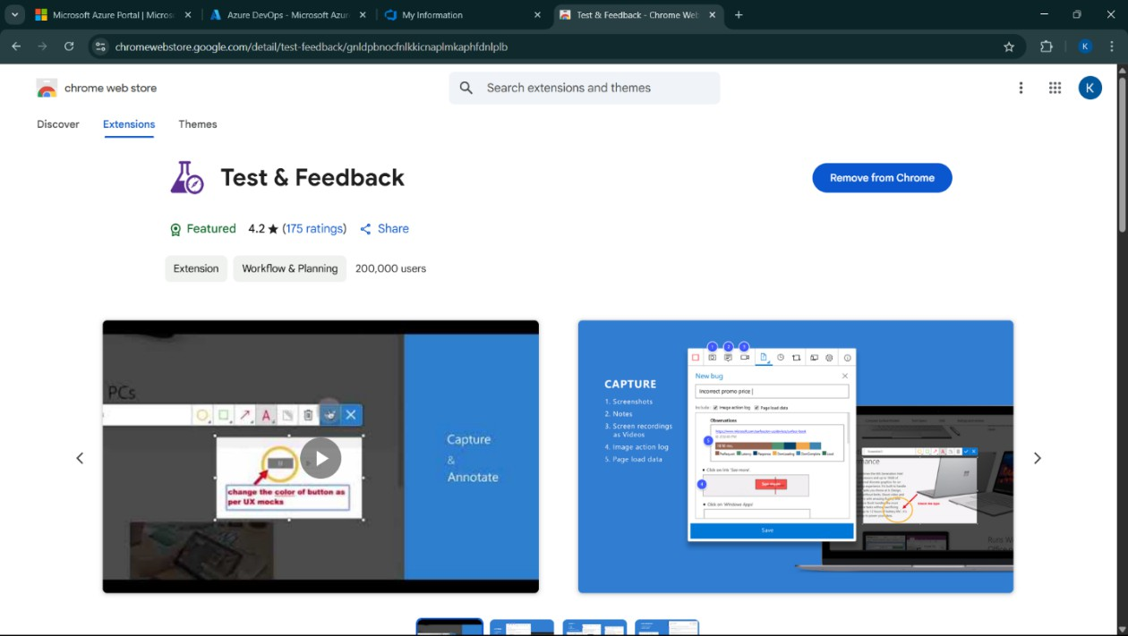

Test and feedback Showing it as an extension

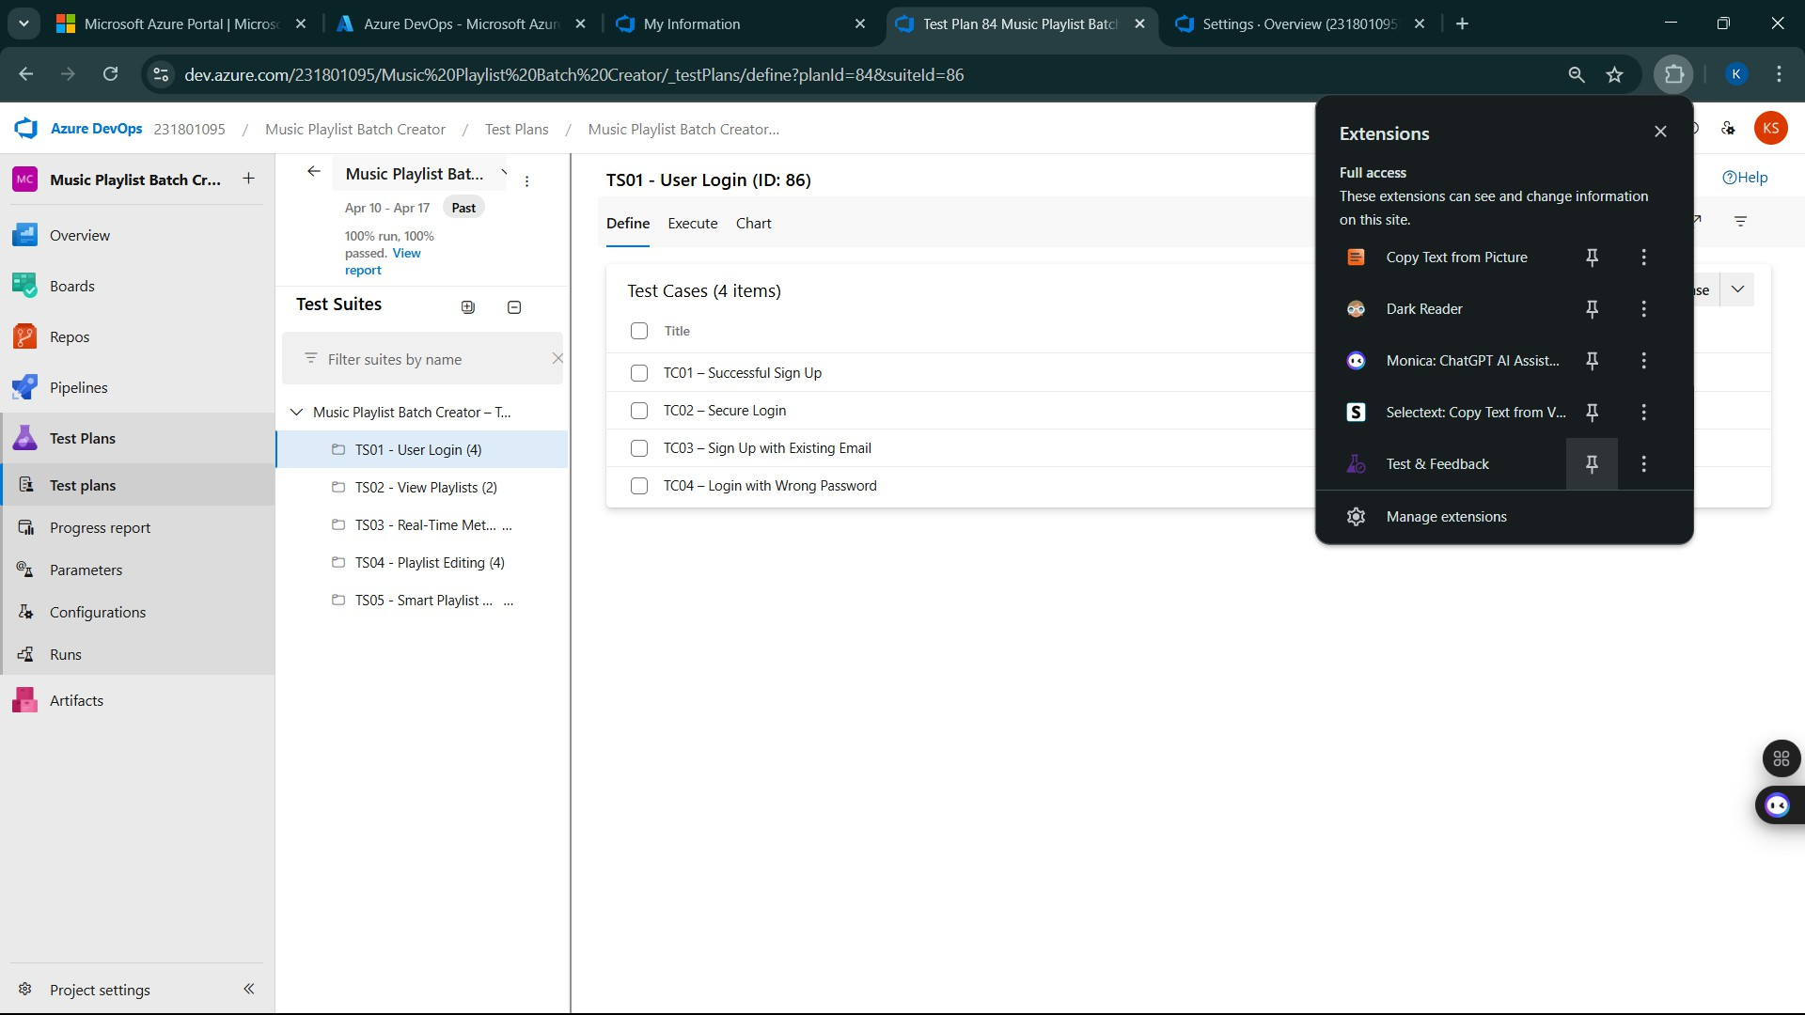

- Running the test cases
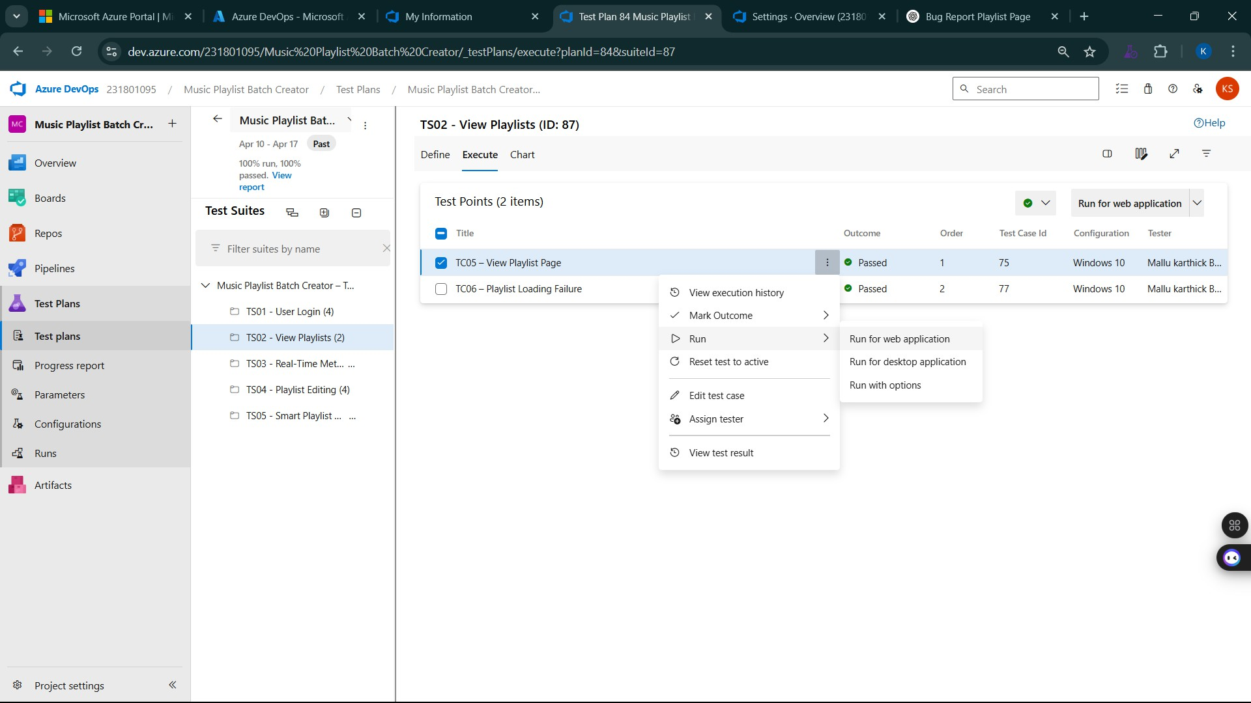

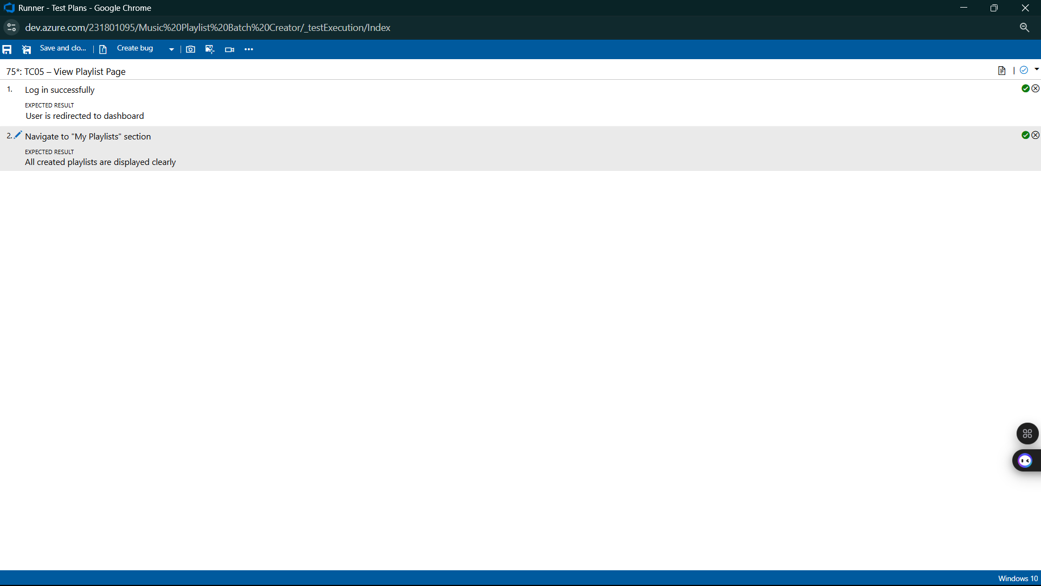

- Recording the test case

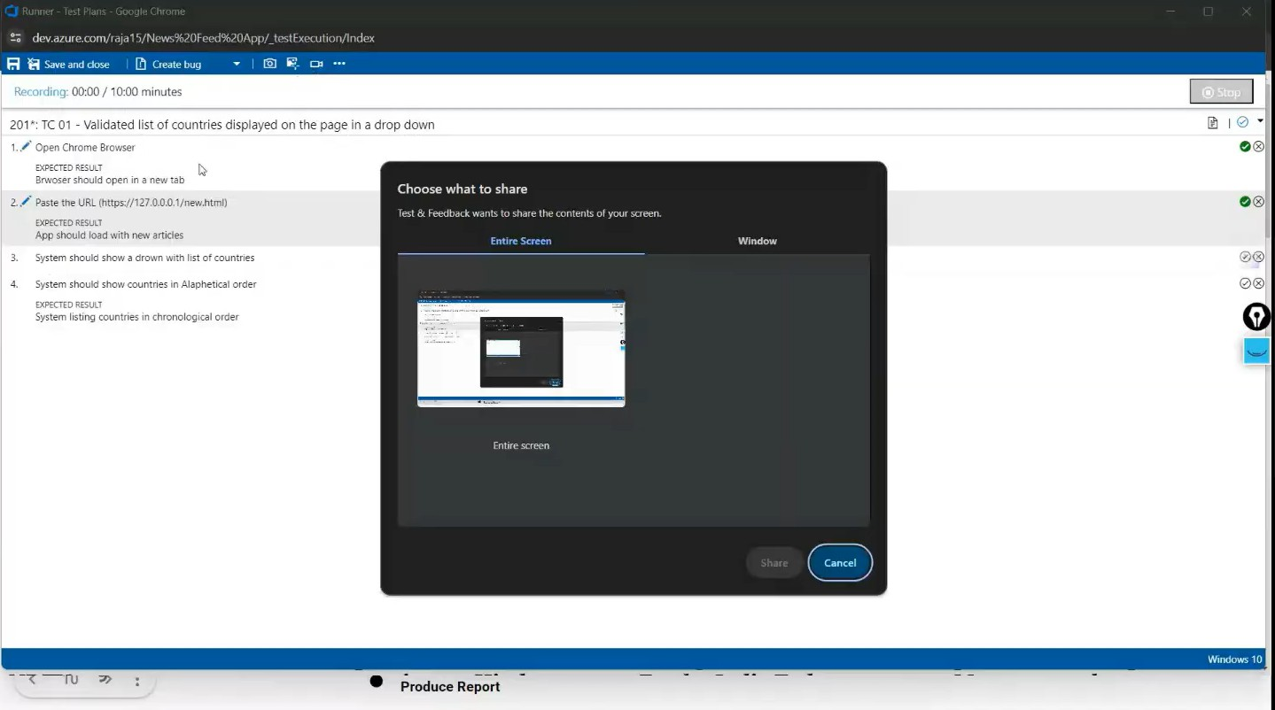

- Creating the bug
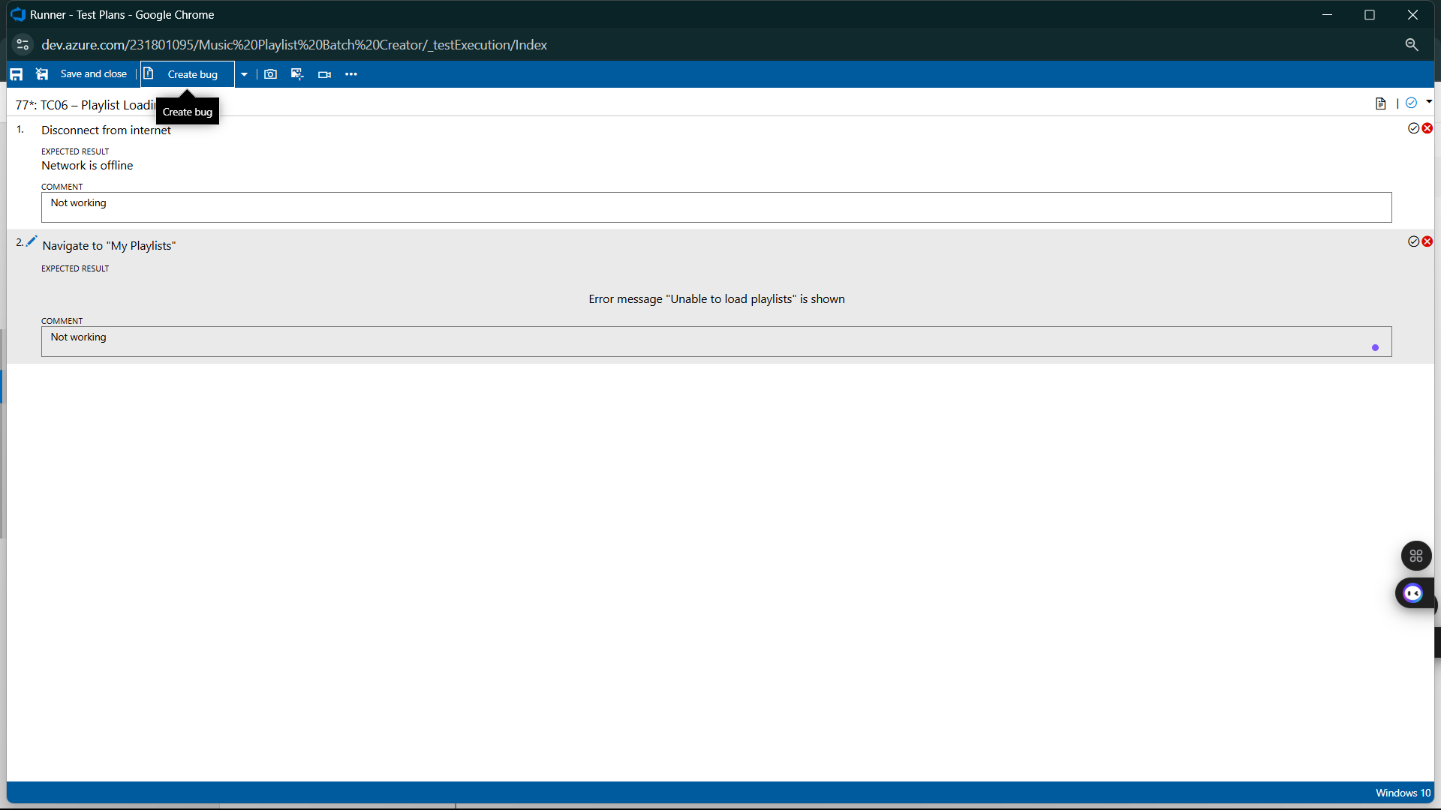

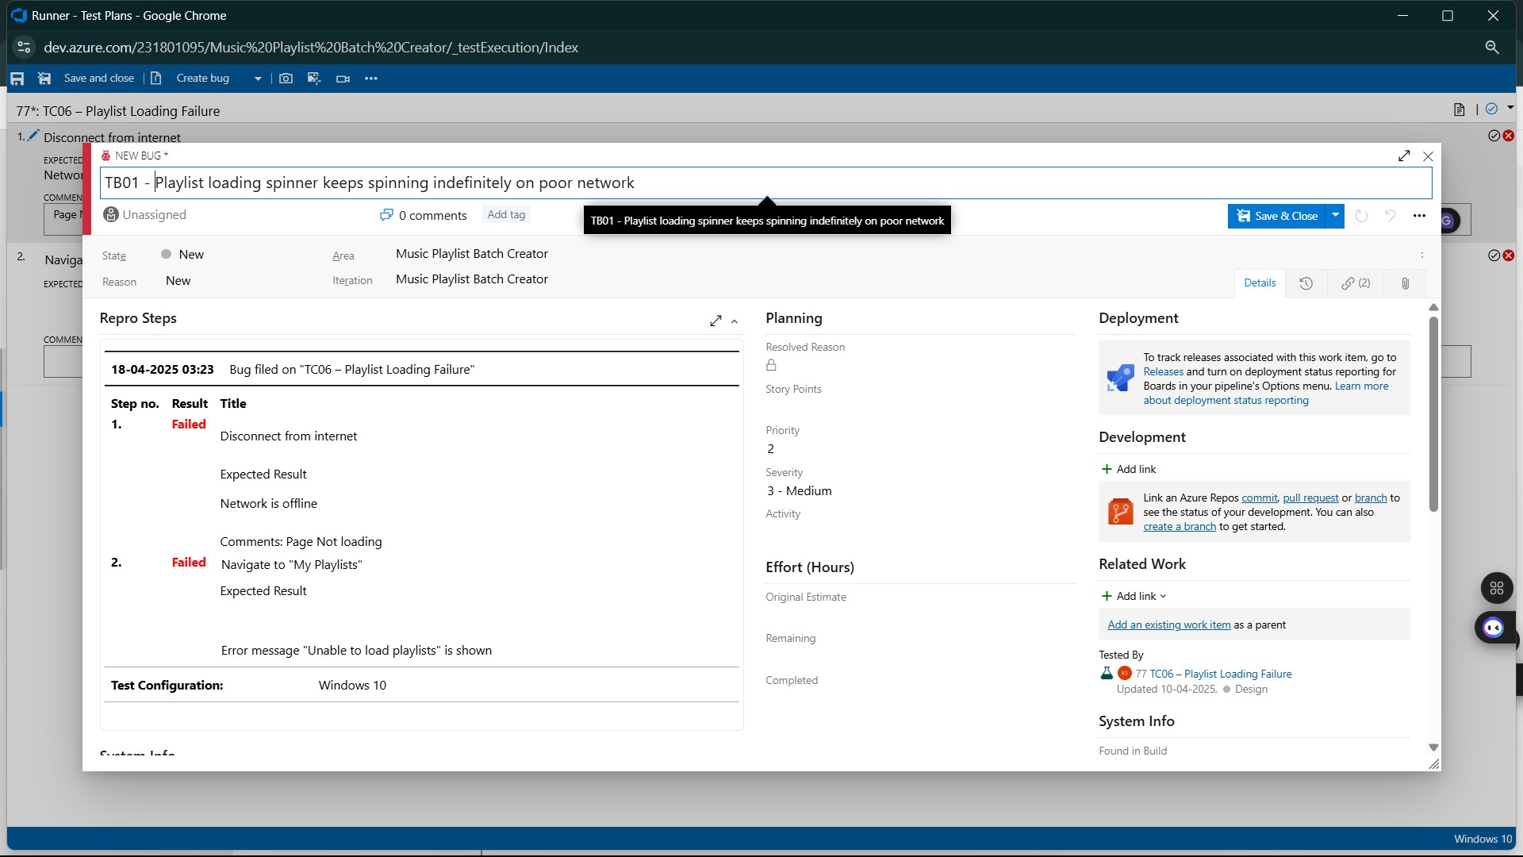
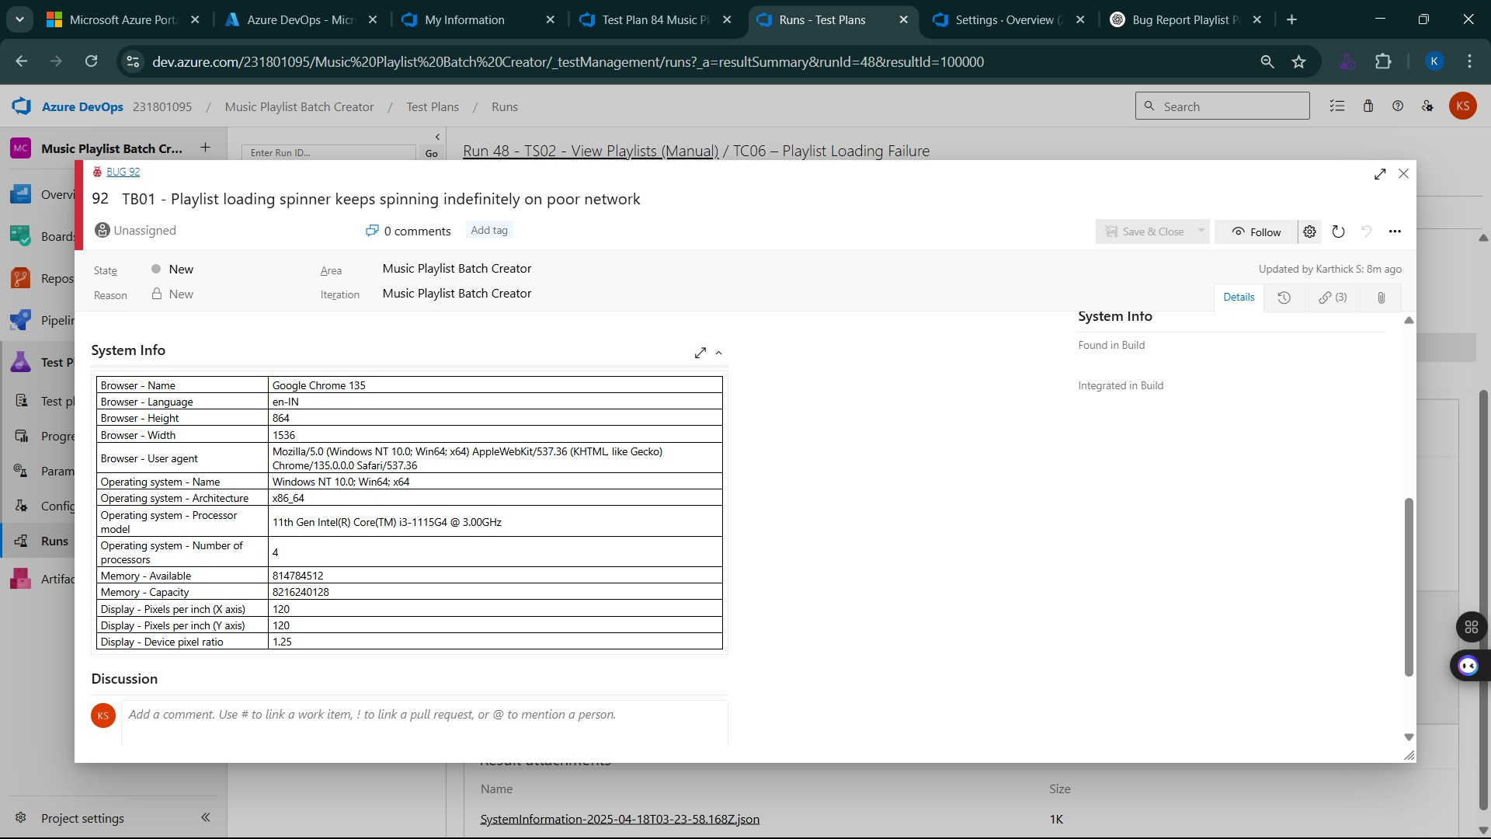

- Test case results
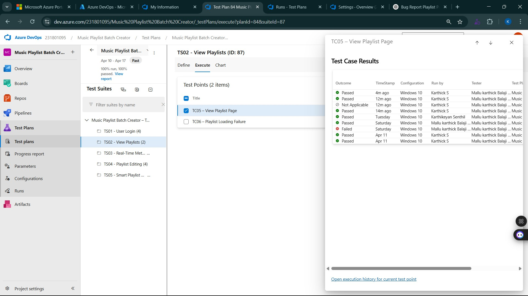

- Test report summary
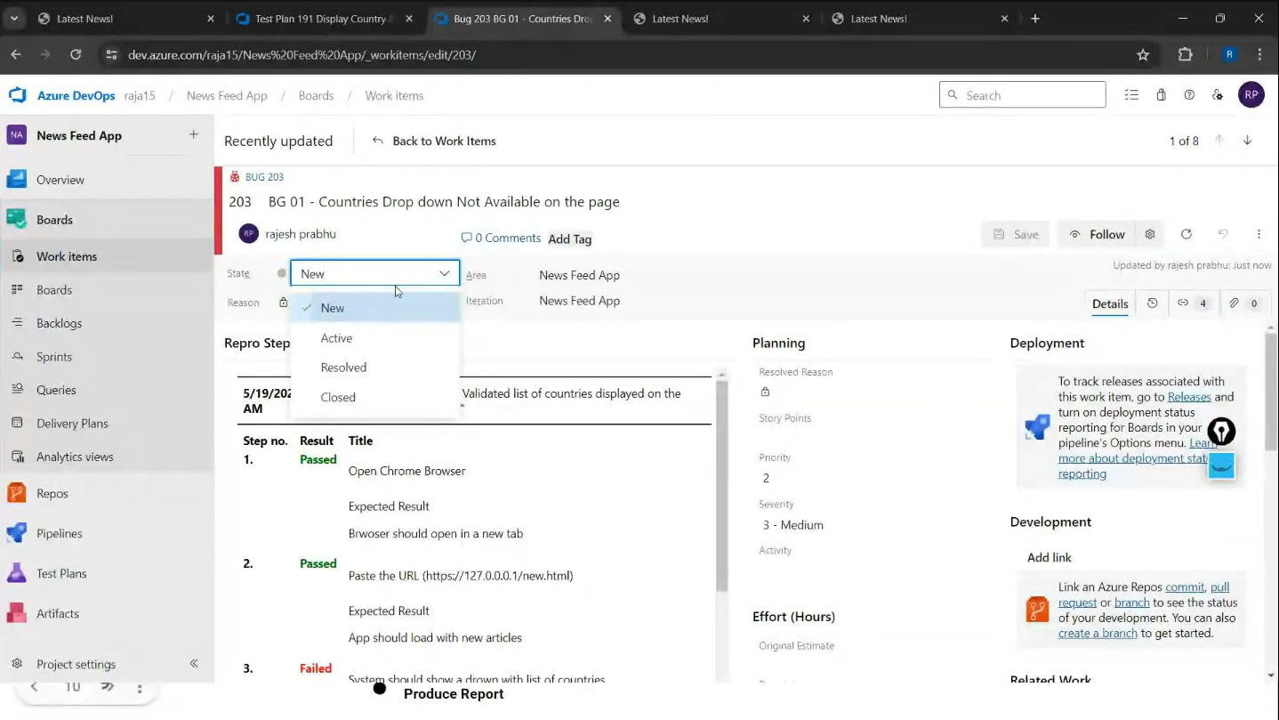

  - Assigning bug to the developer and changing state

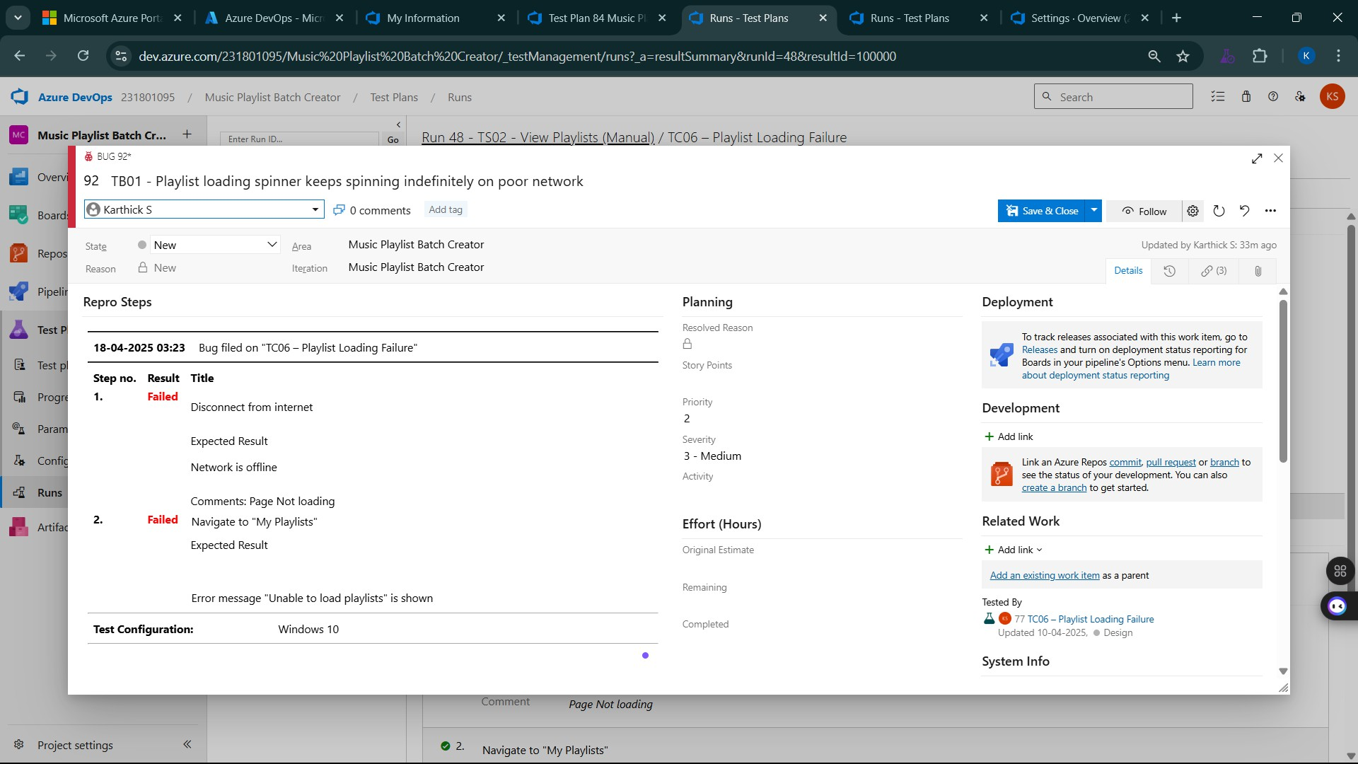

- Progress report
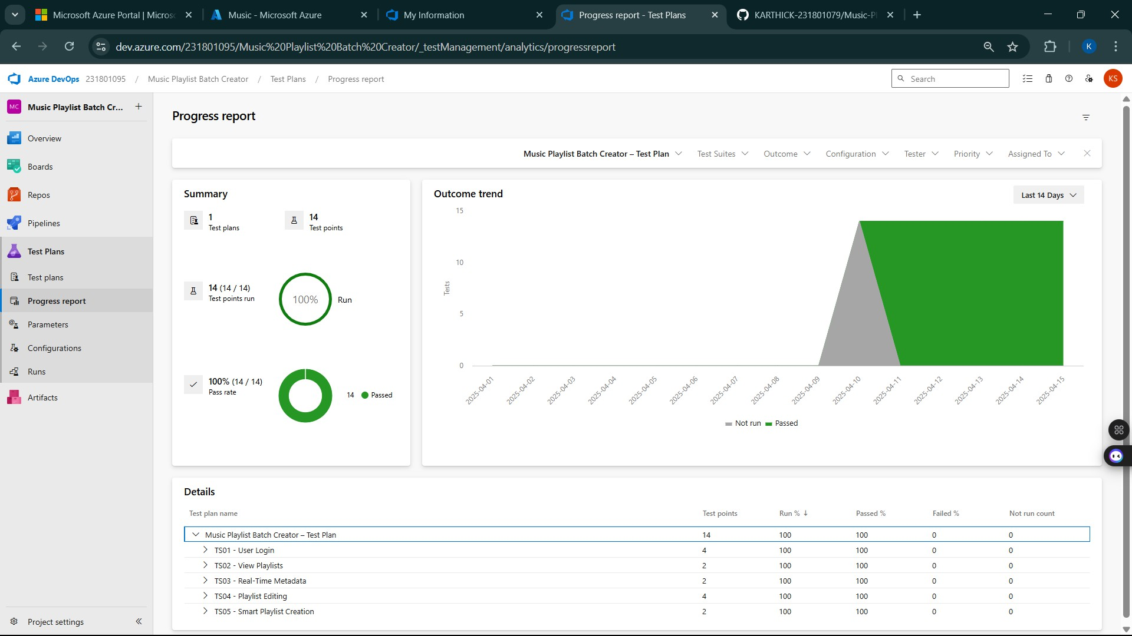

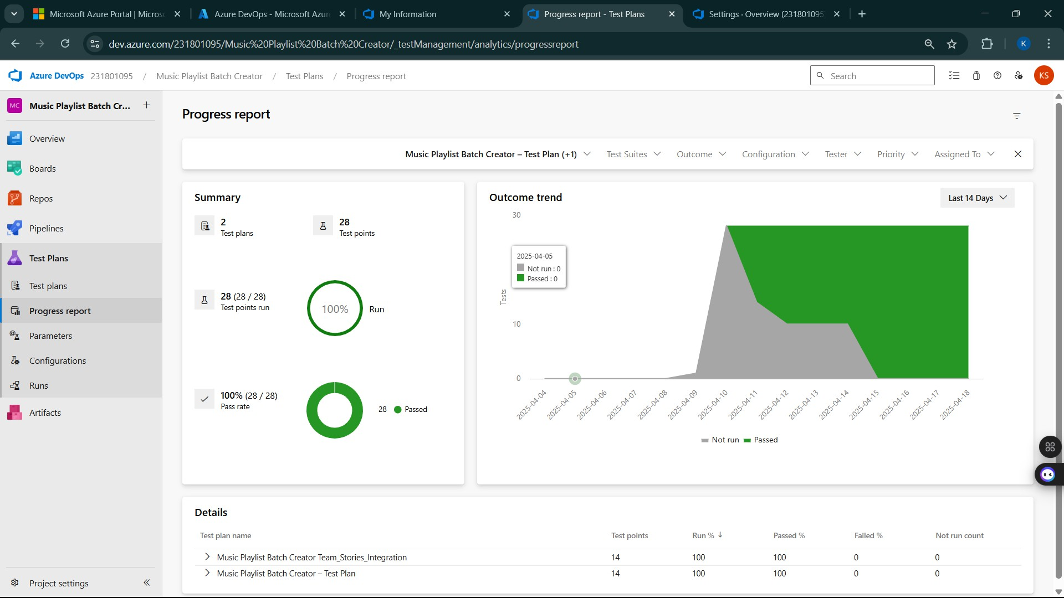

- Changing the test template
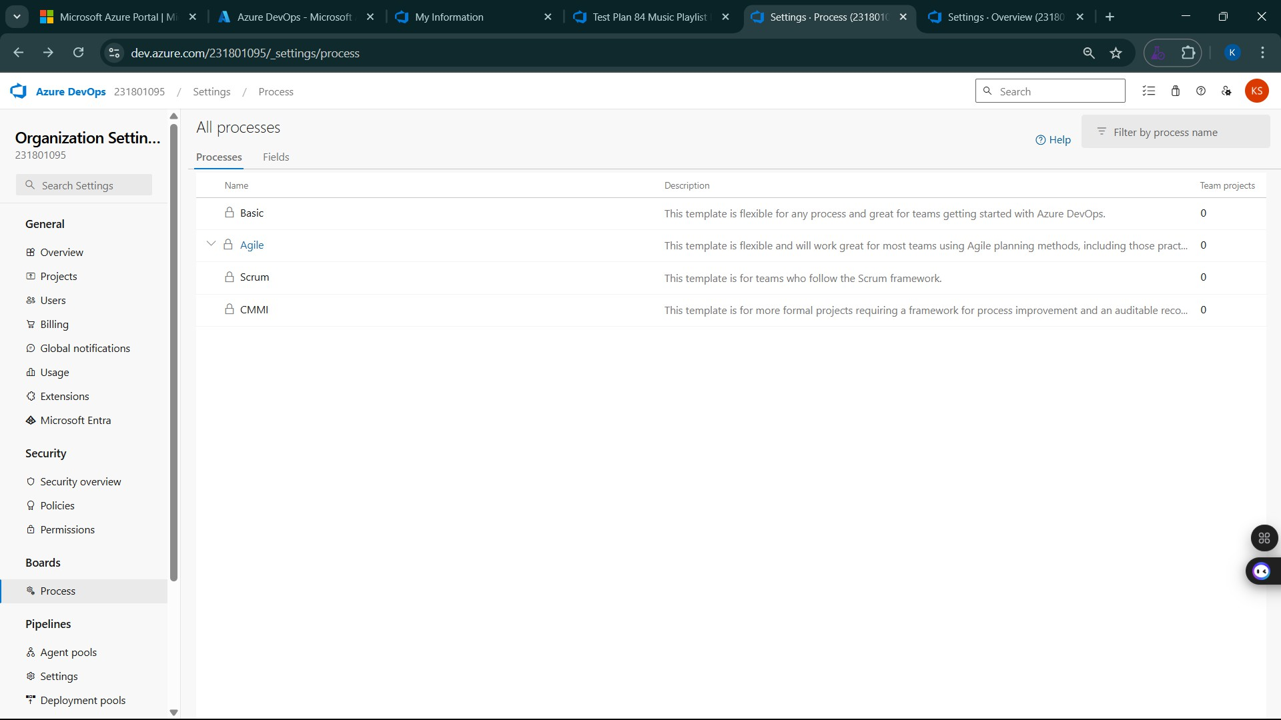

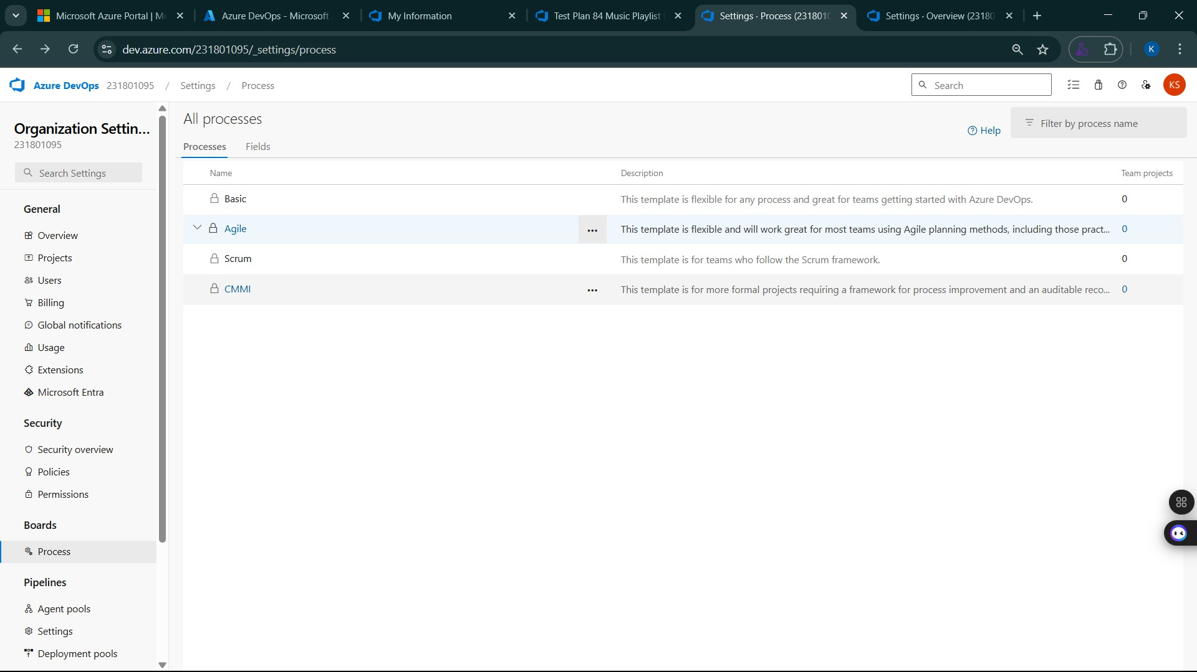
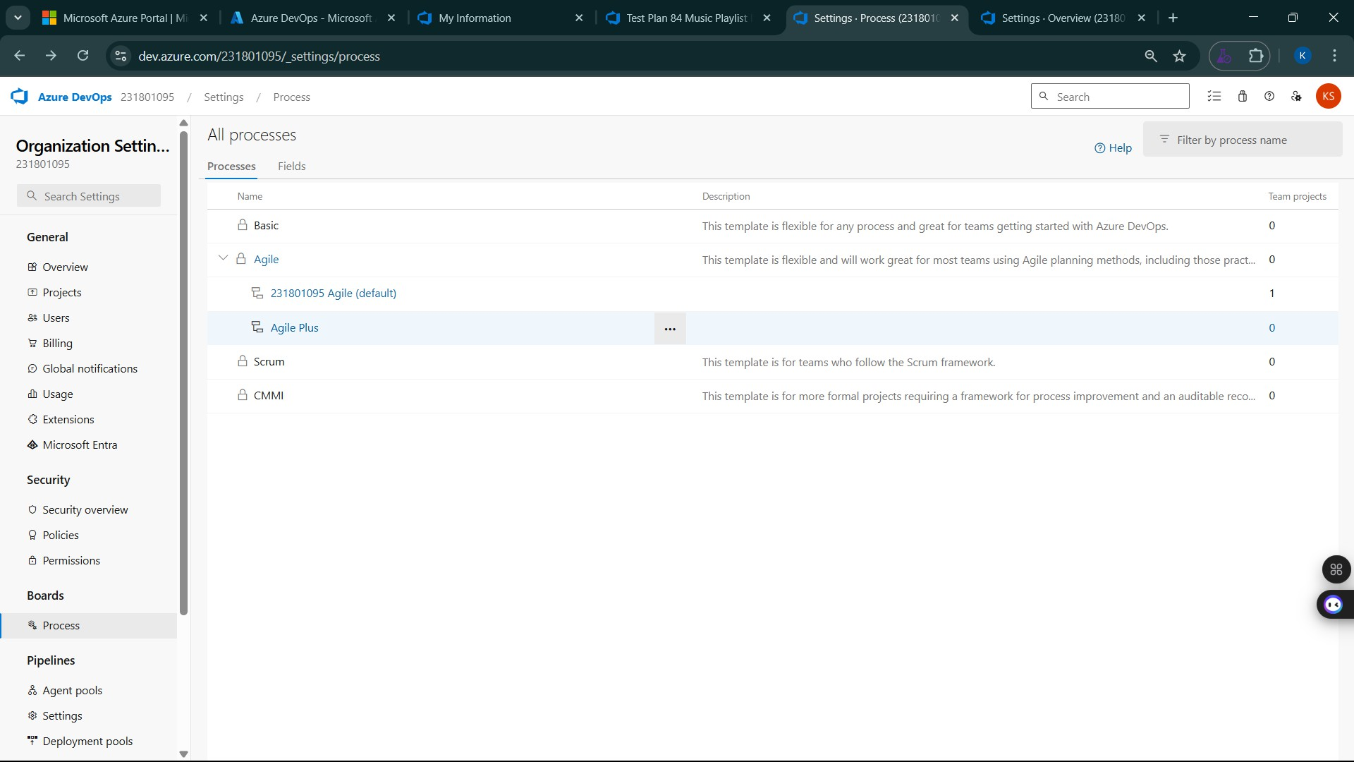

- View the new test case template
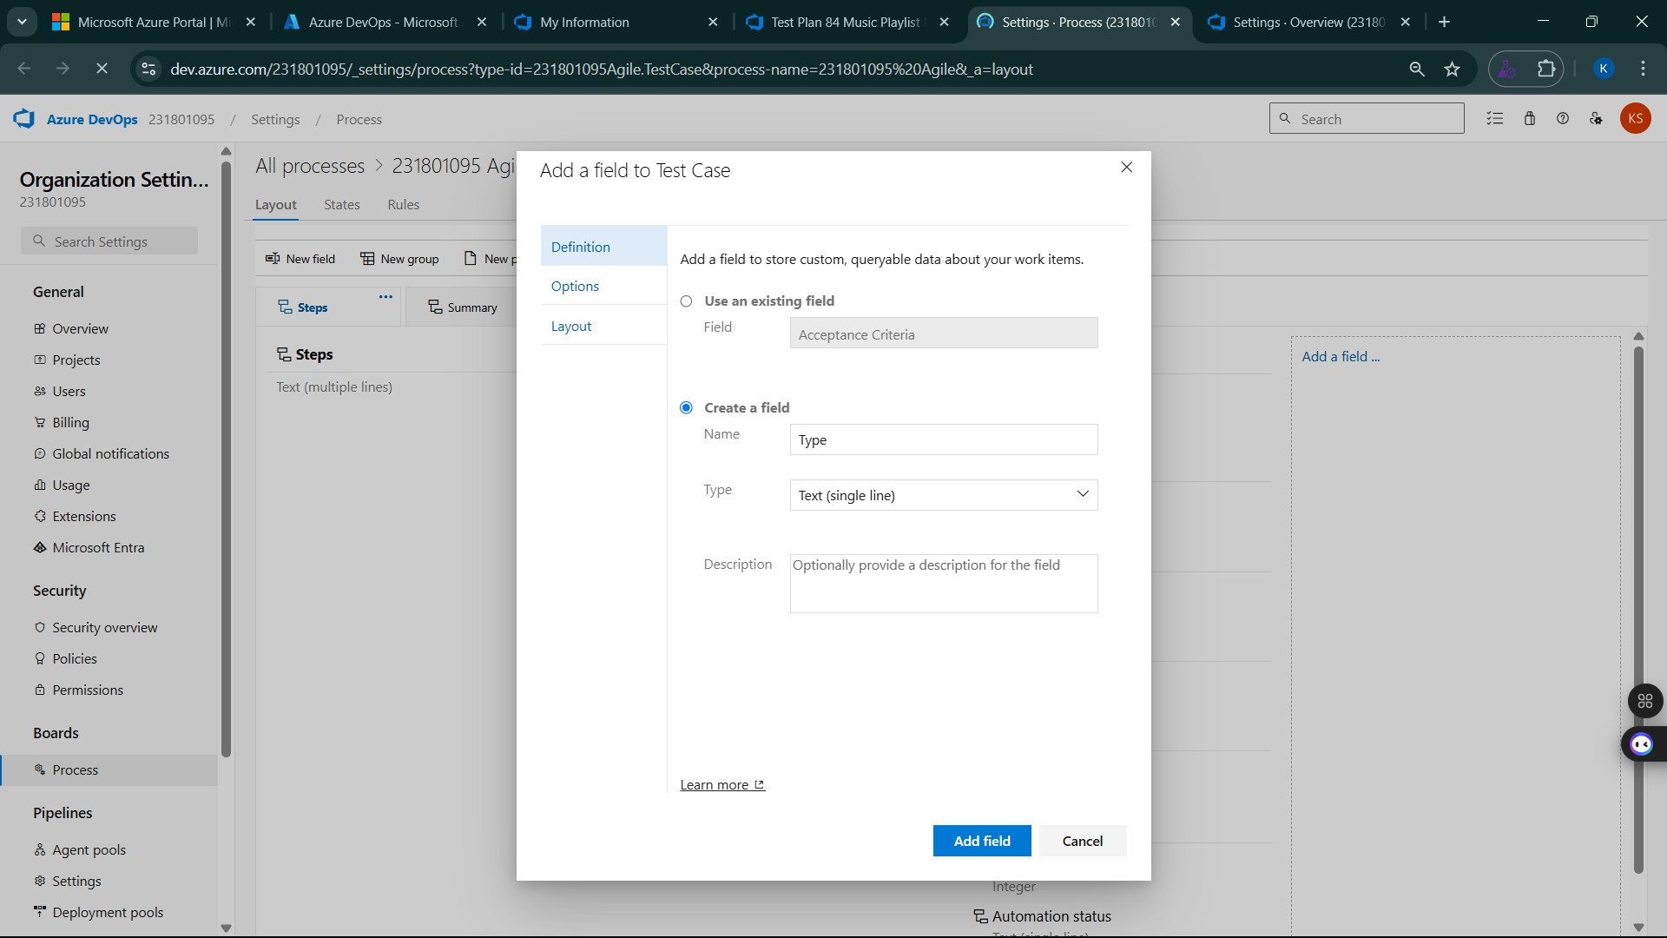

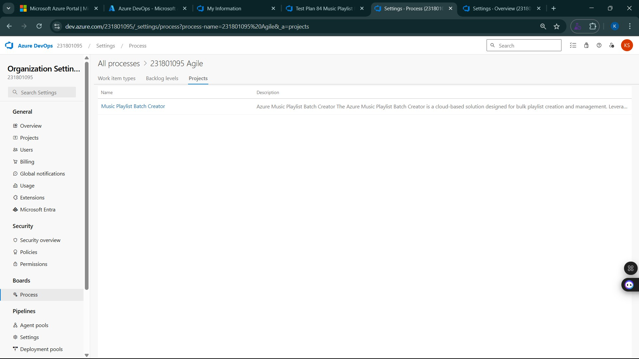

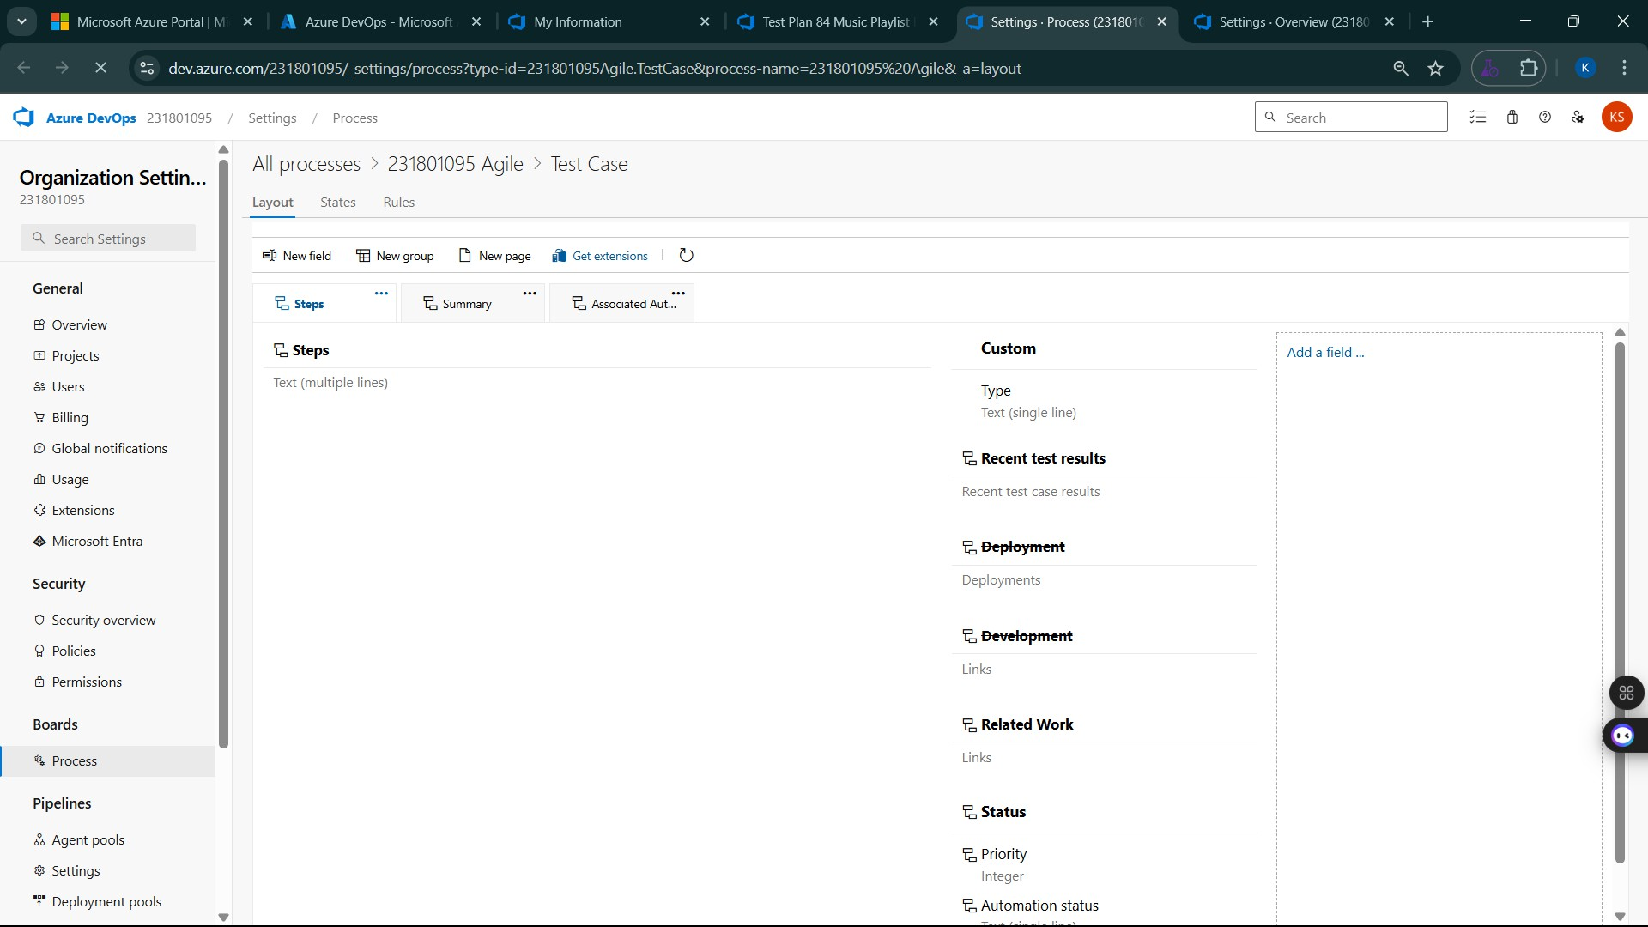

Result:
The test plans and test cases for the user stories is created in Azure DevOps with Happy Path and
Error Path

