LOAD TESTING AND PIPELINES

EXP NO: 9

Aim:
Create Epic, Features, User Stories, Task
To create an Azure Load Testing resource and run a load test to evaluate the performance of a target endpoint and to create and demonstrate an Azure DevOps pipeline for automating application builds, tests, and deployment.

Load Testing
Azure Load Testing:
Azure Load Testing allows you to simulate high traffic and stress tests for your web applications and APIs to understand how they perform under load. It helps identify performance bottlenecks, scalability issues, and optimize resource usage before deployment.

Steps to Create an Azure Load Testing Resource:
Before you run your first test, you need to create the Azure Load Testing resource:
- Sign in to Azure Portal
Go to https://portal.azure.com and log in.
- Create the Resource
  - Go to Create a resource → Search for “Azure Load Testing”.
  - Select Azure Load Testing and click Create.
- Fill in the Configuration Details
  - Subscription: Choose your Azure subscription.
  - Resource Group: Create new or select an existing one.
  - Name: Provide a unique name (no special characters).
  - Location: Choose the region for hosting the resource.
- (Optional) Configure tags for categorization and billing.
- Click Review + Create, then Create.
- Once deployment is complete, click Go to resource.

Steps to Create and Run a Load Test:
Once your resource is ready:
- Go to your Azure Load Testing resource and click Add HTTP requests > Create.
- Basics Tab
  - Test Name: Provide a unique name.
  - Description: (Optional) Add test purpose.
  - Run After Creation: Keep checked.
- Load Settings
  - Test URL: Enter the target endpoint (e.g., https://yourapi.com/products).

- Click Review + Create → Create to start the test.

Load Testing
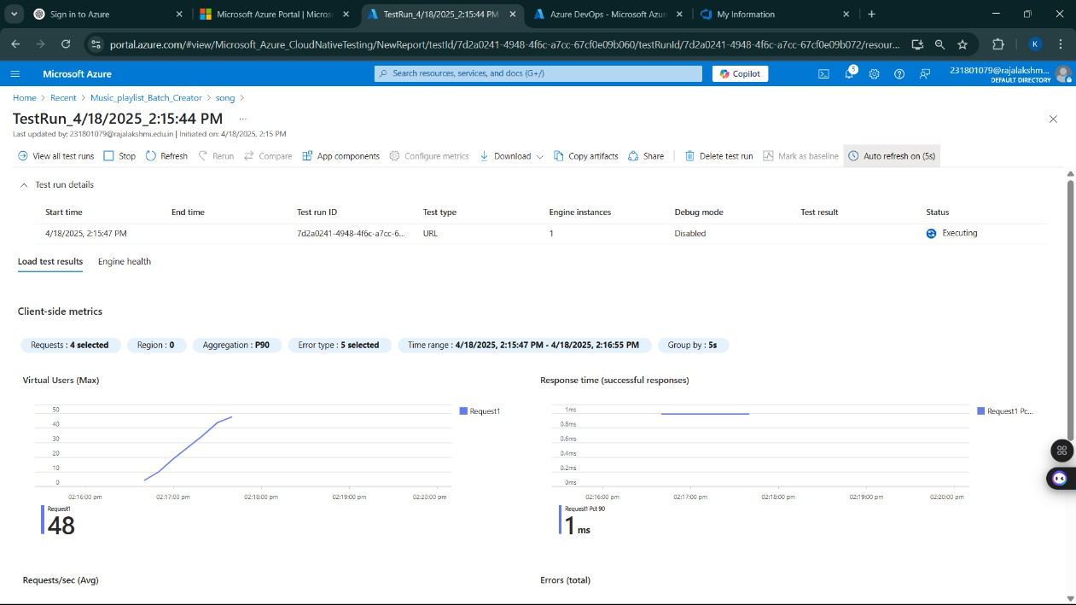
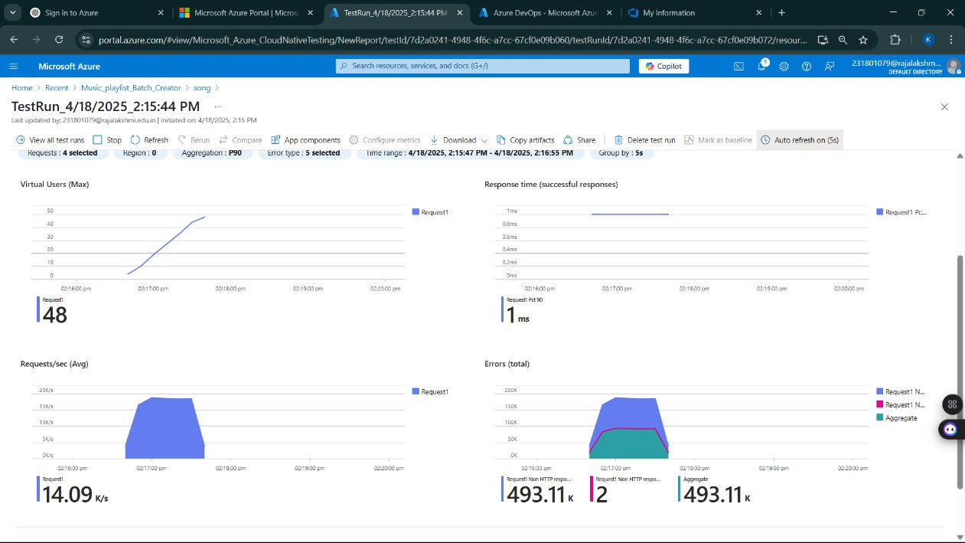

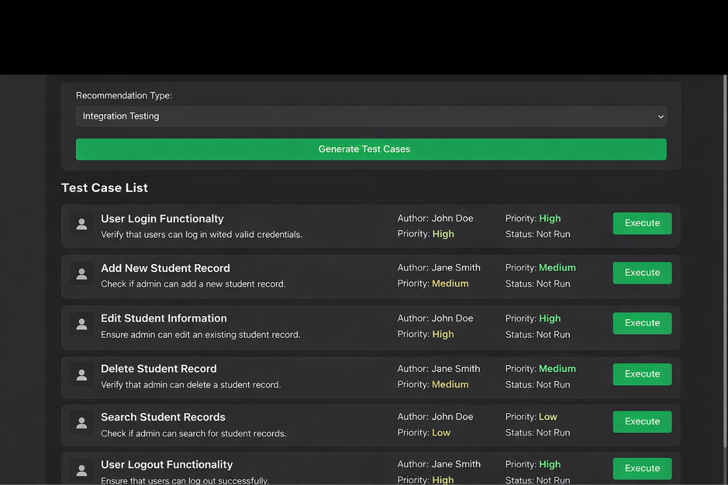

Pipelines Description:
This experiment demonstrates how to connect a GitHub-hosted Flask-based music recommendation project with Azure DevOps. The pipeline will automatically install dependencies, run basic tests, and publish artifacts. This ensures that every commit triggers checks for reliability and smooth deployment.

Steps:
- Connect GitHub to Azure DevOps:
  - In Azure DevOps, create a new project.
  - Create a pipeline and select GitHub as the source.
  - Authorize access to your GitHub repository, ensuring that Azure DevOps can pull the repository for your pipeline.
- Create azure-pipelines.yml in Your Repo Root:
  - In your GitHub repository, create a new file called azure-pipelines.yml in the root directory.
  - Add the following basic pipeline configuration for Python and Flask:

yml Code
trigger:
- main # Trigger pipeline when changes are pushed to the main branch

pool:
vmImage: ubuntu-latest # Use a hosted Ubuntu agent

steps:
# Step 1: Checkout the code from GitHub
- checkout: self

# Step 2: Set up Python environment
- task: UsePythonVersion@0 inputs:
versionSpec: '3.x' # Use the latest Python 3.x version displayName: "Set up Python"

# Step 3: Install dependencies from the correct path
- script: |
python -m pip install --upgrade pip
pip install -r project/requirements.txt # Adjusted path to requirements.txt displayName: "Install dependencies"

# Step 4: Run a simple Python script to check the environment
- script: |
python -c "print(' Hello from Music Playlist Batch Creator!')" displayName: "Run a Python script"

- Pipeline Tasks Include:
  - Setting up the Python environment using the UsePythonVersion task.
  - Installing project dependencies from project/requirements.txt. Make sure the path to requirements.txt is correct (it is located under the project folder).
  - Running a simple Python script to verify that Python is set up correctly and the pipeline works.
- Run and Monitor Pipeline:
  - Commit changes to the main branch of your repository to trigger the pipeline in Azure DevOps.
  - Monitor the logs in the Azure DevOps portal to view logs, errors, or success messages and ensure everything runs smoothly.

Result:
Successfully created the Azure Load Testing resource and executed a load test to assess the
performance of the specified endpoint and also demonstrated pipelines in azure devops.

