**[HUMANOID ROBOTS- FACE OF FUTURE](https://www.livewireindia.com/machine_learning_training.php)**

Humans and robots are interesting perceptions in this world and these are the stuff of modern-day science invention. Massive leaps made in the field of robotics and AI will be the next face to future. Of all the robots, humanoid robots have a special place. Here are some humanoid robots that are driving innovation for the future.

1. **Ocean One**

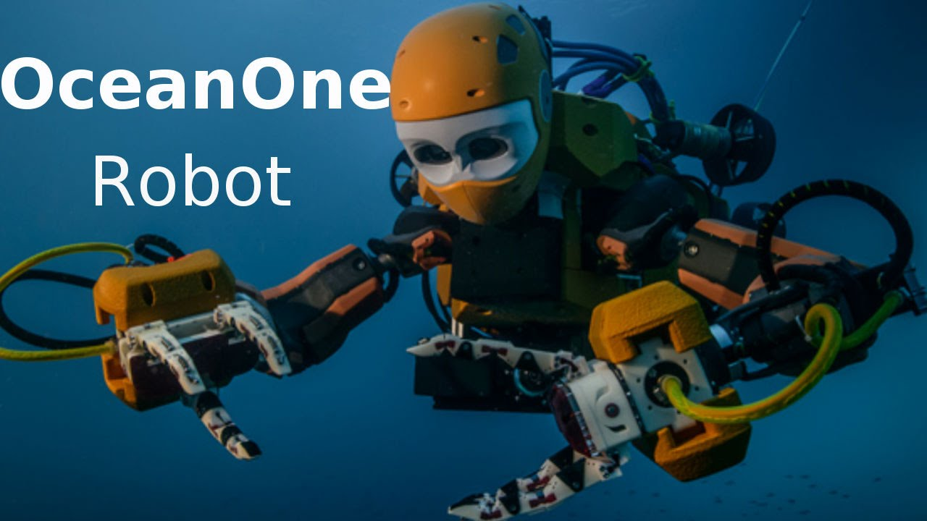

It’s an underwater humanoid robot created by the Stanford Robotics Lab. Theses can explore coral reefs, Ocean ie, One can reach depths that most human beings cannot. It is a perfect synergy of robotics, haptic feedback systems, and artificial intelligence.

Its features are two fully articulated arms, eight multi-directional thrusters, and stereoscopic vision. They can counter the massive pressure exerted on it at great underwater depths. This ‘robo mermaid’ is designed similar to that of a real human diver which greatly improves its maneuverability and navigational capabilities.

**2. ATLAS**

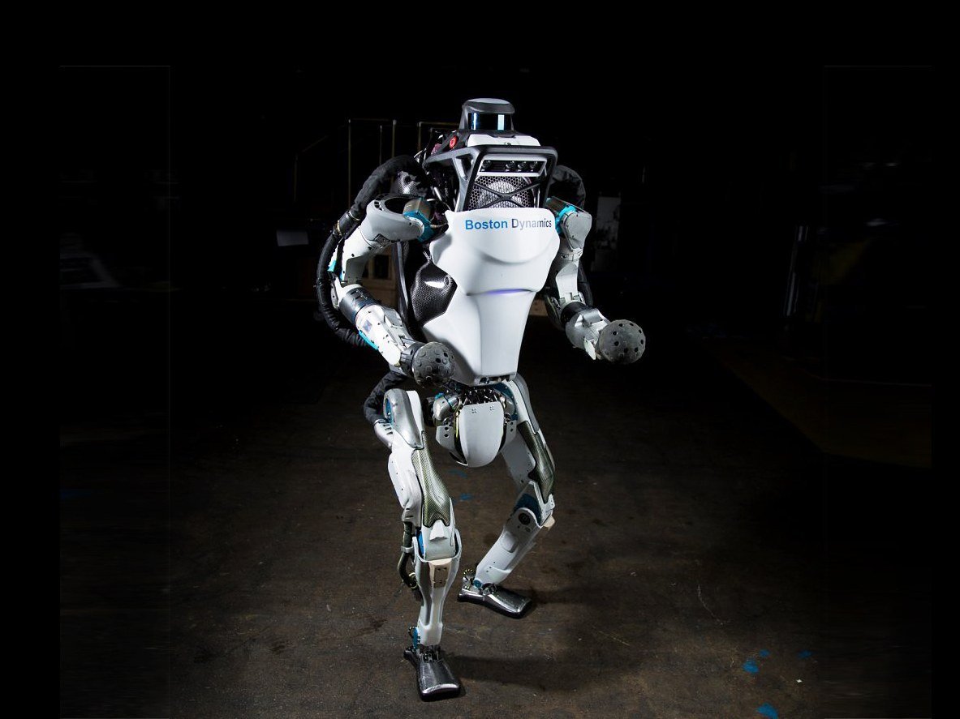

It is described as “the world’s most dynamic humanoid” by its creators, ATLAS was unveiled in 2013. It was built to carry out search and rescue missions. It can navigate its way through tough terrain and obstacles in its path using its range sensing, stereo vision, and other sensors. ATLAS Unplugged was unveiled in 2015 and the designers claimed made it nearly 75% different from the original ATLAS.

**3. Nao**

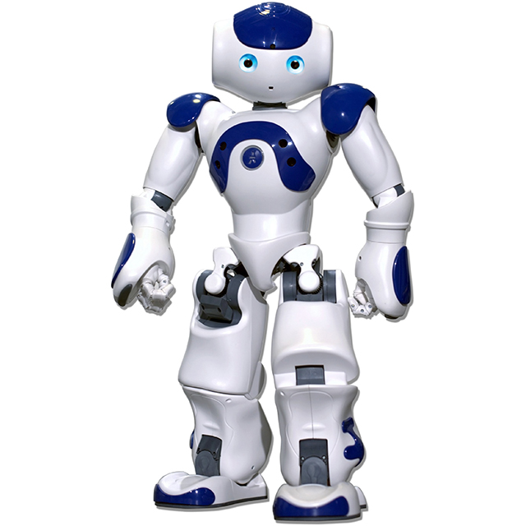

Imagine a soccer match with adorable baby-sized robots on both sides. Nao, the 23-inch robot has an entire event, RoboCup Standard Platform League, dedicated to it as a part of Robocup.

It was originally developed by the French robotics company, Aldebaran Robotics, and the production version was launched in 2008. NAO’s makeup by motors, sensors, and software powered by NAOqi — a dedicated operating system. Nao is adopted in 70 countries, especially for academic and research purposes. One of the most special applications that Nao has seen is in the education of autistic children.

**4. Petman**

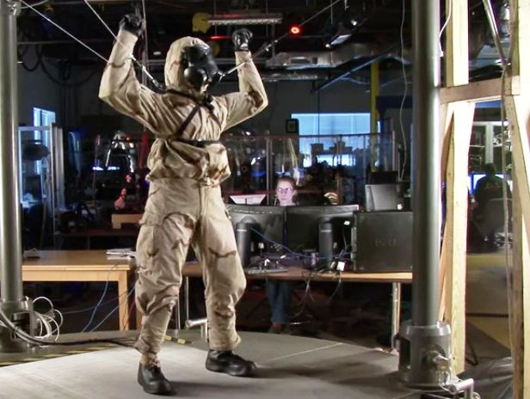

Protection Ensemble Test Mannequin (‘Petman’) is another creation by Boston Dynamics. It was developed to test biological and chemical suits for the US military. It is nearly 6 feet tall and weighs 80 kilos. The likeness of its walk to that of a human being is a rarity even among humanoid robots. Petman is the fastest bipedal robot with a top walking speed of about 7.08 kilometers per hour. The main use of Petman is to serve as a crash dummy to test the effect of chemical and biological agents and help develop superior ones in the future.

**5. Pepper**

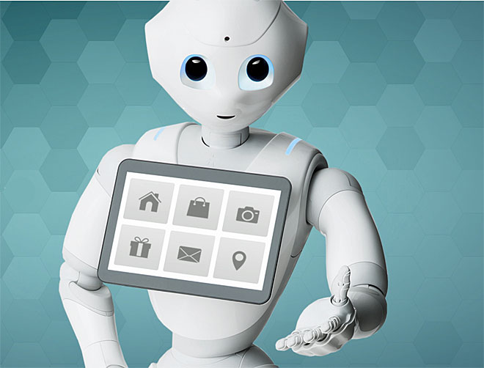

Now Technology leads as a robot that can read primary human emotions such as anger, joy or sadness. No robot does it better than Pepper. It was built by SoftBank Robotics.

Pepper can interpret one’s facial expressions, the tone of voice and other non-verbal cues, and respond appropriately. Due to this special ability, Pepper has seen employment in many areas that rely on interaction with clients such as in supermarkets, banks and in SoftBank stores itself. It can remember the faces and preferences of customers and make an order or choice the next time it interacts with the customer.

**6. Sophia**

Sophia was developed by roboticist David Hanson and his company Hanson Robotics. She was activated in April 2015 and came to international renown in October 2017 after she was granted citizenship by the Kingdom of Saudi Arabia.

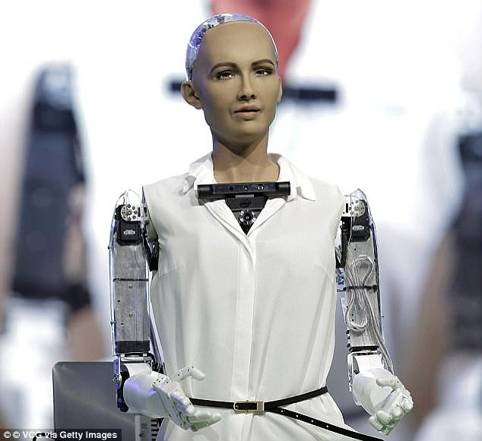

Sophia’s programming is similar to ELIZA where she responds with pre-written responses for specific questions. This gives the illusion of a conversation. Sophia got ‘legs’ in January 2018 and can move now.

Based on the above inventions we can clearly evident that Machine Learning have huge opportunity and technical growth. [**Machine Learning Certification Course**](https://www.livewireindia.com/article.php?title=Why_Is_It_Necessary_To_Learn_Data_Science_In_The_Current_Scenario?&id=54) is one of the hottest topics in Information Technology and Computer Science. LIVEWIRE enhance special education courses in IT, Electronics and Electricals making specialists for rising innovation enterprises and master innovation occupations. Livewire provides technical guidance in Machine Learning Course for beginners in Artificial Intelligence, Predictive analysis, Neural Network etc. Livewire provides best [**Machine Learning Course in Kerala**](https://www.livewireindia.com/machine_learning_training.php) with advanced technological features of Artificial Intelligence. [**Data Analytics Course in Kerala**](https://www.livewireindia.com/machine_learning_training.php) also has the huge demand.

Livewire provides best [**Machine Learning Training in Thrissur, Kerala**](https://www.livewireindia.com/machine_learning_training.php). This is the best and right step for a wonderful career.